CAPSTONE PROJECT
DineDash – Food Delivery Data Analysis
By:
Name: Kishore Donipudi
Mail: Kishoredonipudi921@gmail.com
Stream batch: Full Stack data engineering- Databricks (Cohort-2)

1. Project Overview
DineDash is a food-delivery analytics project designed to turn order, customer, restaurant, menu, location, and delivery-agent data into useful business insights. The case study focuses on ETL pipelines, streaming data analytics, and dashboards using Databricks.

Project Goals
- Integrate data from orders and dimension datasets into a common analytics environment.
- Clean and validate the data before analysis.
- Build Bronze, Silver, and Gold layers using Delta Live Tables.
- Generate order, customer, restaurant, item, delivery, and revenue insights.
- Publish key metrics through Databricks dashboards and automate execution with a workflow.

Technology Used
- Azure Databricks
- Apache Spark / Databricks SQL
- Delta tables and Delta Live Tables
- JSON and CSV source files
- Databricks Dashboards and Workflows

2. Data Ingestion
The DineDash datasets are stored in the project Volume. The order data is provided month-wise, while customer, restaurant, location, menu-item, and delivery-agent data are dimension datasets.
Source path: /Volumes/kishoredb/cap_db/cap_files/dimensions/

Datasets
Dataset | Purpose
Orders | Monthly JSON files for 2024
Customers | Customer details and signup information
Restaurants | Restaurant, cuisine, rating, and location information
Menu Items | Menu item, category, price, and restaurant information
Delivery Agents | Agent details and ratings
Locations | Area, city, state, and geographic information

Displaying the files ingestion location using the dbfs command
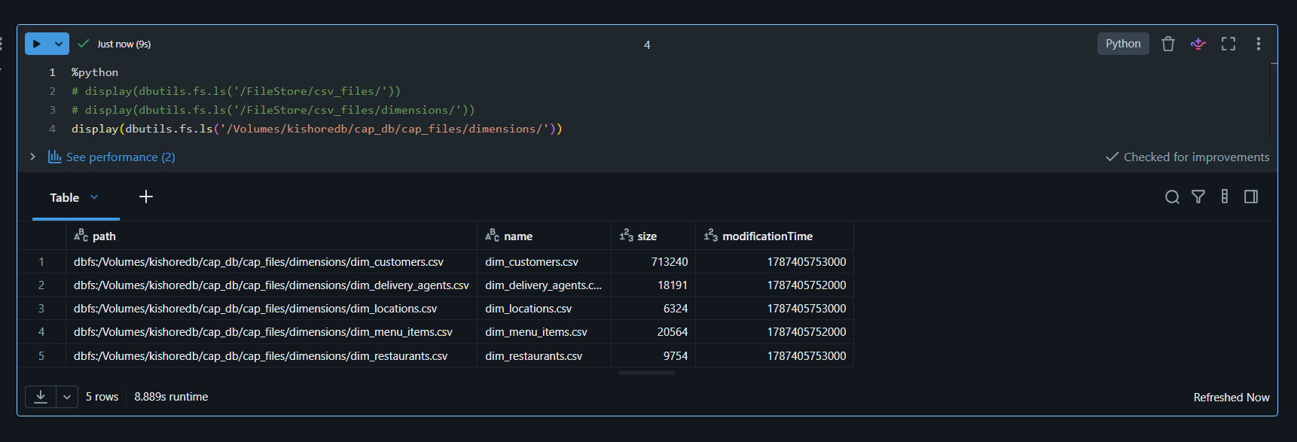

3. Bronze Layer – Data Exploration and Ingestion
The Bronze layer stores the source data with minimal transformation. Before creating permanent tables, the datasets are explored to understand their structure and inferred schema.

3.1 Schema Discovery
Temporary views are created over the dimension datasets so that the schema and sample records can be checked before defining permanent Bronze tables.
1.Creating the Temporary view for customers Dataset using read_files() command and Displaying First 10 Records
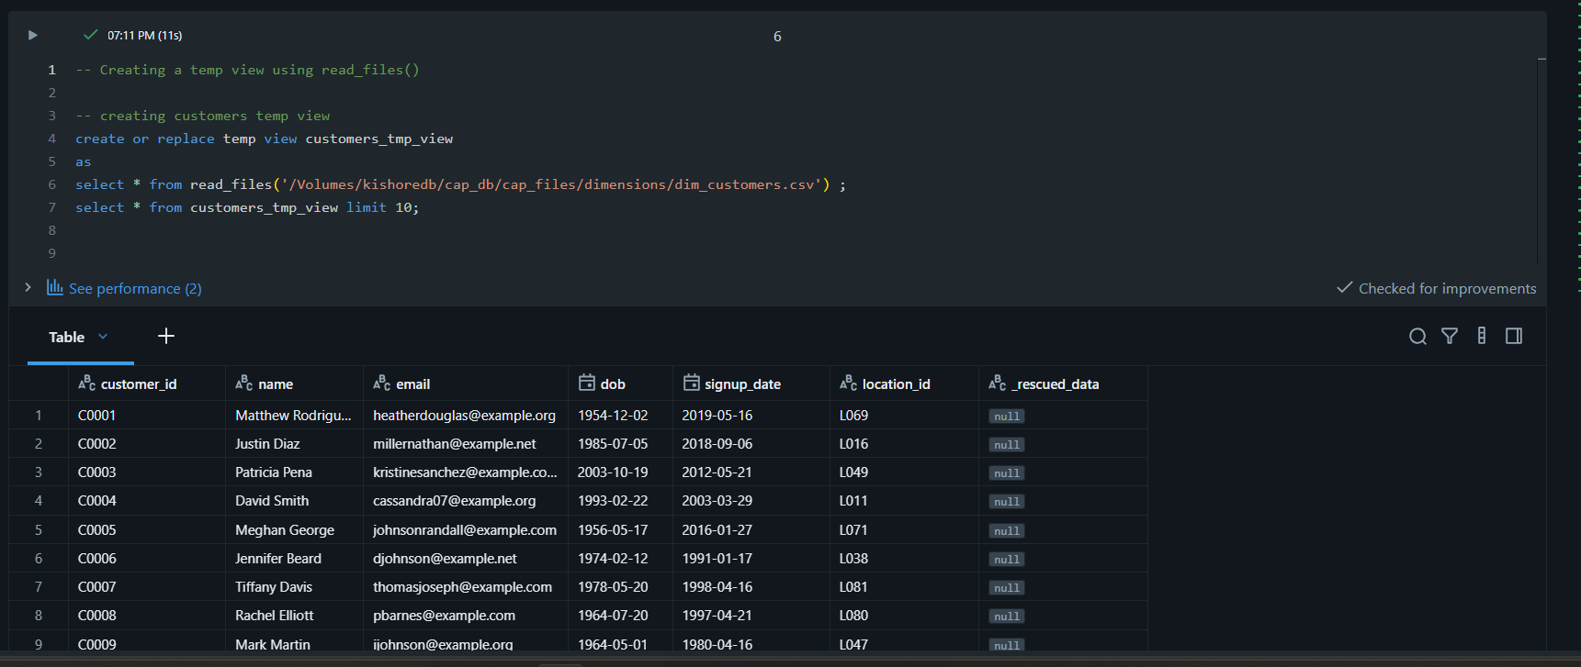
2.Creating the Temporary view for menu_items Dataset using read_files() command and Displaying first 10 records
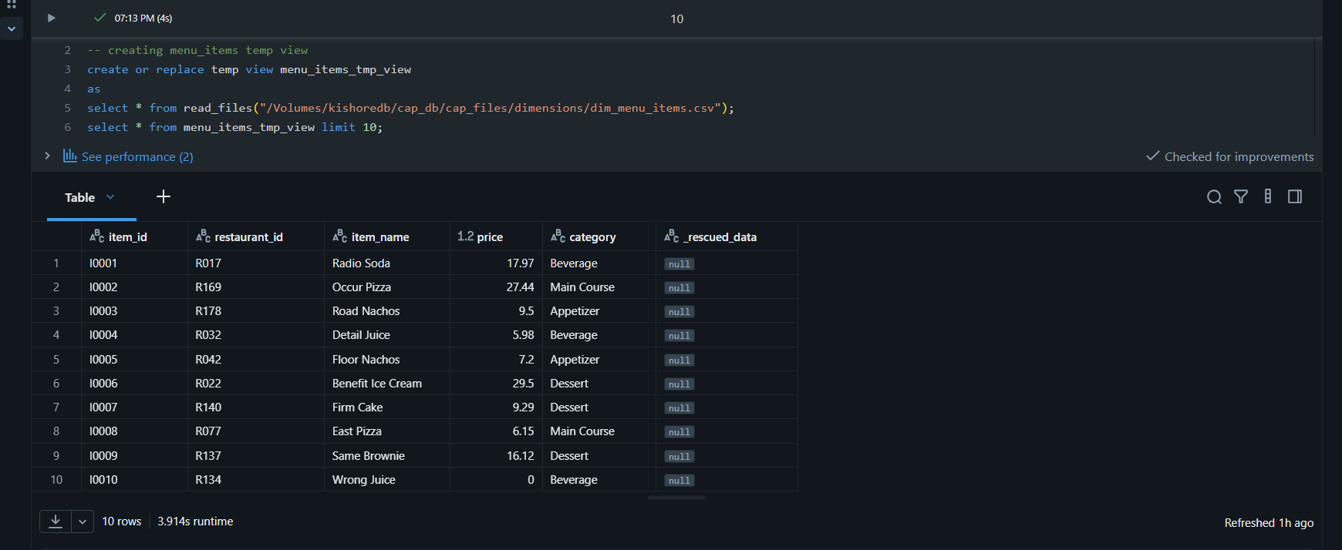
3.Creating the Temporary view for delivery_agents Dataset using read_files() command and Displaying first 10 records
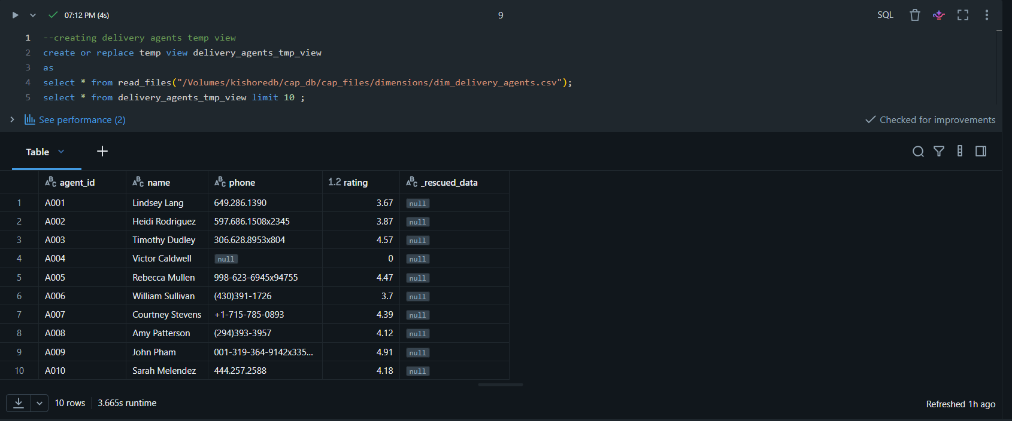
4.Creating the Temporary view for Locations Dataset using read_files() command and Displaying first 10 records
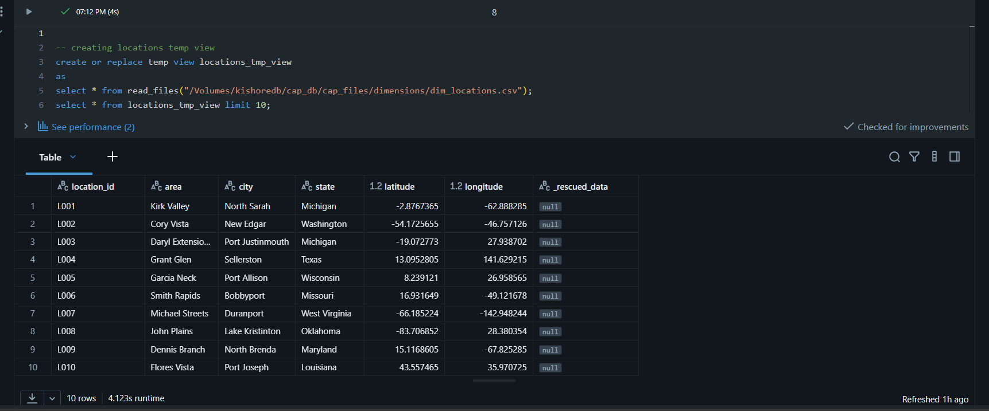
5.Creating the Temporary view for Restaurants Dataset using read_files() command and Displaying first 10 records
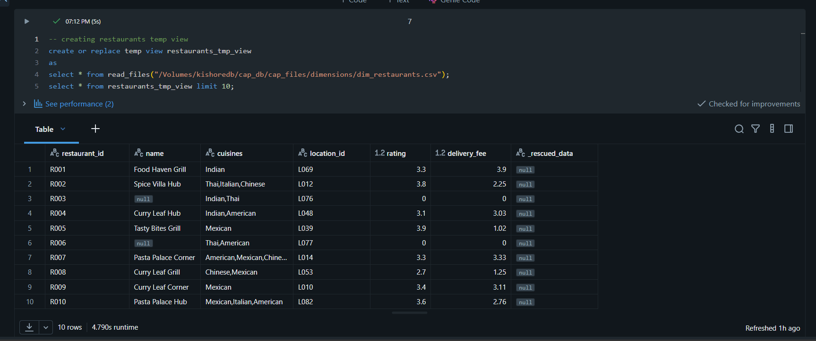
3.2 Raw Delta Tables
- Reading the dimensions csv files and creating delta table using manual schema.
- Recording the ingestion time and also the source location (Csv file path ) for each record.
- Display the few records for the verification .

1.Creating the delta table by defining the Manual Schema using Pyspark for the Restaurant Dataset and displaying the first 10 records
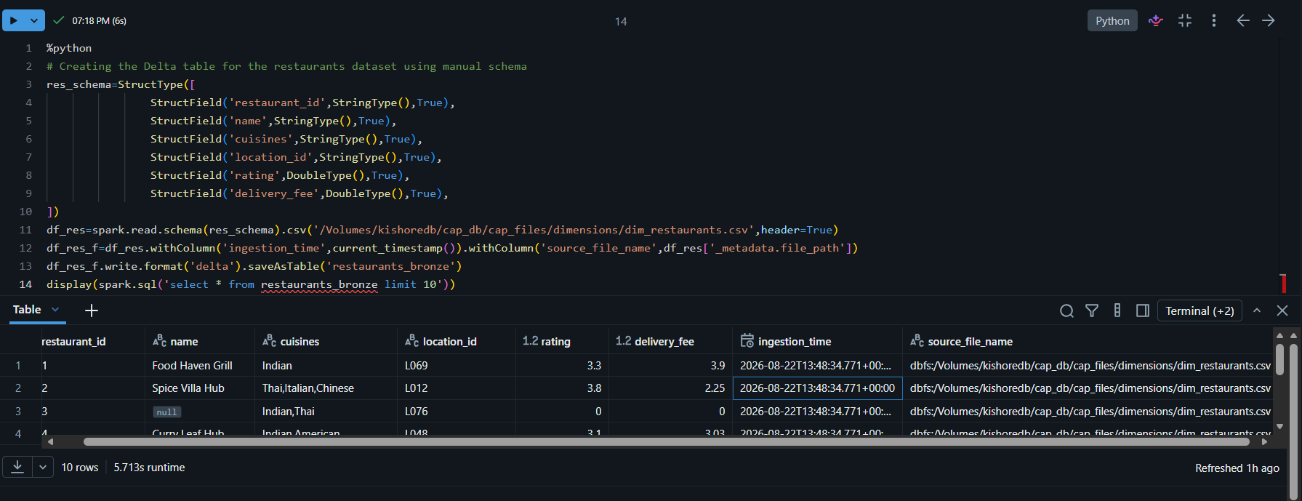
2. Creating the delta table by defining the Manual Schema using Pyspark for the Customers Dataset and displaying the first 10 records
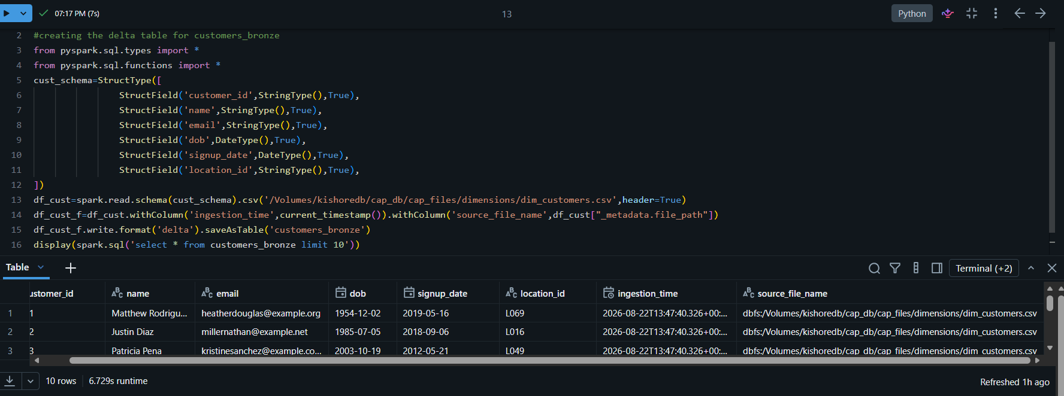
3. Creating the delta table by defining the Manual Schema using Pyspark for the menu_items Dataset and displaying the first 10 records
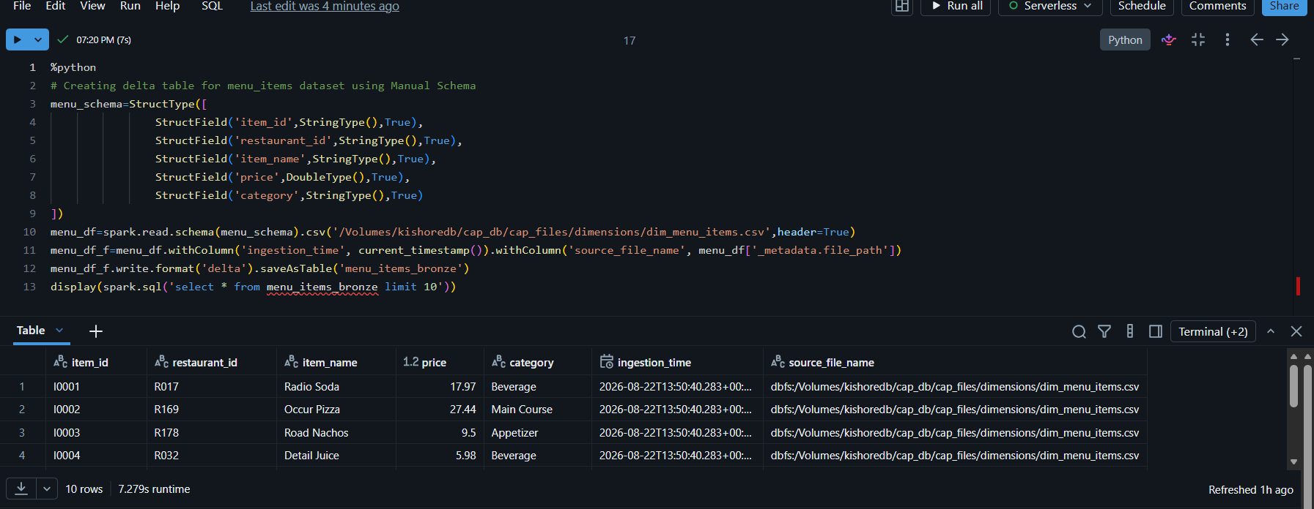
4. Creating the delta table by defining the Manual Schema using Pyspark for the Delivery Agents Dataset and displaying the first 10 records
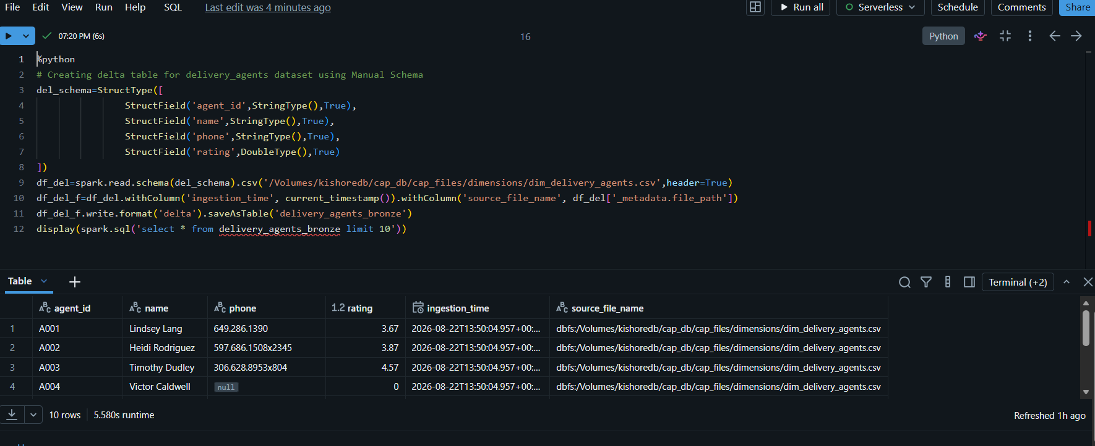
5 . Creating the delta table by defining the Manual Schema using Pyspark for the Locations Dataset and displaying the first 10 records
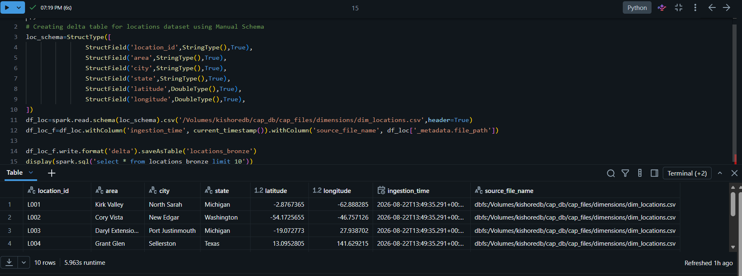

3.3 Data Quality Filtering
- Create the cleaned tables (Silver Tables) using the above Raw Bronze Delta tables.
- We have to remove all the nulls from all columns .

- Ensure that cleaned tables doesn’t have any nulls values.

1.Creating the cleaned table using the customer_bronze after removing nulls values and Displaying the first 10 records.
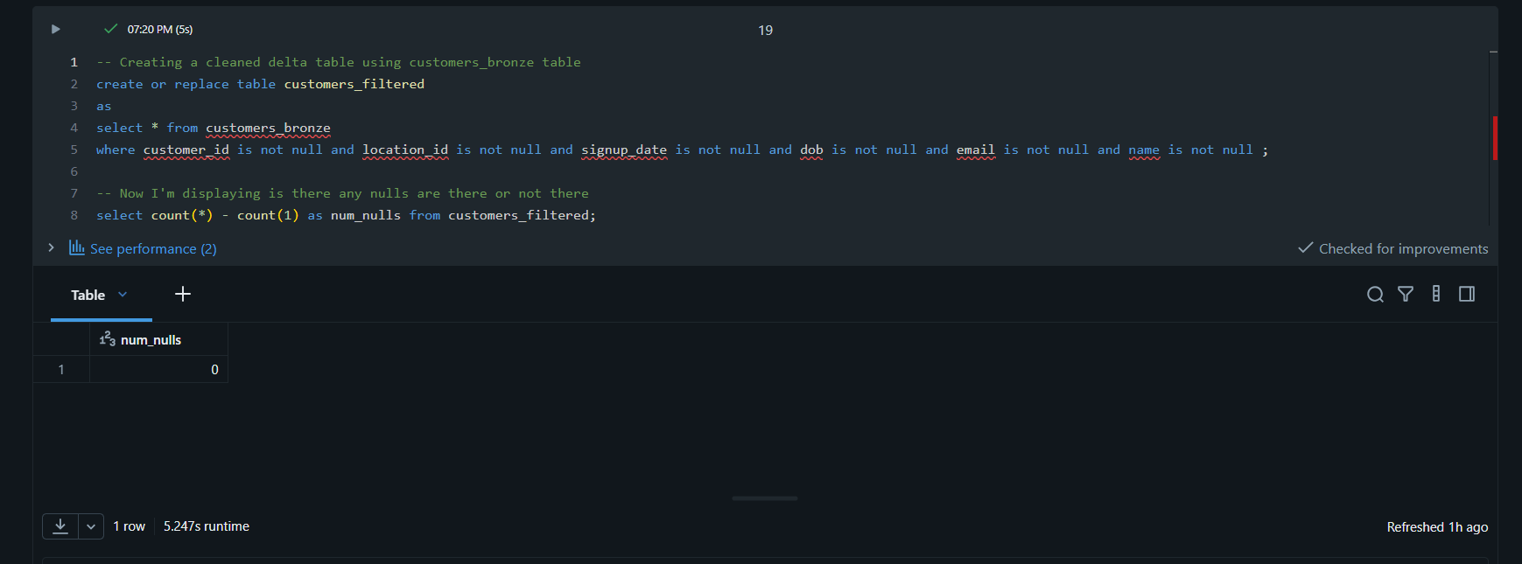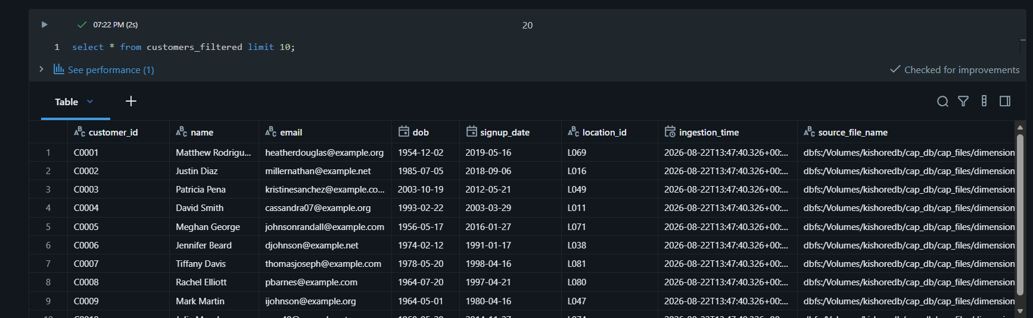

2. Creating the cleaned table using the location_bronze after removing nulls values and Displaying the first 10 records.
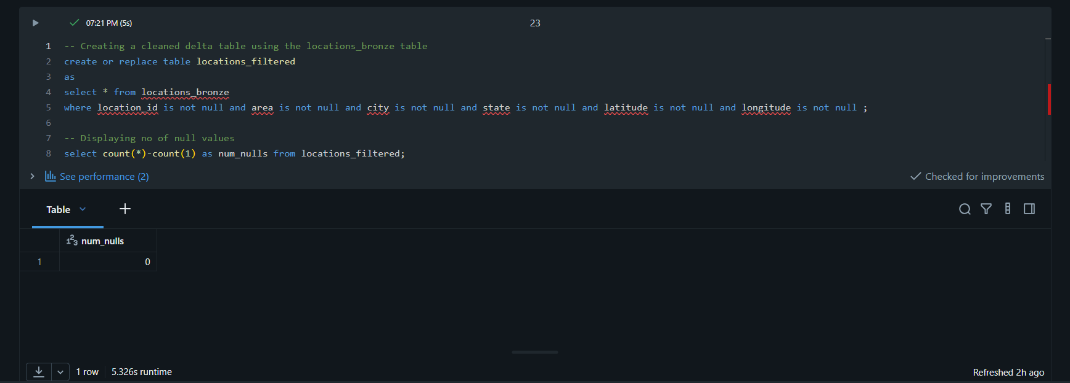
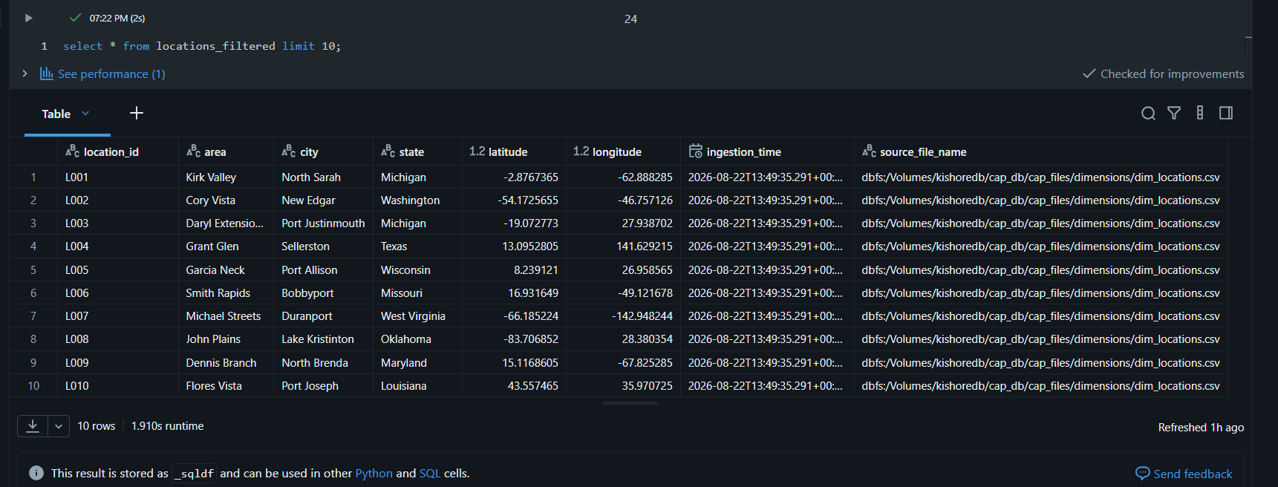
3.Creating the cleaned table using the restaurants_bronze after removing nulls values and Displaying the first 10 records.
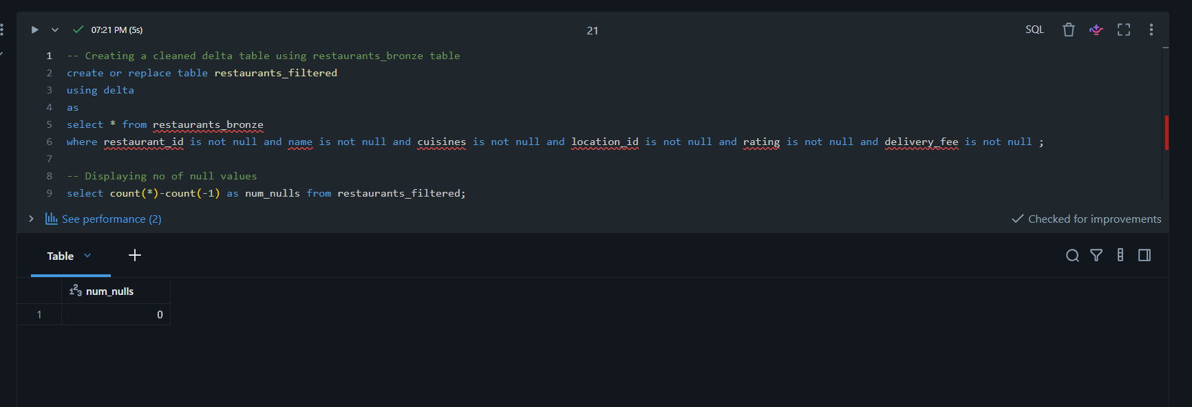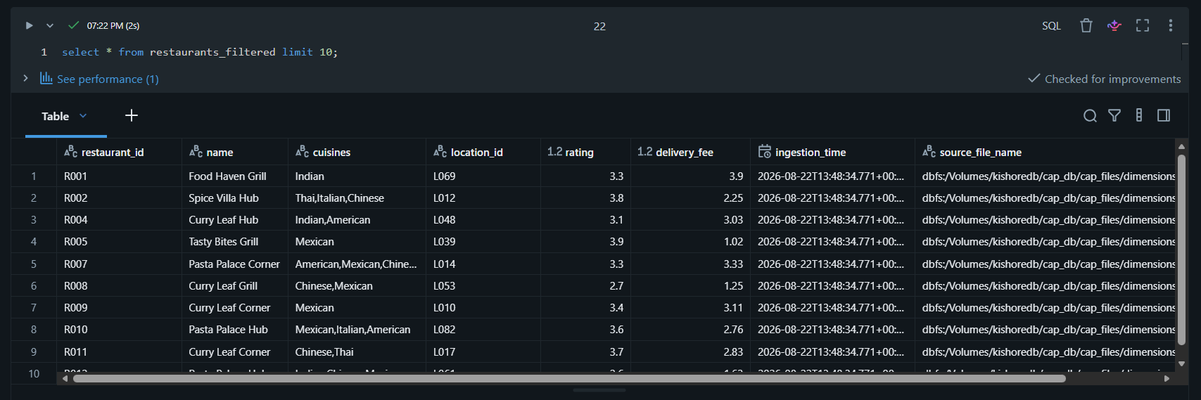

4. Creating the cleaned table using the Delivery_agents_bronze after removing nulls values and Displaying the first 10 records.
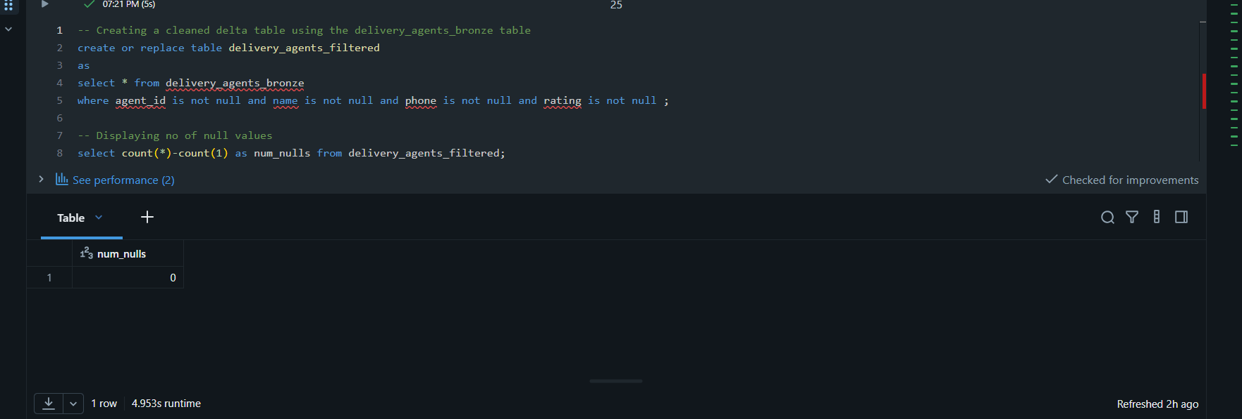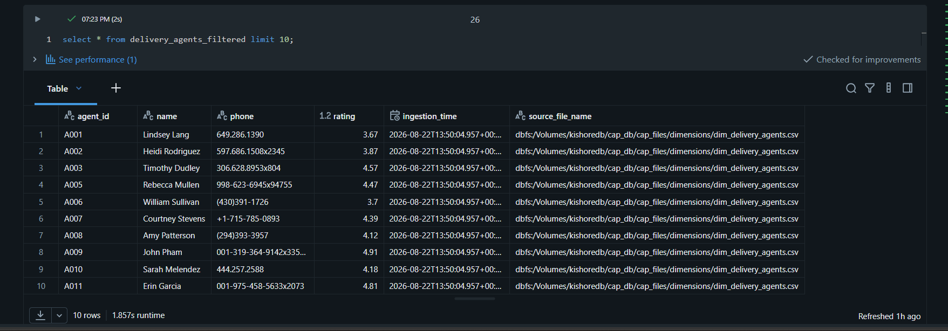
5.Creating the cleaned table using the menu_items_bronze after removing nulls values and Displaying the first 10 records.
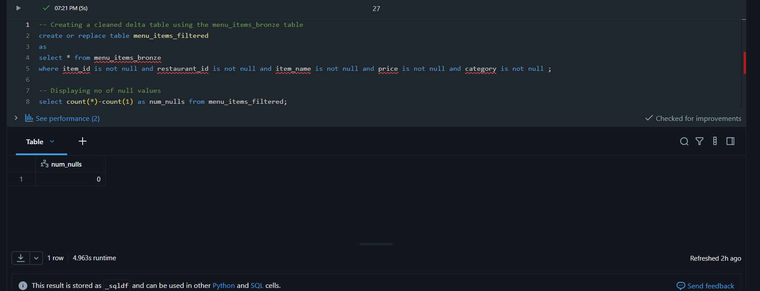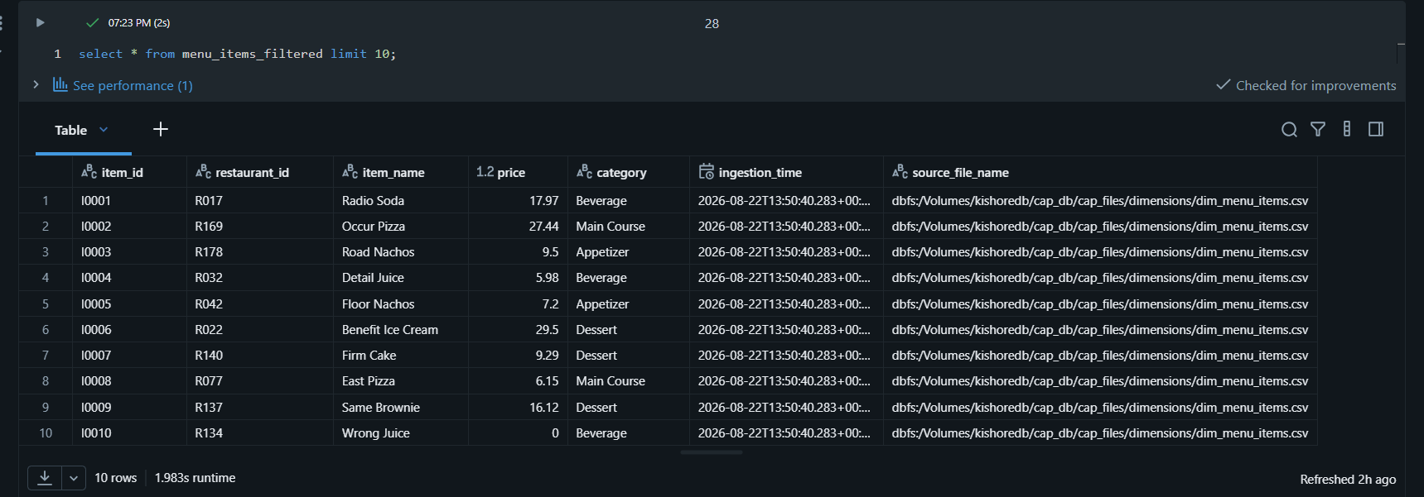
Showing all tables in my Schema
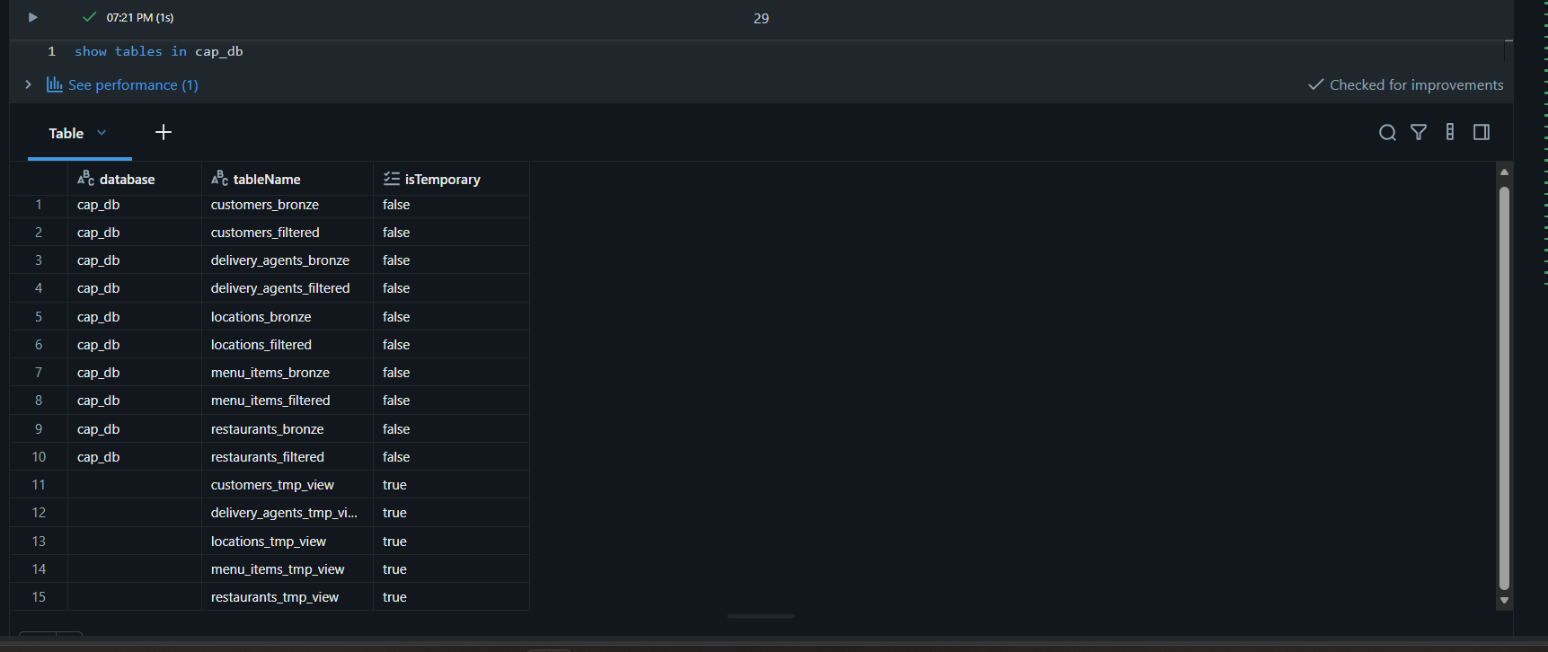

4 Incremental Orders Loading
The orders data is loaded month by month into orders_bronze using COPY INTO. Re-running an already processed file does not increase the row count, demonstrating idempotent incremental ingestion.
- Creating a table without schema
- Using COPY INTO command for my orders source
- Running the COPY INTO cell and Fetching the count.
- After adding March dataset again re-running the query again and Fetching the count .

Creating the table without schema and Adding my orders file source location dir in COPY INTO code.
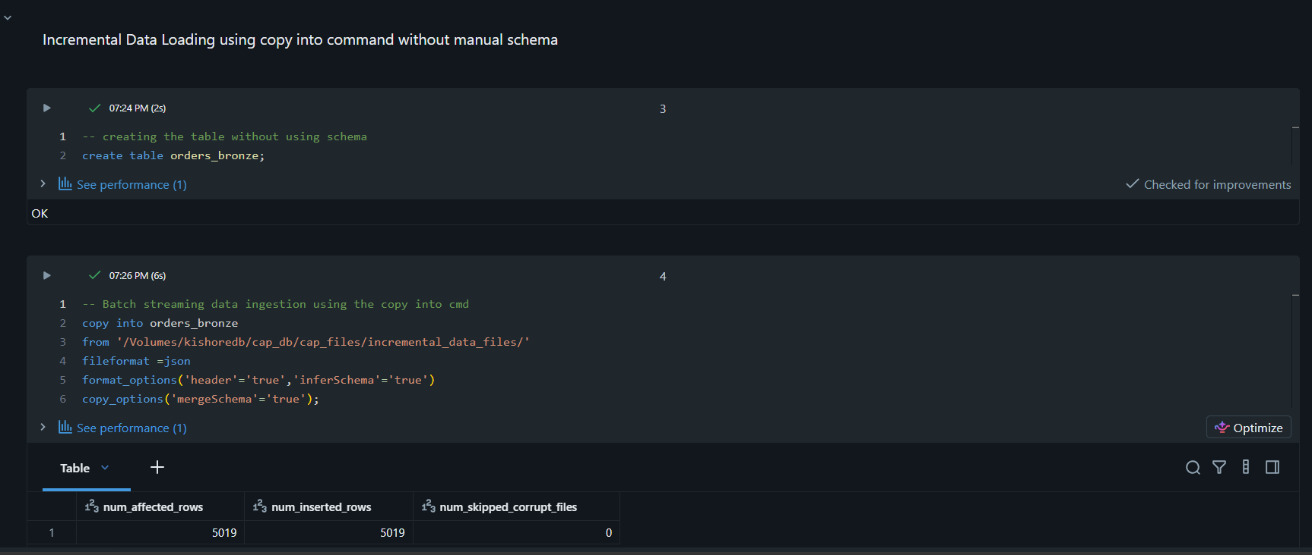
Displaying the Count of the orders_bronze after running the above code with jan and feb datasets
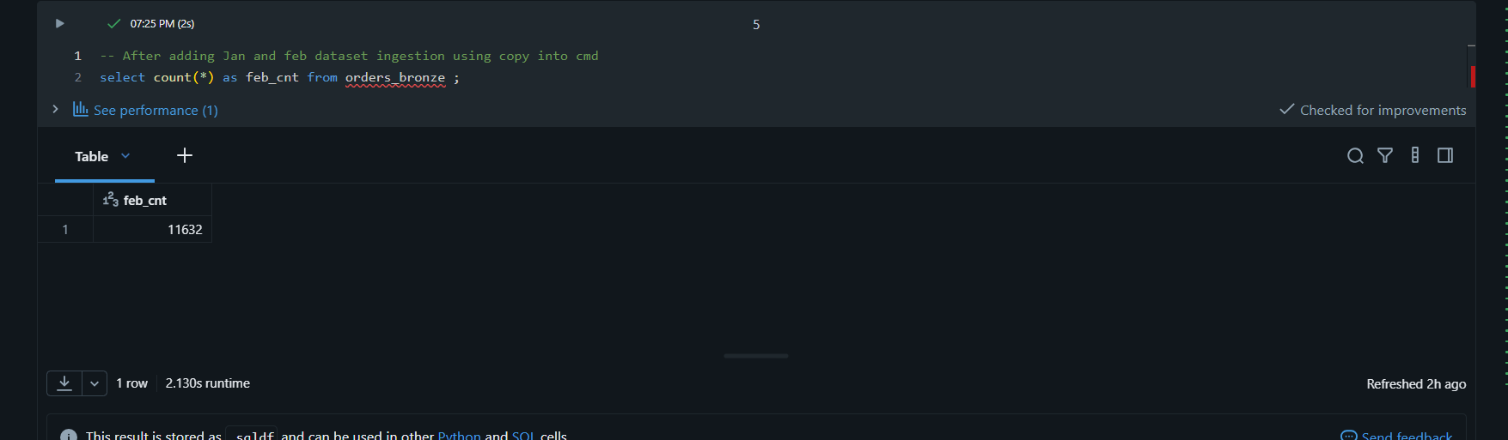
Displaying the count after adding the March dataset
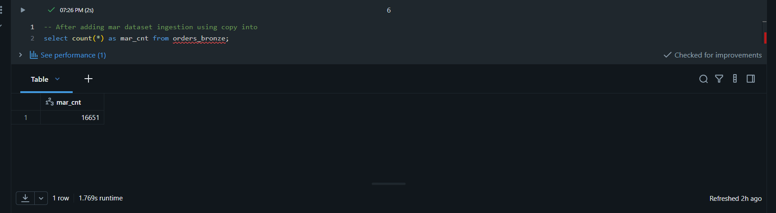

5.Order Data Analysis
- Total Numbers of orders Placed
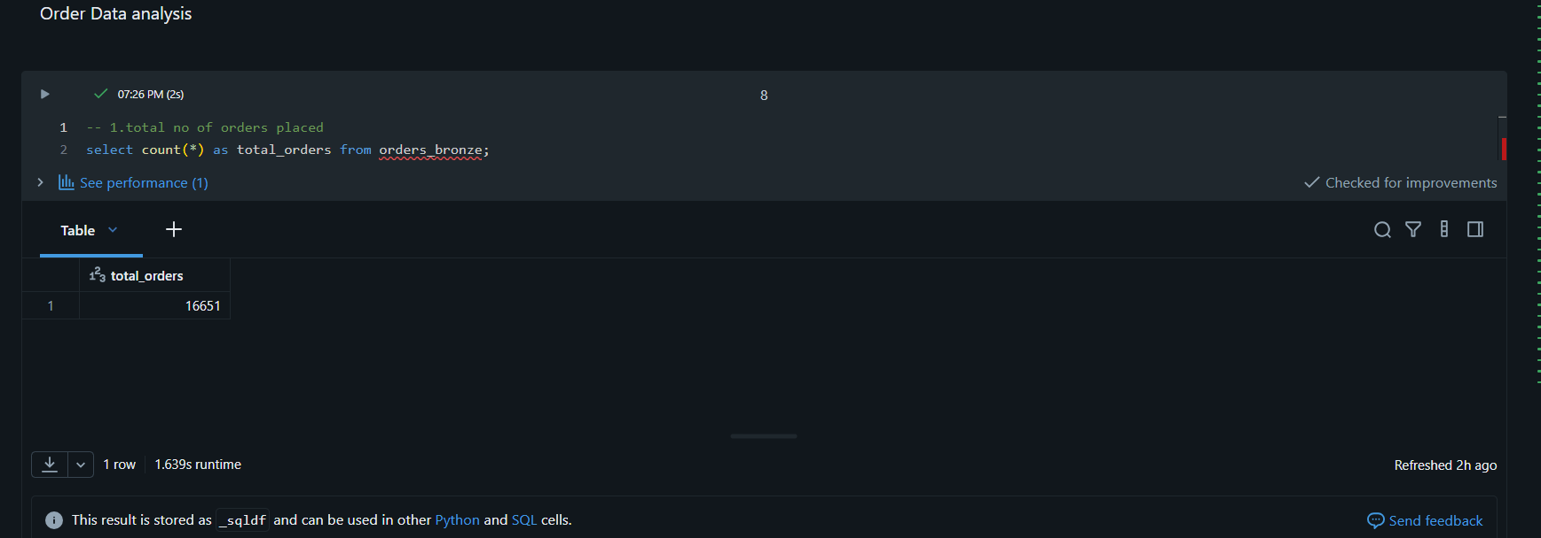
- Distribution of orders by payment method
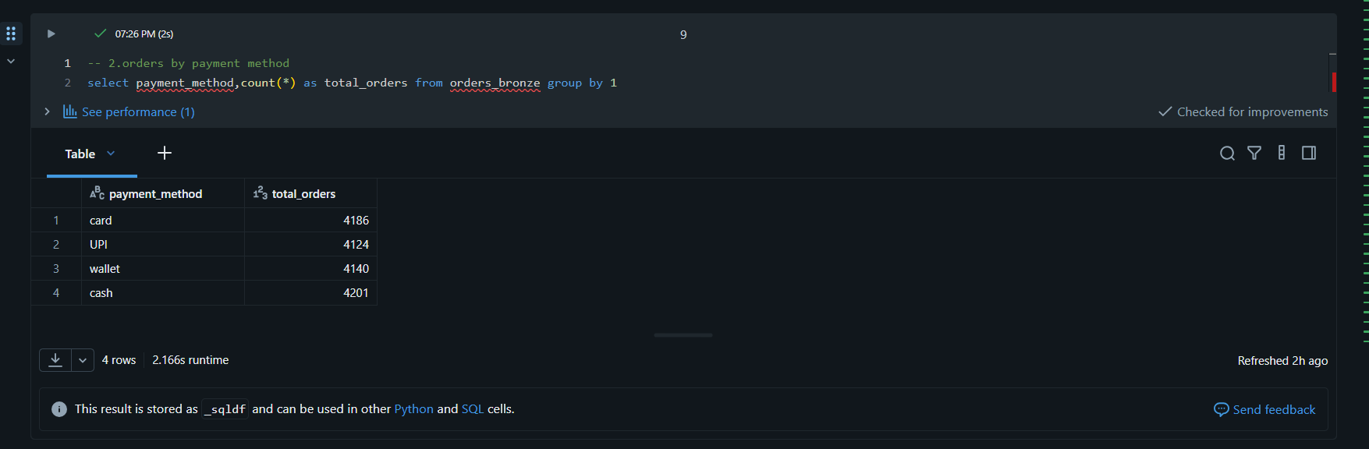
- Distribution of orders status (Delivered,Preparing,cancelled,En route)
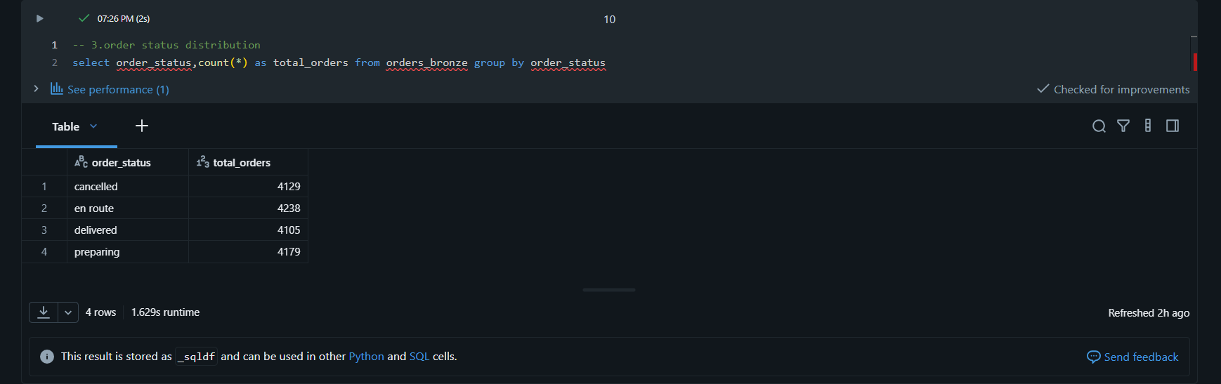
- Orders per restaurant (volume of business)
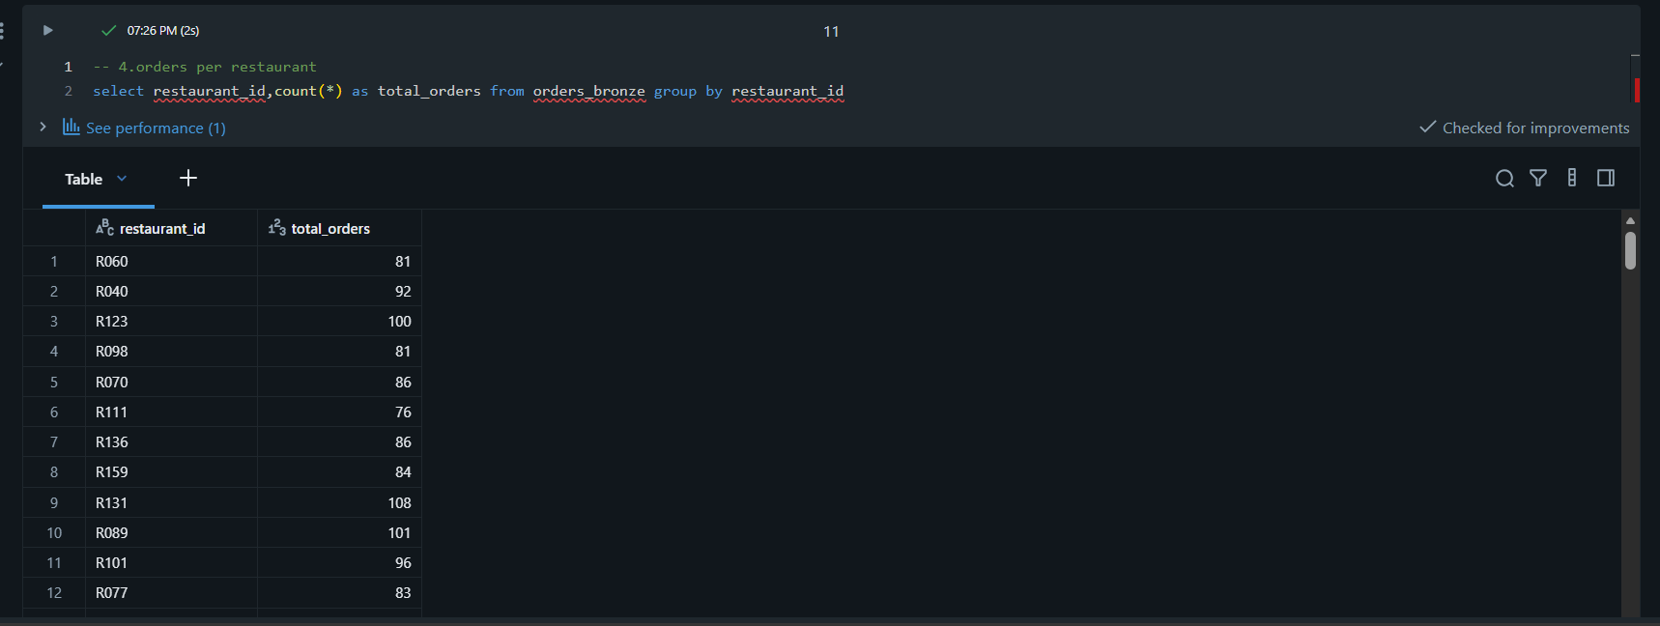
- Orders per customer (Loyality Insight)
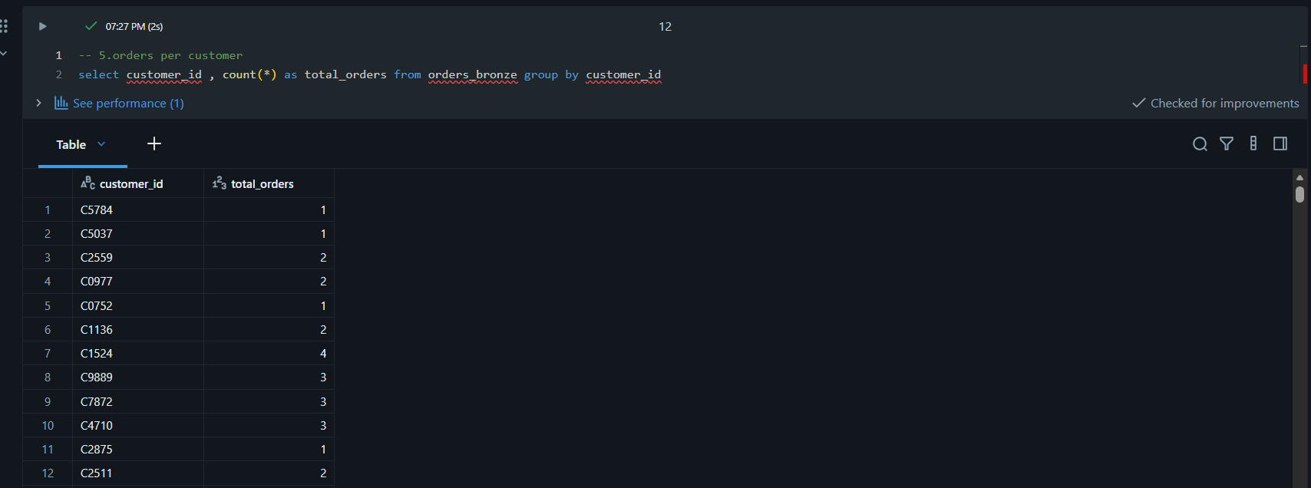
- Orders Handled per delivery agent
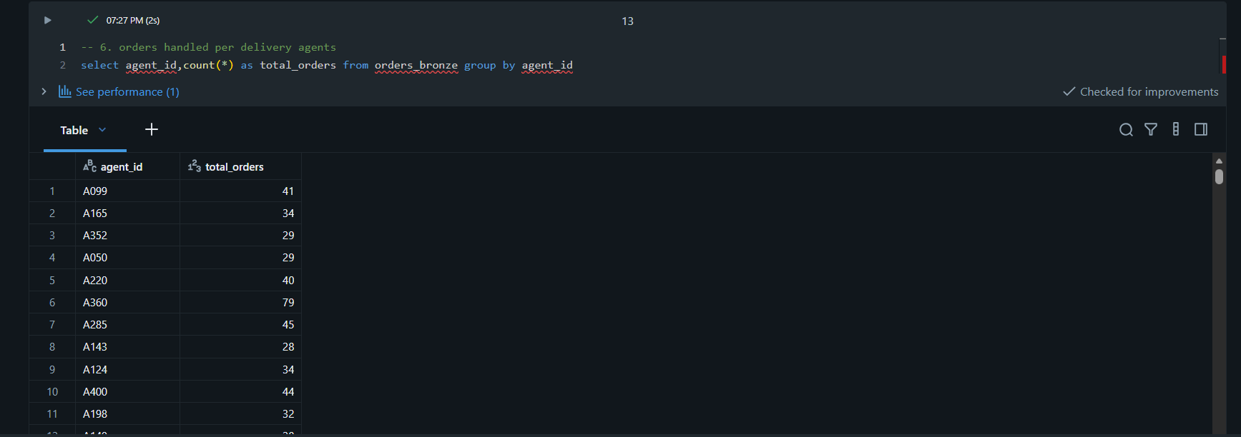

- Top 10 orders by total amount
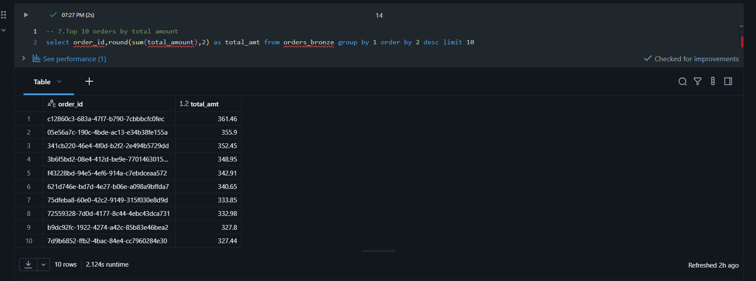
- Average tip amount per payment method
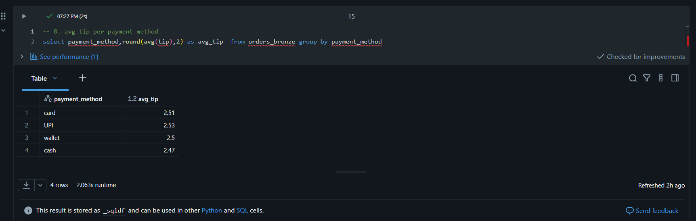
- Percentage of orders with tip > 10% of Total Amount
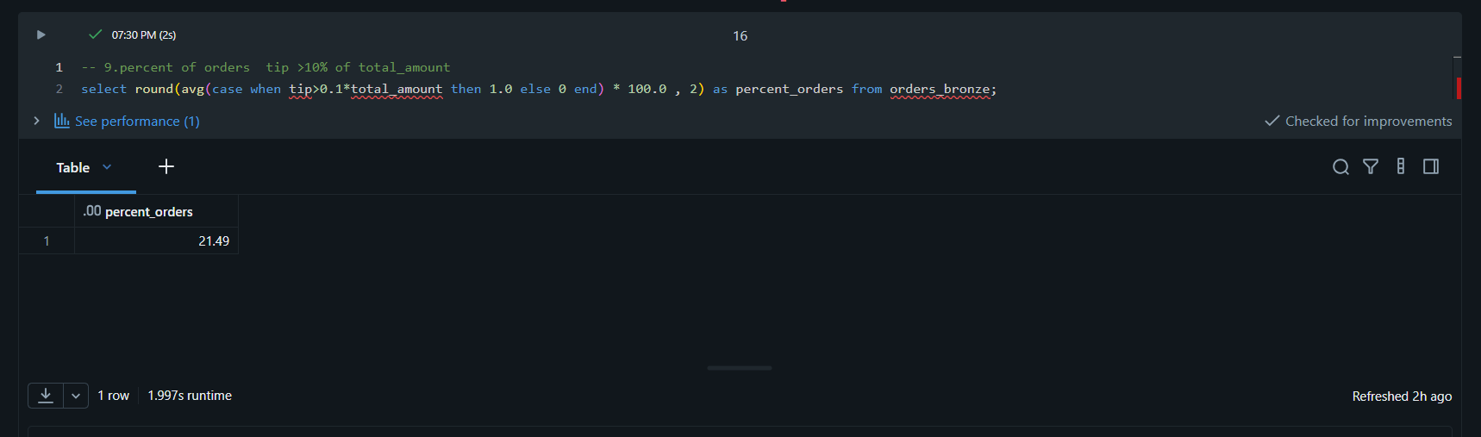

- Percentage of successful vs cancelled vs failed orders
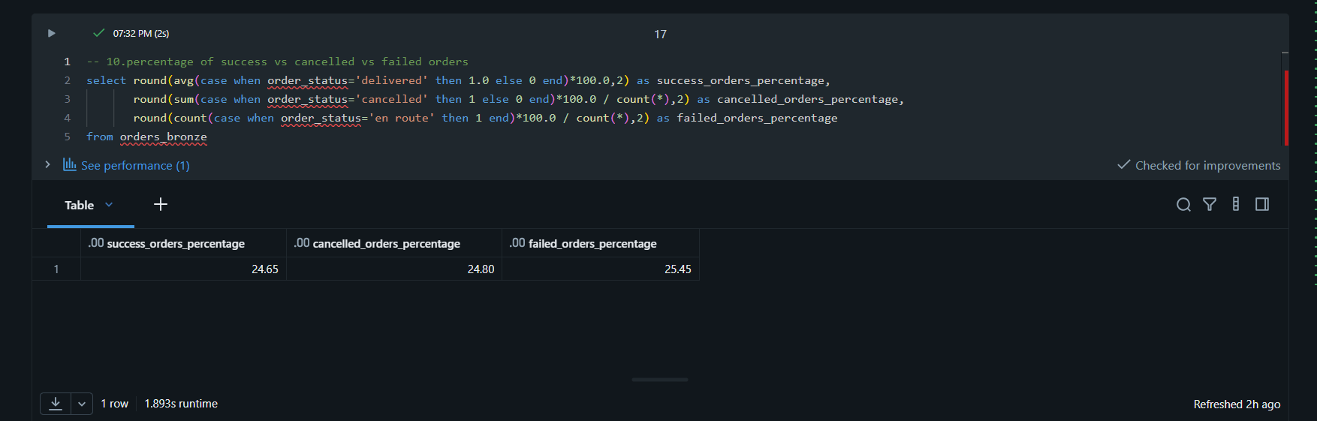
- Top Customer and top restaurants
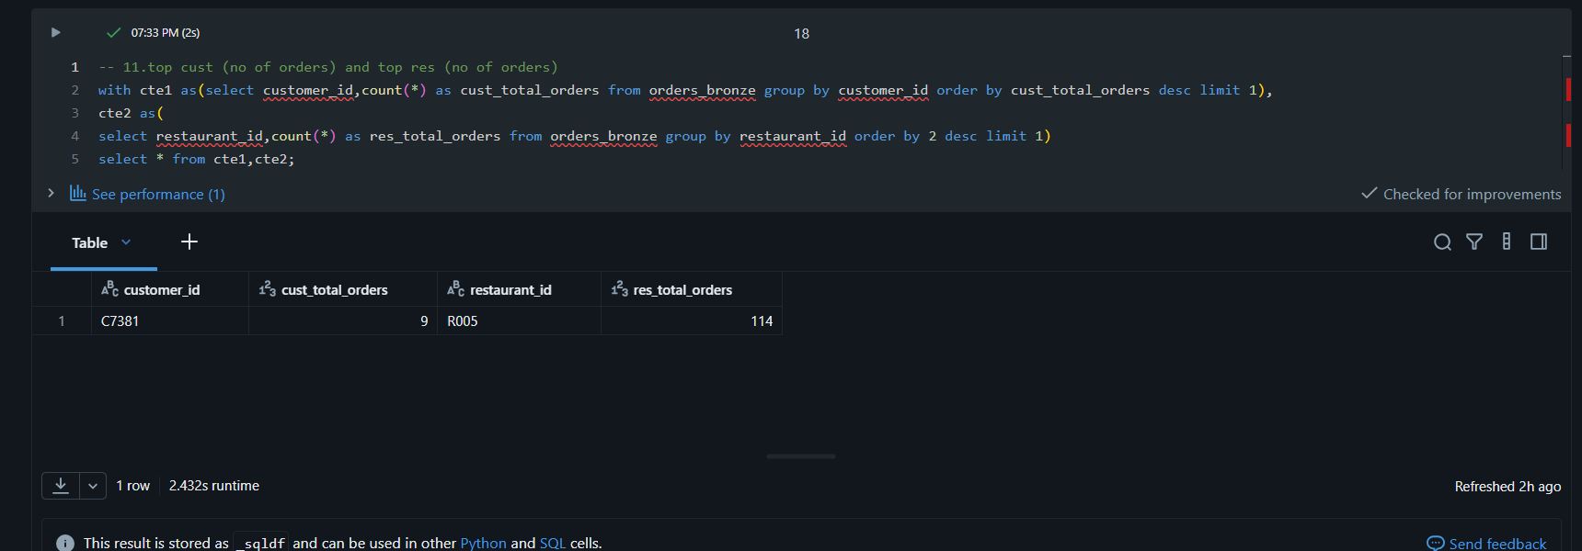
- Items- level insights
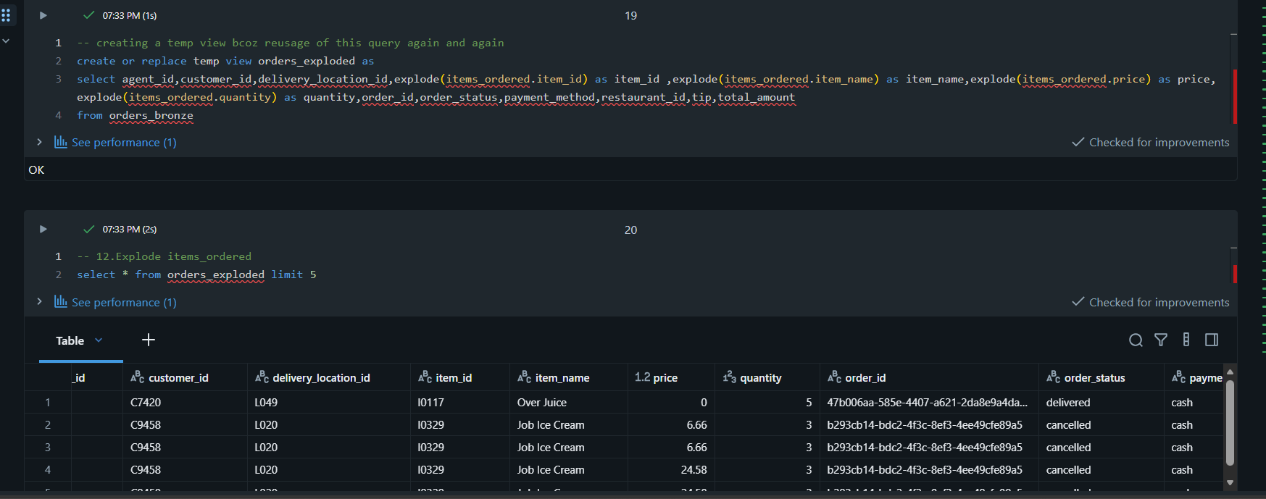
- Find most frequently ordered items
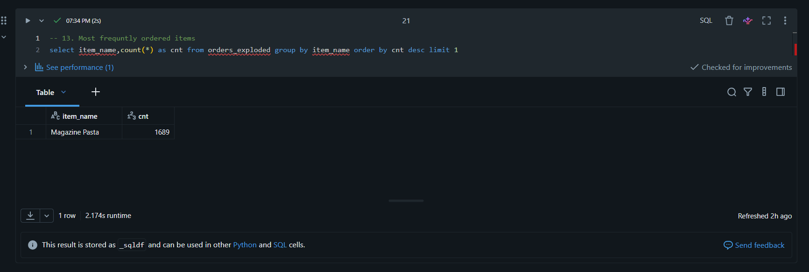
- Find average number of items per order
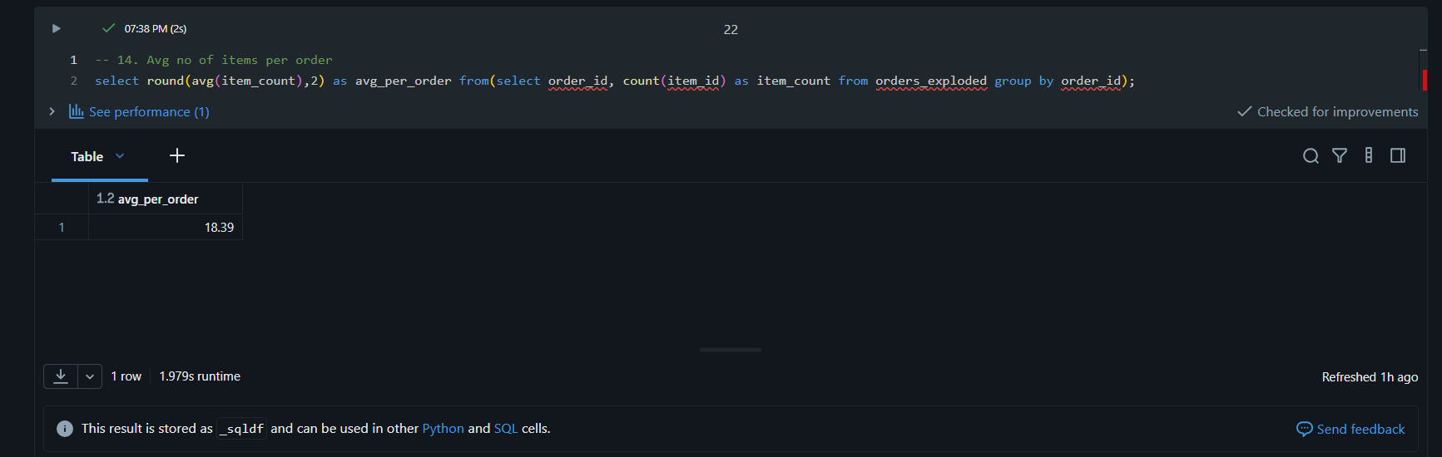
15 . Find item revenue contribution per restaurant
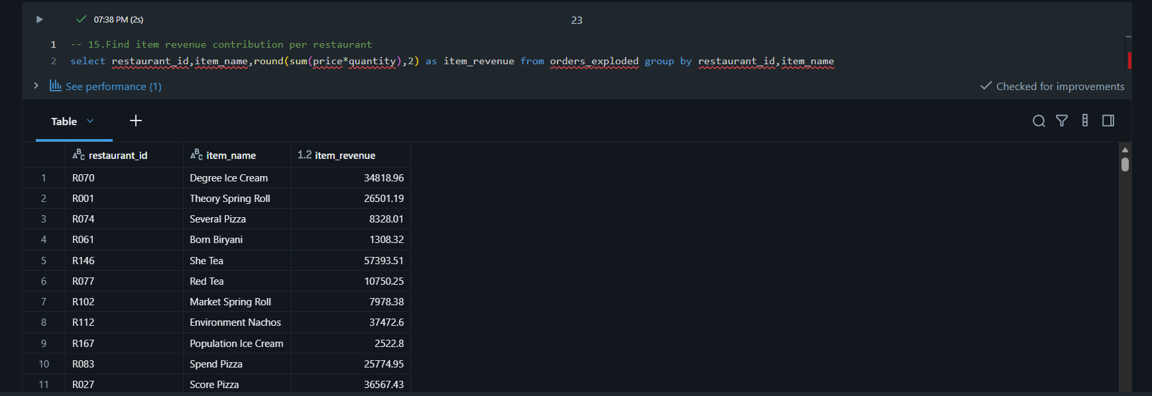

6.Orders Data And Dimension Datasets Analysis
- Find the preferred restaurant names for each customer
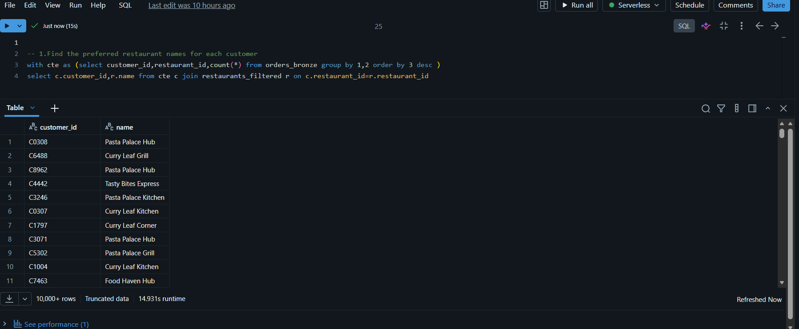
- Find the top 10 areas receiving orders in each month

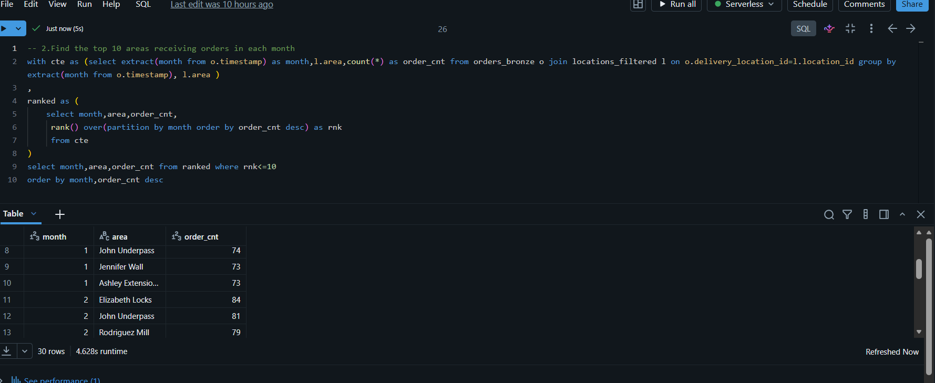
3. Which cuisines generate the highest average order value
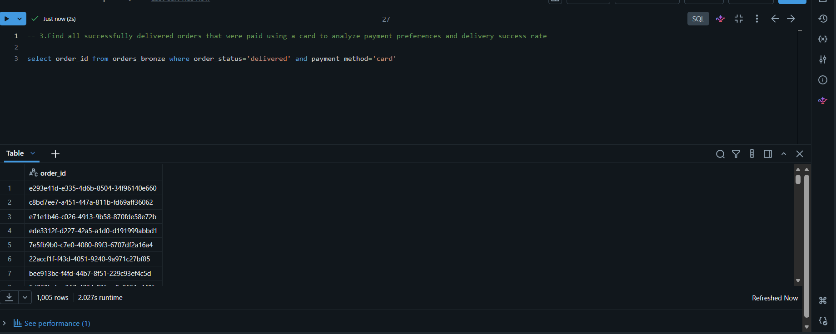
4. Which cuisines generate the highest average orders values
Creating a temp table after splitting the comma separated strings in the cuisines column
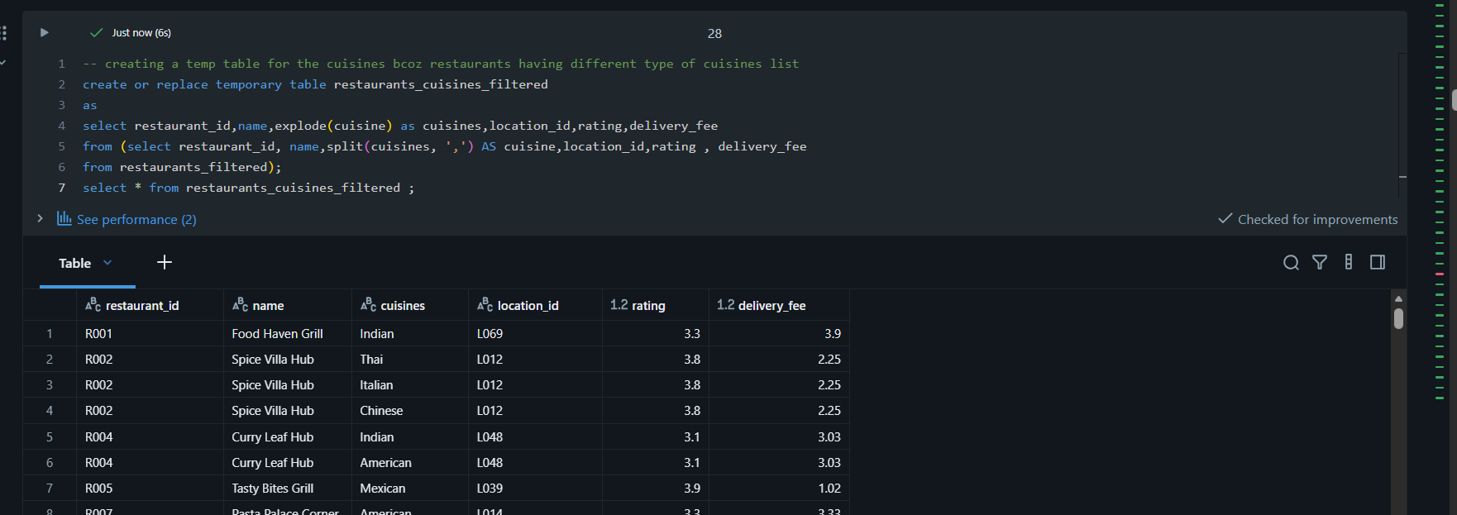
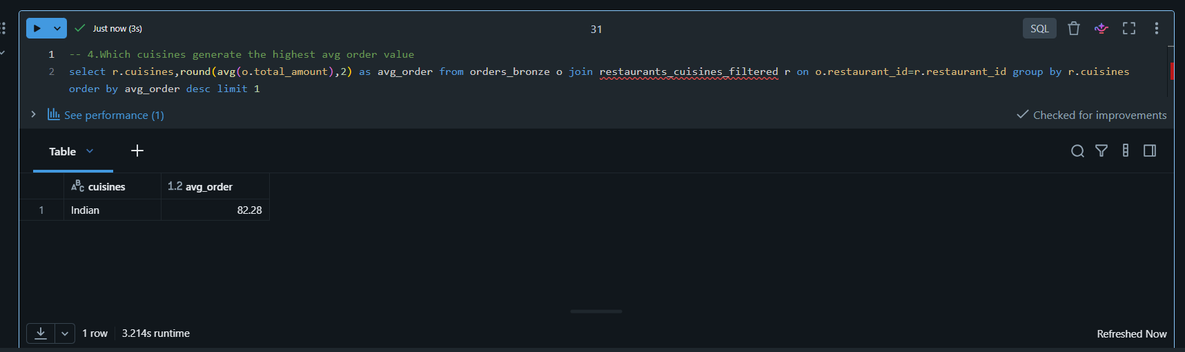
5. Which delivery agents have delivered the most high-value orders (above 50$)
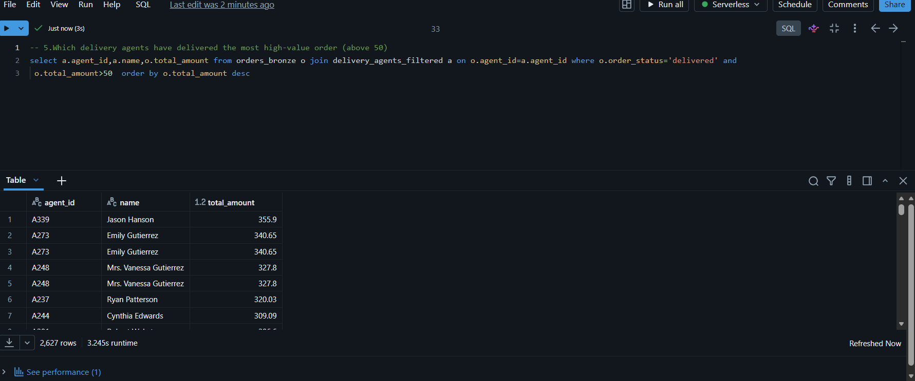
6. Which cities (Area_names) are generating most revenue for Italian restaurants ?
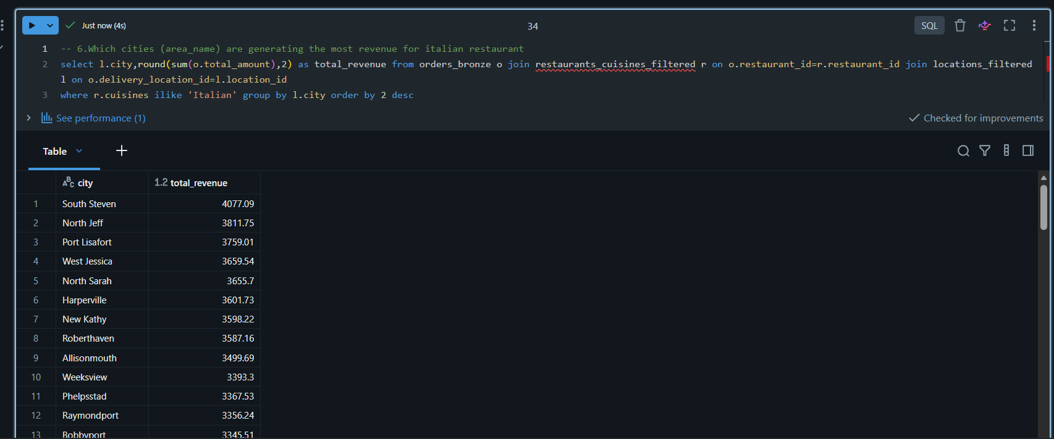
7. What is the tip-to-total ratio by cuisine type ?
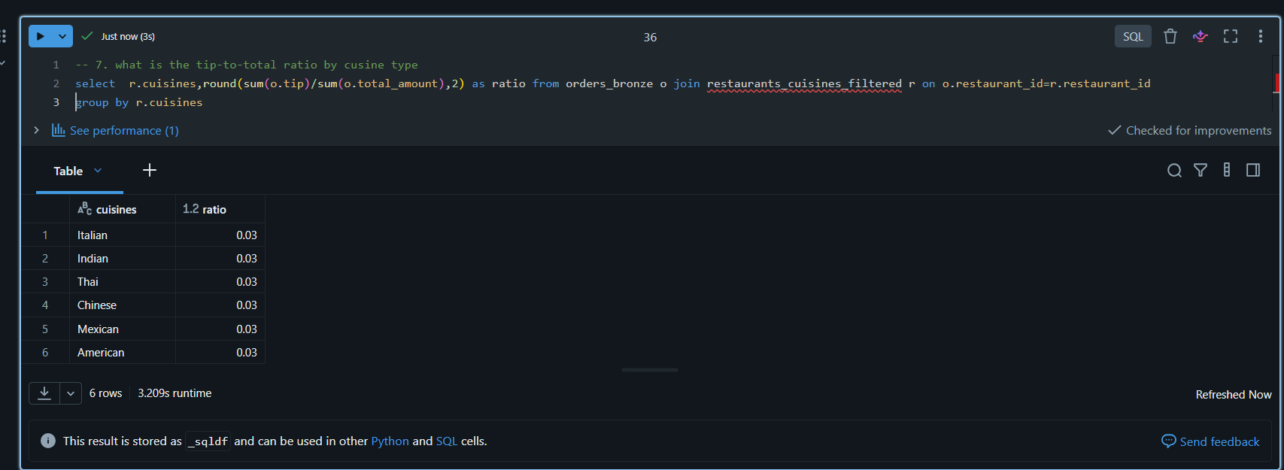

8. Which menu items are most frequently ordered , and from which restaurants ?
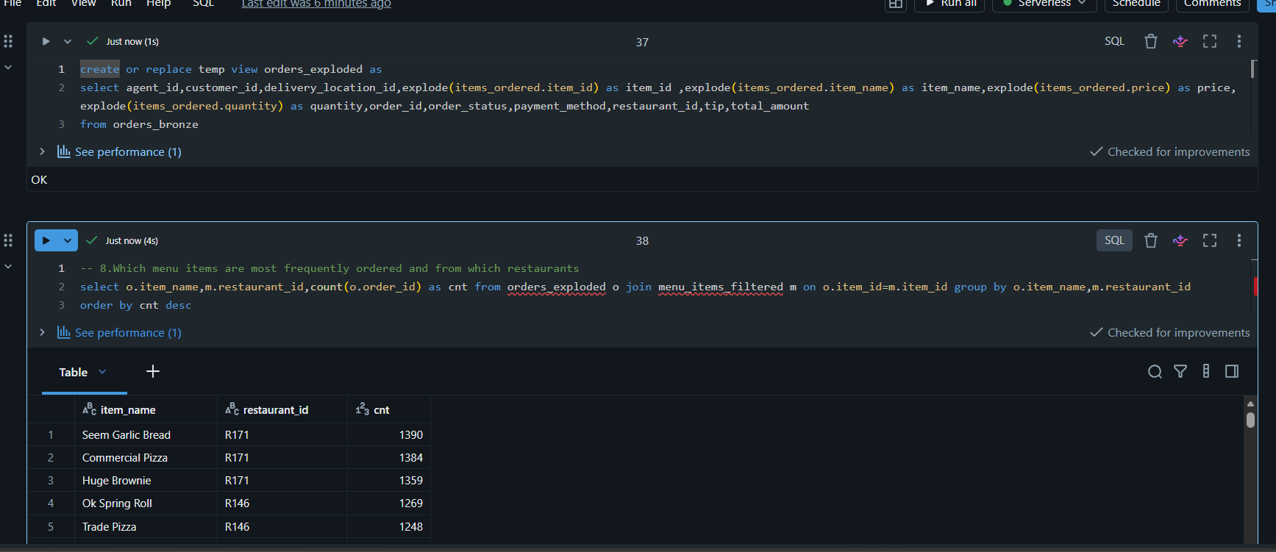
9. Which agents have delivered the most diverse cuisines ?
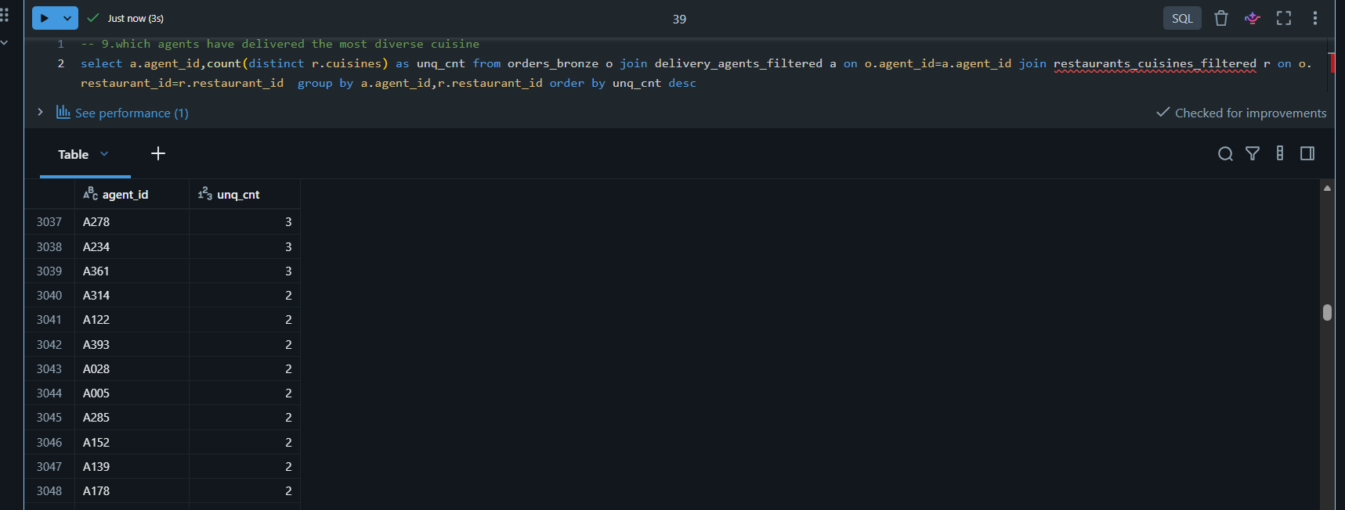
Trying to Show number of type of cuisines in restaurants
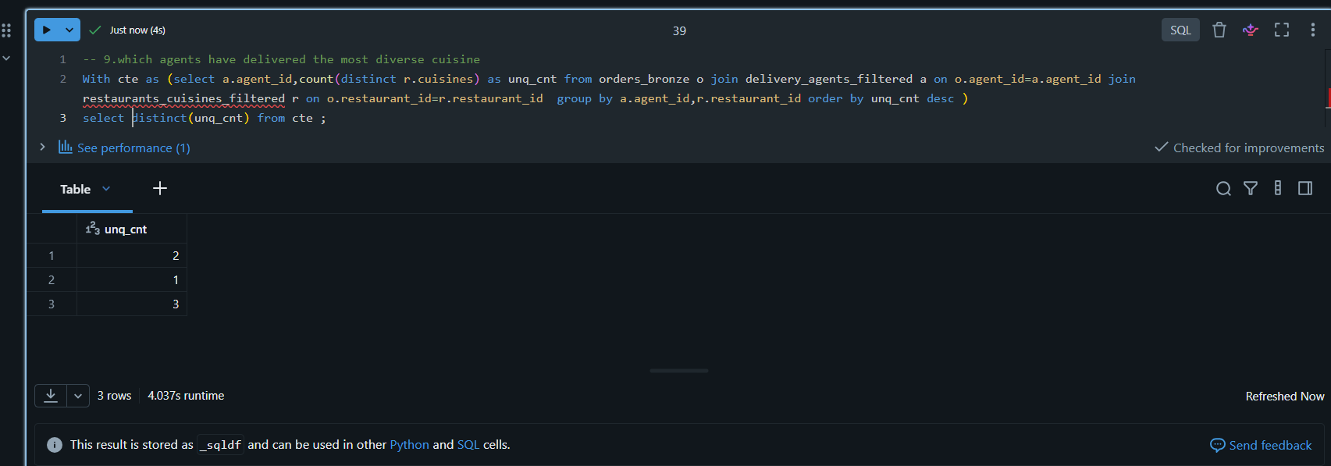
10. What is the average customer lifetime value by signup year ?
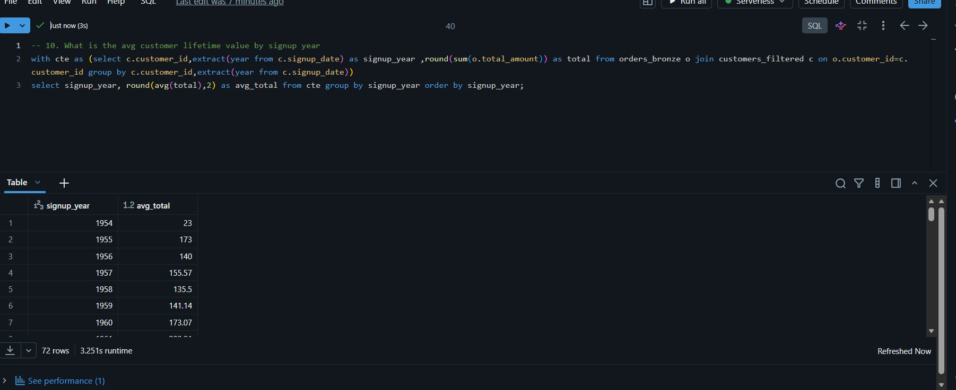
11. Which restaurants have the highest order frequency per location ?
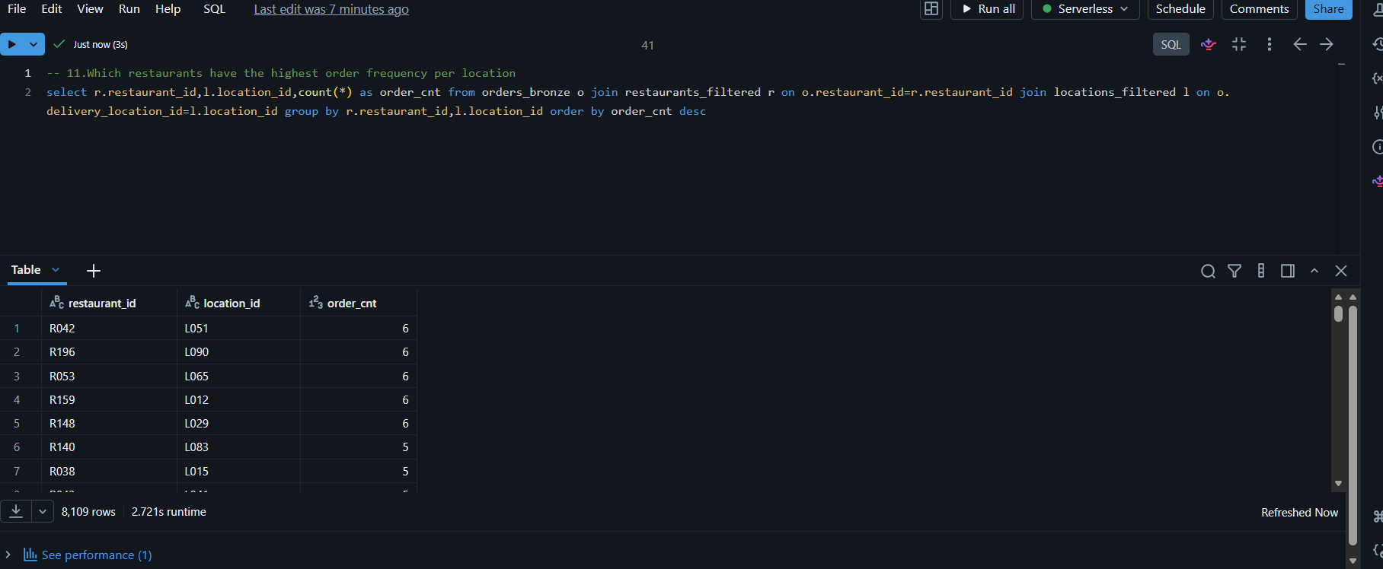
12. Which locations are prone to order cancellations ?
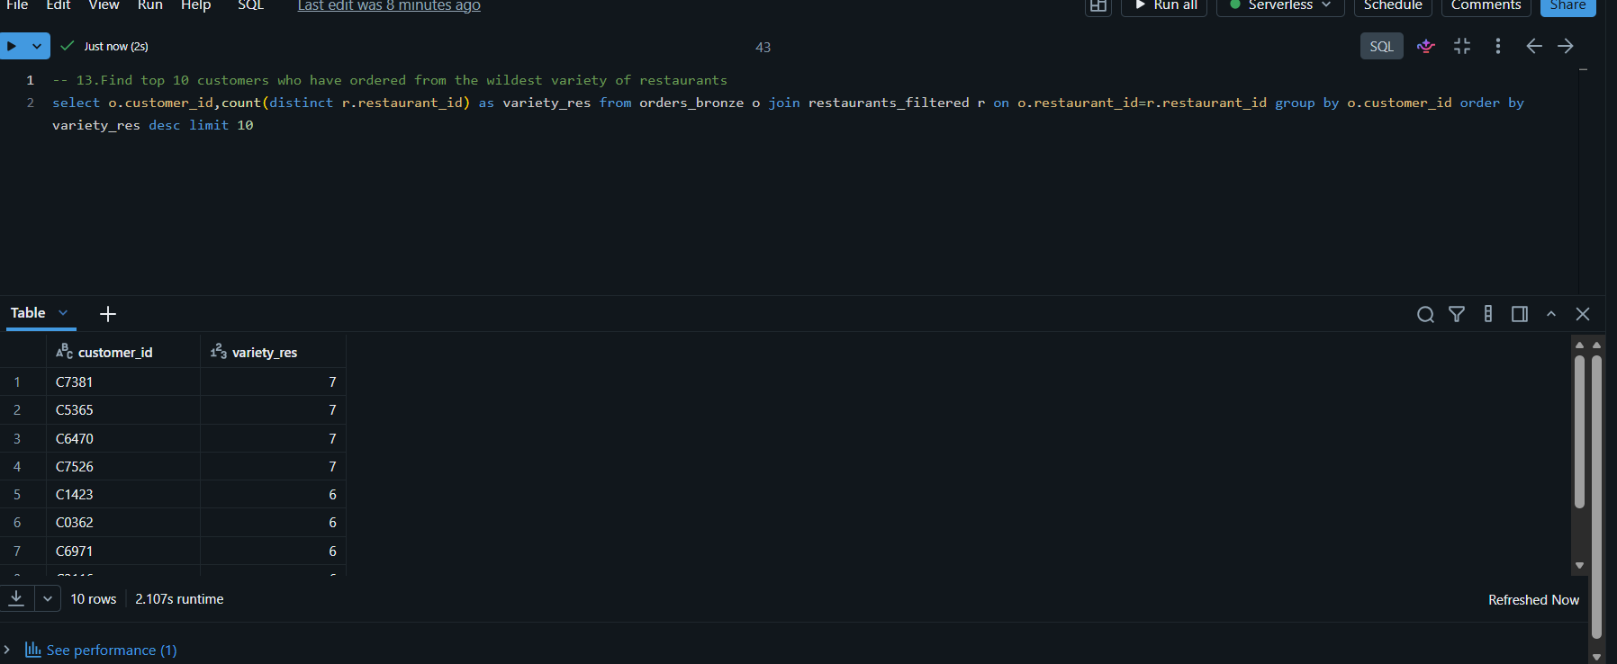
13. Find top 10 customers who have ordered from the widest variety of restaurants ?
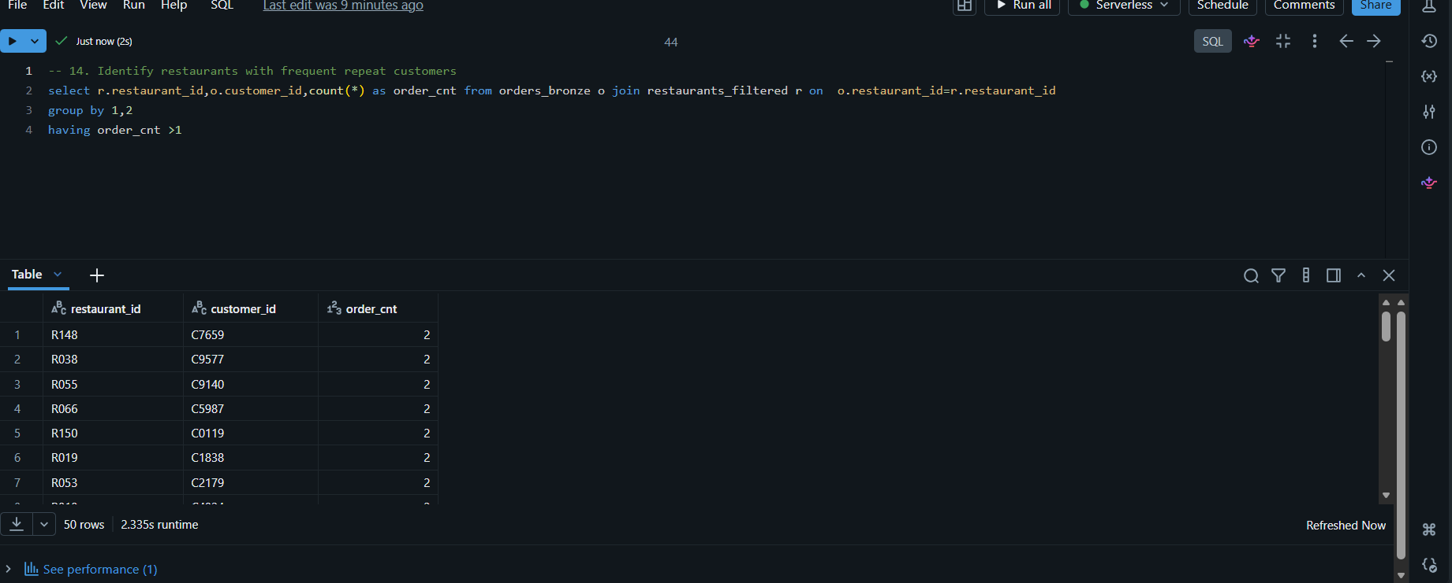
14. Identify restaurants with frequent repeat customers ?
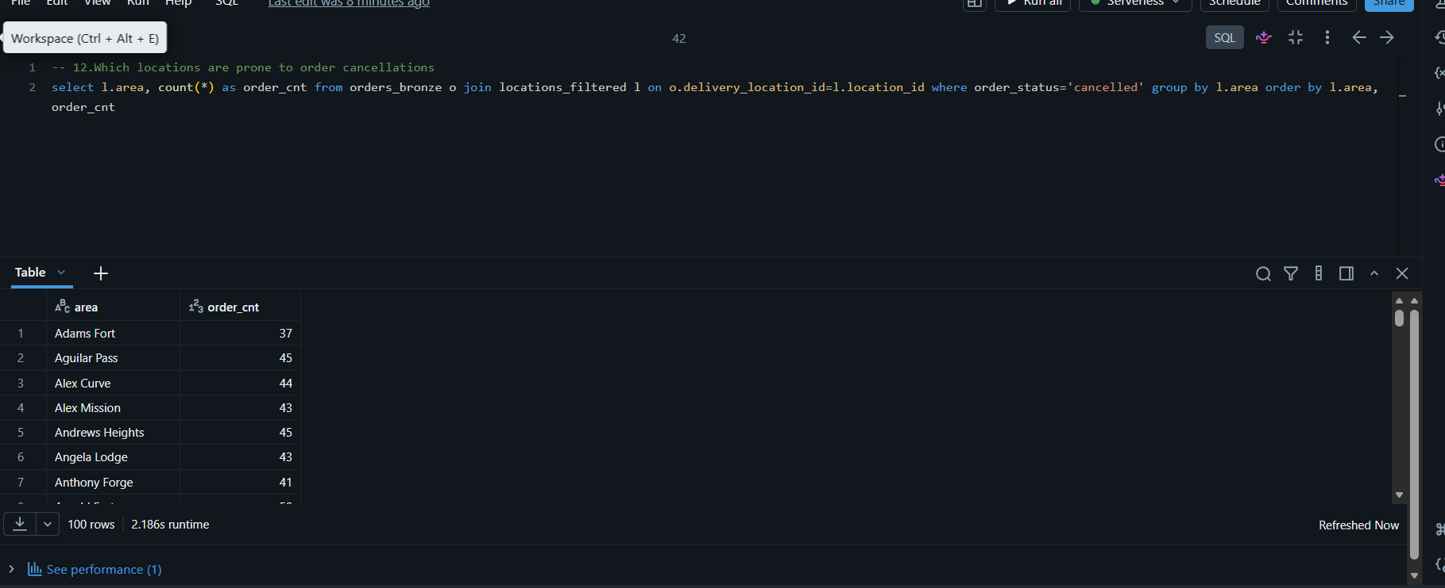
15. Which payment methods are most preferred for high-value orders across cuisines ?
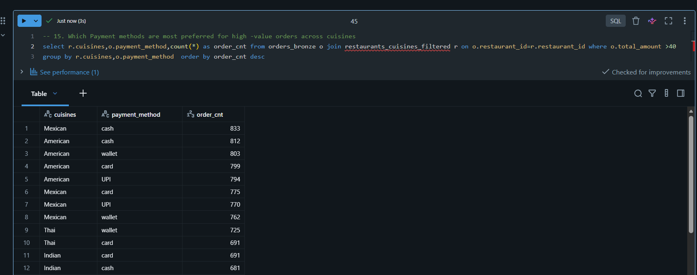

7. Delta Live Tables (DLT) Pipeline
The DLT pipeline automates the movement of data through Bronze, Silver, and Gold layers. A separate schema is used for pipeline-created tables to avoid name collisions with the earlier tables.

1 Pipeline Flow
Source Files → Bronze → Silver → Gold → Dashboard
Before the first pipeline run, the order files are staged up to June. Additional months are added later to demonstrate incremental processing.

2 Bronze Layer
The Bronze layer ingests the orders JSON data and the five dimension datasets into pipeline-managed tables.

3 Silver Layer
The Silver Layer filters out the nulls from which column , so that its helps us to create a gold aggregation or analysis table.

4 Gold Layer
The Gold Layer is used for create a Dashboard related data by using aggregation , Joins , Deep filtering’s .

Displaying my order files location to create a DLT Pipeline
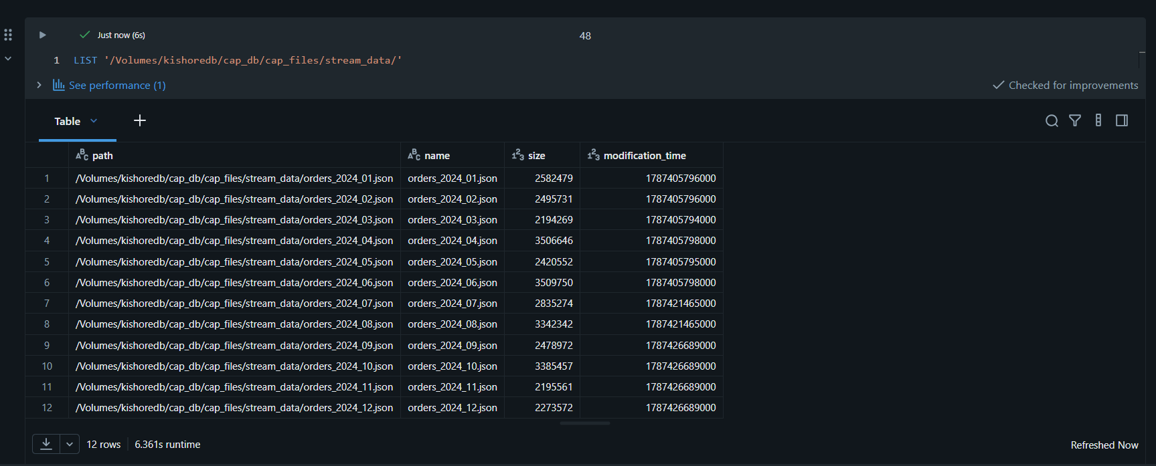

Creating the Pipeline including the medallion Architecture
Creating a live streaming table for the orders and live tables for all dimensions datasets
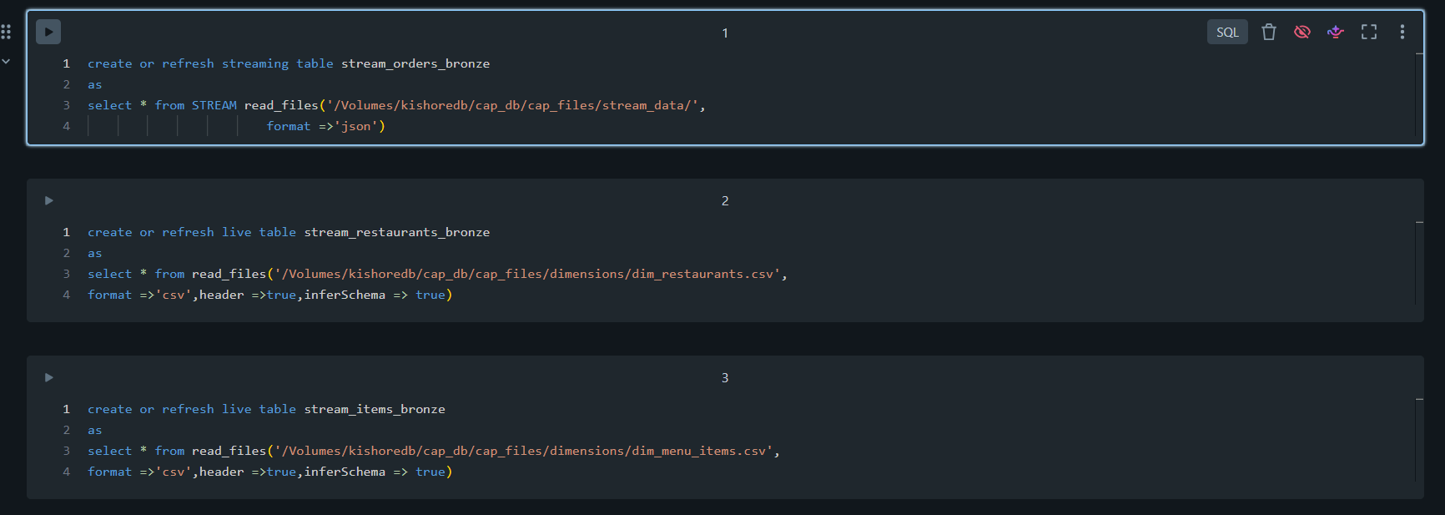
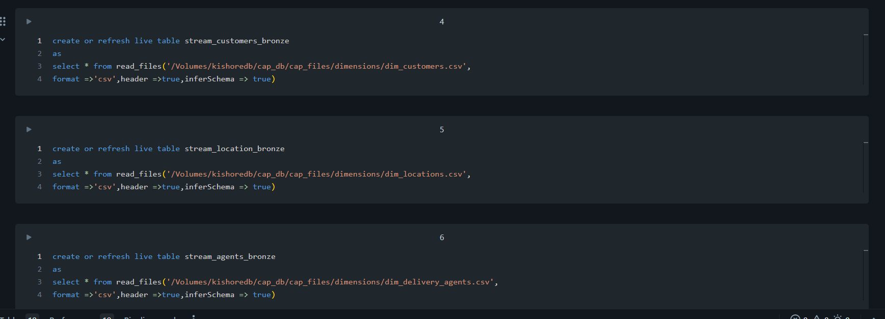

Creating a Silver streaming tables
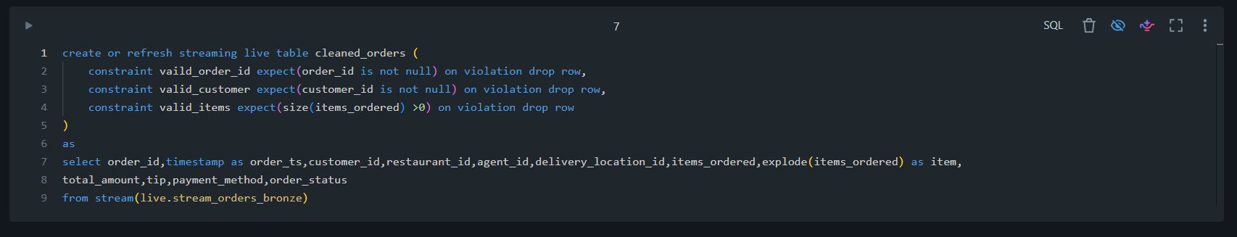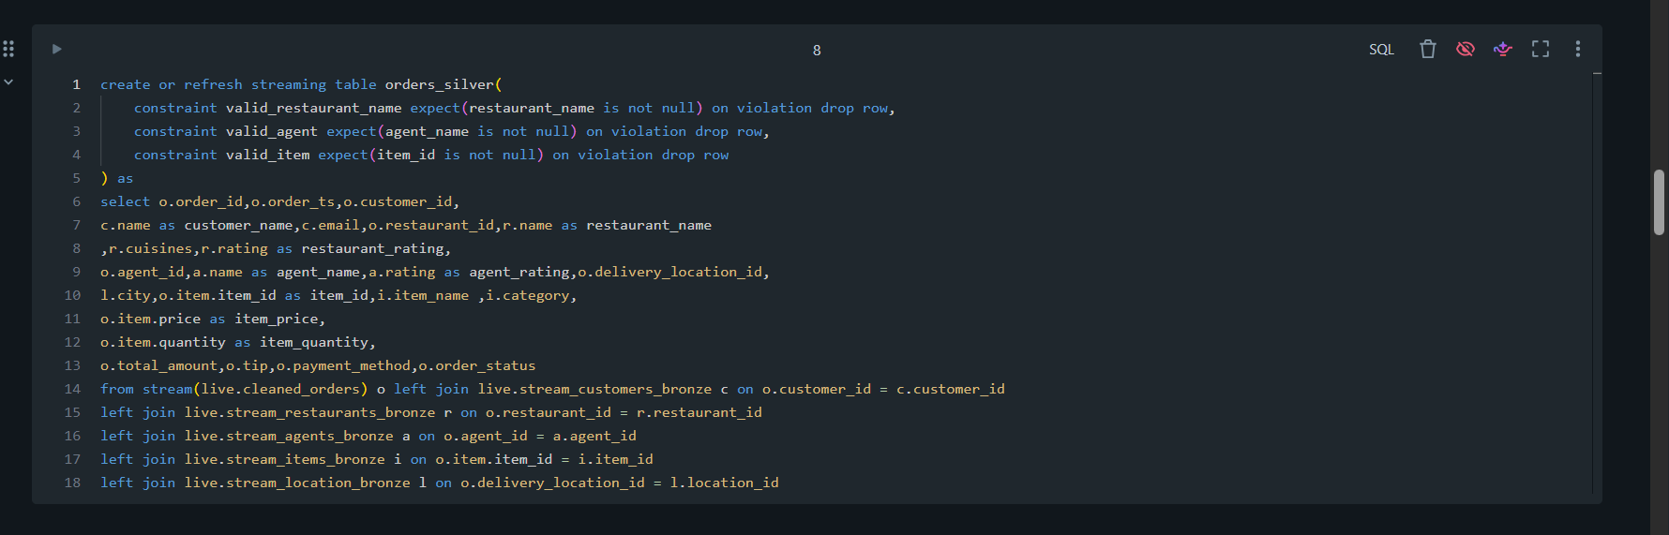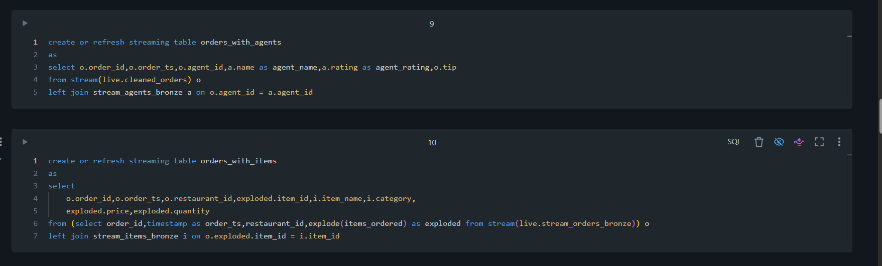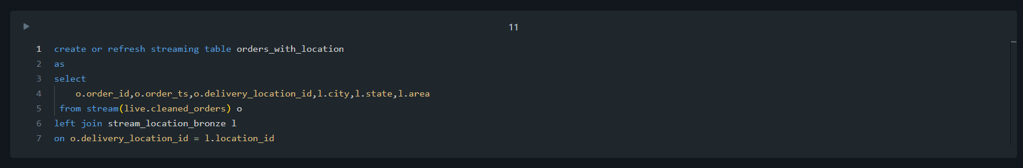
Creating a Gold Live Tables
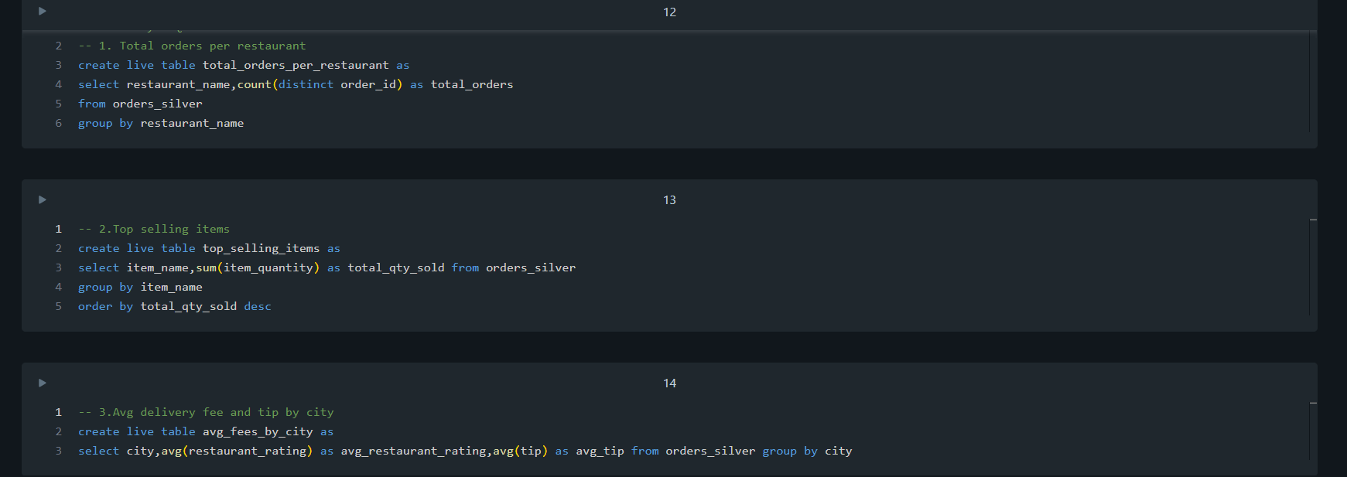
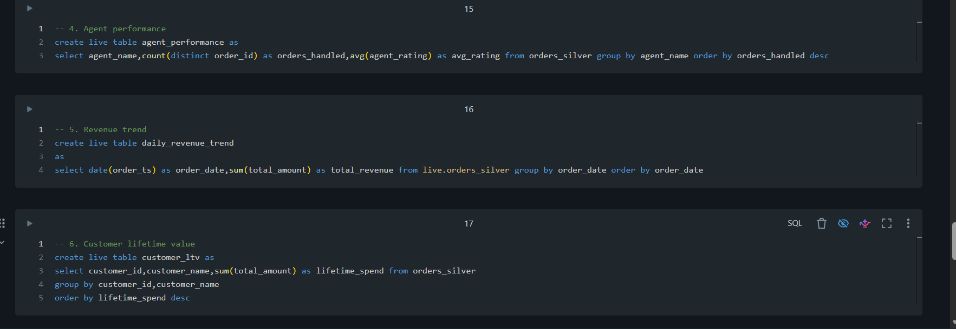

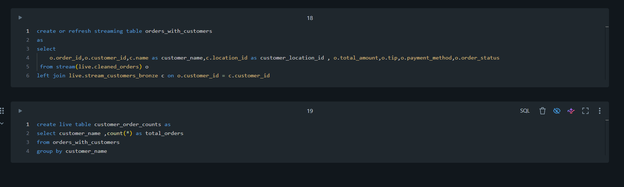

Pipeline Settings :
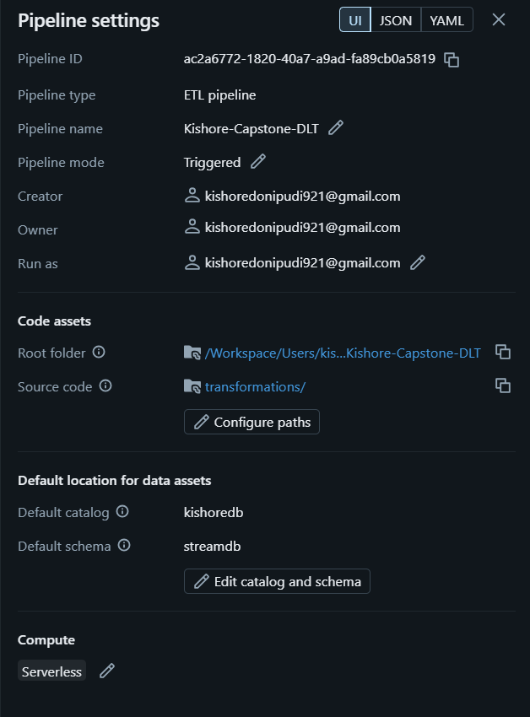

Bronze Streaming Tables Pipeline Graph : -
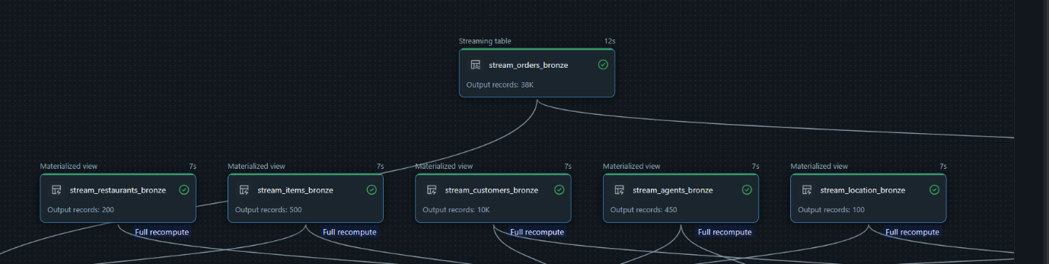
Silver Streaming Tables Pipeline Graph :-
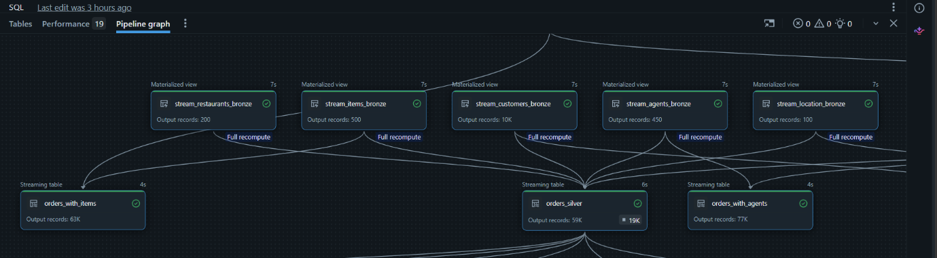
Gold Aggregation Tables Pipeline Graph :-
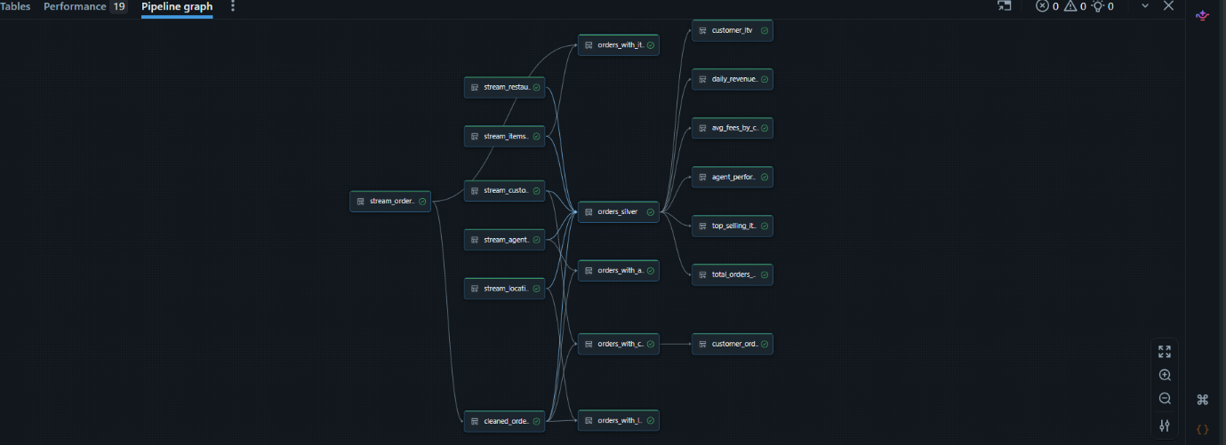
Complete Pipeline 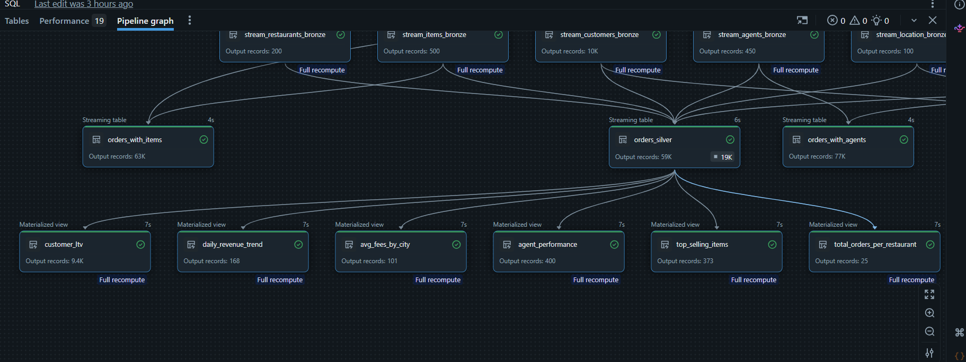

Displaying the Data Quality of Orders Silver Table
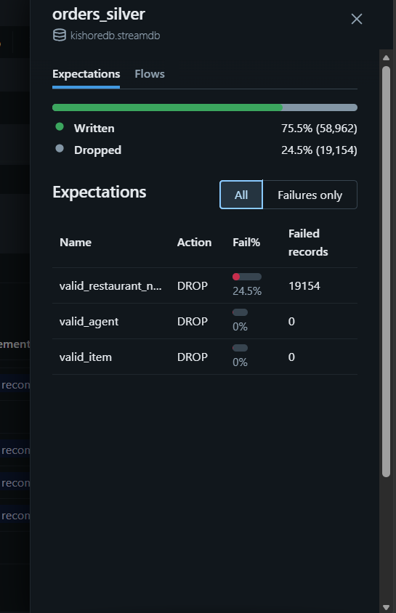

After adding the files UPTO August :
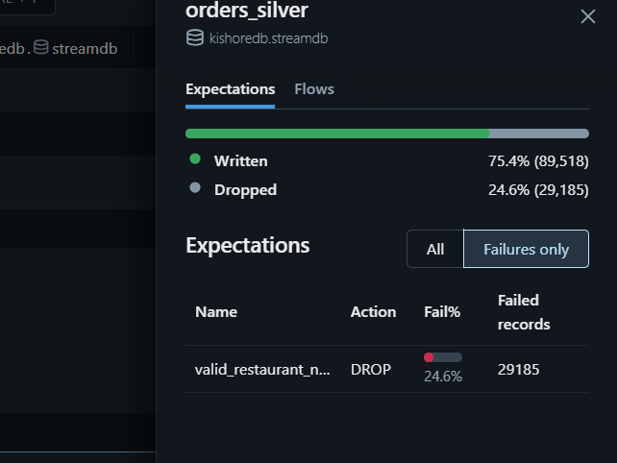
After adding the all files :
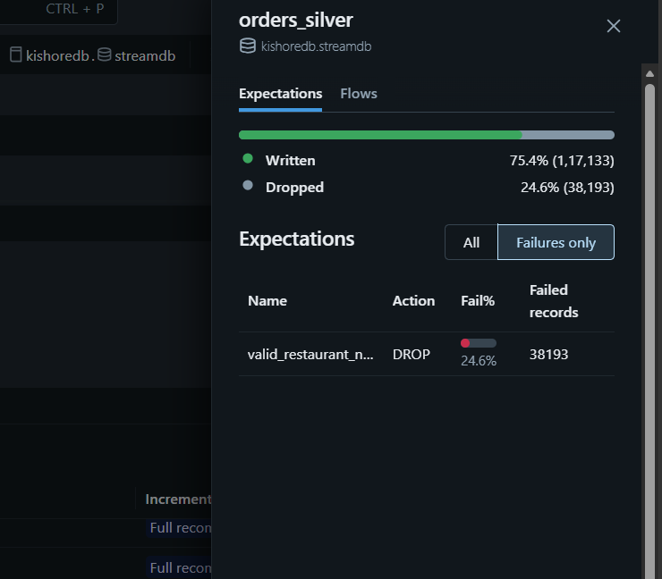

Creating a Dashboard Using the Gold Tables
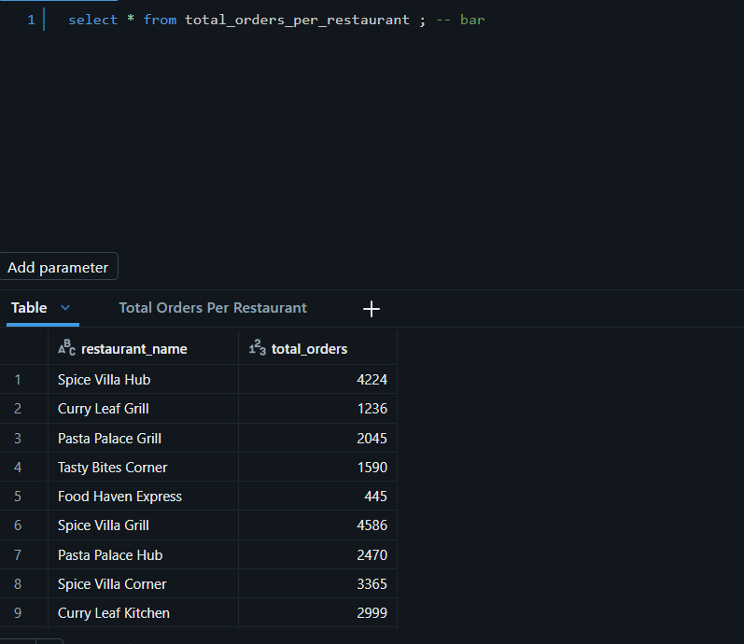
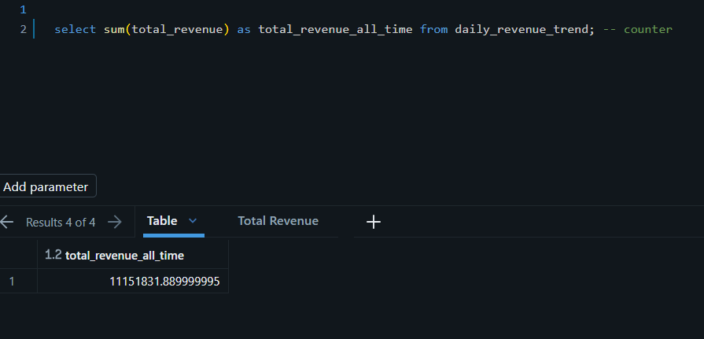
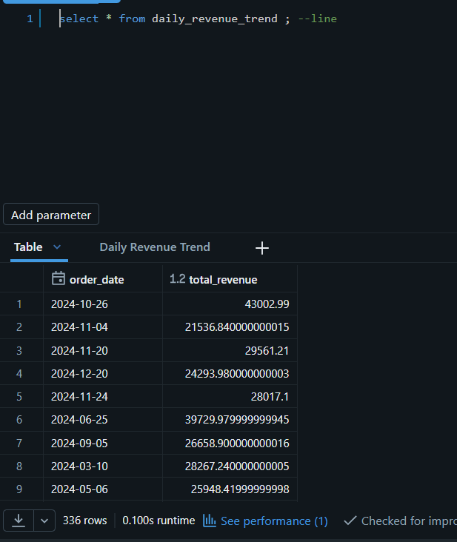
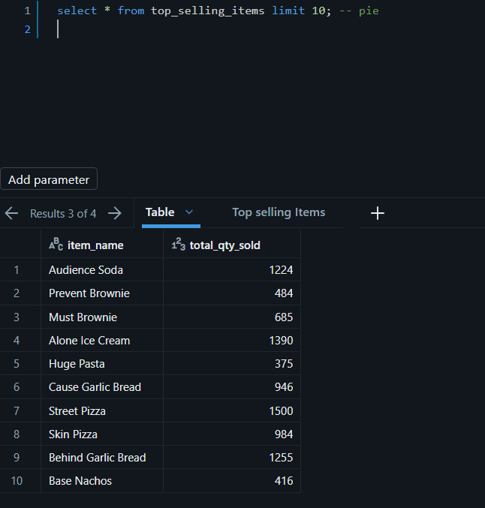
Final output Dashboard after adding all the order files

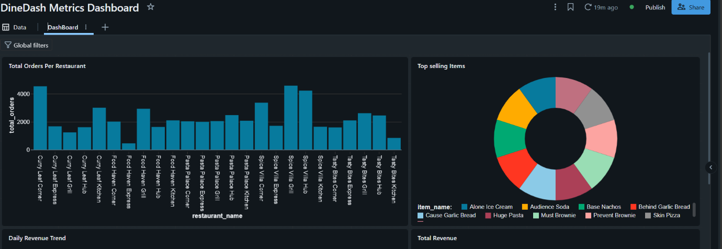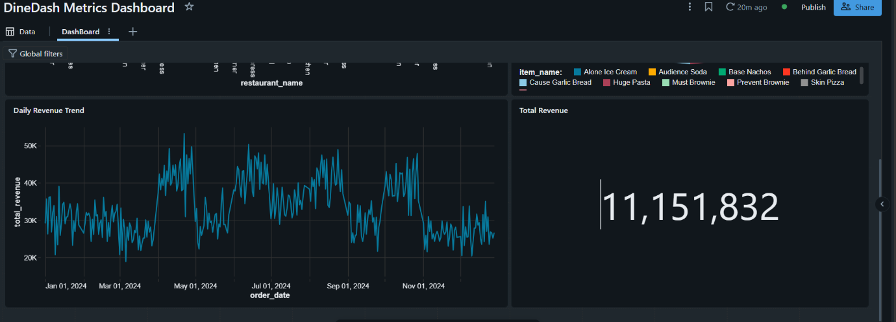
Creating the workflow
- Creating a job and adding tasks .
- First task is Pipeline we created above , we use that pipeline and set it to Full refresh when triggered.
- Creating another task and adding Dashboard we created previously and linking it with task-1
- Run the job ,we will get a run id ,from that run id we observe our job details like run success or failed ,errors ,etc .
- After running the job ,we see the resultant output respectively for the Pipeline and also for the Dashboard

Assigning the pipeline as first task :
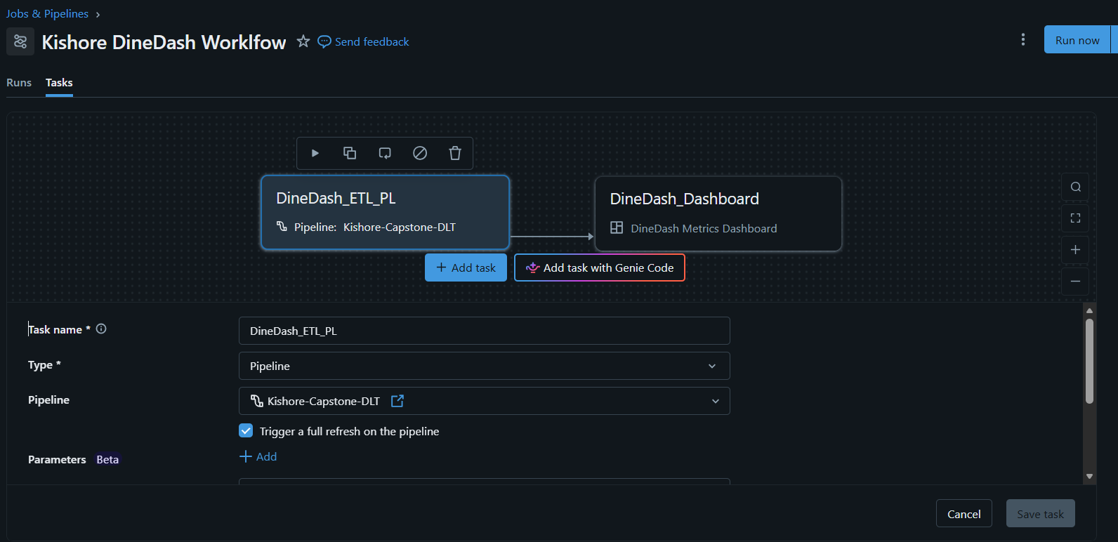
Assigning the Dashboard as first task :
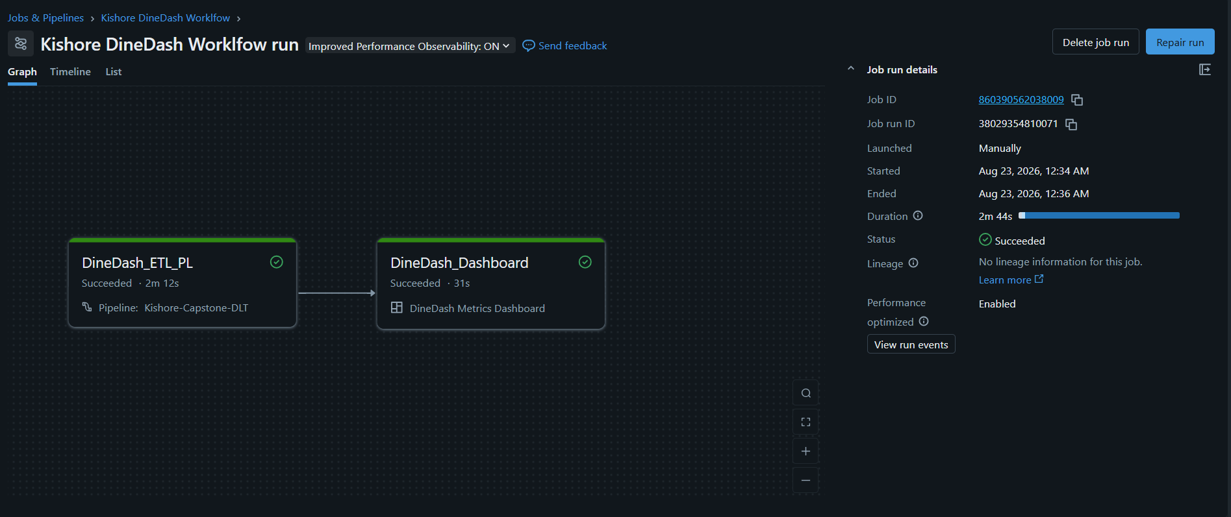

The DashBoard Output for this workflow for the files from the Jan Aug :
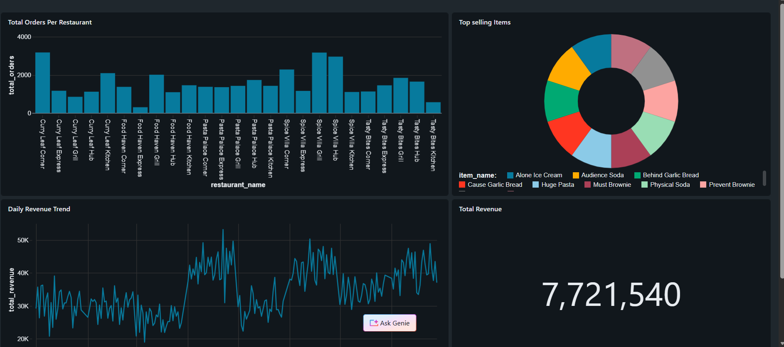
The DashBoard Output After adding all the files :
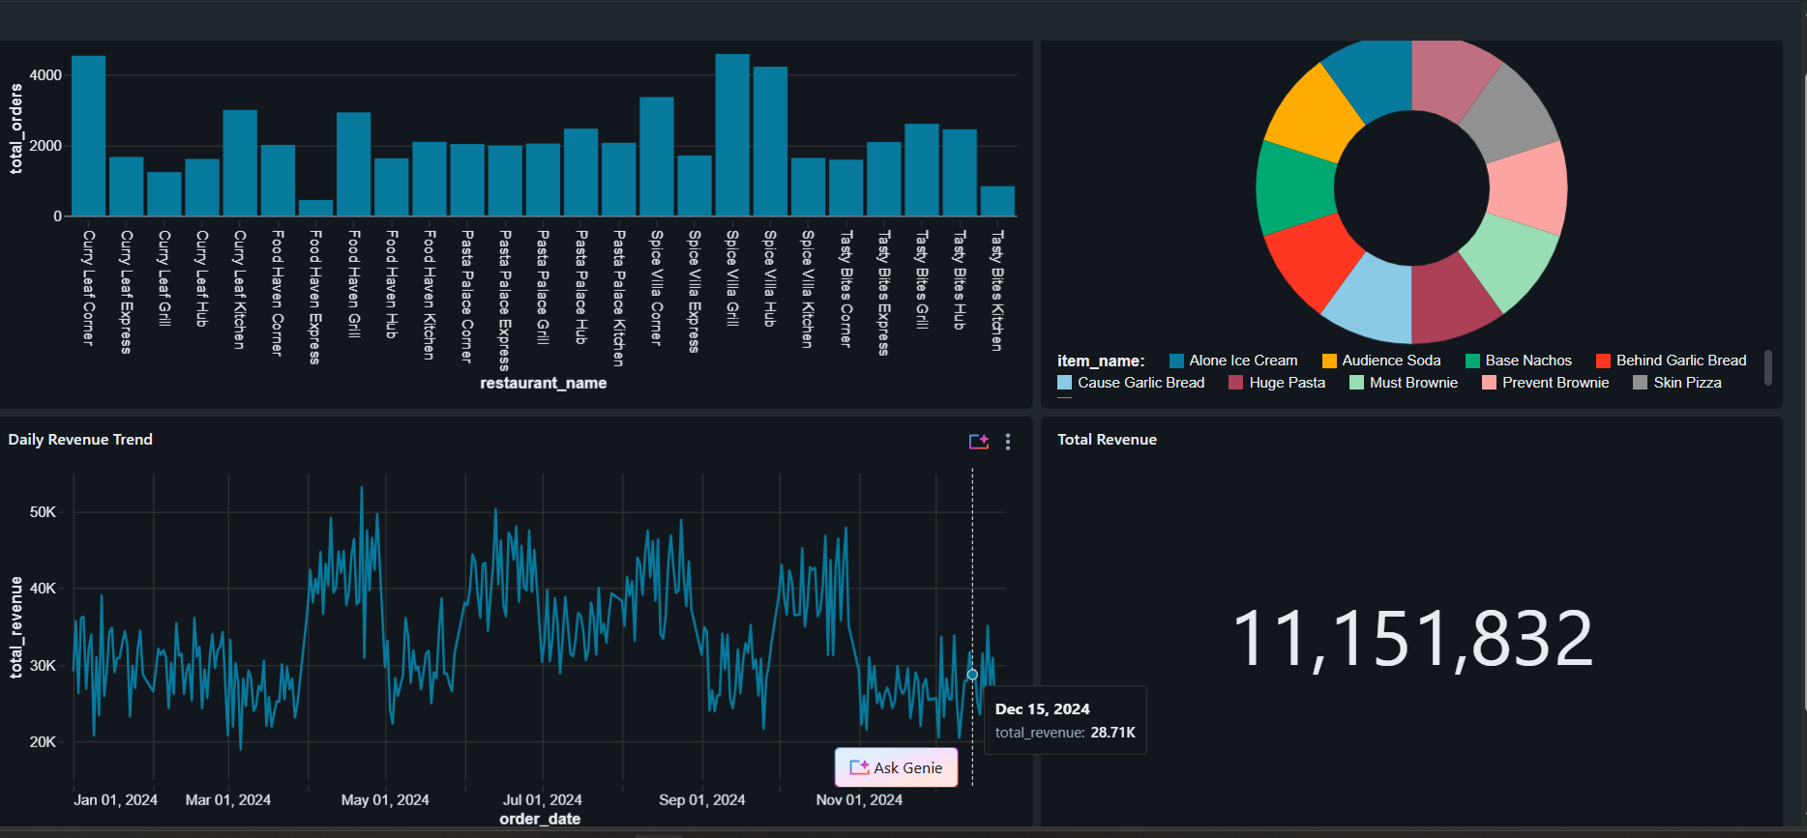
Final Outcome :
The completed solution provides a repeatable data flow from raw DineDash files to cleaned and enriched data, business metrics, dashboards, and an executable workflow. The project demonstrates ingestion, data quality, incremental processing, transformation, analytics, visualization, and orchestration in Databricks.
- Bronze: raw and incrementally ingested data.
- Silver: cleaned, validated, exploded, and enriched order data.
- Gold: business-ready metrics.
- Dashboard: visual presentation of key KPIs.
- Workflow: repeatable execution of the pipeline and dashboard tasks.

Thank You

