Bug Fix-1
- categories (including Biryani Station, Pizza Ovens, and other non Veg/Non-Veg prefixed categories) to:
- Populate the Item Name dropdown correctly,
- Add quote-based Live Catering items to the order.
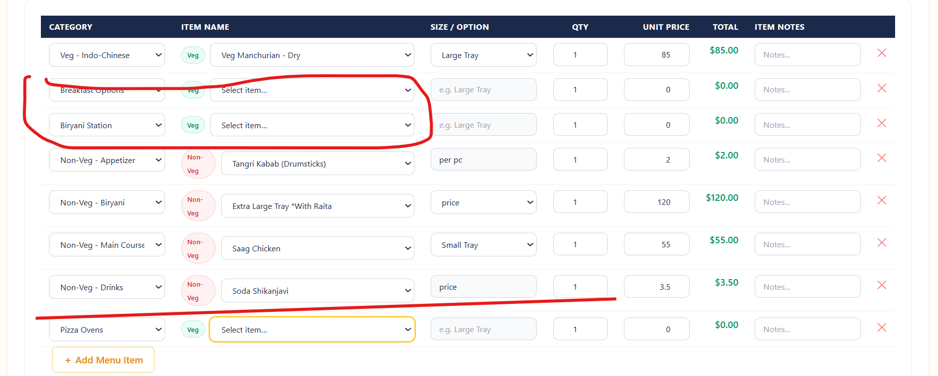

After Fix:
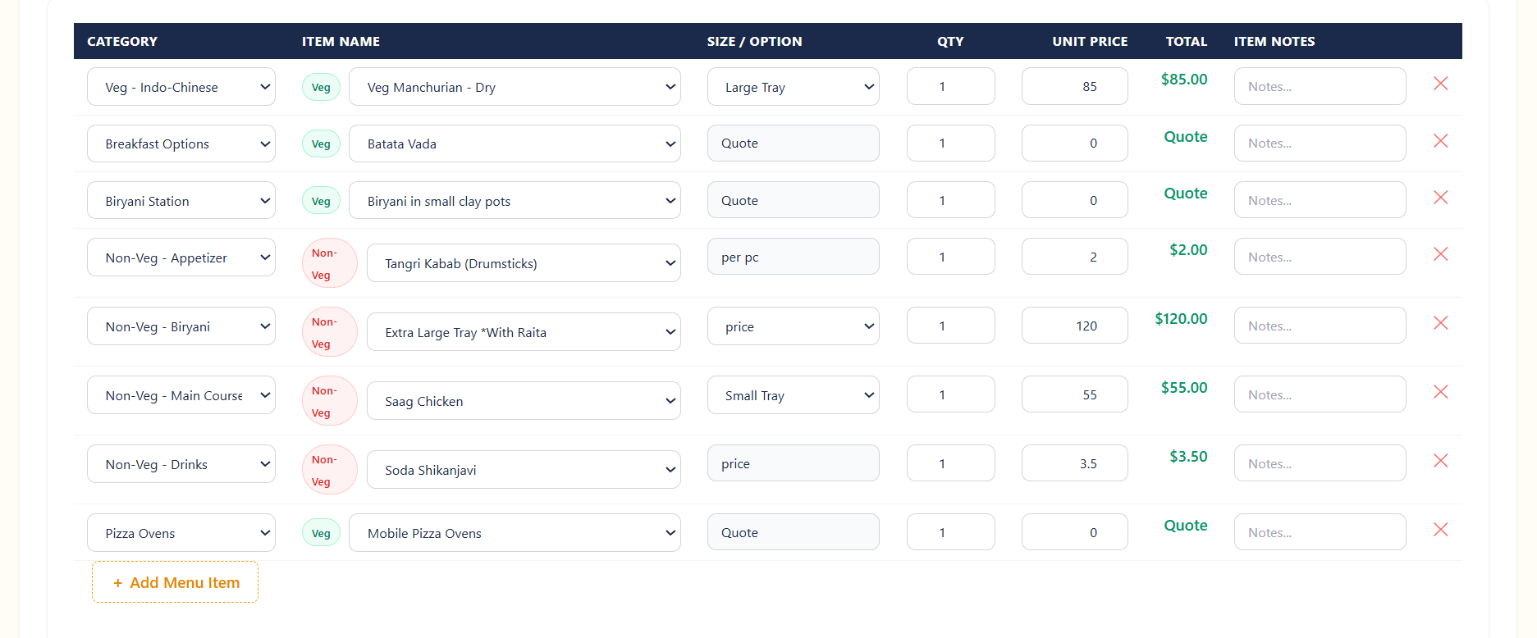
Bug Fix-1 – Repeated size options
- In the Size / Option dropdown (Small Tray, Large Tray, Extra Large Tray), the same sizes are listed multiple times. The list should contain each tray size only once, with no duplicate entries.
- This removes repeated entries like multiple “Small Tray / Large Tray” rows that differed only by backend price, so each unique size appears once in the dropdown anywhere in the app where that menu is used
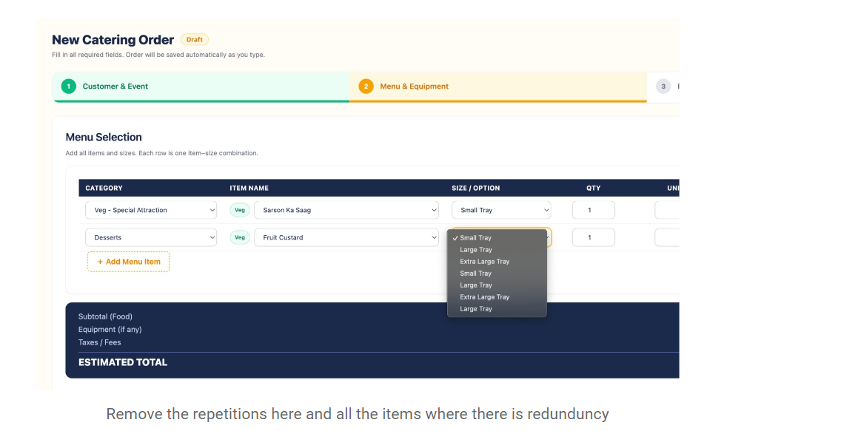

Bug Fix-3 – “Trash”/placeholder menu categories
In the Category dropdown, there are junk/placeholder items like 15, 31, Non-veg - 53, Veg - 85 mixed in with real categories. These “trash” entries should be removed from the category list so only valid, meaningful categories remain.
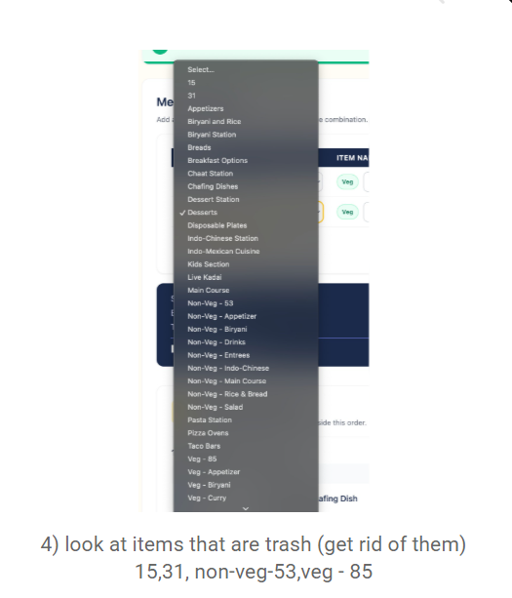
- Bug Fix-4– Remove “Return Date” and “Return Status” from Chafing Dishes

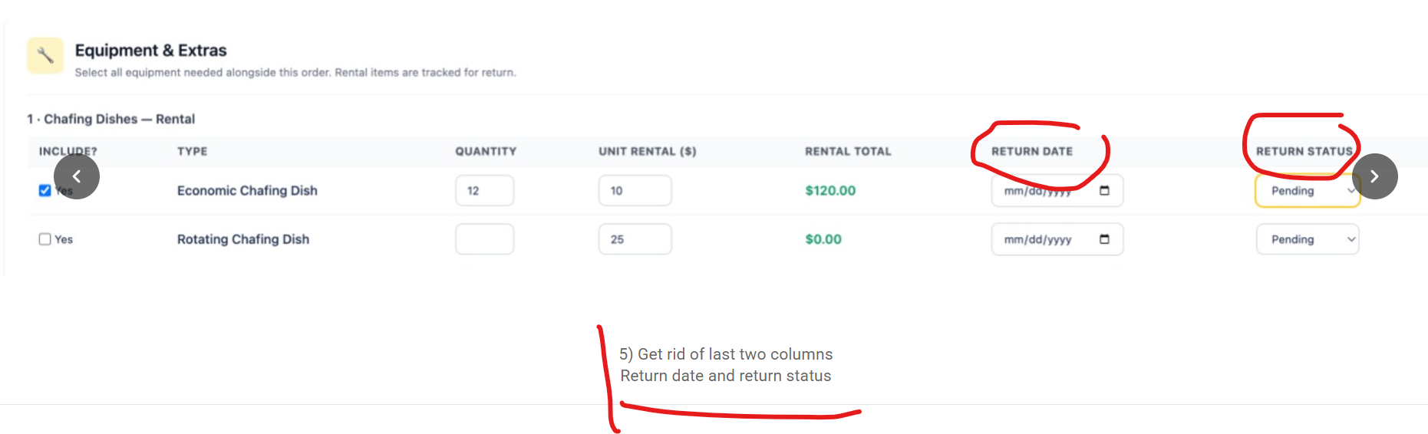
Bug Fix -5
To change the totals row label from “Equipment (if any)” to “Other / Additional Equipment”
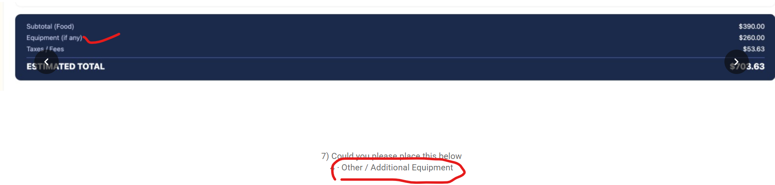

Bug Fix-6:
- Stronger global email & mobile validation (backend + shared)

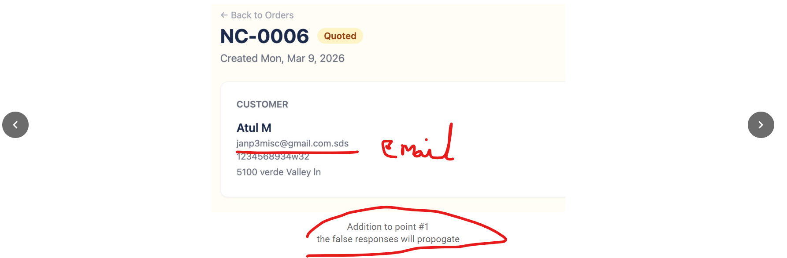

Bug Fix-7
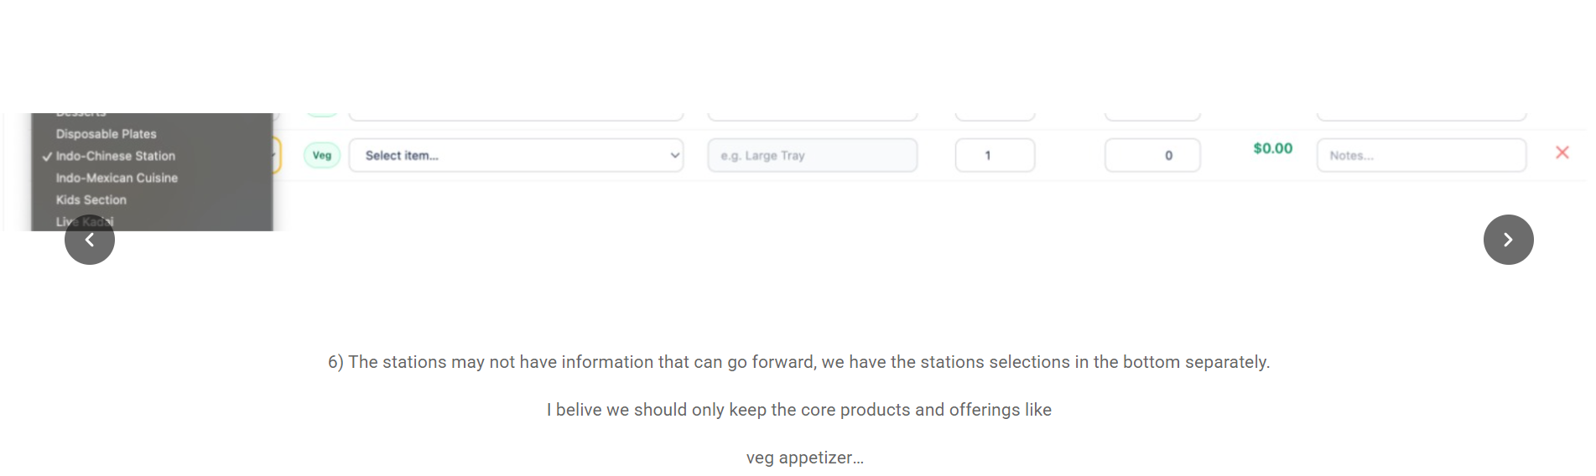

Bug Fix-8- It was data issue and need to cross verify once with Client on this(Jeera rice is available both in veg and Non-Veg Sheet)
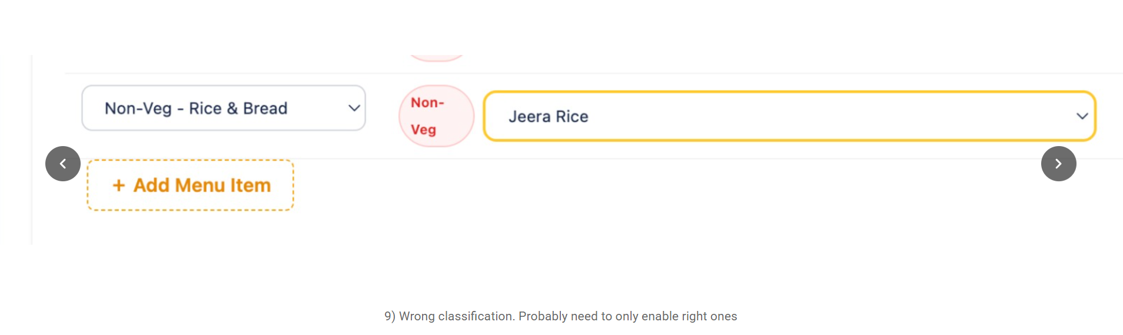

Bug Fix-9
When you click Export CSV on the Weekly Kitchen Lineup:
- The EVENTS section is unchanged.
- The CATEGORY BREAKDOWN — PREP QUANTITIES section now matches the updated UI: only prep quantities, no $ amount

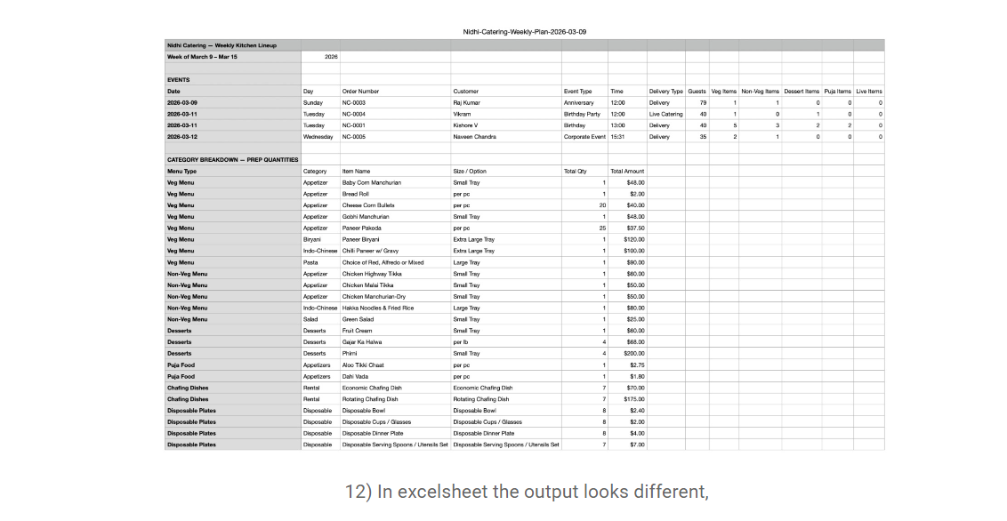

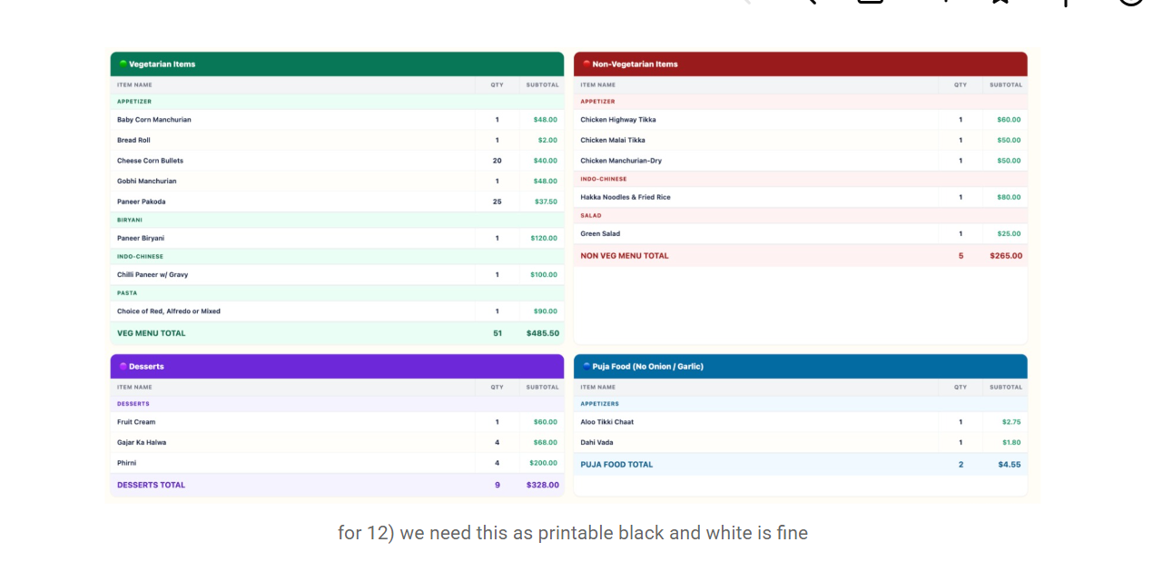

Bug Fix-10
- Removed emojis before item names everywhere that uses getMenuTypeIcon.
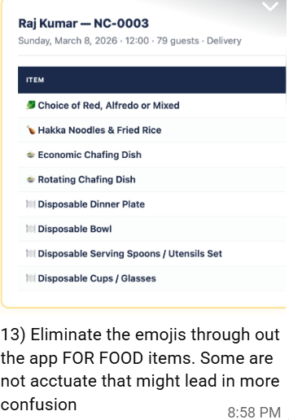

Bug Fix-11
- Removed all dollar ($) amounts from the Weekly Category Breakdown — Prep Quantities tables on the kitchen page.
- The breakdown panels now only show Item Name and Qty columns; the Subtotal money column and totals in dollars have been removed from both item rows and the total row.
- Quantities and section totals (e.g. VEG MENU TOTAL quantity) still display; only the currency values are gone.

c