Chapter 1

INTRODUCTION
Answers to Multiple Choice Questions
1.d 2.d 3. d 4. b 5.d

Answers to Selected Review Questions

1. What is the principal aim of the software engineering discipline? What does the discipline of software engineering discuss?
Ans: The principal aim of the software engineering discipline is to produce high quality software in a cost-effective manner. Software engineering discusses systematic and cost-effective techniques for software development.
2. Why do you think systematic software development using the software engineering principle is any different than art or craft?
Ans: The reasons are the following:
- Software engineering makes heavy use of the knowledge that has accrued from the experiences of a large number of practitioners. These past experiences have been systematically organized and wherever possible theoretical basis to the empirical observations have been provided. Whenever no reasonable theoretical justification could be provided, the past experiences have been adopted as rules of thumb.
- Using software engineering principles, several conflicting goals are encountered while solving a problem. In such situations, several alternate solutions are first proposed. An appropriate solution is chosen out of the candidate solutions based on various trade-offs that are made on account of issues such as of cost, maintainability, and usability. Therefore, while arriving at the final solution, several iterations and backtracking are usually needed. In science, on the other hand, only unique solutions are possible.
- Software engineering make use of only well-understood and well-documented principles.
3. Distinguish between a program and a software product.
Ans: Programs are developed by individuals for their personal use. They are, therefore, small in size and have limited functionality. Further, since the author of a program himself uses and maintains his programs, these usually lack good user-interface and proper documentation. For example, the programs developed by a student as part of his class assignments are programs and not software products. On the other hand, software products have multiple users and, therefore, have good user-interface, proper users’ manuals, and good documentation support. Since, a software product has a large number of users, it is systematically designed, carefully implemented, and thoroughly tested. In addition, a software product consists not only of the program code but also of all associated documents such as requirements specification document, design document, test document, users’ manuals, etc. A further difference is that the software products often are too large to be developed by any individual. It is usually developed by a group of engineers working in a team.

4. Distinguish among a program, a software product and a software service.
Ans: Programs are usually small in size and support limited functionality. Further, the author of a program is usually the sole user of the software and himself maintains the code. These toy software therefore usually lack good user-interface and proper documentation. Besides these may have poor maintainability, efficiency, and reliability. Since these toy software do not have any supporting documents such as users’ manual, maintenance manual, design document, test documents, etc.; we call these toy software as programs. Software products are purchased off-the-shelf by the customers. Software services covers a large gamut of software projects such as customization, outsourcing, maintenance, testing, and consultancy.
5. What is a software product line? Give an example of a software product line.
Ans: A company often has software product lines that are essentially different versions of a software product target slightly different market segments. For example, Microsoft targets desktops and laptops through its Windows 8 operating system, while it targets high-end mobile handsets through its Windows mobile operating system, and targets servers through its Windows server operating system.

6. What are the main types of projects that are undertaken by software development companies?
Ans: Indian software companies have excelled in executing software services projects and have made a name for themselves all over the world. Of late, the Indian companies have slowly started to focus on product development as well.
7. Do you agree with the following statement: ”The emphasis of exploratory programming is error correction while the software engineering practices emphasize error prevention”? Give the reasonings behind your answer.
Ans: Yes. Exploratory programming involves quickly coming up with a solution code and correcting it until it meets the requirements. On the other hand, software engineering emphasizes careful planning and designing and preventing errors.
8. What difficulties would a software development company face, if it tries to use the exploratory (build and fix) program development style in its development projects? Explain your answer.
Ans: The main problems that would be faced are the following:
• Exploratory style results in the perceived difficulty of a problem to grow exponentially with size due to human cognitive limitations. This results in exponential growth of effort, cost, and the time to develop a software product.
• The code generally becomes very unstructured and bad due to large number of rounds of bug fix.
• It becomes difficult to use this approach when a product is developed by a large team.
• This approach breaks down after certain problem size, implying that the development effort fails for large problems.
9. What are the symptoms of the present software crisis? What factors have contributed to the making of the present software crisis? What are possible solutions to the present software crisis?
Ans: The symptoms of the present software crisis are increasing cost of software products, unreliable products that are full of bugs, and products delivered late.
The factors contributing to software crisis are the increasing complexity of software products being developed, lack of professionals adequatwely trained in software engineering techniques, and lack of progress of the software engineering discipline itself.
The possible solutions to the presenty software crisis are adequate training in software engineering techniques and progress of the software engineering discipline itself.
10. Explain why the effort, time, and cost required to develop a program using the build and fix style increase exponentially with the size of the program? How do software engineering principles help tackle this rapid rise in development time and cost?
Ans: The effort, time, and cost required to develop a program using the build and fix style increase exponentially with the size of the program primarily due to the human cognitive limitations. Software engineering principles overcome this problem through abundant use of the abstraction and decomposition.
11. Distinguish between software products and services.
Ans: Software products are purchased off-the-shelf by the customers. Software services covers a large gamut of software projects such as customization, outsourcing, maintenance, testing, and consultancy.
12. What are the different types of software development projects that are normally undertaken by software companies? Out of these, which type of projects are the forte of the indian software development companies?
Ans: Outsourced projects and product development projects. Indian software companies are strong in handling outsourced projects.
13. Name the basic techniques used by the software engineering techniques to handle complexity in a problem.
Ans: Abstraction and decomposition.
14. What do you understand by the exploratory (some times also called as the build and fix) style of software development? What are the shortcomings of this approach?
Ans: In the build and fix (exploratory) style, normally a ‘dirty’ program is quickly developed without making any specification, plan, or design, The different imperfections that are subsequently noticed while using or testing are fixed.
The main problems with the exploratory style are the following:
• Exploratory style results in the perceived difficulty of a problem to grow exponentially with size due to human cognitive limitations. This results in exponential growth of effort, cost, and the time to develop a software product.
• The code generally becomes very unstructured and bad due to large number of rounds of bug fix.
• It becomes difficult to use this approach when a product is developed by a large team.
• This approach breaks down after certain problem size, implying that the development effort fails for large problems.
15. List the major differences between the exploratory and modern software development practices.
Ans:
• Use of life cycle model emphasises phase containment of errors.
• Modern development starts with a complete and documented requirements specification.
• Proper design using some well-defined design methodology.
• Systematic testing
• Better visibility of design and code
• Several metrics used
• Projects are being thoroughly planned
• Use of several CASE tools
• Emphasis has shifted from error correction to error prevention.
16. What is the difference between the actual complexity of solving a problem and its perceived complexity? What causes the difference between the two to arise?
Ans: Humans experience larger than the actual complexity in solving a problem due to human cognitive restrictions. The complexity that humans face in solving a problem is called its perceived complexity.
18. Why is the number 7 considered as a magic number in software engineering? How is it useful software engineering?
Ans: The short term memory can store at best seven items at any time. Therefore, humans experience difficulty for understanding if more than seven information is handled at any time. In software engineering, the abstraction and decomposition principles are used to restrict the number of new information that one has to deal with any time to seven.
19. What do you understand by the principles of abstraction and decomposition? Why are these two principles considered important in software engineering?
Ans:
Abstraction
Abstraction refers to construction of a simpler version of a problem by ignoring details. The principle of abstraction is popularly known as modelling (or model construction). It involves simplifying a problem by omitting unnecessary details is known as the principle of abstraction.

Decomposition
The decomposition principle is popularly known as the divide and conquer principle. The decomposition principle advocates decomposing the problem into many small independent parts. The small parts are then taken up one by one and solved separately. The idea is that each small part would be easy to grasp and understand and can be easily solved. The full problem is solved when all the parts are solved.

Abstraction and decomposition are two principles deployed by software engineering to overcome the problems arising due to human cognitive limitations. Without these two principles, the effort and duration to develop a product would exponehntially.

20. What do you understand by control flow structure of a program? Why is it difficult to understand a program having a messy control flow structure?
Ans: The control flow structure of a program represents the sequence in which the various statements of the program are executed.
It is difficult to understand a program having a messy flow structure, since one normally understands a program by tracing different paths from the inputs to the outputs or from the outputs to the inputs. A program having a messy flow structure has an extremely large number of paths and one needs considerably longer time to trace all the paths to understand the program.

21. What is a flow chart? How is the flow charting technique useful for software development?
Ans:
• Flow charts represent flow of control in a program.
• Flow charts can be used to design a program having good control flow structure.
• Flow charts can be useful for documentatio and help understanding a program.
22. What do you understand by ‘visibility’ of design and code? How does increased visibility help in systematic software development?
Ans: Visibility refers to the production of good quality reviewed documents. Increased visibility helps in systematic developments since it becomes easier to track the progress vis-a-vis the plans.
23. What do you understand by the term “structured programming”? How do modern programming languages such as PASCAL and C facilitate writing structured programs? What are the advantages of writing structured programs vis-a-vis unstructured programs?
Ans: Structured programming refers to the following two important features:
• Modular program
• Use of only structured constructs (sequence, selection, and iteration)
The advantage of writing structured programs is that structured programs are easier to understand and therefore are easier to debug and maintain.

24. What is a high-level programming language? Why do programmers using high-level programming language for application development have higher productivity compared while using machine language?
Ans: A high-level language is close to natural languages and are therefore easy to learn and use. Writing each high-level programming construct in effect enables the programmer to write several machine instructions. Also, the machine details (registers, flags, etc) are abstracted from the programmer.
25. What are the three basic types of program constructs necessary to develop the program for any given problem? Give examples of these constructs from any high-level language you know.
Ans: The three basic types of program constructs necessary to develop a program are:
• Sequence
• Selection
• Iteration
Examples of these constructs from "C" language:
• Sequence: a=b;
• Selection: if(a≤b) b=0 else c=0;
• Iteration: while(a≤b) a++;
26. What do you understand by a “program module”? What are the important characteristics of a program module.
Ans: A program module is an independently compilable piece of program code. It contains several functions and defines data items that are shared by the functions of the module.
27. Explain how do the use of software engineering principles help to develop software products cost-effectively and timely. Elaborate your answer by using suitable examples.
28. What is the basic difference between a control flow-oriented and a data flow-oriented design technique? Can you think of any reason as to why a data flow-oriented design technique is likely to produce better designs than a control flow-oriented design technique?
Ans: In a control flow-oriented design, the software is designed by carefully designing the control flow in the program using a flow chart or a similar notation.
In a data flow-oriented design, the design is arrived at from an analysis of the data flow inherent in the problem.
Data flow-oriented design techniques provide better decomposition of the problem.
29. Name the two well-known principles used in software engineering to tackle the complexity of development of large programs? Discuss these two principles and explain how these two principles help tackle program complexity.
Ans: The two well-known principles to handle complexity of development of large programs are abstraction and decomposition.
30. What does the control flow graph (CFG) of a program represent? Draw the CFG of the following program:
main(){
int y=1;
if(y<0)
if(y>0) y=3;
else y=0;
printf("%d\n",y);
}

Ans: A program’s control flow structure indicates the sequence in which the program’s instructions are executed.
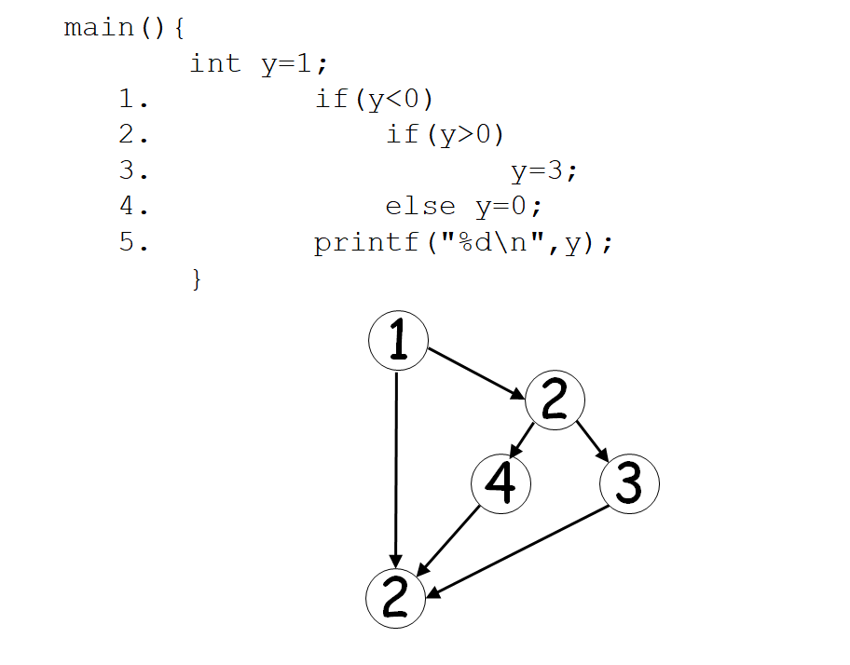
32. What is a data structure-oriented software design methodology? How is it different from the data flow-oriented design methodology?
Ans: In data structure-oriented design, the data structures required in the program are first designed carefully. Based on the data structures, the code structure is designed.
33. Discuss the major advantages of the Object-Oriented Design (OOD) methodologies over the data flow-oriented design methodologies.
Ans: Object-oriented methodologies provide better abstraction and decomposition of a problem and therefore can more easily handle complexity. OOD methodologies also facilitate reuse of existing software components.
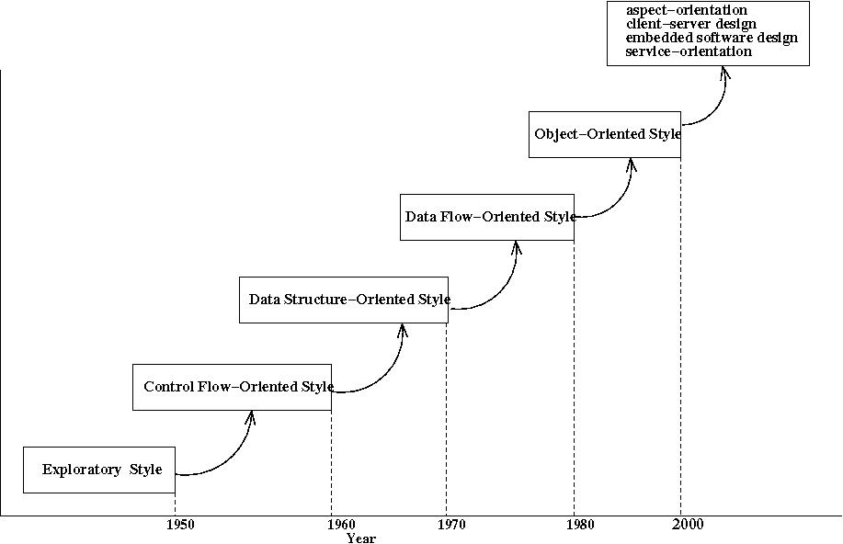
Figure 1: Evolution of software design techniques
34. Explain how the software design techniques have evolved in the past. How do you think shall the design techniques evolve in the near future?
Ans: We pictorially summarize this evolution of the software design techniques in Fig. 1. It can be observed that almost every passing decade, revolutionary ideas have been put forward to cater to design of larger and more sophisticated programs, and at the same time increasing the quality of the design solutions. But, what would the next improvement to the design techniques be? It is very difficult to speculate about the developments that may occur in the future. However, we have already seen that in the past, the design techniques have evolved each time to meet the challenges faced in developing contemporary software. Therefore, the next development would most probably occur to help meet the challenges being faced by the modern software designers. To get an indication of the techniques that are likely to emerge, let us first examine what are the current challenges in designing software products. First, program sizes are further increasing as compared to what was being developed a decade back. Second, many of the present day software are required to work in a client-server environment through a web browser (i.e. web-based). At the same time, many other software products have to work in small hand held devices and embedded processors.
35. What is computer systems engineering? How is it different from software engineering?
Ans: Computer systems engineering addresses the issues in development of high quality systems cost-effectively.

