Chapter 8

Object-Oriented Software Development
Answers to Multiple Choice Questions

1.c 2.d 3.d 4.a 5.d 6.a 7.d 8.b 9.b

Answers to True/False Questions

1.F 2.F 3.F 4.F 5.T

Answers to Selected Review Questions

1. What is the difference between Object Oriented Analysis (OOA) and Object Oriented Design (OOD)?
Ans:
The term object oriented analysis (OOA) refers to a method of developing an initial model of the software from the requirements specification. The analysis model is refined into a design model through Object Oriented Design (OOD).
2. What is a pattern in the context of software development? Explain why patterns are considered to be an effective form of software reuse. What are the limitations of this approach for software reuse?
Ans:
At a basic level, patterns can also be viewed as well-documented building blocks for software design.
Important shortcomings of design patterns are the following:
• Design patterns do not directly lead to code reuse.
• At present no methodology is available that can be used to select the right design pattern at the right point during a design exercise.
4. Do you need to develop all the views of a system using all the modeling diagrams supported by UML? Justify your answer.
Ans:
The answer is "No". For a simple system, the use case model, class diagram, one of the interaction diagrams may be sufficient. For a system in which the objects undergo many state changes, a state chart diagram may be necessary. For a system, which is implemented on a large number of hardware components, a deployment diagram may be necessary. So, the type of models to be constructed depends on the problem at hand.
5. What are design patterns? What are the advantages of using design patterns? Name some popular design patterns.
Ans:
Patterns are standard solutions to some commonly recurring problems. A pattern serves as a guide for creating a "good" design. Patterns are based on sound common sense and the application of fundamental design principles. Once we become familiar with the patterns, we can spot them in our development projects and reuse them.
Some important patterns are the following:
• Expert
• Creator
• Controller
• Facade
7. What is unified process? What are the different phases of the unified process? What activities are carried out during each phase of the unified process?
Ans:
The unified process is an extensible framework which needs to be customized for specific types of projects.
The unified process involves iterating over the following four distinct phases:
Inception: During this phase, the scope of the project is defined and prototypes may be developed to form a clear idea about the project.
Elaboration: In this phase, the functional and the non-functional requirements are captured.
Construction: During this phase, analysis, design, and implementation activities are carried out. Full text descriptions of use cases are written during the construction phase and each use case is taken up for the start of a new iteration. System features are implemented in a series of short iterations. Each iteration results in an executable release of the software.
Transition: During this phase the product is installed in the user’s environment and maintained.
8. Algorithms such as sorting are famed as reusable solutions to problems. Since patterns provide reusable solutions, is it correct to say that patterns are essentially algorithms? Explain your answer.
Ans:
Patterns and algorithms are in some respects similar since both attempt to provide reusable solutions. However, algorithms primarily focus on solving problems with reduced space and/or time requirements, whereas patterns focus on understandability and maintainability of design and easier development.
10. Define the term cohesion in the context of object-oriented design of systems.
Ans:
In OOD, we are concerned about cohesion at three levels:
• Cohesiveness of the individual methods. Cohesiveness of each of the individual method is desirable, since it assures that each method does only a well-defined function.
• Cohesiveness of the data and methods within a class. This is desirable since it assures that the methods of an object do actions for which the object is naturally responsible, i.e. it assures that no action has been improperly mapped to an object.
• Cohesiveness of an entire class hierarchy. Cohesiveness of methods within a class is desirable since it promotes encapsulation of the objects.
11. What are some of the important features that characterize a good object-oriented design?
Ans:
The following are some of the accepted criteria for judging the goodness of a design.
Coupling guidelines. The number of messages between two objects or among a group of objects should be minimum. Increase in the number of message exchanges between two objects results in increasing the coupling between them. Excessive coupling between objects is detrimental to modular design and prevents reuse.
Cohesion guideline. In OOD, we are concerned about cohesion at three levels:
• Cohesiveness of the individual methods. Cohesiveness of each individual method in a class is desirable. This requires that each method should perform only a certain well-defined function. This is desirable since it assures that the methods of an object do actions for which the object is naturally responsible, i.e. it assures that no action has been improperly mapped to an object.
• Cohesiveness of the data and methods within a class. The classes in a hierarchy should be coherent. For example, from the base class Issuable in a library, only issuable items should be derived. It would be highly inappropriateness to derive a library Member class from the issuable class.
• Cohesiveness of an entire class hierarchy. Cohesiveness of methods within a class is desirable since it promotes encapsulation of the objects.
Hierarchy and factoring guidelines. A base class should not have too many subclasses. If too many subclasses are derived from a single base class, then it becomes difficult to understand the design. In fact, there should approximately be no more than 7±2 classes derived from a base class at any level.
Keeping message protocols simple. Complex message protocols are an indication of excessive coupling among objects. If a message requires more than 3 parameters, then it is an indication of inferior design.
Number of Methods. Objects with a large number of methods are likely to be more application-specific and also difficult to comprehend — limiting the possibility of their reuse. Therefore, objects should not have too many methods. In fact, the number of methods can be used as a measure of the complexity of a class.
Response for a class: The response for a class can be defined as the maximum number of methods of other objects that an instance of this class invokes. Please note that if the same method is called more than once, then it is counted only once. A class which calls more than about seven different methods is susceptible to errors.
12. Explain the differences between an architectural pattern, a design pattern, and an idiom in the context of object-oriented software development.
Ans:
The architectural patterns identify and provide solutions to problems that are identifiable while carrying out architectural (or very high-level) designs. Architectural designs concern the overall structure of software systems. Architectural designs cannot directly be translated to code, but form the basis for more detailed design.
A design pattern usually suggests a scheme for structuring the classes in a design solution and defines the interactions required among those classes.
An idiom describes how to implement a solution to a particular problem using the features of a given programming language.
13. What is an anti-pattern? How antipatterns are helpful in arriving a good design solution to a problem?
Ans:
If a pattern represents a “best practice”, then an antipattern represents lessons learned from a bad design. The following are two types of antipatterns that are popular:
• Those that describe bad solutions to problems which leads to bad situations.
• Those that describe how to avoid bad solutions to problems.
Antipatterns are valuable because they help us to recognize why a particular alternative might seem at first like an attractive solution, but later on lead to complicacies and finally turn out to be a poor solution. After we become familiar with the important antipatterns, we can consciously try to avoid them while solving a problem.

14. Briefly outline the important steps involved in developing a software system using a popular Object-oriented design methodology.
Ans:
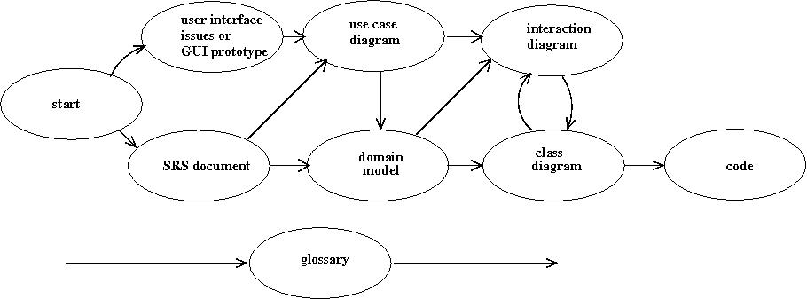
Figure: An object-oriented analysis and design process
As shown in above Figure, the use case model is developed first. As pointed out in Sec. 8.3.1, in any user-centric development process such as the unified process, all developed models must conform to the use case model. Therefore, the use case model has a crucial role in the design process, and needs to be developed first. As shown in Fig. Error: Reference source not found, the domain model is constructed next through an analysis of the use case model and the SRS document. The domain model is refined into a class diagram through a number of iterations involving the interaction diagrams. Once the class diagram has been constructed, it can easily be translated to code.

