# **AI in Retail Store**

## **Introduction**

Adventureworks has retail store in various cities. One of the challenges for the retail store is to get feedback on paper or through device from the customer. Most of the time customer skips it. They decided to capture customer reaction while purchasing items or at billing counter. Their internal IT department decided to use Microsoft Cognitive services.

In this HOLs, we will use Microsoft Cognitive Services and Python to detect customers emotions. We’ll also capture your feedback at OSI2017 and detect sentiment out of it.

## **Prerequisites**

* Azure Subscription
* Python 2.7
* Python code <https://aka.ms/osi2017pycode>

## **Setting up Cognitive Services**

In this section, we’ll setup 2 services. First ‘Emotion API’ services which will detect emotion from the photo. The another one is ‘Text Analytics API’ to detect sentiment from the written feedback on HOL.

### Emotion API Services

* Login to Azure portal. <https://portal.azure.com>
* Once login successfully, Click **New** -> Type ‘**Cognitive Services**’ in search box -> Press Enter

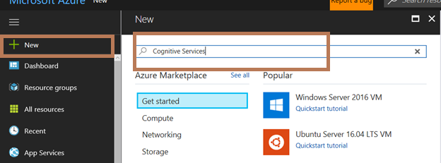

* Click **Emotion API (preview)**

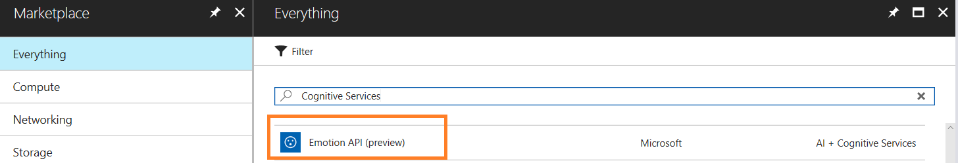

* Click **Create**

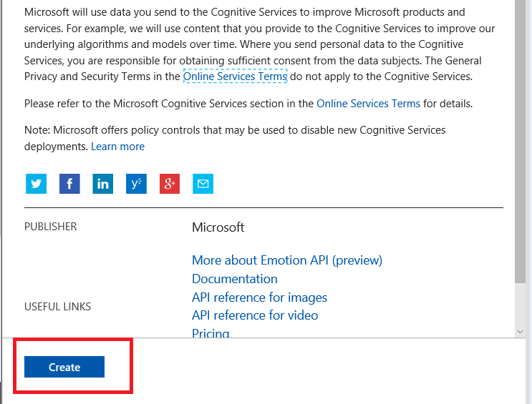

* Enter **Name** (of your choice) of the services
* Select **Location** as ‘**West US**’
* Select **Pricing** as F0 (it’s a free tier)
* Select **Create new** in **Resource group**
* Enter Resource group name
* Agree terms and conditions
* Click ‘**Pin to Dashboard**’
* Click **Create**

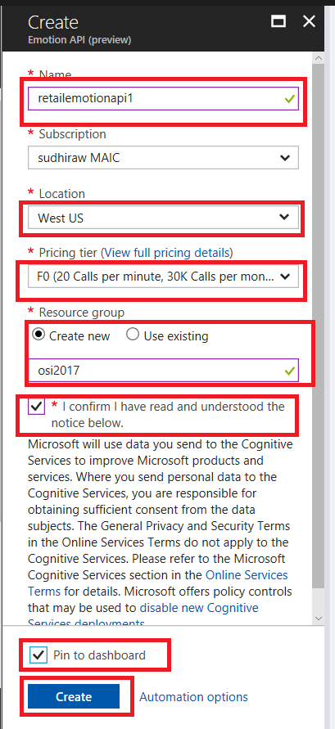

* Once Service is created, click **Show access keys…**

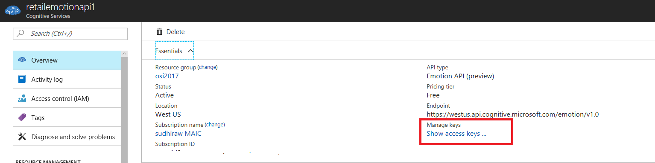

* Copy KEY 1, Click on copy icon

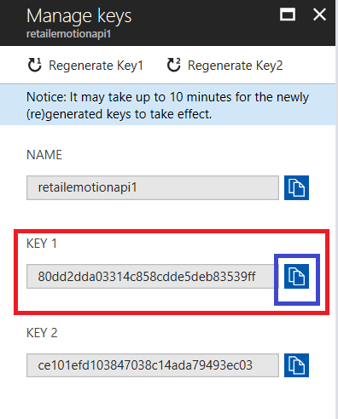

* Open a notepad, paste KEY 1 in it

### **Text Analytics API Services**

* Click **Microsoft Azure** (on top left corner of the screen)

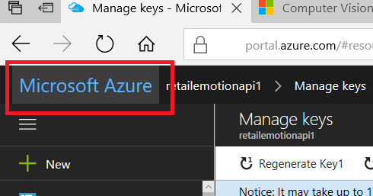

* Click **New** -> Type ‘**Cognitive Services**’ in search box -> Press Enter



* Click **Text Analytics API**

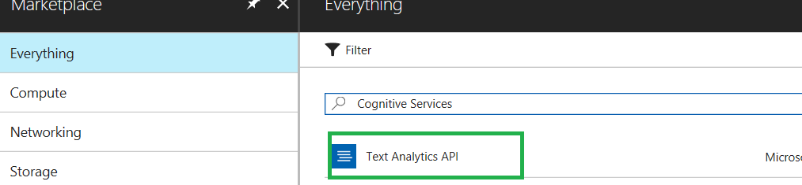

* Click **Create**



* Enter **Name** (of your choice) of the services
* Select **Location** as ‘**West US**’
* Select **Pricing** as S1
* Select **Use existing** in **Resource group**
* Select Resource group name created earlier
* Agree terms and conditions
* Click ‘**Pin to Dashboard**’
* Click **Create**

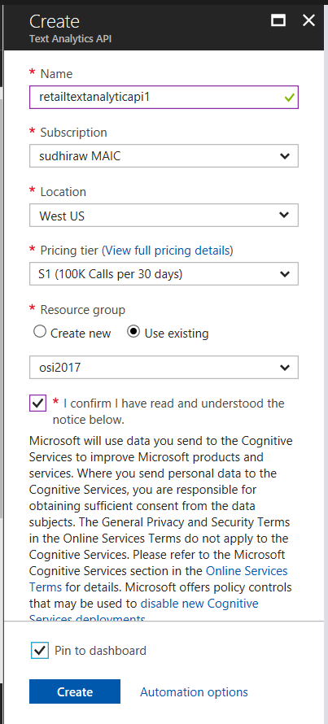

* Once Service is created, click **Show access keys…**

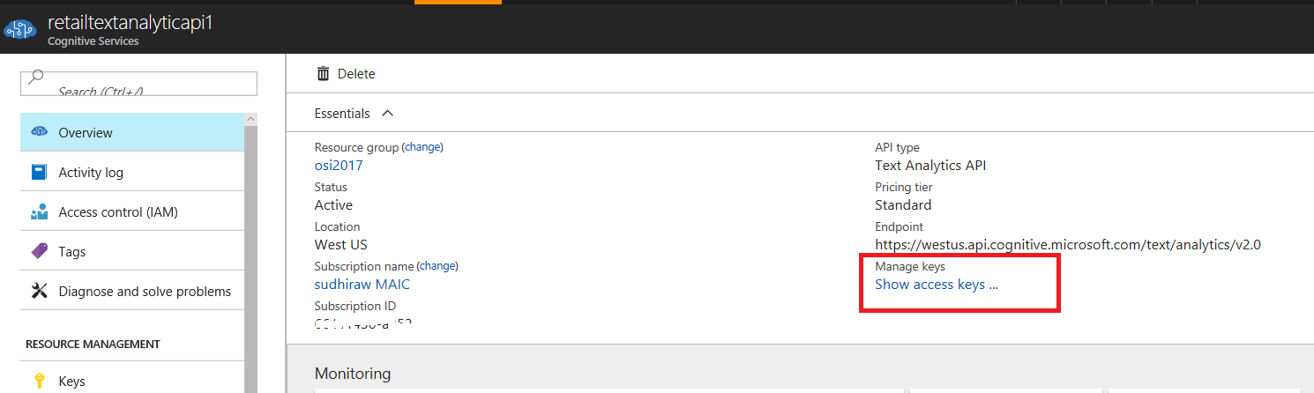

* Copy KEY 1, Click on copy icon

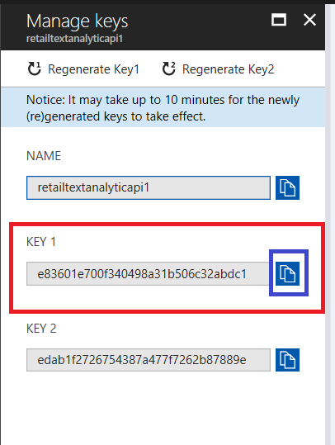

* Open a notepad, paste KEY 1 in it
* After created both services and copied keys in notepad, notepad will look like below

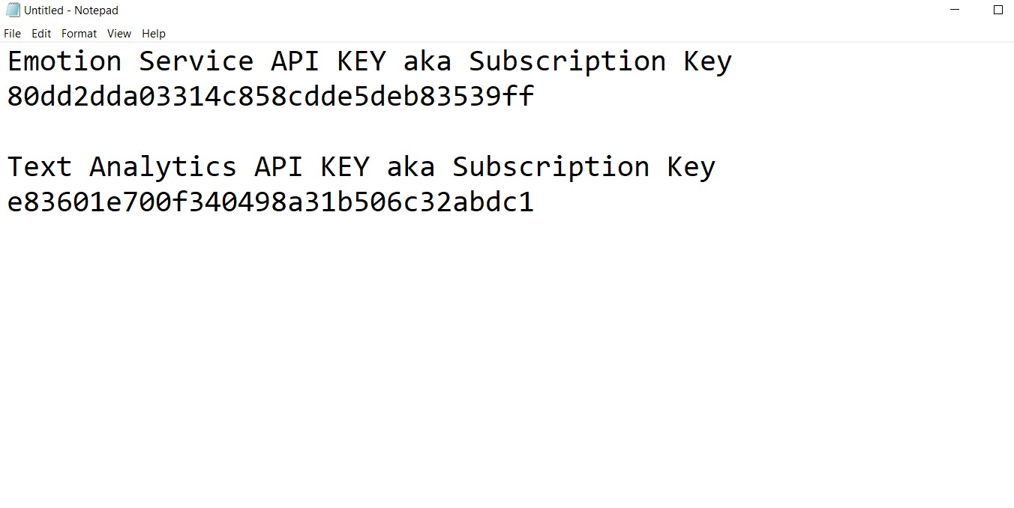

## **Python Code**

* Click on **Windows** icon. Type **Python** and click **IDLE (Python GUI)**

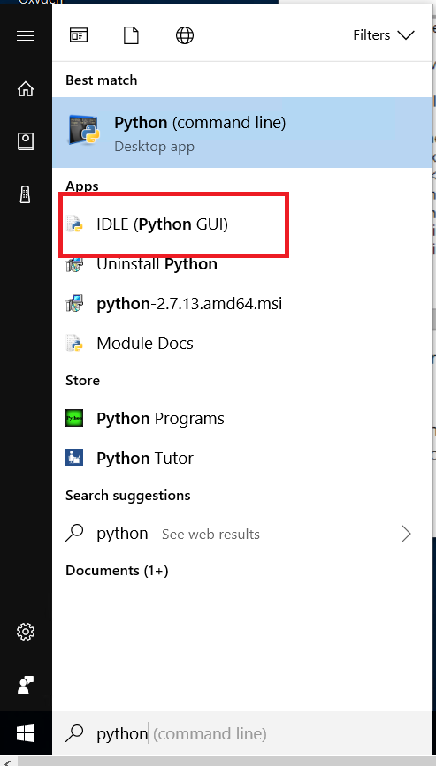

* Click **File** -> **New File**

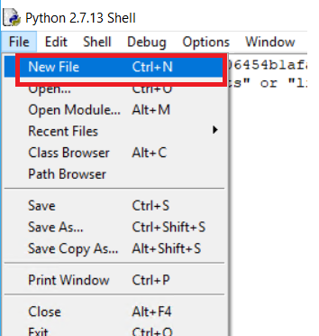

* Copy code from github repository [here](https://github.com/rawatsudhir1/OSI2017/blob/master/AI/RetailEmotionDetection.py) (<https://aka.ms/osi2017pycode>)
* Go through to the code
* Change API keys with the one created in earlier section

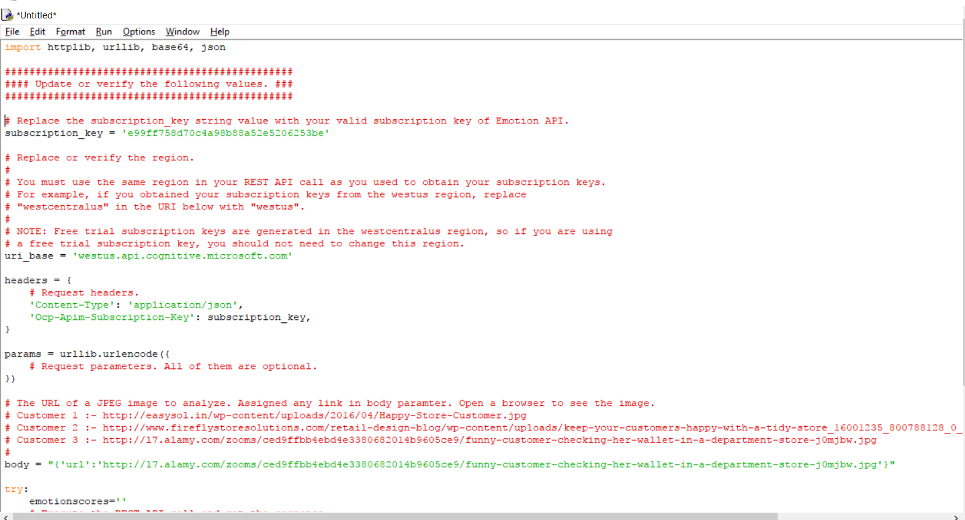

* Click **File** -> **Save As…**

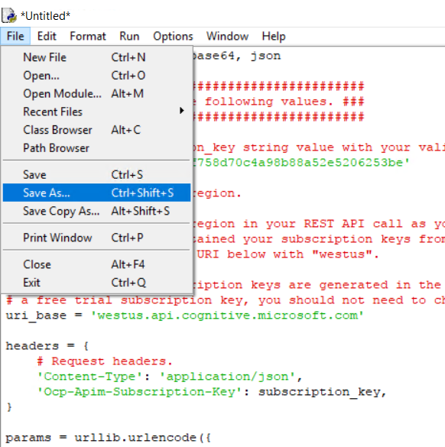

* Provide file name and click **Save**

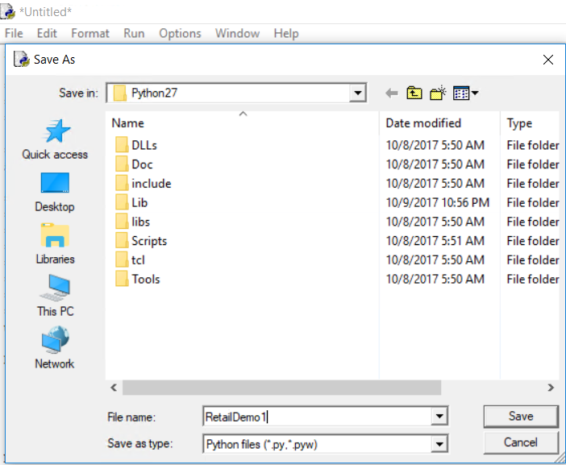

* Click **Run -> Run Module F5**

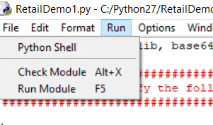

* Output looks like below

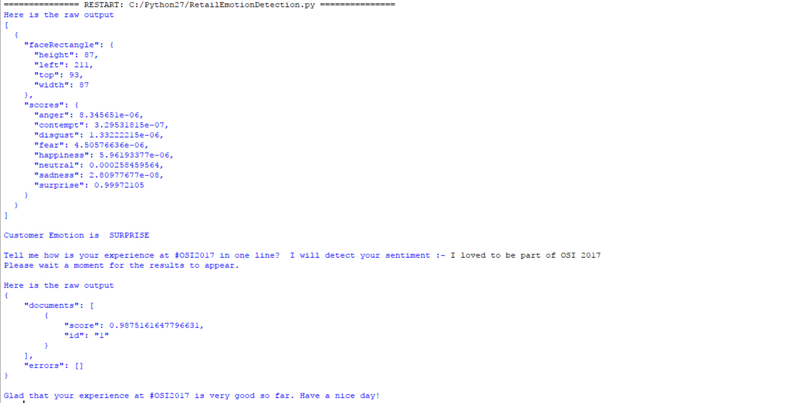

## **Conclusion**

* Great. You completed the HOL. You noticed how easy it is to integrate AI in your solution. Since it’s a API based approach it will work with any other programming language.

## **Clean up**

* You may want to delete Cognitive services API. The pricing of APIs is based on number of calls.

## **Resources**

* There are other APIs available like speech, knowledge, language and so on. You may want to have a look at it. Just Bing it.