### **Strings:**

### Return the count of a given substring from a string

### Print characters from a string that are present at an even index number.

1. Split a string on spaces.
2. Reverse a given string.
3. Replace a substring with new substring. Ex: “image.png” replace ‘.png’ with ‘.jpg’

### **Lists:**

### Check if the first and last number of a list is the same

### Create a new list from a two list using the following condition

→ Given a two list of numbers, write a program to create a new list such that the new list should contain odd numbers from the first list and even numbers from the second list.

### Write a Program to extract each digit from an integer in the reverse order.

**Files:**

1. Write all content of a given file into a new file by skipping line number 5
2. functions:
3. Check file is empty or not

**Numpy Arrays:**This NumPy exercise is to help Python developers to learn NumPy skills quickly. NumPy is a Numerical Python library to create and manipulate multidimensional arrays useful in data science.

1. Create a 5X2 integer array from a range between 100 to 200 such that the difference between each element is 10
2. Return array of odd rows and even columns from below numpy array
3. Delete the second column from a given array and insert the following new column in its place. Array: [[34,43,73],[82,22,12],[53,94,66]] New arr: [[10,10,10]]

**Dictionary:**This Python dictionary exercise aims to help Python developers to learn and practice dictionary operations. All questions are tested on Python 3.

Python dictionary is a mutable object, and it contains the data in the form of key-value pairs. Each key is separated from its value by a colon (:).

1. Convert two lists into a dictionary

keys = ['Ten', 'Twenty', 'Thirty']

values = [10, 20, 30]

{'Ten': 10, 'Twenty': 20, 'Thirty': 30}

### Initialize dictionary with default values

employees = ['Kelly', 'Emma']

defaults = {"designation": 'Developer', "salary": 8000}

O/p: {'Kelly': {'designation': 'Developer', 'salary': 8000}, 'Emma': {'designation': 'Developer', 'salary': 8000}}

### Check if a value exists in a dictionary

### Change value of a key in a nested dictionary

### **Functions:**

### Create an inner function to calculate the addition in the following way

* Create an outer function that will accept two parameters, a and b
* Create an inner function inside an outer function that will calculate the addition of a and b. At last, an outer function will add 5 into addition and return it

1. Create a recursive function. A recursive function is a function that calls itself, again and again.
2. Write a program to create a recursive function to calculate the sum of numbers from 0 to 10.

**Tuples:** A tuple is an immutable object in Python that can’t be changed. Tuples are also sequences, just likePython lists.

1. Reverse the tuple
2. Access value ‘20’ from a tuple.
3. Sort a tuple of tuples by 2nd item

Ex: Tuple1 = ((‘a’,44),(‘b’,25),(‘c’,9),(‘d’,52))

1. Counts the repeated number in the tuple.

Ex: tuple1 = (50,10,60,70,50)

**Date and time**:This Date and Time exercise aims to help Python developers to learn and practice DateTime-related frequently occurring problems.

### Print current date and time in Python

### Convert string into a datetime object

### Subtract a week (7 days) from a given date in Python

### Find the day of the week of a given date

### Add a week (7 days) and 12 hours to a given date

### Calculate number of days between two given dates

**Matplotlib** is a Python 2D plotting library that produces high-quality charts and figures, which helps us visualize extensive data to understand better. Pandas is a handy and useful data-structure tool for analyzing large and complex data.

### **Read Total profit of all months and show it using a line plot**

Total profit data provided for each month. Generated line plot must include the following properties: –

X label name = Month Number

Y label name = Total profit

The line plot graph should look like this.

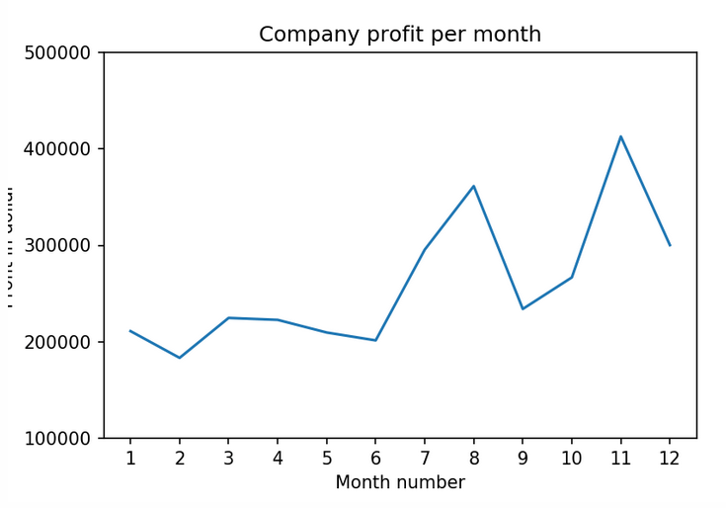

### **Read all product sales data and show it using a multi line plot**

Display the number of units sold per month for each product using multi line plots. (i.e., Separate Plotline for each product ).

The graph should look like this.

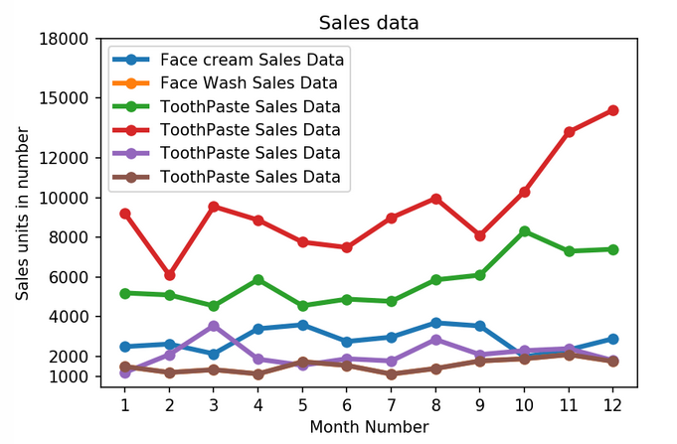

### **Read Bathing soap facewash of all months and display it using the Subplot**

### The Subplot should look like this.

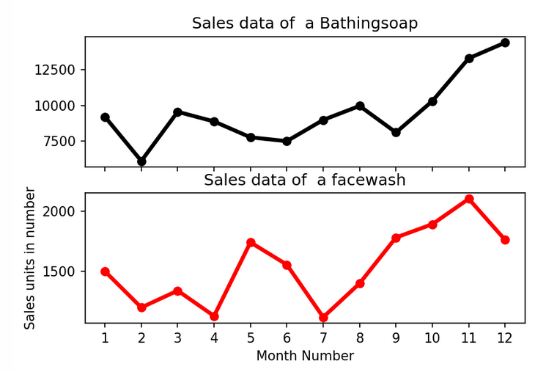

### **Read sales data of bathing soap of all months and show it using a bar chart. Save this plot to your hard disk**

The bar chart should look like this.

