1. **Create a TRIGGER BEFORE/AFTER UPDATE on employee table FOR EACH ROW/statement.**

* **BEFORE UPDATE**: The trigger will execute before the update occurs.
* **AFTER UPDATE**: The trigger will execute after the update occurs.
* **FOR EACH ROW**: Ensures that the trigger is executed for each row affected by the UPDATE statement.

**BEFORE UPDATE:**

**mysql>**

CREATE TABLE employees (

employee_id INT PRIMARY KEY,

first_name VARCHAR(100),

last_name VARCHAR(100),

salary DECIMAL(10, 2),

department_id INT

);

CREATE TABLE salary_changes (

change_id INT AUTO_INCREMENT PRIMARY KEY,

employee_id INT,

old_salary DECIMAL(10, 2),

new_salary DECIMAL(10, 2),

change_date TIMESTAMP DEFAULT CURRENT_TIMESTAMP

);

**mysql>**

INSERT INTO employees (employee_id, first_name, last_name, salary, department_id)

VALUES

(1, 'John', 'Doe', 50000, 10),

(2, 'Jane', 'Smith', 55000, 10),

(3, 'Jim', 'Brown', 60000, 20),

(4, 'Jack', 'Davis', 45000, 10);

**mysql>**

SELECT * FROM employees;

**mysql>**

DELIMITER $$

CREATE TRIGGER before_employee_update

BEFORE UPDATE ON employees

FOR EACH ROW

BEGIN

-- Check if salary is being changed

IF OLD.salary != NEW.salary THEN

-- Insert a record into the salary changes table

INSERT INTO salary_changes (employee_id, old_salary, new_salary)

VALUES (OLD.employee_id, OLD.salary, NEW.salary);

END IF;

END $$

DELIMITER ;

**mysql>**

UPDATE employees

SET salary = 55000

WHERE employee_id = 1;

**mysql>**

SELECT * FROM employees;

**mysql>**

SELECT * FROM salary_changes;

**OUTPUT:**

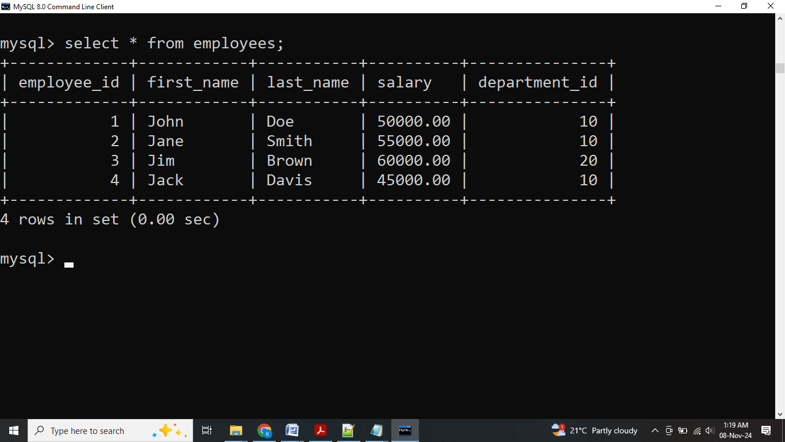

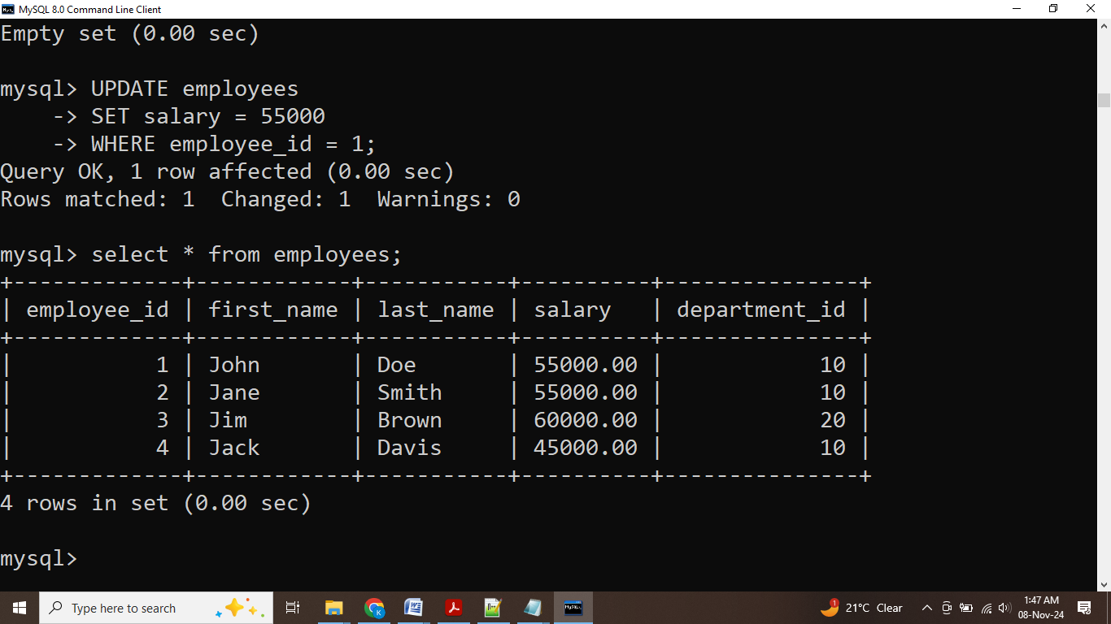

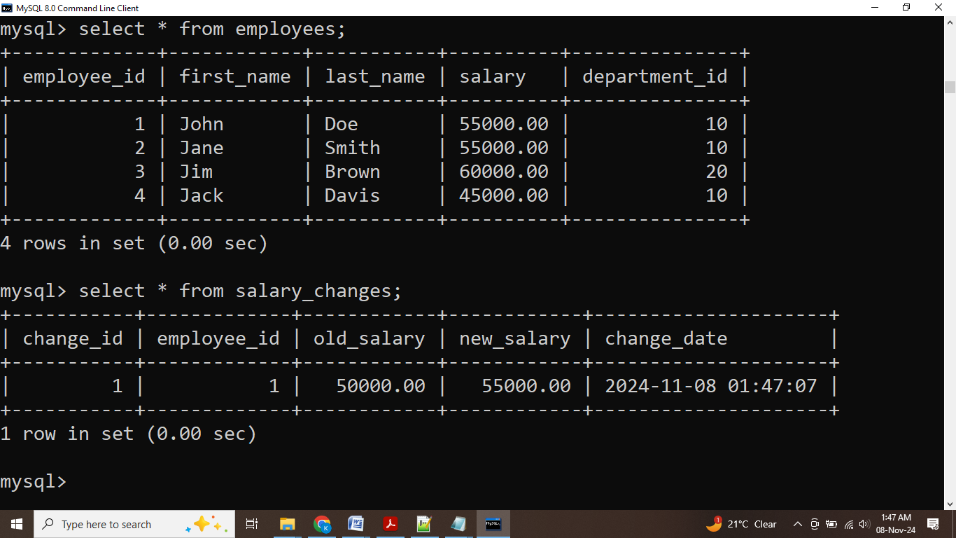

**AFTER UPDATE**:

**mysql>**

DELIMITER $$

CREATE TRIGGER after_employee_update

AFTER UPDATE ON employees

FOR EACH ROW

BEGIN

-- Check if salary is being changed

IF OLD.salary != NEW.salary THEN

-- Insert a record into the salary changes table

INSERT INTO salary_changes (employee_id, old_salary, new_salary)

VALUES (OLD.employee_id, NEW.salary, NEW.salary);

END IF;

END $$

DELIMITER ;

**mysql>**

UPDATE employees

SET salary = 90000

WHERE employee_id = 1;

**mysql>**

SELECT * FROM employees;

**mysql>**

SELECT * FROM salary_changes;

**OUTPUT:**

