1. **Create a TRIGGER BEFORE/AFTER DELETE on employee table FOR EACH ROW/statement.**

* **BEFORE DELETE**: The trigger will execute before the delete occurs.
* **AFTER DELETE**: The trigger will execute after the delete occurs.
* **FOR EACH ROW**: Ensures that the trigger is executed for each row affected by the DELETE statement.

**BEFORE UPDATE:**

**mysql>**

CREATE TABLE employees (

employee_id INT PRIMARY KEY,

first_name VARCHAR(100),

last_name VARCHAR(100),

salary DECIMAL(10, 2),

department_id INT

);

CREATE TABLE employee_deletions (

deletion_id INT AUTO_INCREMENT PRIMARY KEY,

employee_id INT,

first_name VARCHAR(100),

last_name VARCHAR(100),

salary DECIMAL(10, 2),

department_id INT,

deletion_date TIMESTAMP DEFAULT CURRENT_TIMESTAMP

);

**mysql>**

INSERT INTO employees (employee_id, first_name, last_name, salary, department_id)

VALUES

(1, 'John', 'Doe', 50000, 10),

(2, 'Jane', 'Smith', 55000, 10),

(3, 'Jim', 'Brown', 60000, 20),

(4, 'Jack', 'Davis', 45000, 10);

**mysql>**

SELECT * FROM employees;

**mysql>**

DELIMITER $$

CREATE TRIGGER before_employee_delete

BEFORE DELETE ON employees

FOR EACH ROW

BEGIN

-- Log the deletion of the employee in the employee_deletions table

INSERT INTO employee_deletions (employee_id, first_name, last_name, salary, department_id)

VALUES (OLD.employee_id, OLD.first_name, OLD.last_name, OLD.salary, OLD.department_id);

END $$

DELIMITER ;

**mysql>**

DELETE FROM employees WHERE employee_id = 2;

**mysql>**

SELECT * FROM employees;

**mysql>**

SELECT * FROM employee_deletions;

**OUTPUT:**

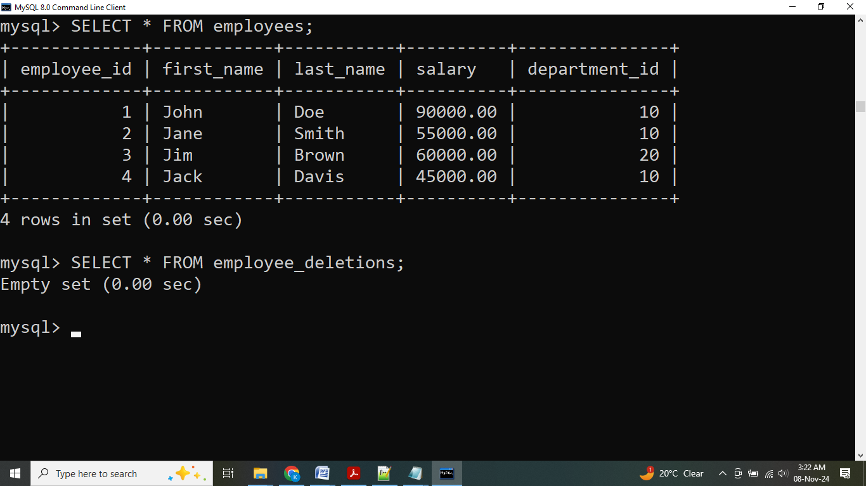

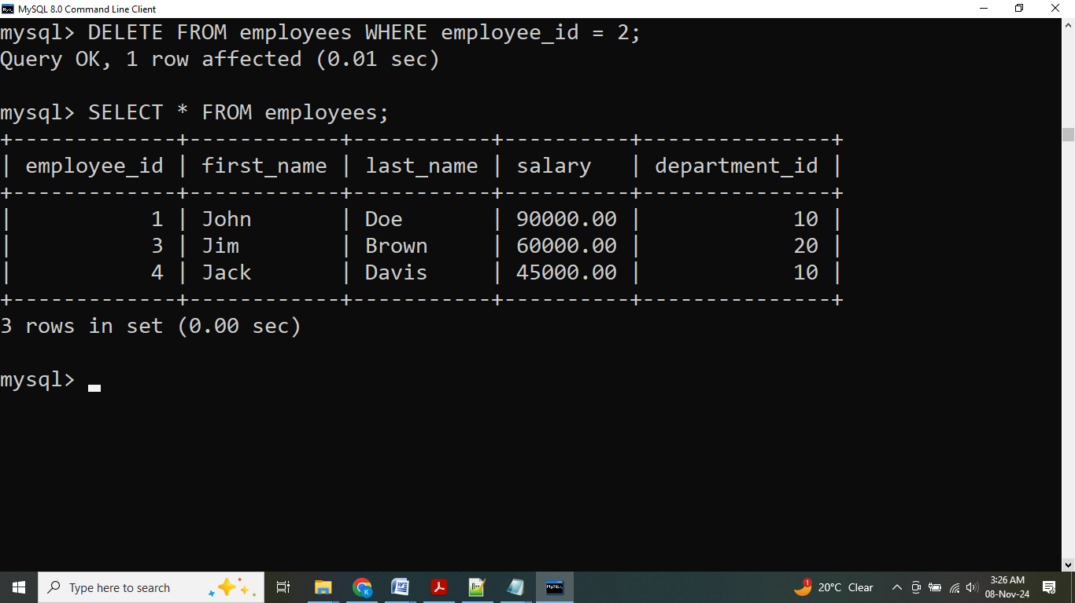

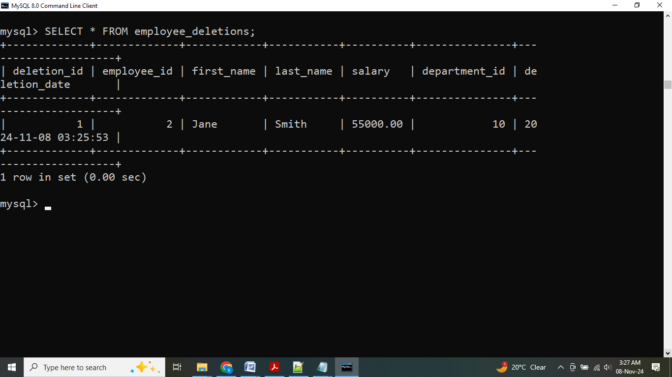

**AFTER DELETE**:

**mysql>**

DELIMITER $$

CREATE TRIGGER after_employee_delete

AFTER DELETE ON employees

FOR EACH ROW

BEGIN

-- Log the deletion of the employee in the employee_deletions table

INSERT INTO employee_deletions (

employee_id, first_name, last_name, salary, department_id)

VALUES (OLD.employee_id, OLD.first_name, OLD.last_name, OLD.salary, OLD.department_id);

END $$

DELIMITER ;

**mysql>**

DELETE FROM employees WHERE employee_id = 3;

**mysql>**

SELECT * FROM employees;

**mysql>**

SELECT * FROM employee_deletions;

**OUTPUT:**

