1. **Create a TRIGGER BEFORE/AFTER INSERT on employee table FOR EACH ROW/statement.**

* **BEFORE INSERT**: The trigger will execute before the insert occurs.
* **AFTER INSERT**: The trigger will execute after the insert occurs.
* **FOR EACH ROW**: Ensures that the trigger is executed for each row affected by the INSERT statement.

**BEFORE UPDATE:**

**mysql>**

CREATE TABLE employees (

employee_id INT PRIMARY KEY,

first_name VARCHAR(100),

last_name VARCHAR(100),

salary DECIMAL(10, 2),

department_id INT

);

CREATE TABLE employee_adding (

audit_id INT AUTO_INCREMENT PRIMARY KEY, employee_id INT,

action VARCHAR(100),

action_date TIMESTAMP DEFAULT CURRENT_TIMESTAMP );

**mysql>**

INSERT INTO employees (employee_id, first_name, last_name, salary, department_id)

VALUES

(1, 'John', 'Doe', 50000, 10),

(2, 'Jane', 'Smith', 55000, 10),

(3, 'Jim', 'Brown', 60000, 20),

(4, 'Jack', 'Davis', 45000, 10);

**mysql>**

SELECT * FROM employees;

**mysql>**

DELIMITER $$

CREATE TRIGGER before_employee_insert

BEFORE INSERT ON employees

FOR EACH ROW

BEGIN

-- Log the insertion into the employee_adding table

INSERT INTO employee_adding (employee_id, action)

VALUES (NEW.employee_id, 'Employee Added');

END $$

DELIMITER ;

**mysql>**

INSERT INTO employees (employee_id ,first_name, last_name, salary, department_id)

VALUES (5,'Alice', 'Johnson', 55000, 10);

**mysql>**

SELECT * FROM employees;

**mysql>**

SELECT * FROM employee_adding;

**OUTPUT:**

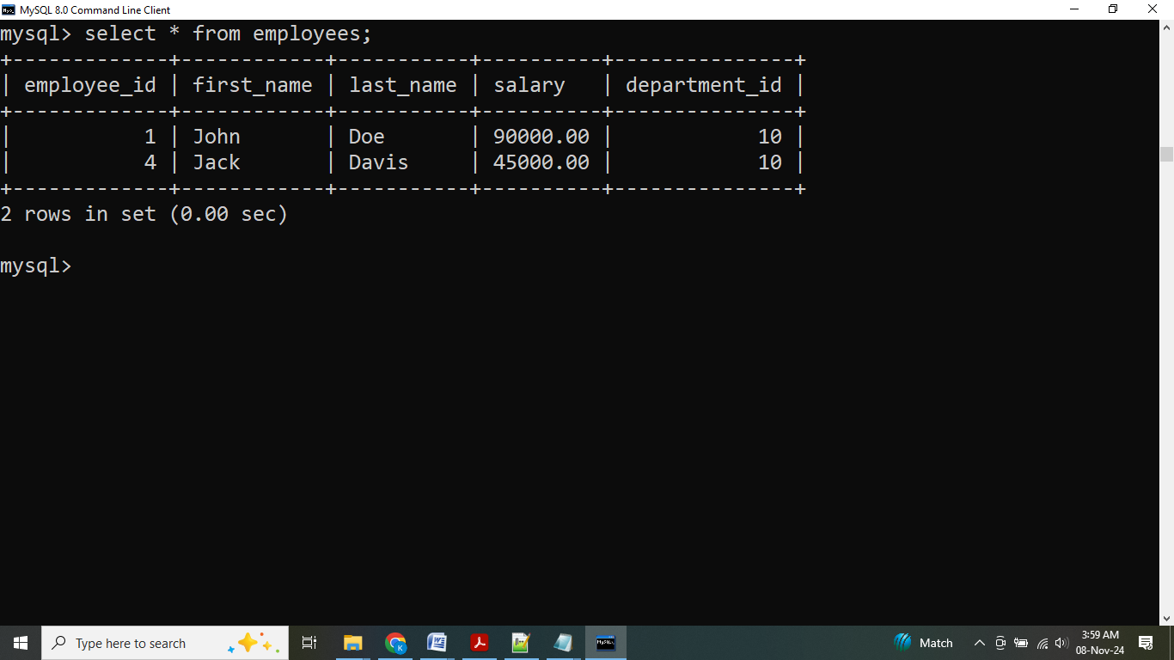

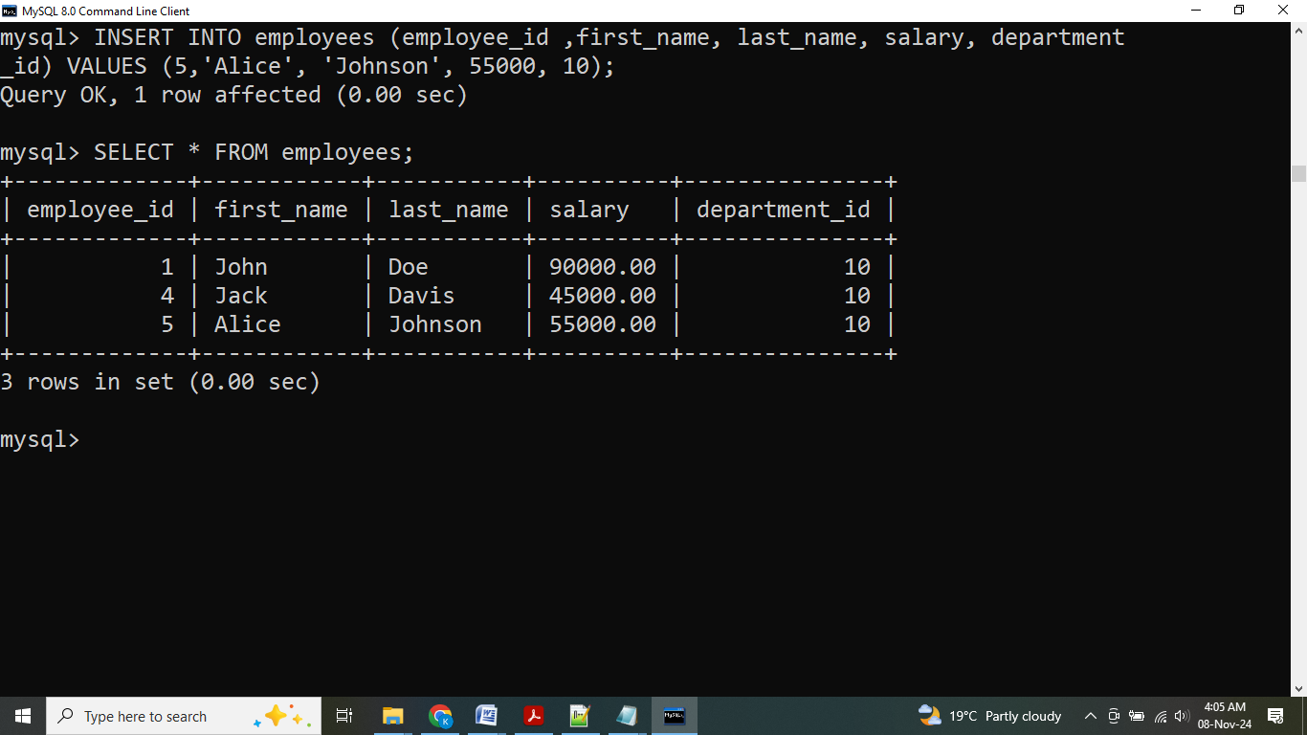

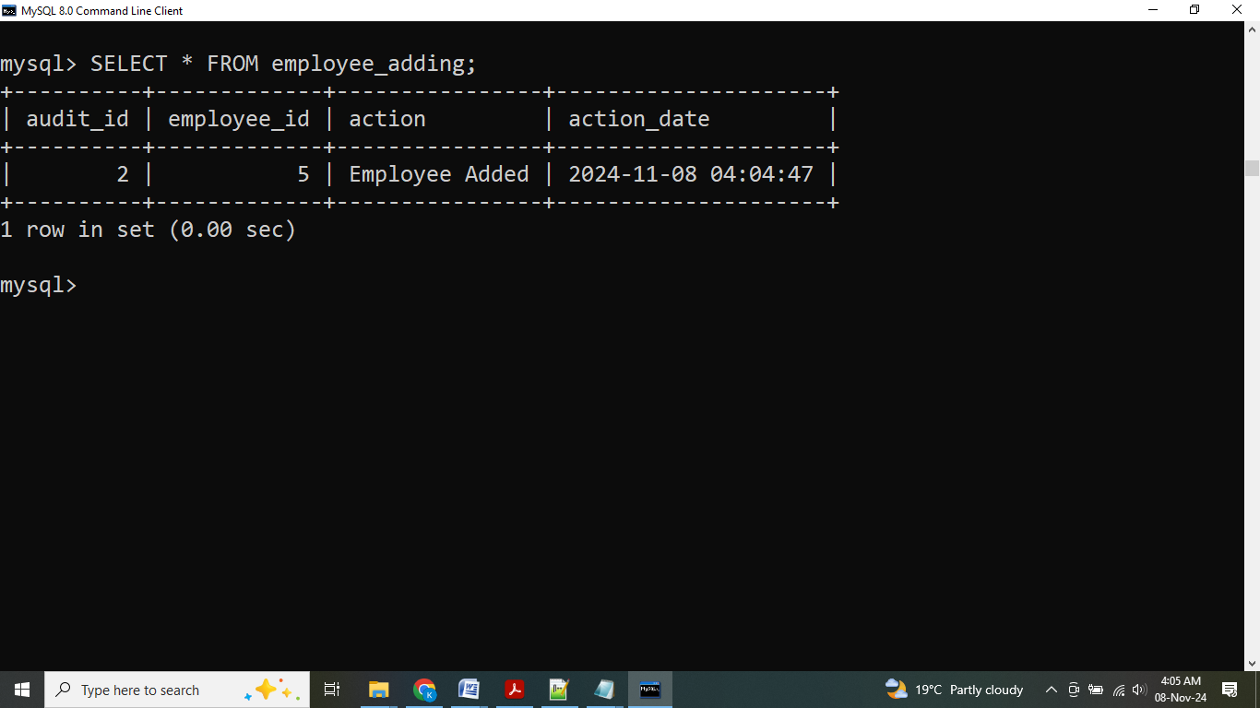

**AFTER INSERT**:

**mysql>**

DELIMITER $$

CREATE TRIGGER after_employee_insert

AFTER INSERT ON employees

FOR EACH ROW

BEGIN

-- Log the insertion into the employee_adding table

INSERT INTO employee_adding (employee_id, action)

VALUES (NEW.employee_id, 'Employee Added');

END $$

DELIMITER ;

**mysql>**

INSERT INTO employees (employee_id ,first_name, last_name, salary, department_id)

VALUES (2, 'john', 'doe', 50000, 10);

**mysql>**

SELECT * FROM employees;

**mysql>**

SELECT * FROM employee_adding;

**OUTPUT:**

