MOODMEAL – A MOOD-BASED RECIPE
& NUTRITION RECOMMENDER
PROFESSIONAL TRAINING I
Submitted in partial fulfilment of the requirements for the award of
Bachelor of Engineering degree in Computer Science and Engineering
By
KISHORE A (Reg. No – 44110382)

DEPARTMENT OF COMPUTER SCIENCE AND ENGINEERING
SCHOOL OF COMPUTING
SATHYABAMA
INSTITUTE OF SCIENCE AND TECHNOLOGY
(DEEMED TO BE UNIVERSITY)
CATEGORY – 1 UNIVERSITY BY UGC
Accredited “A++” by NAAC | Approved by AICTE
JEPPIAAR NAGAR, RAJIV GANDHI SALAI, CHENNAI - 600119
OCTOBER – 2026


DEPARTMENT OF COMPUTER SCIENCE AND ENGINEERING
BONAFIDE CERTIFICATE
This is to certify that this Professional Training I Report is the bonafide work of KISHORE A (Reg. No – 44110382) who carried out the project entitled “MOODMEAL – A MOOD-BASED RECIPE & NUTRITION RECOMMENDER” under my supervision.
Internal Guide
DR. SRIDEVI
ASSOCIATE PROFESSOR, CSE
Head of the Department
DR. L. LAKSHMANAN, M.E., Ph.D.,
Submitted for Professional Training I Viva Voce Examination held on ____________
Internal Examiner External Examiner

DECLARATION
I, KISHORE A (Reg. No – 44110382), hereby declare that the Professional Training – 1 Report entitled “MOODMEAL – A MOOD-BASED RECIPE & NUTRITION RECOMMENDER” done by me under the guidance of Dr. SRIDEVI, Associate Professor, CSE, is submitted in partial fulfillment of the requirements for the award of Bachelor of Engineering degree in Computer Science and Engineering.
DATE: SIGNATURE OF THE CANDIDATE
PLACE: CHENNAI

ACKNOWLEDGEMENT
I am pleased to acknowledge my sincere thanks to the BOARD OF MANAGEMENT of Sathyabama Institute of Science and Technology for their kind encouragement in doing this project and for completing it successfully. I am grateful to them.
I convey my thanks to Dr. L. Lakshmanan, M.E., Ph.D., Dean and Head, School of Computing, Department of Computer Science and Engineering, for providing me with the necessary support and details at the right time during the progressive reviews.
I would like to express my sincere and deep sense of gratitude to my Project Guide, Dr. SRIDEVI, Associate Professor, CSE, for her valuable guidance, suggestions and constant encouragement, which paved the way for the successful completion of my project work.
I wish to express my thanks to all Teaching and Non-teaching staff members of the Department of Computer Science and Engineering who were helpful in many ways for the completion of the project. I also thank the Panel Members, supportive professors, and all technical and non-technical staff who helped me in this project.

TRAINING CERTIFICATE

Certificate of Completion – Advanced Data Structures with Java, Stellar Academy For Education (2-month training programme, certified 30 September 2026)

ABSTRACT
Most recipe and diet-tracking applications recommend meals based only on the ingredients a user has available or on fixed dietary restrictions, and they overlook the mood and situational context in which people actually choose what to eat. MoodMeal is a desktop application developed using Java (Swing/JavaFX) and MySQL that recommends recipes based on the current mood of the user, the ingredients available in the user’s pantry, and basic nutritional goals.
Each recipe in the database is tagged with mood-suitability scores, nutritional values and an ingredient list. The application filters and ranks the recipes and displays the suggestions as visual cards that show the preparation time, the nutrition values and a “comfort versus energy” rating. The system also records a mood-to-meal history and presents simple charts, produced with JFreeChart, that reveal eating patterns over time.
The project applies core Java concepts, JDBC-based MySQL CRUD operations and graphical user interface design to an underexplored intersection of nutrition and emotional wellbeing. Testing with a sample recipe dataset confirmed that the recommendation, recipe card and history features work as designed. The tagging of recipes is currently manual or rule-based and performance with much larger datasets has not yet been evaluated; these points are identified as future work.
Keywords: Java, Swing/JavaFX, MySQL, JDBC, Recipe Recommendation, Mood-Based Recommendation, Nutrition, JFreeChart.

TABLE OF CONTENTS
Chapter No. | Title | Page No.
 | ABSTRACT | vi
 | LIST OF FIGURES | viii
 | LIST OF TABLES | ix
1 | INTRODUCTION | 1
2 | LITERATURE SURVEY | 3
 | 2.1 Inferences from Literature Survey | 3
 | 2.2 Open Problems in Existing System | 4
3 | REQUIREMENTS ANALYSIS | 5
 | 3.1 Feasibility Studies / Risk Analysis of the Project | 5
 | 3.2 Software Requirements Specification Document | 6
4 | DESCRIPTION OF PROPOSED SYSTEM | 9
 | 4.1 Selected Methodology or Process Model | 9
 | 4.2 Architecture/ Overall Design of Proposed System | 9
 | 4.3 Description of Software Implementation and Testing plan of the Proposed Model/System | 13
 | 4.4 Project Management Plan | 17
 | 4.5 Transition / Software to Operations Plan | 18
5 | CONCLUSION | 19
 | REFERENCES | 21

LIST OF FIGURES
Figure No. | Figure Name | Page No.
4.1 | MoodMeal System Architecture | 9
4.2 | Request and Data Flow Across MoodMeal Modules | 10
4.3 | Entity Relationship Diagram | 11
4.4 | Mood-Based Recommendation Workflow | 13
4.5 | Recipe Card Layout | 15

LIST OF TABLES
Table No. | Table Name | Page No.
2.1 | Literature Survey and Application to MoodMeal | 3
3.1 | Project Risk Assessment | 6
3.2 | Software Requirements and Acceptance Criteria | 7
3.3 | Mood Categories and Recommendation Preferences | 7
4.1 | Technologies and Their Roles in MoodMeal | 10
4.2 | Database Tables and Their Purpose | 11
4.3 | Test Cases and Expected Outcomes | 15
4.4 | Testing and Verification Results | 16
4.5 | Work Packages and Outputs | 17

CHAPTER 1

INTRODUCTION
Diet and recipe recommendation applications have become increasingly common, but most of them operate on a narrow set of inputs. Typically they consider only the ingredients that a user has on hand or a fixed dietary restriction such as vegetarian, low-carbohydrate or gluten-free. This approach is useful, but it treats the selection of a meal as a purely logistical problem and ignores the psychological and situational factors that influence what people choose to eat on a given day.
Food choices are rarely made in a vacuum; they are shaped by how a person is feeling at that moment. Emotional eating is a well-documented behavioral pattern in which stress, fatigue, boredom or celebration drive people toward particular kinds of food, such as comfort food during stressful periods or lighter meals when energy is low. Existing nutrition and recipe platforms largely overlook this connection, which leaves a gap between how people actually decide what to eat and how technology tries to help them decide.
MoodMeal is designed to address this gap. It is a desktop application that uses the mood of the user as a core factor in generating recipe recommendations, alongside the ingredients available in the pantry and the nutritional goals of the user. Recipes are tagged with mood-suitability scores, nutrition values and ingredient lists, and the suggestions are presented as visual cards showing the preparation time, nutrition information and a comfort-versus-energy rating.
The application is developed in Java using a graphical toolkit (Swing/JavaFX) and stores its data in a MySQL database that is accessed through JDBC. In addition to recommending recipes, MoodMeal keeps a record of the mood logged by the user and the meal suggested at that time, and it uses the JFreeChart library to draw simple charts so that the user can see recurring patterns, for example a tendency to choose high-comfort foods on stressful days.

1.1 OBJECTIVES
The principal objectives of MoodMeal are:
- To build a desktop application that recommends recipes based on the mood of the user, the available pantry ingredients and nutrition goals.
- To allow users to log their daily mood and to track their eating patterns over time.
- To present recipe suggestions as visually engaging cards showing preparation time, nutrition information and a comfort-versus-energy rating.
- To store users, recipes, ingredients, mood logs and meal history reliably in a MySQL database using JDBC-based CRUD operations.
- To generate simple charts of the mood-to-meal history so that users can understand their eating trends.
- To demonstrate the practical integration of core Java, JDBC and MySQL in a real-world application.

1.2 SCOPE OF THE PROJECT
The implemented system covers user registration, login and profile management; daily mood logging; entry of pantry ingredients and basic nutrition goals; storage of recipes with mood-suitability tags, nutrition values and ingredient lists; filtering and ranking of recipes; display of recipe cards; and a mood-to-meal history with simple charts. The data is held in a MySQL database accessed from the Java application through JDBC.
Features such as a mobile version, machine-learning-based mood detection and a much larger recipe database are identified as future enhancements and are not part of the present implementation.

1.3 ORGANIZATION OF THE REPORT
This report is organized into five chapters. Chapter 1 introduces the problem, the objectives and the scope of MoodMeal. Chapter 2 presents the literature survey, the inferences drawn from it and the open problems in existing recipe and diet applications.
Chapter 3 analyses the requirements, including technical, economic and operational feasibility, the risk assessment and the software requirements specification. Chapter 4 describes the proposed system, covering the methodology, the architecture, the database design, the implementation of each module, the testing plan and results, the project management plan and the transition plan. Chapter 5 concludes the report and outlines future enhancements.
CHAPTER 2

LITERATURE SURVEY
The literature survey examines publications on the influence of emotion on eating behavior and on recipe and recommender systems. These sources provide the conceptual basis for using mood as an input to meal recommendation. Their application to the project is identified explicitly, together with the limitation of each work relative to the present system.
Table 2.1 Literature Survey and Application to MoodMeal
Ref. | Author and year | Main contribution | Application to MoodMeal | Limitation relevant to this project
1 | M. Macht, 2008 | Proposes a five-way model describing how emotions affect eating. | Supports the use of the logged mood as an input to meal selection. | A psychological model; it does not describe a software system for recommending meals.
2 | E. L. Gibson, 2006 | Reviews sensory, physiological and psychological pathways through which emotion influences food choice. | Provides the basis for mood-suitability tags and the comfort-versus-energy rating. | A review of food choice; it does not implement recommendations or tracking.
3 | J. Freyne and S. Berkovsky, 2010 | Presents personalized recipe recommendation that relies on the ingredients of recipes. | Supports describing each recipe by its ingredient list and matching it to the user. | Does not consider the mood or situational context of the user.
4 | C. Teng, Y. Lin and L. Adamic, 2012 | Studies networks of ingredients that combine well or substitute for one another and uses them for recipe recommendation. | Informs the idea of matching recipes to the ingredients available in the pantry. | Based on large-scale web data; it has no mood or nutrition-goal inputs.
5 | F. Ricci, L. Rokach, B. Shapira and P. Kantor (Eds.), 2011 | Reference text covering the techniques and evaluation of recommender systems. | Guides the filtering, scoring and ranking approach of the Recommendation Module. | General in scope; it is not specific to food or to mood.

2.1 INFERENCES FROM LITERATURE SURVEY
The literature indicates that emotional state is one of the factors that shape food choice. Work on emotional eating describes how stress, fatigue and other states change what people want to eat and how much they eat. MoodMeal applies this inference by asking the user to log a mood and by storing, for every recipe, a mood-suitability score and a comfort-versus-energy rating so that the recipes can be matched to the mood.
Work on personalized recipe recommendation shows that describing a recipe through its ingredients allows the preferences of a user to be matched with recipes that were not seen before. The same ingredient-based description is used in MoodMeal so that the application can favor recipes that can be prepared from the ingredients that the user already has in the pantry.
The recommender systems literature explains that content-based filtering compares the attributes of items with the requirements of a user and then ranks the results. The Recommendation Module of MoodMeal follows this pattern: it filters the recipe attributes against the mood, the pantry and the nutrition goals and then produces a ranked list.
The resulting design combines a mood-aware filtering approach with a conventional desktop application built from core Java, JDBC and MySQL. Its contribution is the implementation of a complete, working mood-based recipe recommender with history tracking, rather than a claim that any individual technique is new.

2.2 OPEN PROBLEMS IN EXISTING SYSTEM
Most existing recipe and diet-tracking applications recommend meals using only the available ingredients or a dietary restriction. They do not ask how the user feels, so the same suggestion is offered whether the user is stressed, tired or celebrating. This makes the recommendation a logistical decision and ignores the emotional side of eating.
Calorie counters and diet trackers record what a user has eaten, but they rarely connect the meals with the mood of the user. A user who tends to choose high-sugar comfort food on stressful days has no simple way to notice this pattern, because the mood and the meal are recorded in separate places, if the mood is recorded at all.
Recipe collections are usually presented as long lists or text pages. Information such as the preparation time, the nutrition values and the suitability of a recipe for the present situation has to be read from each page, which makes comparison difficult and slows down the decision.
Several matters remain outside the present implementation, including automatic mood detection, a mobile version and a much larger recipe database. These are identified as future work in Chapter 5.
CHAPTER 3

REQUIREMENTS ANALYSIS

3.1 FEASIBILITY STUDIES / RISK ANALYSIS OF THE PROJECT
The feasibility study evaluates whether MoodMeal can be developed, operated and maintained with the available technical and financial resources. The assessment considers the selected technology stack, the user workflow and the operational requirements of a desktop application.

3.1.1 Feasibility

3.1.1.1 Technical Feasibility
The application is technically feasible because all of its functions can be implemented with established, freely available technologies. The user interface is built with the Java GUI toolkits (Swing/JavaFX), the data is stored in a MySQL relational database, and the application communicates with the database through JDBC. The JFreeChart library provides the charts used for the mood-to-meal history.
The recommendation logic consists of filtering and ranking operations on recipe records, which can be implemented with standard Java collections and SQL queries and do not require specialized hardware. The team has the required skills in core Java, SQL and GUI programming.

3.1.1.2 Economic Feasibility
MoodMeal uses the Java Development Kit, MySQL, the MySQL JDBC driver and JFreeChart, all of which are available without license cost for an academic project. The application runs on an ordinary personal computer, so no additional hardware or server investment is required.
Actual long-term maintenance costs were not measured. The project is therefore considered economically feasible as an academic prototype, and a cost estimate would be required before any wider release.

3.1.1.3 Operational Feasibility
The workflow is simple enough for a non-technical user. The user registers, logs in, selects a mood, enters the pantry ingredients and the nutrition goals, and receives recipe cards. The history screen can be opened at any time to review earlier moods and meals.
The application and the database run on the same computer, so the user does not need to maintain a separate server. Recipe data can be added or corrected through the Recipe Module without changing the program.

3.1.2 Risk Assessment
The most important risks concern the quality of the mood tagging, the protection of user data, the reliability of the database connection, the responsiveness of the interface and the interpretation of the patterns shown to the user. Risk severity in Table 3.1 is an engineering assessment of the potential effect on the application.
Table 3.1 Project Risk Assessment
Risk | Severity | Possible effect | Implemented control or current limitation
Inaccurate mood-suitability tags | Medium | Recipes that do not fit the selected mood are recommended | Tags are assigned by manual or rule-based classification and can be edited; automatic tagging is future work
Loss or corruption of stored data | High | Loss of users, recipes or mood history | Data held in MySQL with keys and constraints; regular database backups are recommended
Invalid or malicious user input | High | Wrong records or unsafe database queries | Input validation in the application and parameterized JDBC statements
Unauthorized access to an account | High | Exposure of the mood history of a user | Login with session handling; passwords not stored in plain text
Database connection failure | Medium | Application cannot load or save data | Connectivity handled in the Database Module with error messages to the user
Slow interface with large datasets | Medium | Delay in showing recipe cards | Filtering in SQL queries; testing with large datasets remains future work
Over-interpretation of eating patterns | Medium | User treats simple charts as medical advice | Charts are descriptive only; the application does not give medical or diagnostic advice

3.2 SOFTWARE REQUIREMENTS SPECIFICATION DOCUMENT

3.2.1 Software Requirements
MoodMeal is implemented as a desktop application in Java. The graphical interface uses the Java GUI toolkits (Swing/JavaFX), the charts are produced with JFreeChart, and the data is stored in MySQL and accessed through the JDBC driver. Development was carried out on a Windows computer using Visual Studio Code, and any Java-capable editor can be used.
The minimum software environment consists of a Java Development Kit, a MySQL server with the MySQL Connector/J driver and the JFreeChart library. The application runs on a standard personal computer; a display capable of showing the recipe cards and charts is the only special requirement.

3.2.2 Software Specifications
The application has one type of end user, who registers, logs moods, enters pantry ingredients and nutrition goals, and views recommendations and history. All operations that change data are validated before they reach the database. Table 3.2 lists the functional and non-functional requirements together with the acceptance criterion for each.
Table 3.2 Software Requirements and Acceptance Criteria
ID | Requirement | Acceptance criterion | Implemented behavior
FR-01 | User registration and login | A new user can create an account and sign in | User Module stores the account and starts a session
FR-02 | Mood logging | The user can record a mood for the day | Mood selection screen saves the mood with the date
FR-03 | Pantry and goal input | The user can enter ingredients and nutrition goals | Inputs are read by the Recommendation Module
FR-04 | Recipe management | Recipes store tags, nutrition values and ingredients | Recipe Module maintains recipe records through CRUD operations
FR-05 | Recipe recommendation | Suggestions match mood, pantry and nutrition goals | Filtered and ranked list is produced
FR-06 | Recipe cards | Each suggestion shows prep time, nutrition and comfort-versus-energy rating | Visual cards are displayed in the interface
FR-07 | Mood-to-meal history | Past moods and meals can be reviewed with charts | History is stored and charted with JFreeChart
NFR-01 | Data persistence | Data remains available after the application is closed | MySQL database accessed through JDBC
NFR-02 | Usability | A new user can reach the recommendations without help | Simple screen sequence with clear labels
NFR-03 | Reliability | Invalid input does not corrupt the stored data | Validation and parameterized statements

3.2.3 Mood Categories and Recommendation Preferences
The user selects a mood, and the Recommendation Module uses it to decide which recipes are most suitable. The moods named in the project include stressed, low-energy and celebratory states. Table 3.3 summarizes how the prototype treats a set of example mood categories; the categories and preferences are stored as data and can be changed without altering the program logic.
Table 3.3 Mood Categories and Recommendation Preferences
Mood | Typical need | Preferred recipe characteristics
Stressed | Comfort and quick preparation | Higher comfort rating, short preparation time
Low-energy | Light meals that give energy | Higher energy rating, simple preparation
Celebratory | A special or shared meal | Richer recipes, longer preparation acceptable
Happy | Balanced everyday meal | Balanced comfort and energy ratings
Neutral | Meal that meets the nutrition goal | Nutrition fit takes priority over mood fit

3.2.4 Assumptions and Constraints
The requirements and the design are based on the following assumptions and constraints:
- The user selects the mood manually; the application does not detect mood automatically.
- The recommendations are only as good as the mood tags, nutrition values and ingredient lists stored for the recipes.
- The application gives general meal suggestions and charts; it is not a medical or clinical diet tool.
- The application and the MySQL database run on the same computer, and a single user is assumed to use the application at a time.
- The testing carried out used a sample dataset and confirms functional behavior; it does not establish performance with very large datasets.
CHAPTER 4

DESCRIPTION OF PROPOSED SYSTEM

4.1 SELECTED METHODOLOGY OR PROCESS MODEL
MoodMeal was developed using an iterative and incremental process. The requirements were implemented in manageable groups, and each group was integrated with the existing application before the next extension was introduced.
The initial work focused on the database design and the User Module, so that accounts and mood logs could be stored. The Recipe Module was added next, followed by the Recommendation Module with its filtering and ranking logic. The recipe cards, the History and Analytics Module with JFreeChart, and finally validation and session handling were introduced in later increments.
Each increment followed a cycle of requirement clarification, design, implementation, verification and review. This approach was appropriate because the modules communicate through the database and could be added step by step without rebuilding the parts that were already working.

4.2 ARCHITECTURE / OVERALL DESIGN OF PROPOSED SYSTEM

4.2.1 Application Architecture
MoodMeal uses a layered architecture, shown in Figure 4.1. The user provides the mood, the pantry ingredients and the nutrition goals through the desktop interface. The Recommendation Engine performs mood matching, ingredient matching, nutrition filtering, comfort-versus-energy scoring and ranking. The application services manage recipes, the mood and meal history, nutrition data, JDBC operations and validation, and the data is stored in the MySQL database.
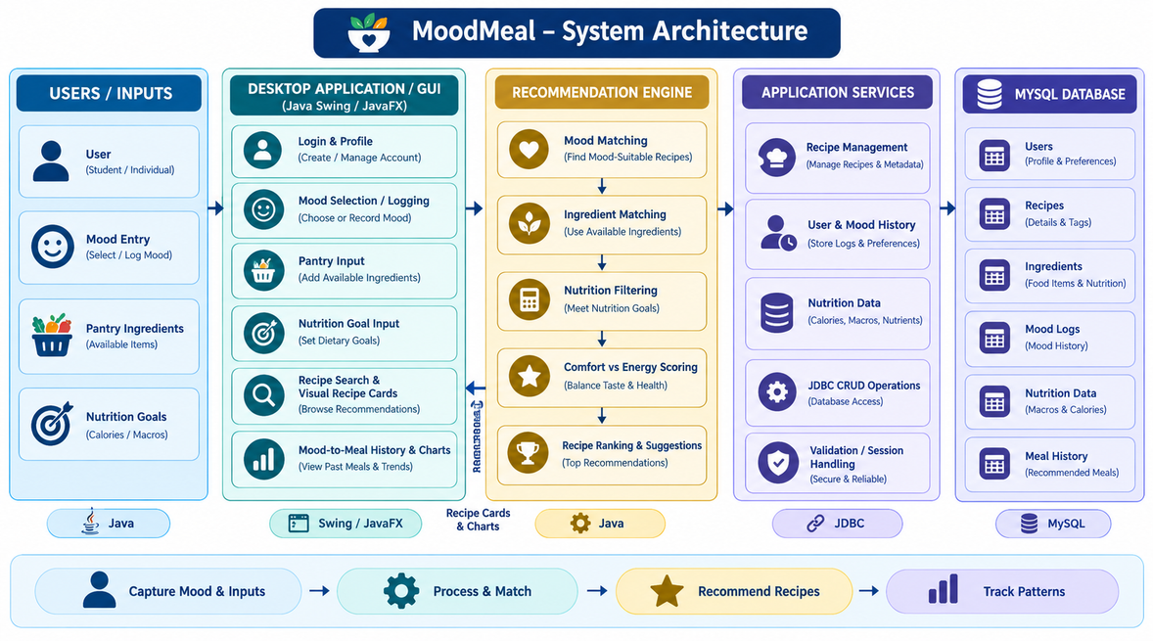
Figure 4.1 MoodMeal System Architecture

4.2.2 Technologies Used
Table 4.1 summarizes the technologies used in the project and the role of each in the application.
Table 4.1 Technologies and Their Roles in MoodMeal
Technology | Category | Role in the application
Java | Programming language | Implements the application logic, the modules and the recommendation rules
Swing / JavaFX | GUI toolkit | Provides the login, mood, pantry, recipe card and history screens
JDBC | Database connectivity | Connects the application to MySQL and executes the CRUD operations
MySQL | Relational database | Stores users, recipes, ingredients, mood logs, nutrition data and meal history
JFreeChart | Charting library | Draws the charts of the mood-to-meal history

4.2.3 Data Flow
The main data flow begins when the user logs in and selects a mood. The user then enters the pantry ingredients and the nutrition goals, and these inputs are validated and passed to the Recommendation Module. The module queries the database through the Database Module, filters the recipes, scores them and returns a ranked list that is displayed as recipe cards.
When the user chooses a meal, the choice is saved together with the mood that was logged at that time. The History and Analytics Module later reads these records and draws the charts, so that the same stored data supports both the recommendation and the tracking of patterns. Figure 4.2 shows this flow between the modules.
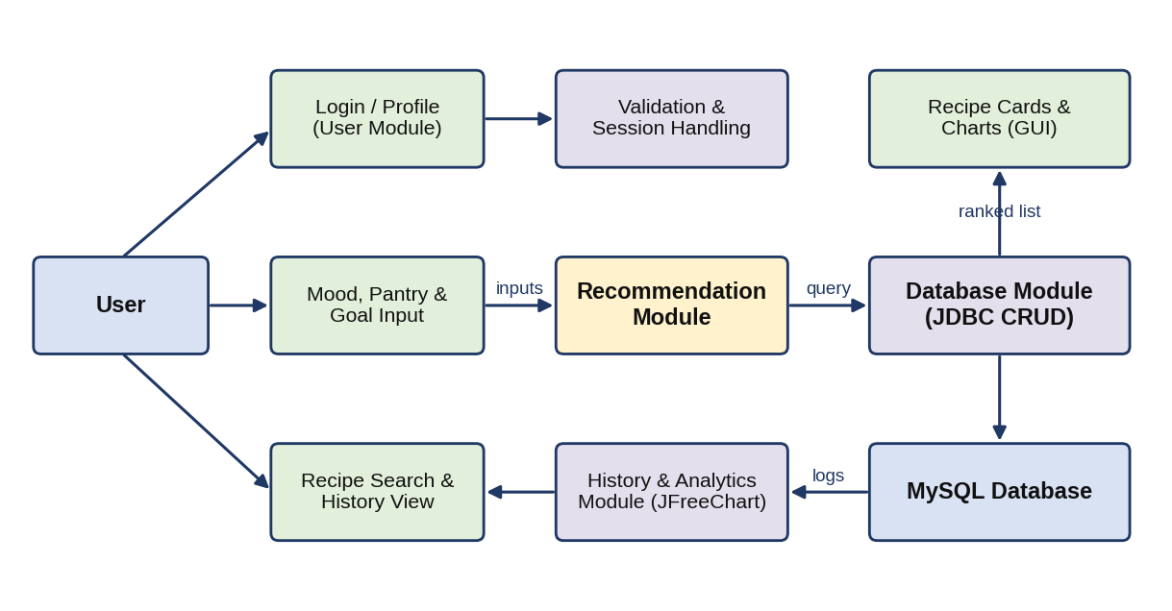
Figure 4.2 Request and Data Flow Across MoodMeal Modules

4.2.4 Database Design
The data is stored in a MySQL database. The principal logical entities are users, recipes, ingredients, mood logs and meal history. Each recipe records its title, preparation time, nutrition values and comfort and energy scores. Mood-suitability scores are held for each recipe and mood, and the ingredients of each recipe are linked through a separate table. Table 4.2 lists the tables and their purpose, and Figure 4.3 shows the relationships.
Foreign keys maintain the relationships between users, recipes, ingredients, mood logs and meal history. Keeping the ingredients of a recipe in a separate linking table allows the same ingredient to be shared by many recipes and makes it simple to compare a recipe with the pantry of the user.
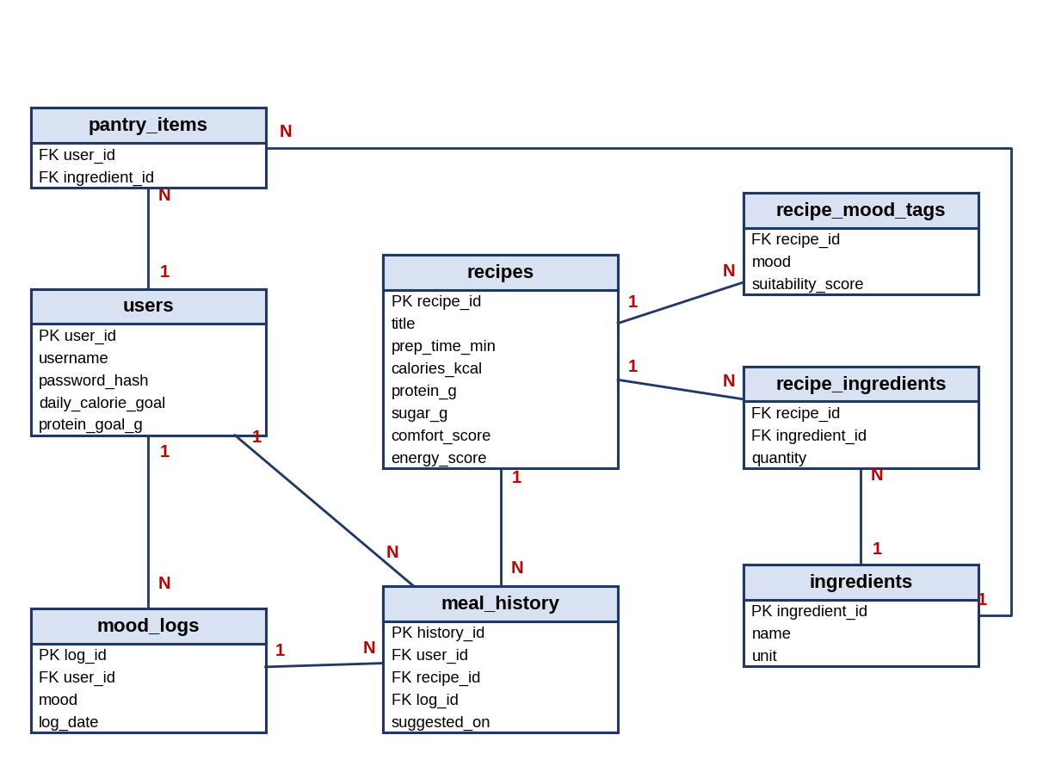
Figure 4.3 Entity Relationship Diagram
Table 4.2 Database Tables and Their Purpose
Table | Purpose
users | Stores the account, login details and the nutrition goals of each user
recipes | Stores the title, preparation time, nutrition values and comfort and energy scores of each recipe
ingredients | Stores the food items that can be used in recipes and in the pantry
recipe_ingredients | Links each recipe with its ingredients and quantities
recipe_mood_tags | Stores the mood-suitability score of each recipe for each mood
pantry_items | Stores the ingredients that a user has available
mood_logs | Stores the mood logged by a user on a given date
meal_history | Stores the meal chosen by the user together with the logged mood

4.2.5 Security and Data Integrity Design
The application protects its data at several levels. User input is validated before it is used, so that empty or malformed values are rejected with a message. Database statements are written as parameterized JDBC statements, which prevents user input from being interpreted as part of an SQL command. Sessions are handled so that each user sees only their own mood logs and meal history.
Data integrity is supported by primary keys and foreign keys in the MySQL database, which prevent a meal history record from referring to a user or recipe that does not exist. Passwords should be stored in a protected form and not as plain text. Regular backups of the database are recommended.

4.2.6 Scalability and Maintainability Design
The modules are separated by responsibility. The User, Recipe, Recommendation, History and Analytics, and Database modules communicate through defined methods, so a change in one module, such as a new scoring rule, does not require changes in the others. The moods and their preferences are held as data, so new moods can be added without rewriting the interface. Performance with significantly larger datasets has not been tested and is identified as future work.

4.2.7 Typical Usage Scenarios
The following scenarios show how a user works with the application and how the modules take part in each interaction.

Scenario 1: A stressed user asks for a meal
- The user signs in and selects the mood “stressed” on the mood screen.
- The user adds the ingredients available in the pantry and sets a calorie goal.
- The Recommendation Module returns recipes with a high comfort rating that can be made from the pantry.
- The user reads the recipe cards and chooses a meal, and the choice is stored with the mood.

Scenario 2: A low-energy user asks for a meal
- The user logs the mood “low-energy” and enters the available ingredients.
- The application ranks light recipes with a high energy rating and a short preparation time first.
- The user chooses a recipe and the meal history is updated.

Scenario 3: A user reviews eating patterns
- The user opens the history screen after using the application for several days.
- The History and Analytics Module reads the stored moods and meals and draws charts with JFreeChart.
- The user can see, for example, which kinds of meals were chosen on stressed days compared with positive days.

4.3 DESCRIPTION OF SOFTWARE IMPLEMENTATION AND TESTING PLAN OF THE PROPOSED SYSTEM

4.3.1 User Module
The User Module handles registration, login and profile management. During registration the user supplies the required details and an account is created in the database. On later visits the user signs in, and the application establishes the identity of the user for the rest of the session.
The module also contains the mood logging interface, in which the user records the current emotional state, such as stressed, low-energy or celebratory, on a daily basis. Each entry is saved with the date and is used by the Recommendation Module and by the history charts.

4.3.2 Recipe Module
The Recipe Module manages the storage and organization of recipes. For every recipe it stores the mood-suitability tags, the nutritional values (calories, protein, sugar and others) and the list of ingredients. Recipes can be added, viewed, updated and deleted through CRUD operations.
The tagging of a recipe with a mood-suitability score is done by manual or rule-based classification. This keeps the prototype simple and transparent, because the reason for a recommendation can be traced to the stored scores, but it is also a limitation, as discussed in Section 4.3.8.

4.3.3 Recommendation Module
The Recommendation Module contains the core filtering logic. It matches the recipes to the current mood of the user, to the pantry ingredients and to the nutrition goals, and it produces a ranked list of suitable suggestions. The workflow is shown in Figure 4.4.
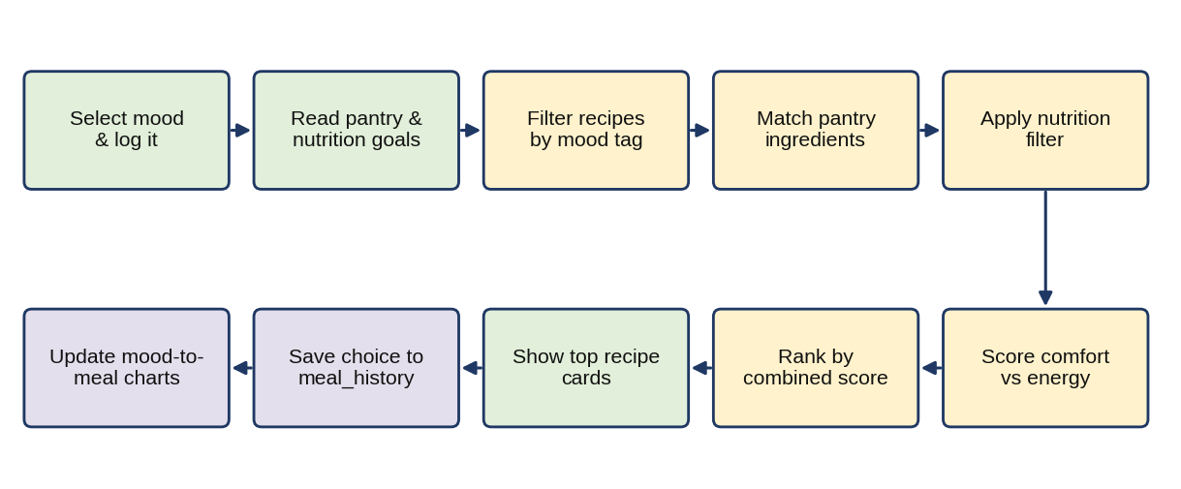
Figure 4.4 Mood-Based Recommendation Workflow
First the recipes tagged for the selected mood are retrieved. The recipes are then compared with the pantry of the user, and recipes that need only a few missing ingredients are preferred. The nutrition filter removes recipes that do not fit the stated goals. Finally a comfort-versus-energy score balances taste and health for the mood. The final ranking can be expressed as a weighted sum, S = wm·M + wi·I + wn·N + wc·C, where M is the mood-suitability score, I is the fraction of ingredients available, N is the fit with the nutrition goal and C is the fit of the comfort-versus-energy rating to the mood. The weights are configurable constants in the module.

4.3.4 History and Analytics Module
The History and Analytics Module tracks the mood-to-meal history over time. Each time the user chooses a recipe, the choice is stored together with the mood that was logged. The module reads these records and generates simple charts with JFreeChart so that the user can understand trends, such as recurring comfort-food choices on stressed days.

4.3.5 Database Module
The Database Module manages the JDBC connectivity between the application and the MySQL database. It handles all CRUD (Create, Read, Update, Delete) operations for users, recipes, ingredients and mood logs. The following fragment illustrates how a mood-based query is executed with a parameterized statement.
String sql =
"SELECT r.recipe_id, r.title, r.prep_time_min " +
"FROM recipes r JOIN recipe_mood_tags t " +
"ON r.recipe_id = t.recipe_id " +
"WHERE t.mood = ? AND r.calories_kcal <= ? " +
"ORDER BY t.suitability_score DESC";
try (Connection con = DBConnection.getConnection();
PreparedStatement ps = con.prepareStatement(sql)) {
ps.setString(1, mood);
ps.setInt(2, calorieLimit);
try (ResultSet rs = ps.executeQuery()) {
while (rs.next()) { /* build Recipe object */ }
}
}
Using try-with-resources closes the connection, statement and result set automatically, and the placeholders (?) keep user input separate from the SQL text.

4.3.6 Recipe Cards and User Interface
The graphical interface presents the recommendations as visual cards. Each card shows the recipe name, the preparation time, the nutrition information and a comfort-versus-energy rating, so that the user can compare several suggestions at a glance. The layout of the cards is shown in Figure 4.5.
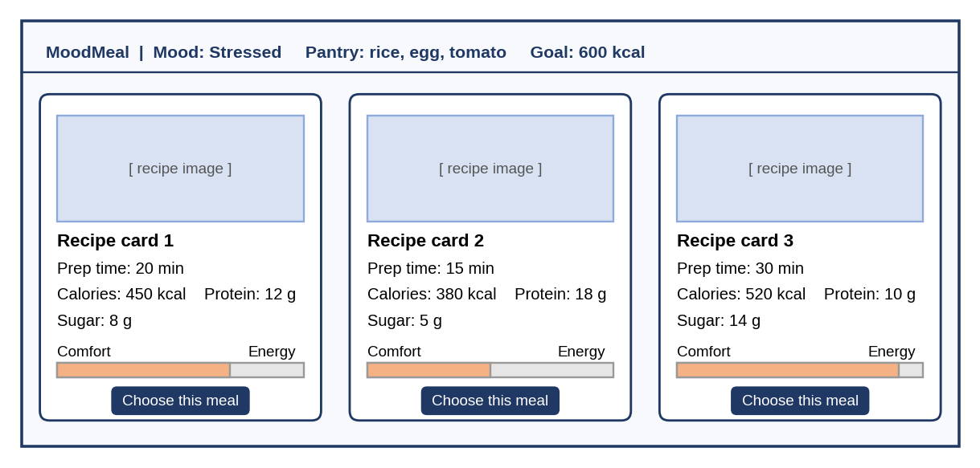
Figure 4.5 Recipe Card Layout
The interface also contains the login and profile screen, the mood selection screen, the pantry and nutrition goal input screen, the recipe search and card view, and the history and charts view, following the structure shown in Figure 4.1.

4.3.7 Testing Plan
Testing was organized around the main user workflows. Functional checks covered registration and login, mood logging, the entry of pantry ingredients and goals, the generation of recommendations, the display of recipe cards and the recording of the mood-to-meal history. Database checks covered the storage and retrieval of records through JDBC. A sample dataset of recipes tagged with mood-suitability scores, nutritional values and ingredient lists was used.
Table 4.3 lists the main test cases that were prepared and the outcome that was expected from each.
Table 4.3 Test Cases and Expected Outcomes
No. | Test case | Input or action | Expected outcome
1 | User registration and login | Submit registration details and sign in | Account is created and the user can sign in
2 | Mood logging | Select a mood for the day | Mood is saved with the date
3 | Recommendation by mood | Select a mood with the sample dataset | Recipes suitable for that mood are listed
4 | Pantry ingredient matching | Enter the available ingredients | Recipes that use those ingredients are ranked higher
5 | Nutrition goal filter | Enter a calorie or nutrition goal | Recipes outside the goal are filtered out
6 | Recipe card display | View the suggested recipes | Cards show prep time, nutrition values and comfort-versus-energy rating
7 | Meal history recording | Choose a recipe from the suggestions | Meal is stored with the mood logged at that time
8 | History charts | Open the history view after repeated use | Charts show the mood-to-meal patterns
9 | Recipe CRUD operations | Add, edit and delete a recipe | Changes are saved in the database

The results obtained from these checks are summarized in Table 4.4.
Table 4.4 Testing and Verification Results
Test area | Method | Observed result | Status
Registration and login | Registering users and signing in | Users registered and signed in as intended | Passed
Mood-based recommendation | Selecting moods with the sample dataset | Relevant recipes returned for the selected mood | Passed
Ingredient and nutrition filtering | Entering pantry items and nutrition preferences | Results filtered according to inputs | Passed
Recipe cards | Viewing suggested recipes | Prep time, nutrition and rating shown clearly | Passed
Mood-to-meal history | Recording recommendations with moods over repeated use | History tracked as intended; patterns visible | Passed
Large-dataset performance | Not yet tested | Not evaluated in this project | Future work

4.3.8 Results and Discussion
The MoodMeal application was tested using a sample dataset of recipes tagged with mood-suitability scores, nutritional values and ingredient lists. The system generated relevant recipe recommendations by filtering the dataset according to the selected mood, the available ingredients and the nutritional preferences. The recipe cards displayed this information clearly, presenting the preparation time, the nutritional breakdown and the comfort-versus-energy rating in a visually intuitive format.
The mood-to-meal history feature also performed as intended, tracking each recommendation alongside the mood logged at that time. Over repeated use, this tracking revealed simple but meaningful behavioral patterns, such as a tendency toward high-comfort, high-sugar recipe selections on days logged as stressed, compared with lighter, higher-energy choices on more positive days.
While the results confirm that the core functionality works as designed, a few areas warrant further discussion. The accuracy of the mood-suitability tagging currently depends on manual or rule-based classification, which may not scale well as the recipe database grows. Performance with significantly larger datasets has not yet been tested and would need to be evaluated before the system could support a broader real-world user base. The observed patterns come from a sample dataset and repeated use of the prototype, and they should not be treated as a statistical or clinical finding.

4.4 PROJECT MANAGEMENT PLAN
The project was organized into work packages with clear outputs and review points. Requirement analysis established the moods, the inputs and the objectives of the application. System design identified the modules, the main entities of the database and the structure of the interface.
Core implementation covered the User, Recipe and Database modules. The Recommendation Module and the recipe cards were then added, followed by the History and Analytics Module with JFreeChart. Testing combined functional checks of the user workflows with checks of the stored data.
Table 4.5 Work Packages and Outputs
Work package | Activities | Output
Requirement analysis | Identify moods, inputs, outputs and the objectives | Requirements and objectives
System design | Define modules, database tables and interface screens | Architecture, data flow and database design
Core implementation | Build the User, Recipe and Database modules | Working application with stored data
Recommendation and interface | Build filtering, ranking and recipe cards | Mood-based recommendations
History and analytics | Store mood-to-meal history and draw charts | Pattern charts
Testing | Check workflows, storage and displayed results | Test results
Documentation | Prepare the project report and presentation | Report and slides

The project was carried out by the student developer, who was responsible for design, implementation, testing, documentation and preparation of the project deliverables. Academic guidance and review were provided by the project guide, Dr. SRIDEVI, Associate Professor, CSE, through the progressive reviews of the Professional Training I course.
The student also completed a two-month training programme on “Advanced Data Structures with Java” conducted by Stellar Academy For Education, for which a Certificate of Completion was issued on 30 September 2026 (see Training Certificate). The programme strengthened the Java and data structure skills that were used in this project.

4.5 TRANSITION / SOFTWARE TO OPERATIONS PLAN

4.5.1 Release Preparation
Transition begins with verification of the selected application version. The Java Development Kit, the MySQL server and the JDBC driver must be installed on the target computer. The database schema must be created and the recipe dataset loaded before the first run, and the database credentials must be kept out of the source code or placed in a configuration file.

4.5.2 Deployment and Initial Operation
The application is packaged as a runnable Java archive and started on the target computer, with the MySQL server running on the same machine. Initial checks should verify the connection to the database, the registration and login of a user, the logging of a mood, the generation of recommendations and the display of the history charts.

4.5.3 Routine Operation and Maintenance
Routine maintenance should include reviewing application errors, adding and correcting recipe records, and checking the mood tags when new recipes are added. Regular backups of the database should be taken and restoration should be tested separately. Updates to the Java runtime and the libraries should be tested before they are used.

4.5.4 Project Outcome
MoodMeal implements a mood-aware recipe recommendation workflow on a desktop platform built from core Java, JDBC and MySQL. The project connects graphical user interface design, relational database design, recommendation logic and chart-based tracking within one working application.
CHAPTER 5

CONCLUSION
MoodMeal demonstrates a functional, mood-aware recipe recommendation system that successfully integrates Java GUI development with MySQL-based data persistence. It brings the mood of the user, the available pantry ingredients and the nutritional goals together in one application, so that the user receives suggestions that fit the situation instead of a generic list of recipes.
The application presents the suggestions as visual recipe cards and records the mood-to-meal history, which makes simple eating patterns visible through charts. Testing with a sample dataset confirmed that the recommendation, card display and history features work as designed. The project highlights an underexplored intersection between nutrition and emotional wellbeing.
The development of the application gave practical experience in core Java, GUI design, JDBC-based CRUD operations, relational database design and charting, supported by the Advanced Data Structures with Java training programme. The system provides a foundation for the future enhancements described below.

5.1 LIMITATIONS
The accuracy of the mood-suitability tagging currently depends on manual or rule-based classification, which may not scale well as the recipe database grows. The performance of the application with significantly larger datasets has not been tested. The mood is entered manually by the user, the charts are descriptive and not diagnostic, and the application is not a substitute for medical or dietetic advice.

5.2 FUTURE ENHANCEMENTS
Several enhancements can build on the present architecture without changing its basic structure:
- Mobile version: provide a mobile application that uses the same recommendation logic and data, so that users can log moods and receive suggestions on their phones.
- ML-based mood detection: incorporate machine learning so that the mood can be inferred, instead of being selected manually.
- Expanded recipe database: add many more recipes and improve the tagging so that the suggestions cover more tastes and dietary needs.
- Larger-scale testing: evaluate the response time and accuracy of the system with significantly larger datasets and more users.

5.3 LEARNING OUTCOMES
The project gave practical experience in the following areas:
- Designing a modular desktop application in which the interface, the recommendation logic and the database access are kept separate.
- Building graphical user interfaces in Java and presenting information as visual cards and charts.
- Using JDBC with MySQL to perform CRUD operations with parameterized statements.
- Modelling users, recipes, ingredients, mood logs and meal history in a relational database.
- Planning and carrying out functional testing of the main workflows, and recording the results and the limits of those results.
These outcomes are consistent with the objectives set out in Chapter 1 and prepare the ground for the enhancements described above.

REFERENCES
[1] M. Macht, “How emotions affect eating: A five-way model,” Appetite, vol. 50, no. 1, pp. 1–11, 2008.
[2] E. L. Gibson, “Emotional influences on food choice: Sensory, physiological and psychological pathways,” Physiology & Behavior, vol. 89, no. 1, pp. 53–61, 2006.
[3] J. Freyne and S. Berkovsky, “Intelligent food planning: Personalized recipe recommendation,” in Proc. 15th Int. Conf. on Intelligent User Interfaces (IUI), 2010, pp. 321–324.
[4] C. Teng, Y. Lin, and L. Adamic, “Recipe recommendation using ingredient networks,” in Proc. 4th ACM Web Science Conf. (WebSci), 2012, pp. 298–307.
[5] F. Ricci, L. Rokach, B. Shapira, and P. B. Kantor, Eds., Recommender Systems Handbook. New York, NY, USA: Springer, 2011.
[6] C. S. Horstmann, Core Java, Volume I – Fundamentals, 12th ed. Prentice Hall, 2022.
[7] P. Deitel and H. Deitel, Java: How to Program, 11th ed. Pearson Education, 2020.
[8] L. Bulusu, Learn JavaFX 8: Building User Experience and Interfaces with Java 8. Apress, 2016.
[9] P. DuBois, MySQL Cookbook: Solutions for Database Developers and Administrators, 3rd ed. O’Reilly Media, 2013.
[10] G. Reese, Database Programming with JDBC and Java, 2nd ed. O’Reilly Media, 2000.
[11] H. Schildt, Java: The Complete Reference, 11th ed. McGraw-Hill Education, 2018.

