***A network is a group of computing devices which is used exchange information between them for various purposes through connections .Connections take place through the medium which is either wired or wireless .An example of network is internet.***

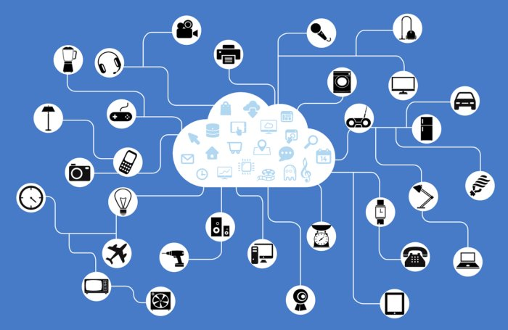

# *WIRED MEDIUM*

***Medium through which the connections between the computing devices are ,made of wired components like cables,telephone lines etc.***

# *WIRELESS MEDIUM*

***Medium through which connections between the devices are made of wireless medium which consists of wave signals,satellite and infrared light waves.More often wireless medium is commonly used in many of the areas.***

# *TOPOLOGY*

***Network topology is the arrangement of elements in specific structure.A topology is of five types.They are***

* ***Mesh topology-the interconnection between the devices.***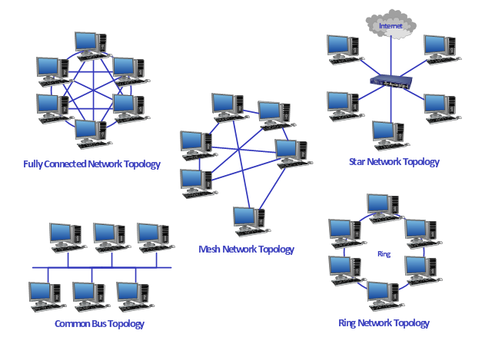
* ***Star topology- a central hub which acts as a controller.***
* ***Bus topology-a connection through a main cable.***
* ***Ring topology-information is transferred to one another devices in a ring structure.***
* ***Hybrid topology-consists of two topologies.***

# *IP ADDRESS*

***IP refers to internet protocol where it gives rules for the network system***.

***We can change the IP address by clicking on the START button . A list of program appears,***

* ***Select control panel in it .A list of items appears,***
* ***Select network and sharing center to go to the next window.***
* ***In the access type connection ,click on local area connection.***
* ***Choose Internet Protocol version 4(IPv4) and choose on its properties.***
* ***In the properties window dialog box, select advanced option in it.***
* ***In the advanced IP settings,we can add and edit the IP address.***