Configurable Report Scheduling & Delivery System – Proposal

Table of Contents
1. Project Overview 2
2. Scope of Work 2
3. Out of Scope 3
4. Assumptions 3
5. Proposed Approach Plan 4
5.1. Requirements & Design Phase 5
5.2. Development Approach 5
5.2.1. Cognos Integration Layer 6
5.2.2. Admin Console 6
5.2.3. End User module 6
5.2.4. Report Delivery 6
5.3. Testing Approach 7
5.4. Deployment 7
5.5. Training & Handover 7
6. Change Request 7
7. Technical Architecture 8
7.1. Technical Architecture Overview 8
8. Technical Stack 9
9. Project Timeline 9
10. Milestones and Deliverables 10
11. Pricing 11
12. Key contacts 11

1. Project Overview
Mobius proposes to implement a Configurable Report Scheduling & Delivery System integrated with IBM Cognos to streamline MetLife’s reporting workflows. Our solution will provide an intuitive experience for both Admins and End Users. The platform will allow MetLife admins to configure predefined Cognos templates with custom filter hierarchies and enable business users to schedule and download reports using secure, authenticated access through the existing MetLife portal.
The system leverages Cognos as the source of report templates and applies configurable parameters from within the new application. Reports can be executed on-demand or based on a schedule, with output delivery via direct download or API handoff. Supported export formats include PDF, CSV, and Excel.
This solution eliminates manual intervention, improves operational efficiency, and enhances reporting accuracy through centralized scheduling and configuration.
2. Scope of Work
Mobius proposes to design and develop a Configurable Report Scheduling & Delivery System integrated with IBM Cognos to streamline MetLife’s reporting workflows. The project will encompass the following scope of work:
A. Application & Experience Design
Mobius will design a clean, user-friendly interface that simplifies the process of configuring filters, selecting templates, and scheduling reports. The interface will reflect MetLife’s enterprise standards, ensuring consistency across admin and user modules.
B. Cognos Integration Layer
- Connect to Cognos using API
- Retrieve list of report templates from Cognos
- Map the associate templates with predefined data sources
- No modification or design of Cognos templates inside the new app
- Export retrieval (PDF, Excel, CSV)
C. Admin Configuration Module
- Allow admins to select predefined Cognos templates
- Configure parameters/filters based on MetLife supplied field lists
- Support multi-level filter hierarchy (parent->child->sub-child)
- Enable/disable templates for end users
D. End User Module
- Login via existing MetLife portal authentication
- View the assigned Cognos templates
- Select template → provide filter values based on admin configuration
- Select option for output format (PDF/CSV/Excel)
- Schedule reports (Daily/Weekly/Monthly) or execute immediately to download
E. Scheduling & Execution
  - Run Now to download the report immediately
  - Backend process: Schedule the reports: Backend engine to the Pass filters to Cognos, Trigger execution, Export in required format, Deliver via download/API
  - Backend engine for recurring schedules with optional end date

F. Audit & Logging
- Activity logs for:
  - Report runs
  - Schedule creations/updates
  - Admin configuration changes
G. Compliance & Functional Testing
The platform will undergo functional, performance, accessibility, and integration testing before UAT. The scope includes the end-to-end design, development, and deployment of a Cognos-integrated reporting platform.
3. Out of Scope
The following items are explicitly out of scope:
    - Creation, modification, or design of Cognos report templates
    - Auto-fetching filter fields from Cognos
    - Email delivery of reports (attachments or links)
    - User provisioning or user role management (handled by existing portal)
    - Data transformation or cleansing beyond what Cognos supports
    - Mobius will move the code to the hosting environment, but on-going hosting management will be the MetLife’s responsibility
    - Any additional customizations beyond the scope of the work mentioned, will be treated as a change request and charged separately
4. Assumptions
This solution is based on the following assumptions:
- Cognos templates and their data sources will be created and maintained by MetLife
- MetLife will provide the complete filter/parameter field list for each template
- Authentication and user access management will be handled by the existing MetLife portal
- Cognos API access credentials and test environments will be provided
- MetLife will provide required infrastructure, hosting, and SSL certificates
- Any new or additional templates or filter structures after final sign-off will require a Change Request
- Any micro-improvements or additional filter rules not in the signed-off scope may require additional effort
- A MetLife SPOC will be available for requirement walkthroughs, reviews, and providing approvals/ Signoff for all our deliverables
- Mobius will move the code to the hosting environment and we assume hosting cost will be borne by MetLife
- Any third-party paid services, licenses, or API costs will be borne by MetLife
5. Proposed Approach Plan
Mobius strongly believes that a common platform and forum facilitating transparency, collaborative planning, seamless communication and engagement review is essential for both Mobius and MetLife. Mobius' approach for seamless execution of the project is through implementing a robust project governance framework involving Executives or Directors from both MetLife & Mobius. Our work process follows a structured methodology to ensure the successful delivery of the MetLife self-service portal.
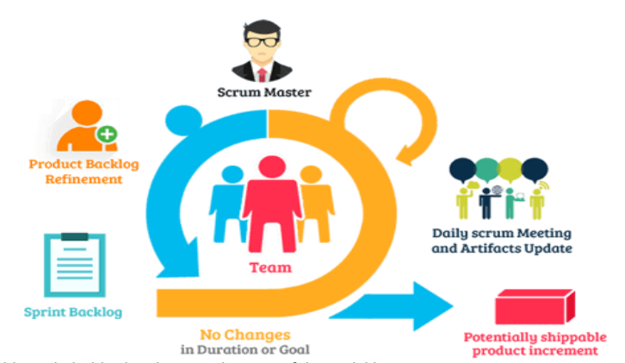
- Enable stakeholder involvement in most of the activities
- Generate more value via Extreme programming (XP)
- Accommodate changes as it is iterative development with MetLife time-to-time
- Cooperative & Collaborative approach between Development Team & MetLife
- Sprint planning process ensures clarity on scope
- Daily Scrum sorts out developers’ impediments
- Ensures delivery of Right product on time
- Sprint Retrospective meeting helps to analyze outcome & challenges faced
5.1. Requirements & Design Phase
While Business Analyst working on Business Requirement Documentations, team members will be working on environment set up activities, wireframe creation, user flow definition, designing the portal and architecting Database. After these crucial activities are carried out in the design phase, the test framework is also formalized.
- UX creates layout structures for admin and user journeys
- Team prepares filter hierarchy designs
- Wireframes for:
  - Template catalog
  - Filter configuration screens
  - Scheduling screens
  - Execution logs
- Early validation with MetLife SMEs
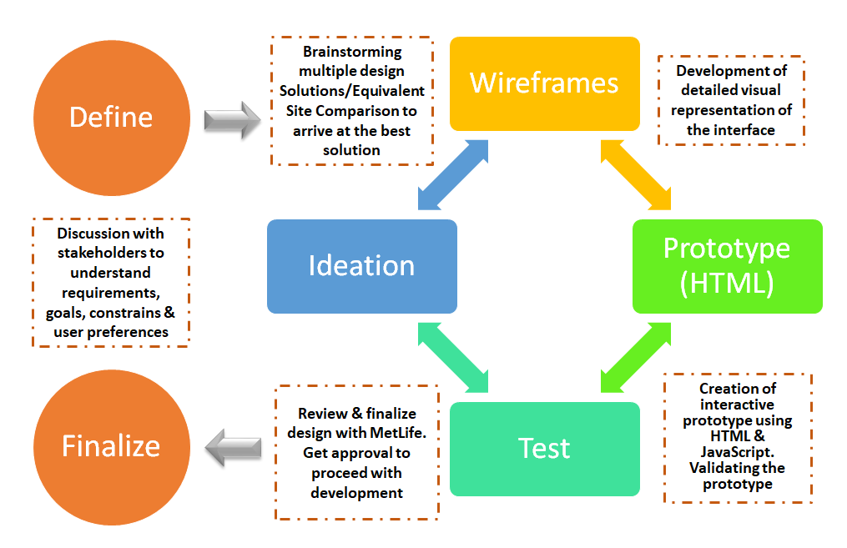
5.2. Development Approach
The proposed solution is a configurable report scheduling platform integrated with IBM Cognos. The platform provides a secure, scalable framework with modularized components, reusability of filter sets, audit trails, and centralized governance.
The reporting application built over Cognos, enabling:
- Admin-driven filter configuration
- End-user-driven scheduling
- Cognos-driven report generation
The proposed solution consists of 4 core modules:
5.2.1. Cognos Integration Layer
- Report templates are authored by MetLife Admin users inside Cognos
- These templates include the report layout and associated data sources
- The new application will not be responsible for designing or editing the template structures
- The app will use Cognos APIs to:
- Authenticate
- Template retrieval: Retrieve a list of Cognos report templates
- Parameter mapping: Identify the associated data sources for each template
- Execution API
- Export retrieval
5.2.2. Admin Console
Admins will be able to:
- Manage templates sourced from Cognos
- Select a Cognos template
- View fields available in its data source
- Filter field configuration using provided list (e.g., dropdowns, date pickers, value fields)
- Defining multi-level hierarchical filters
- Update the template with the filter configuration inside the app
- Assigning user with templates: Enabling/disabling templates for users
5.2.3. End User module
- Login using existing MetLife Portal
- End users will be able to:
- View a list of Cognos templates
- Select a template
- Choose filter values as defined by admin
- Select report output format (PDF, Excel, CSV, etc.)
- Choose: Immediate execution or Schedule delivery (e.g., Daily, Weekly, Monthly)
5.2.4. Report Delivery
- Configurable scheduling (Daily/Weekly/Monthly)
- Task scheduler to handle recurring jobs
- Triggers Cognos report generation
- Report will be exported as PDF, CSV, or Excel from Cognos
- Delivered to user via:
  - Download
  - API handoff
- Job logs and execution monitoring
5.3. Testing Approach
Mobius will conduct a comprehensive testing to ensure the Reporting and scheduling Platform functions as expected:
- Test individual components and features for functionality and performance
- Verify that all integrated systems and components work together seamlessly
- Conduct UAT sessions with MetLife stakeholders to validate the overall user experience and functionality
- Ensure the report scheduling system meets the compliance and other accessibility standards
- Perform security assessments to identify and address vulnerabilities
5.4. Deployment
The deployment phase will include:
- Staging environment deployment for final testing
- Review and validation to ensure everything is functioning correctly
- User Acceptance Testing
- Production rollout with final smoke test
- Post-go-live monitoring to ensure stability and address any immediate issues
5.5. Training & Handover
After the UAT sign-off, training on system usability, features and functionalities will be given by Mobius team. Mobius will provide:
- Admin training on configuration module
- User training documents
- Support handover kit
6. Change Request
Any Change Request (CR) other than the agreed deliverables or developing any new feature will be reviewed by the steering committee from both MetLife & Mobius. With a mutual agreement, the extended timeline for delivering the CR & additional cost with T&M model as hourly rate will be incorporated into the contract as an amendment if applicable. Below process flow explains about handling change requests.
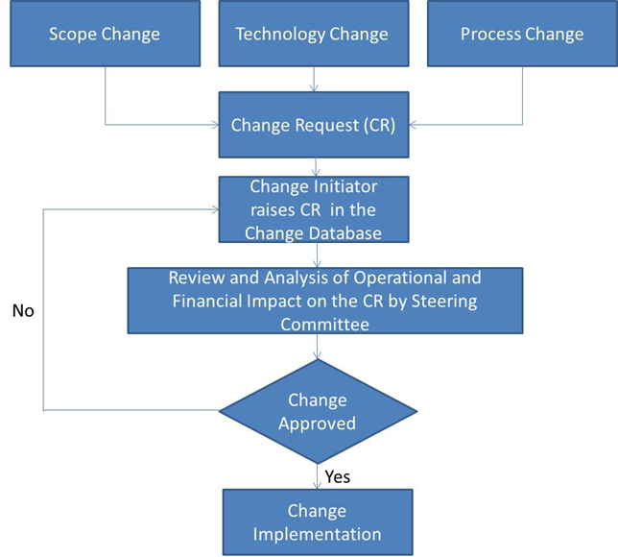
7. Technical Architecture
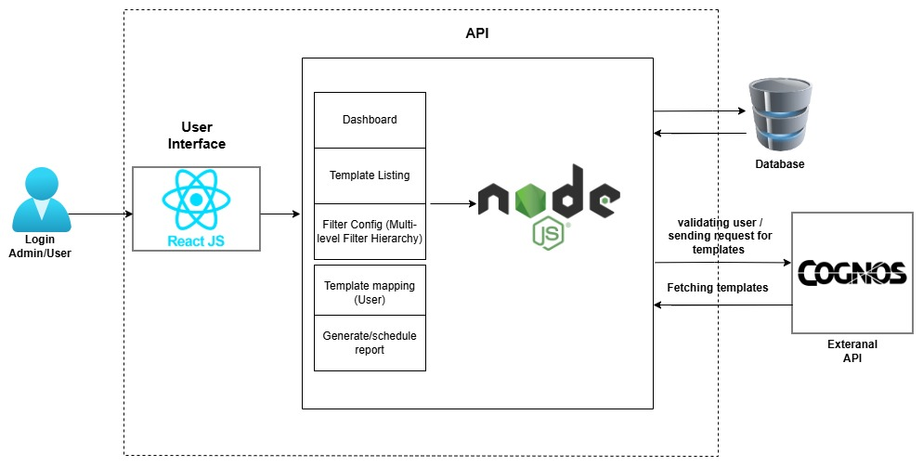
7.1. Technical Architecture Overview
Mobius proposes a modern, modular, API-driven architecture for MetLife Reporting and scheduling Platform that separates the user interface, backend services, and external integrations to ensure high scalability and maintainability. The frontend application is developed using React.js, enabling a clean, responsive, and intuitive user experience for both Admins and End Users. All interactions such as template listing, filter configuration, report execution, and scheduling will be initiated from the UI and securely routed through the backend services.
At the core of the backend, Node.js acts as the orchestration engine responsible for validating user access, processing configuration data, triggering Cognos requests, and managing scheduled executions. It integrates with the Cognos External API to fetch templates, submit parameterized execution requests, and retrieve exported reports in PDF, CSV, or Excel formats. The backend also interacts with the application database to store template configurations, multi-level filter hierarchies, schedule metadata, and audit logs, ensuring full operational governance.
The architecture supports both “Run Now” and automated scheduling through a dedicated background job engine that periodically reads the schedule definitions stored in the database and executes reports at the configured intervals. This decoupled, API-driven architecture ensures that the platform remains performant, secure, and easy to extend, while offering MetLife users a seamless experience from configuration to report generation.
8. Technical Stack
Mobius will set up all environments to configure the application by the technology stack described below
TECHNICAL STACK
Frontend | React.js, Material UI, CSS
Backend | Node.js, Express.js
Database | MySql
Project Management Tool | Azure DevOps
Integration | IBM Cognos API
Version Control | Git/ Azure Repos
9. Project Timeline
Mobius proposes the following timeline to design and build the Reporting and scheduling Platform for MetLife.

10. Milestones and Deliverables
The below table explains the milestones and deliverables by Mobius for the proposed configurable report scheduling development, at the end of each phase Mobius will be delivering all the proposed deliverables in the below table and intended to get signoff for the respective deliverables.
11. Pricing
Mobius proposes the following cost for MetLife required in the RFP
Particulars | Fixed Fee in USD
Report Scheduling & Delivery System Design & Development | $ 24,200.00
Hosting Fee | $ 274.48 /month

Note: Hosting fee is based on: D4 v3 (4 vCPUs, 16 GB RAM) x 730 Hours. The hosting fee is indicative and might vary based on factors including VM size, performance requirements, workload, and scaling needs.
12. Key contacts
NAME | TITLE | EMAIL
Ashwinkumar Toppur | Director – Software Services | ashwinkumar.toppur@mobiusservices.com

