GuardianEdge AI Technical Guide
  - Problem solution architecture operation and testing
16 October 2026

What this project delivers
GuardianEdge AI is a working local prototype that turns real video detections into restricted-zone incident records. CraftifAI PipeGen generates and runs the NVIDIA DeepStream detection pipeline. A Python application using model view controller architecture validates its tracked metadata and produces actionable JSON events. A native view extension draws a labelled demonstration zone in the real video output.
The core coding and local end-to-end verification are complete. All 32 automated tests pass on Windows and Ubuntu. The final real GPU run processed 1,442 frames, produced 140 incident lifecycle events and recorded a video that decoded fully without errors. Submission remains under the participant's control.

Fastest way to run on this laptop
Open Ubuntu 22.04 from the Windows Start menu. Keep Docker Desktop and the PipeGen application running. Run these two commands in Ubuntu, not inside the PipeGen chat box.
cd ~/craftifai/guardianedge-ai
bash scripts/run_guardianedge.sh
To test the application code instead of running video, use the same project directory and run:
python3 -m unittest discover -s tests -v

How to use this guide
The following chapters explain the problem and mandatory track requirements, proposed solution, MVC responsibilities, metadata and incident rules, the real PipeGen build, step-by-step operation, automated and video testing, measured results, troubleshooting and the submission inventory. Commands are written for the existing Ubuntu WSL environment. Clean-machine deployment is discussed separately and is not claimed as verified.

1 Problem statement and track requirements
A passive camera feed can show a person near a hazard without producing a usable incident record. An operator needs to know which camera and configured zone were involved, whether a person stayed inside long enough to confirm an event, whether the person was observed leaving, and whether tracking was lost. GuardianEdge addresses this metadata and incident-reporting problem on top of person detection.
The hackathon submission follows PipeGen Track A. A Python-only detector demonstration would not establish the mandatory PipeGen integration. The generated DeepStream pipeline is therefore the source of all demonstrated detections and tracker IDs.
Requirement | Implementation and evidence
Use the five PipeGen stages | Requirement, Pipeline IR, Model, Compiler and Run completed in the actual 0.5.1 app.
Compile a TensorRT engine | YOLO11s model compiled through PipeGen into a real TensorRT plan.
Save the PipeGen speed report | Actual benchmark JSON and screenshot retained in evidence.
Run real video on NVIDIA hardware | Bundled 1280 by 720 pedestrian video processed by the generated DeepStream app on the MX550.
Produce results beyond boxes | MVC analytics creates confirmed intrusion, observed exit and lost-track JSON events from real metadata.
Preserve the actual export | Real export source and manifest retained; working copy includes documented zone and recording extensions.
Provide genuine demonstration evidence | Real Pipeline IR, speed screenshot, live output, zone frame, metadata, incident output and logs included.

Acceptance scope
The demonstration zone is deliberately labelled as a demo on public sample footage. It demonstrates the software path, not a commissioned industrial site or validated worker-protection system. No microcontroller is required for this Track A implementation. FirmGen BLE and MCU materials belong to a separate track.

2 Proposed solution and technical approach
The system separates vision execution from safety analytics. PipeGen is responsible for model preparation and the generated GPU pipeline. GuardianEdge receives the resulting metadata, applies deterministic zone rules and writes a compact event stream that another application could consume.

Processing sequence
A local video is decoded into frames. A YOLO11s model performs person-capable COCO detection through TensorRT. The generated DeepStream tracker attaches persistent object IDs. Its metadata sink writes frame number, source ID, presentation timestamp, frame dimensions and object records. The schema adapter selects person records, then the MVC controller sends every processed observation to the zone model. The view writes incident JSONL.
The native overlay runs before DeepStream's on-screen display stage. It attaches polygon lines and a demonstration label to frame display metadata. It only presents the configured geometry; it does not duplicate the Python incident state machine.
Component | Choice and reason
Vision platform | CraftifAI PipeGen 0.5.1 with the official DeepStream 7.1 runtime image.
Model execution | YOLO11s COCO model, batch one, 640 by 640 network input, TensorRT 10.3.
Application code | Python 3.10 or newer; the analytics uses only the standard library.
Presentation extension | Generated C++ metadata sink plus a small NvDsDisplayMeta zone overlay.
Environment | Windows with Ubuntu 22.04 WSL2, existing Docker Desktop integration and NVIDIA MX550 with 2 GB VRAM.
Data outputs | Actual frame metadata JSON, incident JSONL, runtime logs, and recorded annotated video.

Resource and privacy choices
One stream and batch one keep resource use appropriate for the 2 GB GPU. No secondary neural model or facial recognition is added. The analytics itself processes metadata. Demonstration screenshots and recorded sample video are retained explicitly as evidence, so the complete demo should not be described as storing no imagery.

3 MVC coding architecture
MVC separates domain decisions, application orchestration and presentation. This makes zone behavior testable without running a GPU and lets the real PipeGen source change without rewriting the safety rules.
Layer | File | Responsibility
Model | guardianedge/models/zones.py | Validate complete frames, evaluate polygons, maintain isolated incident state, and create event dictionaries.
Controller | guardianedge/controllers/  metadata.py | Accept observations, call the model, send resulting events to the view, and stop invalid JSONL input.
View | guardianedge/views/jsonl.py | Write machine-readable event JSONL separately from human-readable status and error messages.
Adapter | guardianedge/adapters/pipegen.py | Map the actual generated DeepStream schema to the normalized model contract.
Composition root | guardianedge/__main__.py | Load configuration, parse CLI arguments, instantiate MVC components and connect streams.
Native presentation | scripts/apply_zone_overlay.py | Generate a zone header and connect it to the exported C++ metadata sink.
Workflow runner | scripts/run_guardianedge.sh | Run the actual GPU pipeline and then the metadata adapter and MVC analytics.

Dependency direction
PipeGen DeepStream detector and tracker
-> real metadata JSON
-> PipeGen schema adapter
-> MetadataController
-> ZoneEngine
-> JsonlView
-> incident JSONL
The model does not import a controller, view, detector, GUI or file reader. The controller does not decide geometry. The adapter does not invent tracker IDs or inference values. The existing guardianedge.zones module re-exports the model symbols so earlier integrations continue to work.

4 Code files and explanatory comments
Comments explain responsibilities and decisions that would otherwise be easy to misuse. They avoid narrating simple assignments. The important boundaries are documented in module and class docstrings and beside safety-sensitive state changes.
File or folder | What to read there
guardianedge/models/zones.py | Model role, validation before mutation, normalized foot point, incident IDs, duplicate suppression, and why missing tracks are not observed exits.
guardianedge/controllers/  metadata.py | Controller role, synchronous session scope, blank-line handling, empty-evidence rejection and output-failure retry limitations.
guardianedge/views/jsonl.py | View role, injected streams, flushed event output and separation of diagnostics from JSONL.
guardianedge/adapters/pipegen.py | Observed schema mapping and explicit distinction between relative media time and capture UTC.
guardianedge/__main__.py | Composition root and the creation of independent model and controller instances per invocation.
scripts/apply_zone_overlay.py | Presentation-only native extension; incident decisions remain in the MVC model.
pipegen-export/ | Actual generated source, runtime script, model manifest, inference configuration, labels and parser build files.
tests/ | Model, CLI, controller, adapter and timestamp-provenance regression tests.

Configuration
config/zones.json is a generic normalized example. config/pedestrian-demo.json is the configuration verified with the real pedestrian clip. Both use three confirming observations and minimum confidence 0.5. The demo polygon spans normalized x values 0.04 to 0.28 and y values 0.45 to 0.95. It is a demonstration area on the left walkway, not a claim that this street area is actually restricted.
To change the zone, edit the demo JSON and run the normal runner. The installer regenerates the native header from the same configuration and the Makefile rebuilds the metadata library. Run the installer as a module from the project root; direct invocation of its file is not the documented interface.

5 Metadata contract and timestamp provenance
The adapter was implemented after inspecting the generated frame_json.h source and a real completed metadata.json file. The actual file contains a top-level frames array. The frame and object schema below is simplified to relevant fields; real output can include additional model-family metadata.
frames[]
frame integer frame number
source_id integer camera source
pts_ns video presentation time in ns
width height metadata coordinate space
objects[]
id upstream tracker ID
class_id COCO class number
label class name
confidence detector confidence
bbox left top width height

Normalized MVC input
The adapter maps source_id into a namespaced camera_id, maps frame into frame_id, selects confirmed person records, and converts the bbox object into a four-number list. It preserves empty person observations. Missing or unconfirmed person IDs and unknown PTS cause an error rather than fabricated state.
Field | Meaning
camera_id and frame_id | Camera namespace and strictly increasing processed frame number.
objects | Stable track ID, person label, confidence and pixel bbox for each qualifying observation.
source_pts_ns | The original nanosecond presentation timestamp from DeepStream.
timestamp_utc | A datetime representation of PTS relative to the 1970 epoch, not a recording date.
timestamp_basis | media_pts_epoch_not_capture_utc explicitly identifies the relative-time representation.

The model rejects contradictory timestamp and PTS values, raw PTS regressions, backwards datetimes and repeated frame numbers before changing state. Datetime precision is microseconds, so original nanoseconds are checked separately. Dwell uses source video time rather than the speed of Python postprocessing.

6 Incident rules and event lifecycle
For each person, the model calculates the bottom-center of the pixel bounding box, normalizes that point by frame width and height, and checks polygon membership. Polygon boundaries count as inside. State is isolated by camera ID, track ID and zone ID.
Observation | Result
Outside the zone | No intrusion is opened.
One or two consecutive qualifying observations inside | Maintain pending state without an alert.
Third consecutive qualifying observation inside | Emit one RESTRICTED_ZONE_INTRUSION and activate the incident.
Continued qualifying presence | Retain the incident and suppress duplicate entry alerts.
Observed outside after an active incident | Emit ZONE_EXIT with the same incident ID and media-derived dwell.
Confirmed reentry after exit | Create a new incident ID.
Missing or low-confidence active track | Emit TRACK_LOST using an explicitly stale last box; do not invent an observed exit.
Missing pending track | Reset the unconfirmed streak.

Event fields
Events contain a unique event ID, incident ID, event type, camera, source frame, zone, track ID, confidence, bounding box and first-seen time. Media events additionally retain source_pts_ns and timestamp_basis. Observed exits include dwell_seconds. Lost-track events flag bbox_is_last_observation and do not assert an exit duration.

Real observed sequence
In the final real run, tracker ID 11 had an observed exit at frame 43 and a confirmed reentry at frame 118. The verification summary also records exit and reentry examples for IDs 40 and 44. These are tracker identities in the sample run, not verified identities of people. Detection fluctuations and tracker failures can fragment one physical presence into several incident records.

7 Real PipeGen implementation
The official application was installed after reviewing its package and generic prerequisite script. The working Docker Desktop and GPU integration were preserved. The generic prerequisite script was not executed because it would configure a competing Linux Docker runtime. PipeGen's actual prerequisite checks subsequently passed.
Stage | What was completed
Requirement | Entered a one-stream person-detection and tracking requirement; accepted the clearer sample_720p.mp4 input with display and frame metadata output.
Pipeline IR | Generated and reviewed the real input, preprocessing, inference, postprocessing, tracking and output graph; preserved JSON and a genuine screenshot.
Model | Selected RestrictedAreaMonitoring from the actual catalog; downloaded the YOLO11s ONNX model and checked operator compatibility.
Compiler | Built a TensorRT plan and measured its inference speed; compiled the actual generated DeepStream pipeline and parser libraries.
Run and export | Ran real video, captured live detections and frame metadata, exported the application, then verified the documented native zone extension.

Engine facts
TensorRT 10.3 compiled an engine of 20,298,204 bytes in 33.7 seconds. FP16 was requested, but TensorRT chose 208 FP16 layers, 18 FP32 layers and one unknown layer. This is a mixed-precision engine, not INT8. The first-build timing warning and layer-coverage caveats remain in the original report.
The exported manifest records the original model and plan checksums. The untouched export is retained in the ignored work/vendor-export folder. The published working source adds a zone display header and replaces fragmented recording with an ordinary MP4 mux after a genuine decode issue was found. The final recording was fully decoded successfully.

8 Start the project step by step

Step 1 Open the required applications
Start Docker Desktop and wait until its engine is running. Open Ubuntu 22.04 from the Windows Start menu. If the PipeGen application is not running, enter the following command in Ubuntu and leave the application open:
pipegen
Use your own CraftifAI account if the application asks you to sign in. Enter credentials only in the official app. The runner requires the existing craftifai-amd64-v3 container created by PipeGen.

Step 2 Enter the canonical project folder
cd ~/craftifai/guardianedge-ai
The complete Linux path is /home/kishore/craftifai/guardianedge-ai. Python must be version 3.10 or newer. The full local export and sample media are already present on this configured machine.

Step 3 Launch the default recorded demonstration
bash scripts/run_guardianedge.sh
The runner installs the presentation overlay, invokes the actual exported GPU pipeline, and then analyzes the completed metadata through the MVC adapter. It creates a new work/run timestamp folder rather than overwriting the previous run. Leave the terminal open until the completion message appears.

Step 4 Locate the results
The final terminal message prints the run directory. It contains output.mp4, metadata.json, incidents.jsonl and pipeline.log. Open output.mp4 to view real tracked boxes and the yellow demonstration polygon. Metadata includes all detected classes; the analytics selects people. Incident processing happens after the video completes.

Step 5 Optional live display
bash scripts/run_guardianedge.sh \
"$PWD/media/sample_720p.mp4" --display
Display mode opens the actual DeepStream window. Default recording mode is easier to preserve and review. For a different source, replace the video argument with an absolute Linux path that is visible inside the existing container. Do not launch overlapping runs.

9 Run the automated tests step by step

Step 1 Open Ubuntu and select the project
cd ~/craftifai/guardianedge-ai
python3 --version

Step 2 Run all tests
python3 -m unittest discover -s tests -v
Expected result: 32 tests run, every named test reports ok, and the output ends with OK. The latest saved transcripts are evidence/unit-tests-ubuntu.txt and evidence/unit-tests-windows.txt. A nonzero exit code, FAILED, ERROR or traceback needs investigation.
Test file | Coverage
test_zones.py | Polygon boundaries, outside observations, persistence, suppression, exit, reentry, camera and person isolation, lost tracks, malformed geometry and overflow atomicity.
test_cli.py | Generic JSONL command execution, invalid JSON, invalid metadata and rejection of empty input.
test_controller.py | Real model and view interaction, direct frame input, stopping on invalid rows, and rejection of blank evidence.
test_pipegen_adapter.py | Inspected schema mapping, actual media-time representation, person filtering, empty observations, unknown IDs/PTS and provenance regression checks.

Step 3 Understand what passing means
These tests verify custom application behavior using controlled synthetic fixtures. They do not claim detector accuracy or replace a real GPU run. Real inference evidence is stored separately. The final verification also reran the complete configured pipeline after the reviewed timestamp fixes.

Terminal copy and paste
In Ubuntu or Windows Terminal, try Ctrl Shift V or right-click to paste. Regular Ctrl V may not paste into the shell. If pasting is unavailable, the folder change, unit-test command and default runner command are short enough to type manually. Never enter terminal commands into the PipeGen requirement text field.

10 Test real metadata and failure behavior

Replay the real saved evidence
mkdir -p work
python3 -m guardianedge.adapters.pipegen \
--input evidence/pipegen-metadata.json \
--config config/pedestrian-demo.json \
> work/replayed-incidents.jsonl
Expected: Processed 1442 metadata frames and 140 output events for the retained metadata and configuration. UUID values change on replay, so compare source frame, track, zone and event type instead of exact UUID strings.
wc -l work/replayed-incidents.jsonl
head -n 3 work/replayed-incidents.jsonl
cat evidence/verification-summary.json

Reject malformed generic JSONL
printf '%s\n' '{broken' | \
python3 -m guardianedge --config config/zones.json
echo $?
Expected: Metadata error at line 1 and exit code 2. The program must not invent events from malformed input.

Reject empty generic input
python3 -m guardianedge \
--config config/zones.json < /dev/null
echo $?
Expected: No frames received and exit code 2. Empty input cannot be reported as a successful inference demonstration.

Actual invalid video test already performed
The generated pipeline was run against an intentionally invalid local MP4 file. GStreamer reported that it could not determine the stream type, failed to preroll and exited with code 1. The retained evidence/corrupt-input.log is the genuine failure output. The final valid video was separately decoded in full with FFmpeg and produced no errors.

11 Verified results and demonstration
Measurement | Verified result
Unit tests | 32 passed on Windows and 32 passed on Ubuntu.
Real run observations | 1,442 frames and 13,754 object records.
Derived incidents | 140 events: 70 intrusion confirmations, 10 observed exits and 60 track losses.
Engine benchmark | 18.539 ms inference time; 16.925 ms GPU compute; about 54 FPS derived.
Live display observation | Screenshot shows 17.36 FPS with dropped frames; a different scope from the engine benchmark.
Recording integrity | Final complete MP4 decode returned exit 0 without decoder errors.

The engine benchmark measures model execution and transfers, not the entire decoded-video application. Power is retained as vendor-reported nvidia-smi telemetry, not an independently calibrated measurement. Accuracy was not measured. Modelled Jetson predictions in the vendor report are not measurements from a Jetson deployment.
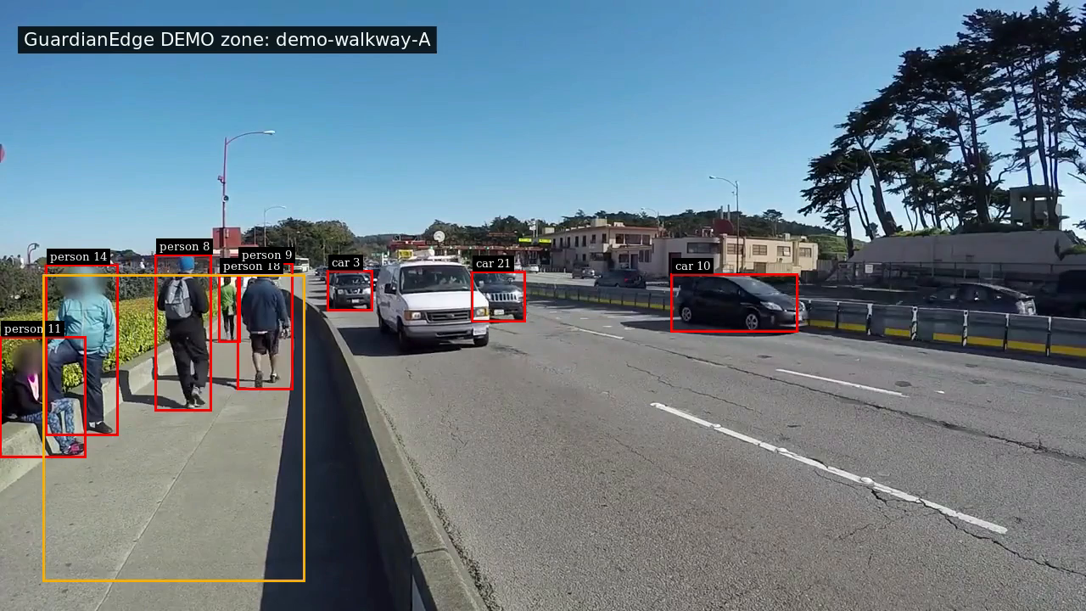
Actual frame from the DeepStream recording with the native demonstration-zone overlay. Boxes and tracker IDs come from real inference. The zone is not an actual site restriction.

12 Troubleshooting and known limitations
Symptom | Action or interpretation
No running container | Start Docker Desktop, launch pipegen in Ubuntu, and keep the app running. The configured runner requires craftifai-amd64-v3.
Video not found | Use the default local sample or pass an absolute path under the mounted Linux home directory.
Model assets missing after Git clone | Git excludes models and engines. Use the complete local export or obtain the catalog ONNX with the recorded checksum and rebuild using the original export workflow.
No module named guardianedge | First cd into the canonical repository. Run the overlay installer as python3 -m scripts.apply_zone_overlay.
No live window | Use --display as the second runner argument. Default mode records a video instead.
1970 appears in an event | This is explicit video-relative PTS representation, not a capture date. Inspect timestamp_basis and source_pts_ns.
Many lost-track events | Confidence dips, missed detections and tracker failures can fragment incidents. Do not interpret every interruption as a physical exit.
A different count after new video run | Tracking and confidence can vary. Exact 140-event replay expectation applies to the retained metadata, not every future inference run.

Practical limits
The configured local workflow is verified. Clean-machine standalone rebuilding is not. It requires compatible NVIDIA hardware, Docker, the official runtime image, source video and model assets. Incident analysis currently runs after video completion rather than as a continuous alert transport. No MQTT alarm, facial identification, calibrated safety accuracy, INT8 optimization or Jetson deployment is claimed.
The frequent track-loss count is material. Before real worker-safety use, validate detection quality on representative site footage, improve observation-gap handling, measure false-alert and missed-event rates, and verify stable tracking and latency under expected operating conditions.

13 Repository and participant handoff
Canonical development folder: /home/kishore/craftifai/guardianedge-ai. The Windows output mirror contains the code, local model assets, actual export, evidence and this guide. The GitHub repository is https://github.com/KishoreKavali0409/guardianedge-ai. Its last verified visibility is private; confirm visibility or grant judges access before submitting.

What belongs with the project
Item | Where to find it
Application and tests | guardianedge/ and tests/
Actual exported source | pipegen-export/ including run.sh, manifest, PipelineIR.json, configs, labels and C++ parsers
Zone configuration | config/pedestrian-demo.json
Genuine graph and speed evidence | evidence/pipeline-ir.png, tensorrt-speed.png and PipeGen-ModelStage.json
Real runtime evidence | evidence/live-run.png, zone-demo-frame.png, pipegen-metadata.json, incidents.jsonl and runtime logs
Final local video | evidence/zone-demo.mp4; video binaries are excluded from Git
Verification and operation | evidence/verification-summary.json, docs/reproduction.md, README.md and this guide

What the participant still controls
The participant will submit personally. Confirm the active Bangalore wildcard form and deadline, complete participant details and subjective feedback, make repository and evidence links accessible to judges, provide any permitted model/export attachments requested by the form, submit and retain the receipt. Coding verification is not proof that a form was submitted.

Primary project references
CraftifAI product and setup: https://developer.craftifai.com/products/pipegen
Track brief: https://docs.google.com/document/d/1nxSV7QiLeO3DvOLIdt2AOiZQtMqIYqt5m2tSAqqwmAY/edit
Original PDF form link: https://forms.gle/eJyeCKCG2UH757QZ8. It opens feedback first and links to project submission on its last page; confirm whether a newer wildcard link applies.

14 Genuine PipeGen screenshots
These are unmodified screenshots captured from the actual running PipeGen application. They are supporting evidence; the readable results and caveats are documented in the earlier chapters and in the original JSON report.
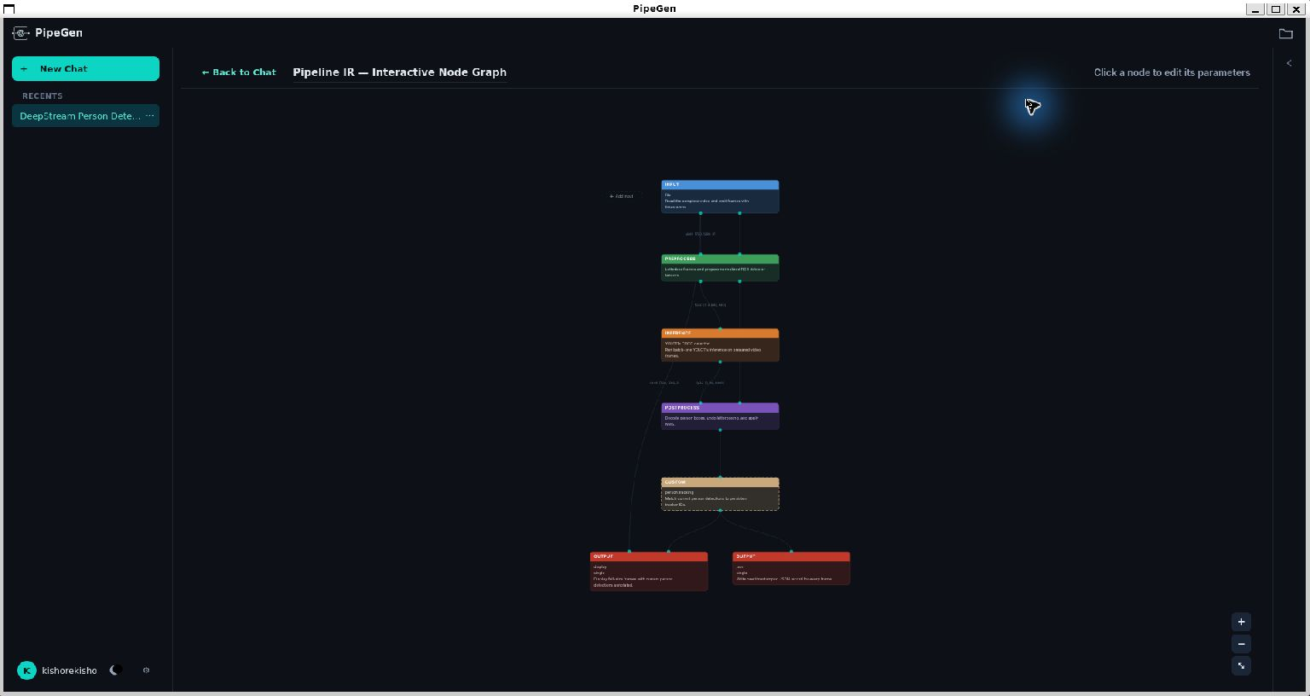
Actual PipeGen interactive Pipeline IR graph showing the video, inference, tracking and output structure.
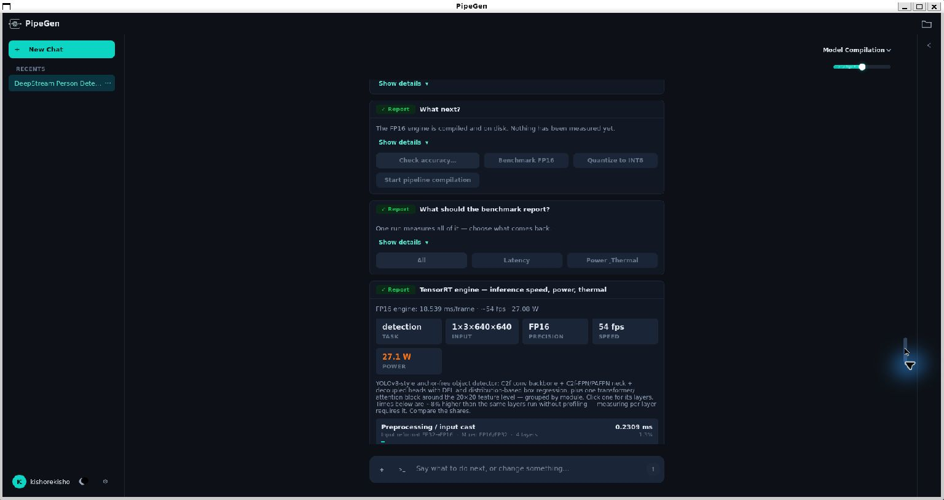
Actual PipeGen TensorRT speed report. The model benchmark must not be confused with full application throughput.

