24CSI024 - Data Structures and Algorithms
Unit 1: Introduction to Data Structures and Algorithms Arrays and Array-Based Techniques

Lab Workbook - 16.07.2026

CATEGORY: EASY

Question 1: Merging Two Sensor Logs (Two-Pointer)
Two weather stations, A and B, each recorded temperature readings independently and stored them in non-decreasing sorted order. Divya needs to merge both logs into one sorted array for her analysis dashboard without using a built-in sort function.

Approach Given
- Initialize one pointer for array A and one pointer for array B.
- Compare the current values and copy the smaller value to the output.
- Advance the pointer from which the value was copied.
- After one array is exhausted, copy the remaining elements of the other array.

Input Format
- The first line contains two integers N and M, the sizes of arrays A and B.
- The second line contains N sorted integers for array A.
- The third line contains M sorted integers for array B.

Output Format
- Print N + M space-separated integers representing the merged sorted array.

Code Constraints
- 1 <= N, M <= 10000
- -10000 <= arr[i] <= 10000

Sample Test Cases

Input 1:
3 4
1 5 9
2 3 8 10

Output 1:
1 2 3 5 8 9 10

Input 2:
2 2
0 0
-1 4

Output 2:
-1 0 0 4

Solution

Aim
To write a C program that merges two sorted sensor logs into one sorted array using the two-pointer technique.

Pseudocode

Read N, M, array A, and array B. Set i = 0, j = 0, and k = 0.
Compare A[i] and B[j] while both arrays still have elements.
Copy the smaller value into the merged array and move that pointer forward. Copy any remaining elements from A or B.
Print the merged sorted array.

C Program

int main() {

scanf("%d %d", &n, &m);

int a[n], b[m], merged[20000];
scanf("%d", &a[i]);
}
for (int j = 0; j < m; j++) { scanf("%d", &b[j]);
}

int i = 0, j = 0, k = 0; while (i < n && j < m) {
if (a[i] <= b[j]) { merged[k++] = a[i++];
} else {
merged[k++] = b[j++];
}
}

while (i < n) { merged[k++] = a[i++];
}
while (j < m) { merged[k++] = b[j++];
}

for (int x = 0; x < k; x++) { printf("%d", merged[x]); if (x < k - 1) {
printf(" ");
}
}
printf("\n"); return 0;
}

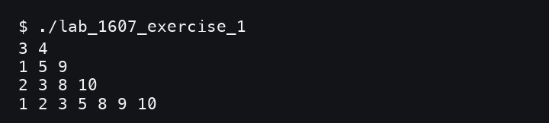
Screenshot of the Output
- Result
Thus, the two sorted sensor logs were merged correctly using the two-pointer method.

CATEGORY: EASY

Question 2: Locating the First Below-Threshold Reading (Linear Search)
Farhan monitors battery voltage readings from IoT sensors in the order they were received. He needs to find the first reading that drops below the safe threshold T.

Input Format
- The first line contains two integers N and T.
- The second line contains N integers representing the voltage readings.

Output Format
- Print the 0-indexed position of the first reading strictly less than T.
- If no such reading exists, print -1.

Code Constraints
- 1 <= N <= 10000
- -1000 <= arr[i], T <= 1000

Sample Test Cases

Input 1:
6 5
9 7 6 4 8 3

Output 1:
3

Input 2:
4 0
1 2 3 4

Output 2:
-1

Solution

Aim
To write a C program that finds the first index where a voltage reading drops below the given threshold.

Pseudocode

Read N, T, and the voltage readings. Set answer = -1.
Scan the readings from left to right.
If a reading is strictly less than T, store its index and stop. Print the stored index.

C Program
#include <stdio.h>

int main() {
int n, t;
scanf("%d %d", &n, &t);

int answer = -1;
for (int i = 0; i < n; i++) { int value;
scanf("%d", &value);
if (answer == -1 && value < t) { answer = i;
}
}

printf("%d\n", answer); return 0;
}

Screenshot of the Output

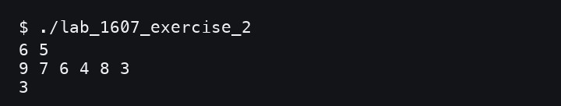

Result
Thus, the first below-threshold reading was located successfully using linear search.

CATEGORY: MEDIUM

Question 3: Maximum Rainwater Between Towers (Two-Pointer)
A telecom company has N transmission towers of varying heights in a row. During rain, water can collect between two towers, bounded by the shorter tower. Meera wants to find the pair of towers that can trap the maximum volume of water.

Approach Given
- Initialize left = 0, right = N - 1, and maxWater = 0.
- Calculate min(height[left], height[right]) * (right - left).
- Update maxWater if the current value is larger.
- Move the pointer at the shorter tower inward and repeat.

Input Format
- The first line contains N, the number of towers.
- The second line contains N non-negative integers representing tower heights.

Output Format
- Print the maximum water in the format: Max Water: X.

Code Constraints
- 2 <= N <= 10000
- 0 <= height[i] <= 10000

Sample Test Cases

Input 1:
9
1 8 6 2 5 4 8 3 7

Output 1:
Max Water: 49

Input 2:
4
1 1 1 1

Output 2:
Max Water: 3

Solution

Aim
To write a C program that finds the maximum water that can be trapped between two towers using two pointers.

Pseudocode

Read N and the tower heights.
Set left = 0, right = N - 1, and maxWater = 0.
Calculate the water between the towers at left and right. Update maxWater if the current water is larger.
Move the pointer at the shorter tower inward.
Repeat until the two pointers meet and print maxWater.

C Program
#include <stdio.h>

int main() {

scanf("%d", &n);

int h[n];

scanf("%d", &h[i]);

int left = 0, right = n - 1; long long maxWater = 0;
while (left < right) {

int shorter = h[left] < h[right] ? h[left] : h[right];

if (water > maxWater) { maxWater = water;
}

if (h[left] < h[right]) {

} else {
right--;
}
}

printf("Max Water: %lld\n", maxWater); return 0;
}

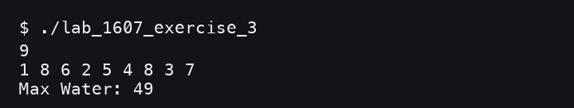
Screenshot of the Output
- Result
Thus, the maximum water between two towers was found successfully using the two-pointer technique.

CATEGORY: MEDIUM

Question 4: Finding the Insertion Point for a New Calibration Value (Binary Search)
A lab keeps a sorted array of calibration reference values. Whenever a new value arrives, Ibrahim needs to find the index where it should be inserted to keep the array sorted.

Approach Given
- Initialize low = 0 and high = N.
- While low < high, calculate mid.
- If arr[mid] < target, move low to mid + 1; otherwise, move high to mid.
- When the loop ends, low is the insertion index.

Input Format
- The first line contains N and target.
- The second line contains N integers in non-decreasing order.

Output Format
- Print the insertion index in the format: Insert At: X.

Code Constraints
- 1 <= N <= 10000
- -10000 <= arr[i], target <= 10000

Sample Test Cases

Input 1:
6 29
10 20 30 40 50 60

Output 1:
Insert At: 2

Input 2:
4 5
1 2 3 4

Output 2:
Insert At: 4

Solution

Aim
To write a C program that finds the correct sorted insertion index for a target value using binary search.

Pseudocode

Read N, target, and the sorted array. Set low = 0 and high = N.
While low < high, calculate mid.
If arr[mid] is less than target, move low to mid + 1. Otherwise, move high to mid.
Print low as the insertion index.

C Program
#include <stdio.h>

int main() {
int n, target;
scanf("%d %d", &n, &target);

int arr[n];
for (int i = 0; i < n; i++) { scanf("%d", &arr[i]);
}

int low = 0, high = n; while (low < high) {
int mid = low + (high - low) / 2;

if (arr[mid] < target) { low = mid + 1;
} else {
high = mid;
}
}

printf("Insert At: %d\n", low); return 0;
}

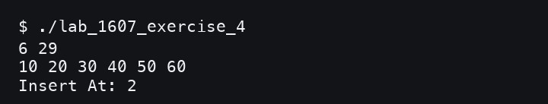
Screenshot of the Output
- Result
Thus, the correct insertion position was found successfully using binary search.

CATEGORY: HARD

Question 5: Locating a Packet in a Rotated Log Buffer (Modified Binary Search)
A circular network buffer stores log entries sorted by timestamp, but the array is rotated because it wraps around. Sana needs to locate a timestamp T in O(log N) time using a modified binary search.

Approach Given
- Initialize low = 0 and high = N - 1.
- Check the middle element.
- Identify whether the left half or right half is properly sorted.
- Search the half where the target can lie; otherwise search the other half.
- Repeat until the target is found or the range becomes empty.

Input Format
- The first line contains N and target.
- The second line contains N distinct integers representing the rotated sorted array.

Output Format
- Print the target index in the format: Found At: X.
- If the target is not present, print Found At: -1.

Code Constraints
- 1 <= N <= 10000
- -100000 <= arr[i], target <= 100000
- The array is sorted and rotated at an unknown pivot; all elements are distinct.

Sample Test Cases

Input 1:
7 0
4 5 6 7 0 1 2

Output 1:
Found At: 4

Input 2:
5 3
4 5 6 7 8

Output 2:
Found At: -1

Solution

Aim
To write a C program that searches for a target value in a rotated sorted array using modified binary search.

Pseudocode

Read N, target, and the rotated sorted array. Set low = 0 and high = N - 1.
While low <= high, calculate mid.
If arr[mid] equals target, print mid. Identify which half of the array is sorted. Search the half where the target can exist. If the target is not found, print -1.

C Program
#include <stdio.h>

int main() {
int n, target;
scanf("%d %d", &n, &target); int arr[n];

for (int i = 0; i < n; i++) { scanf("%d", &arr[i]);
}

int low = 0, high = n - 1; int answer = -1;

while (low <= high) {
int mid = low + (high - low) / 2;

if (arr[mid] == target) { answer = mid;
break;

if (arr[low] <= arr[mid]) {
if (arr[low] <= target && target < arr[mid]) { high = mid - 1;
} else {
low = mid + 1;
}
} else {
if (arr[mid] < target && target <= arr[high]) { low = mid + 1;
} else {
high = mid - 1;

}
}

printf("Found At: %d\n", answer); return 0;

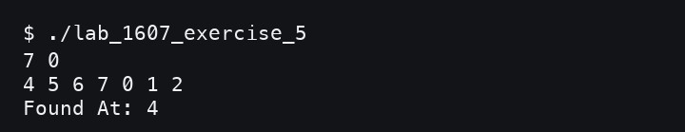
Screenshot of the Output
- Result
Thus, the target packet was located successfully in the rotated sorted buffer.

Viva Questions and Answers

In binary search, why must the array be sorted before we can safely discard half the search space at each step?
Sorting gives a clear order, so we know which half cannot contain the target. If the array is unsorted, discarding half may remove the correct answer.

Contrast the worst-case and best-case time complexity of linear search. When can it outperform binary search?
Best case is O(1) when the item is first; worst case is O(N). It can beat binary search on very small or unsorted data because it has simple sequential access.
- In rotated sorted array search, why can't we simply check arr[mid] < target like standard binary search?
Because rotation means one side may not follow normal sorted order. We must first identify which half is sorted, then check whether the target lies there.
- Why is two-pointer merge O(N + M) better than sorting the concatenated arrays from scratch?
Both input arrays are already sorted, so merging uses that structure directly. Sorting again costs more, usually O((N + M) log(N + M)).

In maximum rainwater between towers, why is it safe to move the shorter tower pointer inward?
The shorter tower limits the current water amount. Moving the taller tower cannot improve the limit, so only moving the shorter side may find a better answer.
- Why is low + (high - low) / 2 preferred over (low + high) / 2 in binary search?
It prevents integer overflow when low and high are very large. In C, overflow can happen if low + high exceeds the maximum value of int.

What trade-off comes with recursive binary search in C?
Recursive binary search uses extra stack space for each call. This matters in embedded systems because stack memory is often limited.

How would you modify binary search to find the last occurrence of a repeated value?
When arr[mid] equals the target, store mid and continue searching the right half. The last stored match becomes the last occurrence.

Why can't two-pointer merge be applied directly if one array is unsorted?
The method depends on the smallest remaining value being at the current pointer. If an array is unsorted, it must be sorted first or handled with another approach.

Why might linear search on a small array be faster than binary search in practice?
Linear search scans memory sequentially, which is cache-friendly. Binary search jumps around, so its overhead can be higher for small arrays.

