RAJALAKSHMI ENGINEERING COLLEGE

(An Autonomous Institution)
RAJALAKSHMI NAGAR, THANDALAM- 602 105



CS19P18 - DEEP LEARNING CONCEPTS
LABORATORY RECORD NOTEBOOK
NAME: KISHORE KAARTHIK S
YEAR/SEMESTER: IV / VII
BRANCH: COMPUTER SCIENCE AND ENGINEERING
REGISTER NO: 220701135
COLLEGE ROLL NO: 2116220701135
ACADEMIC YEAR: 2025 -2026


RAJALAKSHMI ENGINEERING COLLEGE

(An Autonomous Institution)
RAJALAKSHMI NAGAR, THANDALAM- 602 105

BONAFIDE CERTIFICATE

NAME: KISHORE KAARTHIK S BRANCH/SECTION: COMPUTER SCIENCE AND ENGINEERING/C ACADEMIC YEAR: 2025 -2026 SEMESTER: SEVEN

REGISTER NO:
220701135

Certified that this is a Bonafide record of work done by the above student in the CS19P18 - DEEP LEARNING CONCEPTS
during the year 2025 - 2026

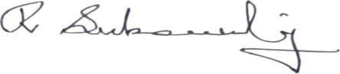
Signature of Faculty In-charge

Submitted for the Practical Examination Held on: ………………………………………...
Internal Examiner External Examiner

INDEX

EX.NO | DATE | NAME OF THE EXPERIMENT | PAGE NO | STAFF SIGN
1 | 14/07/2025 | Create a neural network to recognize handwritten digits using MNIST dataset | 5 | 
2 | 21/07/2025 | Build a Convolutional Neural Network with Keras/TensorFlow | 8
3 | 28/07/2025 | Image Classification on CIFAR-10 Dataset using CNN | 11
4 | 04/08/2025 | Transfer learning with CNN  and Visualization | 13
5 | 25/08/2025 | Build a Recurrent Neural Network using Keras/Tensorflow | 17
6 | 15/09/2025 | Sentiment Classification of Text using RNN | 19
7 | 22/09/2025 | Build autoencoders with keras/tensorflow | 21
8 | 29/09/2025 | Object detection with yolo3 | 24
9 | 29/09/2025 | Build GAN with Keras/TensorFlow | 27
10 | 06/10/2025 | Mini Project | 31

INSTALLATION AND CONFIGURATION OF TENSORFLOW

Aim:
To install and configure TensorFlow in the anaconda environment in Windows 10.

Procedure:
- Download Anaconda Navigator and install.

- Open Anaconda prompt

- Create a new environment dlc with python 3.7 using the following command: conda create -n dlc python=3.7
- Activate newly created environment dlc using the following command: conda activate dlc
- In dlc prompt, install tensorflow using the following command: pip install tensorflow
- Next install Tensorflow-datasets using the following command: pip install tensorflow-datasets

- Install scikit-learn package using the following command: pip install scikit-learn
- Install pandas package using the following command: pip install pandas
- Lastly, install jupyter notebook pip install jupyter notebook

- Open jupyter notebook by typing the following in dlc prompt: jupyter notebook
- Click create new and then choose python 3 (ipykernel)

- Give the name to the file

- Type the code and click Run button to execute (eg. Type import tensorflow and then run)

EX NO: 1 CREATE A NEURAL NETWORK TO RECOGNIZE HANDWRITTEN
DATE:14/07/2025 DIGITS USING MNIST DATASET

Aim:
To build a handwritten digit’s recognition with MNIST dataset.

Procedure:
- Download and load the MNIST dataset.
- Perform analysis and preprocessing of the dataset.
- Build a simple neural network model using Keras/TensorFlow.
- Compile and fit the model.
- Perform prediction with the test dataset.
- Calculate performance metrics.

Code:

import numpy as np import tensorflow as tf
from tensorflow import keras

from sklearn.datasets import make_classification from sklearn.model_selection import train_test_split from sklearn.preprocessing import StandardScaler from sklearn.metrics import accuracy_score
# Generate a synthetic dataset

X, y = make_classification(n_samples=1000, n_features=20, random_state=42) # Split the dataset into training and testing sets X_train, X_test, y_train, y_test = train_test_split(X, y, test_size=0.2, random_state=42) # Standardize features (optional but often beneficial) scaler = StandardScaler()

X_train = scaler.fit_transform(X_train)

X_test = scaler.transform(X_test # Define the model
model = keras.Sequential([ keras.layers.Input(shape=(X_train.shape[1],)), # Input layer
keras.layers.Dense(64, activation='relu'), # Hidden layer with 64 neurons and ReLU activation keras.layers.Dense(1, activation='sigmoid') # Output layer with 1 neuron and sigmoid activation
)

# Train the model

history = model.fit(X_train, y_train, epochs=10, batch_size=32, validation_split=0.1) # Evaluate the model on the test set
y_pred = model.predict(X_test) y_pred_classes = (y_pred > 0.5).astype(int) # Calculate accuracy on the test set
accuracy = accuracy_score(y_test, y_pred_classes) # Calculate test loss test_loss = model.evaluate(X_test, y_test)
print(f"Test accuracy: {accuracy * 100:.2f}%") print(f"Test loss: {test_loss[0]:.4f}")

Output:
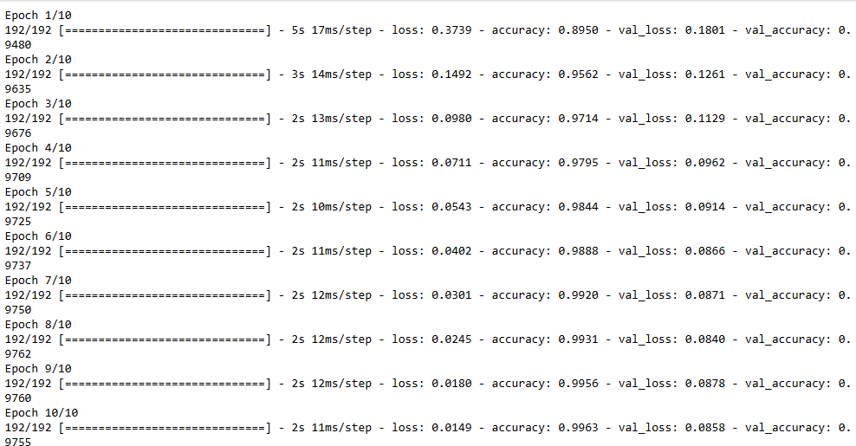

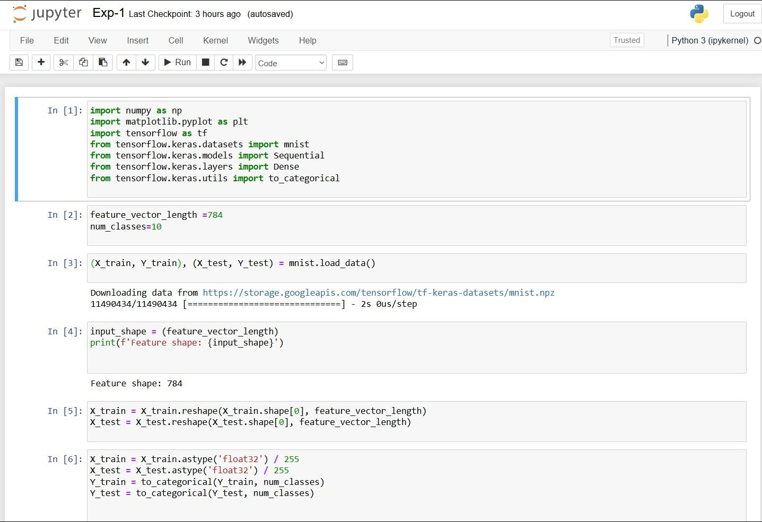

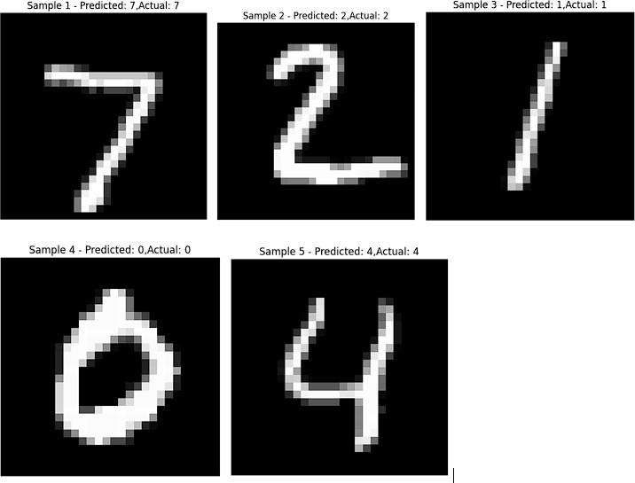

Result:
Thus, the implementation to build a simple neural network using Keras/TensorFlow has been successfully executed.

EX NO:2 BUILD A CONVOLUTIONAL NEURAL NETWORK
DATE:21/07/2025 USING KERAS/TENSORFLOW

Aim:
To implement a Convolutional Neural Network (CNN) using Keras/TensorFlow to recognize and classify handwritten digits from the MNIST dataset with high accuracy.

Procedure:
- Import required libraries (TensorFlow/Keras, NumPy, etc.).
- Load the MNIST dataset from Keras.
- Normalize and reshape the image data.
- Convert labels to one-hot encoded vectors.
- Build a CNN model with Conv2D, MaxPooling, Flatten, and Dense layers.
- Compile the model using categorical crossentropy and Adam optimizer.
- Train the model on training data.
- Evaluate the model on test data.
- Display accuracy and predictions.

Code:

import tensorflow as tf
from tensorflow.keras.models import Sequential
from tensorflow.keras.layers import Conv2D, MaxPooling2D, Flatten, Dense, Dropout from tensorflow.keras.datasets import mnist
import matplotlib.pyplot as plt import numpy as np

(train_images, train_labels), (test_images, test_labels) = mnist.load_data() train_images = train_images / 255.0
test_images = test_images / 255.0
train_images = train_images.reshape(-1, 28, 28, 1)
test_images = test_images.reshape(-1, 28, 28, 1) model = Sequential([
Conv2D(32, (3, 3), activation='relu', input_shape=(28, 28, 1)),
MaxPooling2D((2, 2)),
Conv2D(64, (3, 3), activation='relu'),
MaxPooling2D((2, 2)), Flatten(),
Dense(64, activation='relu'), Dropout(0.5),
Dense(10, activation='softmax')
])

model.compile(optimizer='adam', loss='sparse_categorical_crossentropy', metrics=['accuracy'])

history = model.fit(train_images, train_labels, epochs=5,
batch_size=64, validation_split=0.2)

test_loss, test_acc = model.evaluate(test_images, test_labels) print(f"\n Test accuracy: {test_acc:.4f}")
print(f" Test loss: {test_loss:.4f}")

plt.figure(figsize=(12, 5))
plt.subplot(1, 2, 1)
plt.plot(history.history['accuracy'], label='Train Accuracy', marker='o') plt.plot(history.history['val_accuracy'], label='Validation Accuracy', marker='o') plt.title('Training and Validation Accuracy')
plt.xlabel('Epoch') plt.ylabel('Accuracy') plt.legend() plt.grid(True)

plt.subplot(1, 2, 2)
plt.plot(history.history['loss'], label='Train Loss', marker='o') plt.plot(history.history['val_loss'], label='Validation Loss', marker='o') plt.title('Training and Validation Loss')
plt.xlabel('Epoch') plt.ylabel('Loss') plt.legend() plt.grid(True) plt.tight_layout() plt.show()

predictions = model.predict(test_images) predicted_labels = np.argmax(predictions, axis=1)

num_samples = 10
plt.figure(figsize=(15, 4))

for i in range(num_samples):
plt.subplot(1, num_samples, i + 1) plt.imshow(test_images[i].reshape(28, 28), cmap='gray') plt.title(f"Pred: {predicted_labels[i]}\nTrue: {test_labels[i]}")

plt.axis('off')
plt.suptitle("Sample Predictions on Test Images", fontsize=16) plt.show()

Output:
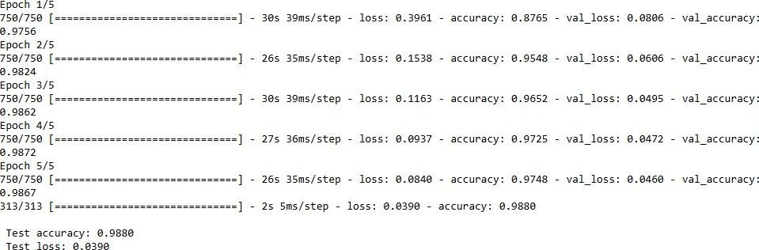
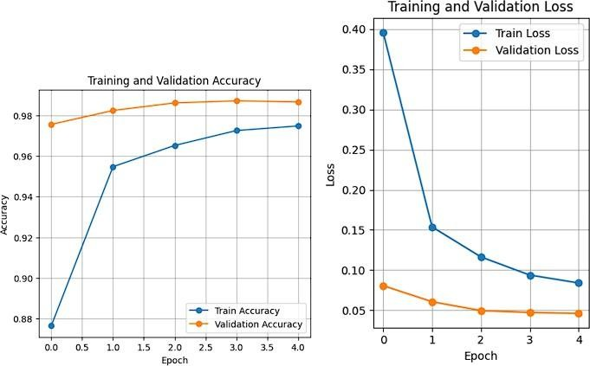
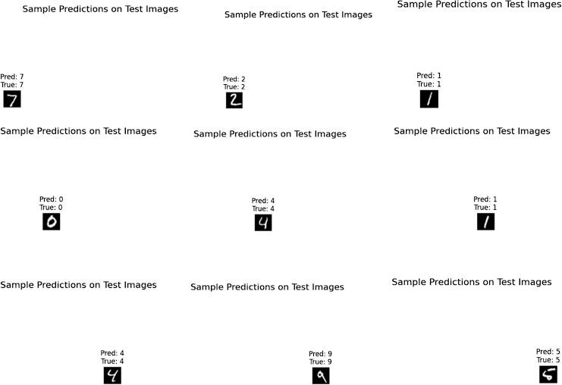

Result:
Thus, the Convolution Neural Network (CNN) using Keras / Tensorflow to recognize and classify handwritten digits from MNIST dataset has been implemented successfully.

EX NO: 3 IMAGE CLASSIFICATION ON CIFAR-10 DATASET USING CNN
DATE:28/07/2025

Aim:
To build a Convolutional Neural Network (CNN) model for classifying images from the CIFAR-10 dataset into one of the ten categories such as airplanes, cars, birds, cats, etc.

Procedure:
- Download and load the CIFAR-10 dataset using Keras/TensorFlow.
- Visualize and analyze sample images from the dataset. 3, Preprocess the data:
  - Normalize the pixel values (divide by 255)
  - Convert class labels to one-hot encoded format
- Build a CNN model using Keras/TensorFlow:
  - Include convolutional, pooling, flatten, and dense layers.
- Compile the model with a suitable loss function and optimizer.
- Train the model using training data and validate using test data.
- Evaluate the model using accuracy and loss on the test dataset.
- Perform predictions on new/unseen CIFAR-10 images.
9 Visualize prediction results with sample images and predicted labels.

Code:
import tensorflow as tf import numpy as np
import matplotlib.pyplot as plt
(x_train, y_train), (x_test, y_test) = tf.keras.datasets.cifar10.load_data() x_train = x_train.astype('float32') / 255.0
x_test = x_test.astype('float32') / 255.0
y_train = tf.keras.utils.to_categorical(y_train, 10) y_test = tf.keras.utils.to_categorical(y_test, 10) model = tf.keras.Sequential()
model.add(tf.keras.layers.Conv2D(32, (3,3), activation='relu', input_shape=(32,32,3))) model.add(tf.keras.layers.MaxPooling2D((2,2))) model.add(tf.keras.layers.Conv2D(64, (3,3), activation='relu')) model.add(tf.keras.layers.MaxPooling2D((2,2))) model.add(tf.keras.layers.Conv2D(64, (3,3), activation='relu')) model.add(tf.keras.layers.Flatten())
model.add(tf.keras.layers.Dense(64, activation='relu')) model.add(tf.keras.layers.Dense(10, activation='softmax')) model.compile(optimizer='adam', loss='categorical_crossentropy', metrics=['accuracy']) model.fit(x_train, y_train, epochs=10, batch_size=64, validation_split=0.2) class_names = ['airplane', 'automobile', 'bird', 'cat', 'deer',

'dog', 'frog', 'horse', 'ship', 'truck']
index = int(input("Enter an index (0 to 9999) for test image: ")) if index < 0 or index >= len(x_test):
print("Invalid index. Using index 0 by default.") index = 0
test_image = x_test[index]
true_label = np.argmax(y_test[index])
prediction = model.predict(np.expand_dims(test_image, axis=0)) predicted_label = np.argmax(prediction)
plt.figure(figsize=(4, 4))
resized_image = tf.image.resize(test_image, [128, 128]) plt.imshow(resized_image)
plt.axis('off')
plt.title(f"Predicted: {class_names[predicted_label]}\nActual: {class_names[true_label]}") plt.show()

Output:
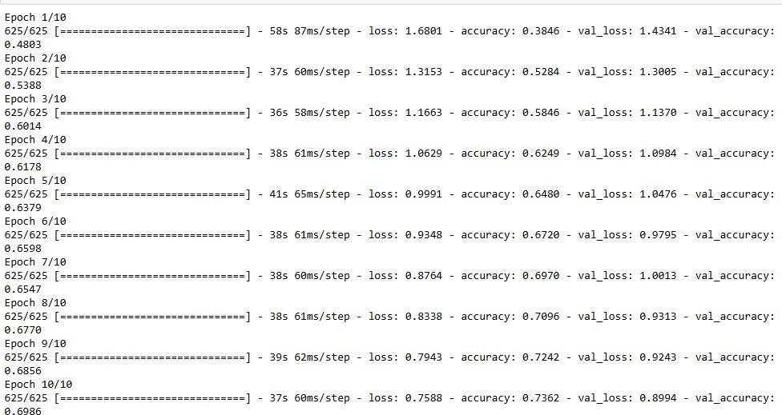
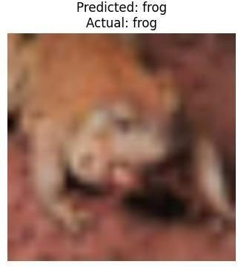

Result
Thus, the Convolution Neural Network (CNN) model for classifying images from CIFAR-10 dataset is implemented successfully.

Ex No: 4 TRANSFER LEARNING WITH CNN AND VISUALIZATION
DATE:04/08/2025

Aim:
To build a convolutional neural network with transfer learning and perform visualization

Procedure:
- Download and load the dataset.
- Perform analysis and preprocessing of the dataset.
- Build a simple neural network model using Keras/TensorFlow.
- Compile and fit the model.
- Perform prediction with the test dataset.
- Calculate performance metrics.

Code:
conda install -c conda-forge python-graphviz -y import tensorflow as tf
from tensorflow.keras.applications import VGG16 from tensorflow.keras.models import Sequential
from tensorflow.keras.layers import Dense, Flatten, Dropout from tensorflow.keras.optimizers import Adam
from tensorflow.keras.datasets import cifar10 from tensorflow.keras.utils import plot_model import matplotlib.pyplot as plt
import numpy as np
(x_train, y_train), (x_test, y_test) = cifar10.load_data() x_train = x_train / 255.0
x_test = x_test / 255.0
vgg_base = VGG16(weights='imagenet', include_top=False, input_shape=(32, 32, 3)) for layer in vgg_base.layers:
layer.trainable = False model = Sequential() model.add(vgg_base) model.add(Flatten())
model.add(Dense(512, activation='relu')) model.add(Dropout(0.5)) model.add(Dense(10, activation='softmax'))
model.compile(optimizer=Adam(learning_rate=0.0001), loss='sparse_categorical_crossentropy', metrics=['accuracy'])
plot_model(model, to_file='cnn.png', show_shapes=True,

show_layer_names=True, dpi=300) plt.figure(figsize=(20, 20))
img = plt.imread('cnn.png') plt.imshow(img) plt.axis('off')
plt.show()
history = model.fit(x_train, y_train, epochs=10,
batch_size=32, validation_split=0.2)

test_loss, test_acc = model.evaluate(x_test, y_test) print(f'Test Loss: {test_loss:.4f}')
print(f'Test Accuracy: {test_acc * 100:.2f}%') plt.figure(figsize=(12, 5))

plt.subplot(1, 2, 1)
plt.plot(history.history['accuracy'], label='Train Accuracy') plt.plot(history.history['val_accuracy'], label='Validation Accuracy') plt.title('Model Accuracy')
plt.xlabel('Epoch') plt.ylabel('Accuracy') plt.legend()

plt.subplot(1, 2, 2)
plt.plot(history.history['loss'], label='Train Loss') plt.plot(history.history['val_loss'], label='Validation Loss') plt.title('Model Loss')
plt.xlabel('Epoch') plt.ylabel('Loss') plt.legend() plt.tight_layout() plt.show()
class_names = ['airplane', 'automobile', 'bird', 'cat', 'deer', 'dog', 'frog', 'horse', 'ship', 'truck']
sample = x_test[0].reshape(1, 32, 32, 3) prediction = model.predict(sample)
predicted_class = class_names[np.argmax(prediction)]

plt.imshow(x_test[0]) plt.title(f"Predicted: {predicted_class}") plt.axis('off')
plt.show()

Output:
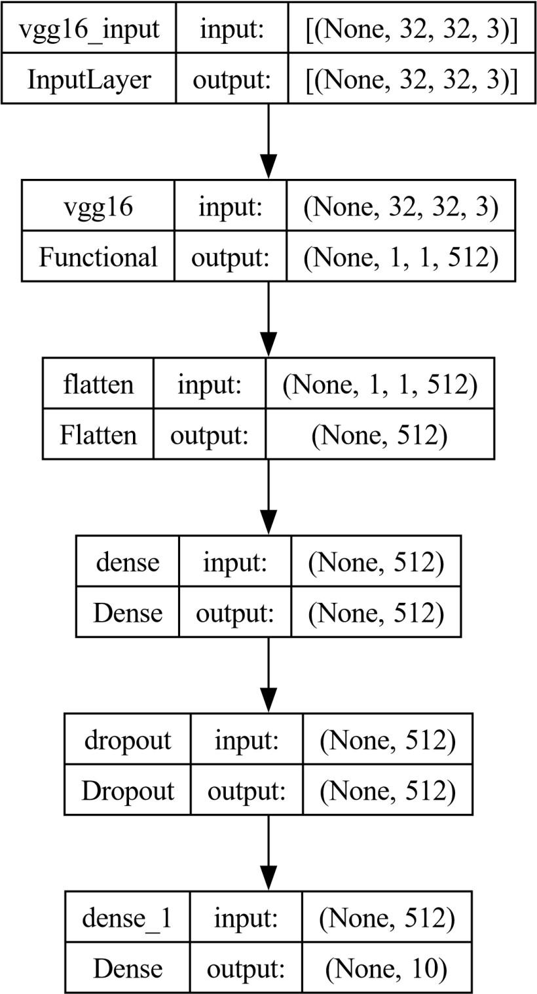

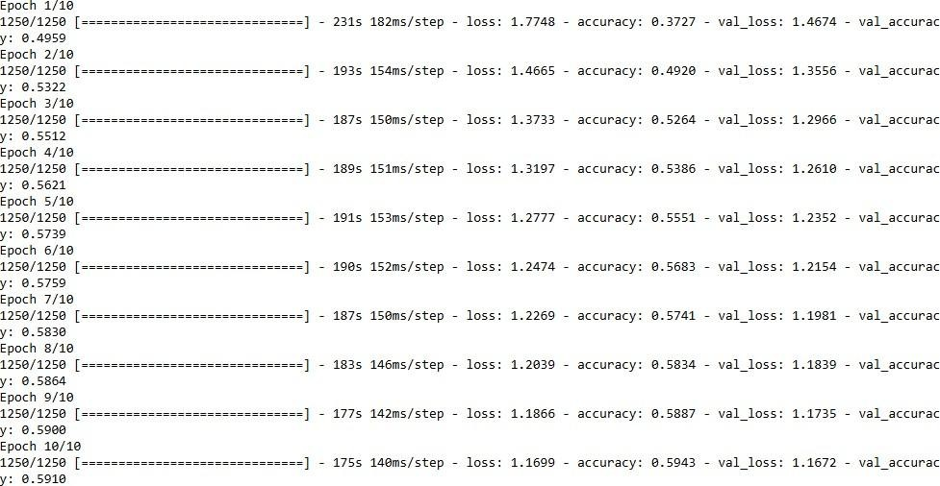
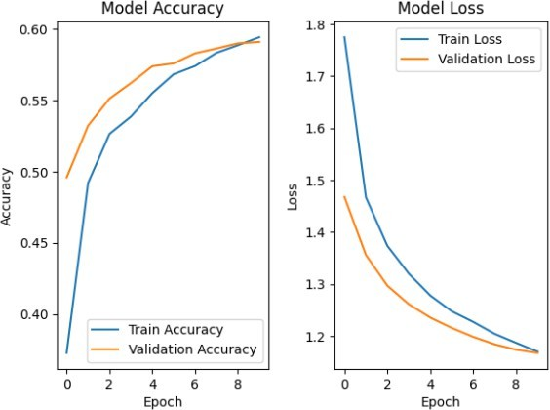
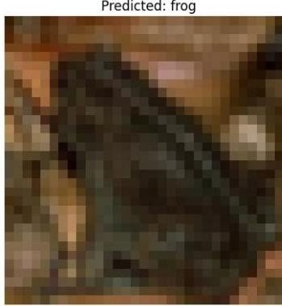

Result
Thus, the Convolution Neural Network (CNN) with transfer learning and perform visualization has been implemented successfully

EX NO: 5 BUILD A RECURRENT NEURAL NETWORK (RNN) USING
DATE:25/08/2025 KERAS/TENSORFLOW

Aim:
To build a recurrent neural network with Keras/TensorFlow.

Procedure:
- Download and load the dataset.
- Perform analysis and preprocessing of the dataset.
- Build a simple neural network model using Keras/TensorFlow.
- Compile and fit the model.
- Perform prediction with the test dataset.
- Calculate performance metrics.

Code:
import numpy as np import tensorflow as tf
from tensorflow.keras.models import Sequential from tensorflow.keras.layers import SimpleRNN, Dense from sklearn.metrics import r2_score np.random.seed(0)
seq_length = 10
num_samples = 1000
X = np.random.randn(num_samples, seq_length, 1)
y = X.sum(axis=1) + 0.1 * np.random.randn(num_samples, 1) split_ratio = 0.8
split_index = int(split_ratio * num_samples) X_train, X_test = X[:split_index], X[split_index:] y_train, y_test = y[:split_index], y[split_index:] model = Sequential()
model.add(SimpleRNN(units=50, activation='relu', input_shape=(seq_length, 1))) model.add(Dense(units=1))
model.compile(optimizer='adam', loss='mean_squared_error') model.summary()
batch_size = 30
epochs = 50 # Reduced epochs for quick demonstration history = model.fit(
X_train, y_train, batch_size=batch_size, epochs=epochs, validation_split=0.2
)
test_loss = model.evaluate(X_test, y_test) print(f'Test Loss: {test_loss:.4f}')

y_pred = model.predict(X_test) r2 = r2_score(y_test, y_pred)
print(f'Test Accuracy (R^2): {r2:.4f}')

new_data = np.random.randn(5, seq_length, 1) predictions = model.predict(new_data) print("Predictions for new data:") print(predictions)

Output:
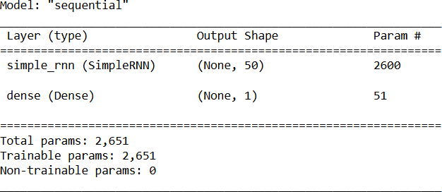
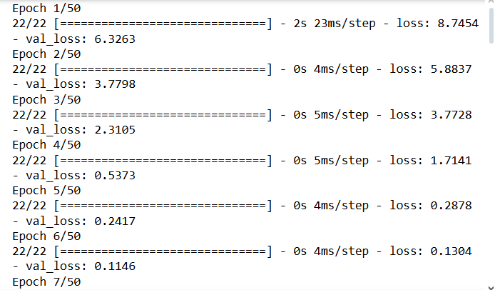
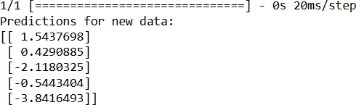

Result:
Thus, the Recurrent Neural Network (RNN) has been implemented using Tensorflow.

EX NO: 6 SENTIMENT CLASSIFICATION OF TEXT USING RNN
DATE:15/09/2025

Aim:
To implement a Recurrent Neural Network (RNN) using Keras/TensorFlow for classifying the sentiment of text data (e.g., movie reviews) as positive or negative.

Procedure:
- Import necessary libraries.

- Load and preprocess the text dataset (e.g., IMDb).

- Pad sequences and prepare labels.

- Build an RNN model with Embedding and SimpleRNN layers.

- Compile the model with loss and optimizer.

- Train the model on training data.

- Evaluate the model on test data.

- Predict sentiment for new inputs

Code:
import numpy as np
from tensorflow.keras.datasets import imdb
from tensorflow.keras.preprocessing.sequence import pad_sequences from tensorflow.keras.models import Sequential
from tensorflow.keras.layers import Embedding, SimpleRNN, Dense max_words = 5000
max_len = 200
(x_train, y_train), (x_test, y_test) = imdb.load_data(num_words=max_words) X_train = pad_sequences(x_train, maxlen=max_len)
X_test = pad_sequences(x_test, maxlen=max_len) model = Sequential()
model.add(Embedding(input_dim=max_words, output_dim=32, input_length=max_len)) model.add(SimpleRNN(32))
model.add(Dense(1, activation='sigmoid'))
model.compile(optimizer='adam', loss='binary_crossentropy', metrics=['accuracy']) print("Training...")
model.fit(X_train, y_train, epochs=2, batch_size=64, validation_split=0.2) loss, acc = model.evaluate(X_test, y_test)
print(f"\nTest Accuracy: {acc:.4f}") word_index = imdb.get_word_index()
reverse_word_index = {v: k for (k, v) in word_index.items()}

def decode_review(review):
return " ".join([reverse_word_index.get(i - 3, "?") for i in review]) sample_review = X_test[0]
prediction = model.predict(sample_review.reshape(1, -1))[0][0] print("\nReview text:", decode_review(x_test[0]))
print("Predicted Sentiment:", "Positive " if prediction > 0.5 else "Negative ")

Output:
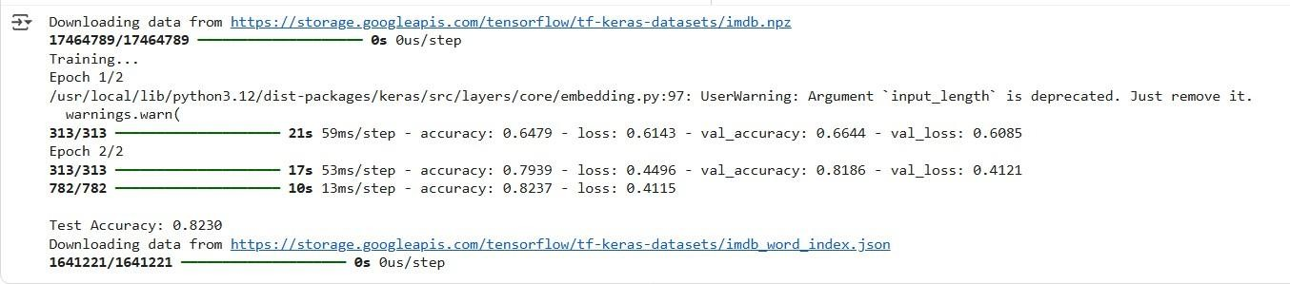
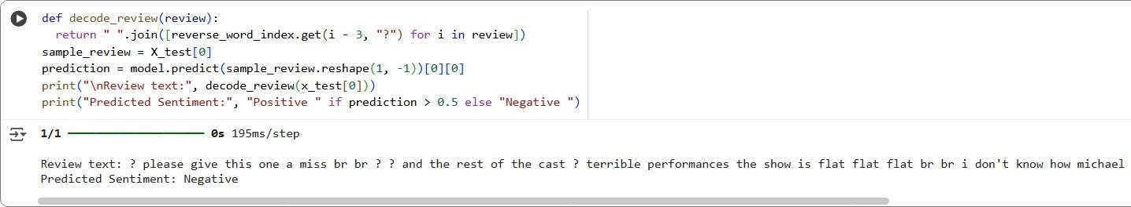

Result
Thus, the Recurrent Neural Network (RNN) using Keras has been implemented for classifying sentiment of text successfully.

Ex No: 7 BUILD AUTOENCODERS WITH KERAS/TENSORFLOW
DATE:22/09/2025

Aim:
To build autoencoders with Keras/TensorFlow.

Procedure:
- Download and load the dataset.
- Perform analysis and preprocessing of the dataset.
- Build a simple neural network model using Keras/TensorFlow.
- Compile and fit the model.
- Perform prediction with the test dataset.
- Calculate performance metrics.

Code:

import numpy as np
import matplotlib.pyplot as plt
from keras.layers import Input, Dense from keras.models import Model from keras.datasets import mnist
(x_train, _), (x_test, _) = mnist.load_data() x_train = x_train.astype('float32') / 255. x_test = x_test.astype('float32') / 255.
x_train = x_train.reshape((len(x_train), np.prod(x_train.shape[1:]))) x_test = x_test.reshape((len(x_test), np.prod(x_test.shape[1:]))) input_img = Input(shape=(784,))
encoded = Dense(32, activation='relu')(input_img) decoded = Dense(784, activation='sigmoid')(encoded) autoencoder = Model(input_img, decoded)
autoencoder.compile(optimizer='adam', loss='binary_crossentropy') autoencoder.fit(x_train, x_train,
epochs=50, batch_size=256, shuffle=True,
validation_data=(x_test, x_test))
test_loss = autoencoder.evaluate(x_test, x_test) decoded_imgs = autoencoder.predict(x_test) threshold = 0.5
correct_predictions = np.sum( np.where(x_test >= threshold, 1, 0) ==
np.where(decoded_imgs >= threshold, 1, 0)) total_pixels = x_test.shape[0] * x_test.shape[1] test_accuracy = correct_predictions / total_pixels print("Test Loss:", test_loss)

print("Test Accuracy:", test_accuracy) n = 10
plt.figure(figsize=(20, 4)) for i in range(n):
# Display original
ax = plt.subplot(2, n, i + 1) plt.imshow(x_test[i].reshape(28, 28)) plt.gray() ax.get_xaxis().set_visible(False) ax.get_yaxis().set_visible(False)
# Display reconstruction with threshold ax = plt.subplot(2, n, i + 1 + n)
reconstruction = decoded_imgs[i].reshape(28, 28) plt.imshow(np.where(reconstruction >= threshold, 1.0, 0.0)) plt.gray()
ax.get_xaxis().set_visible(False) ax.get_yaxis().set_visible(False) plt.show()

Output:
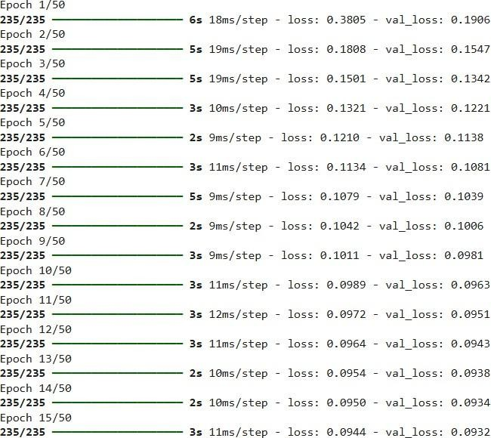

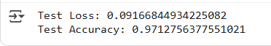
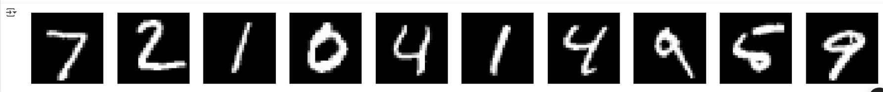

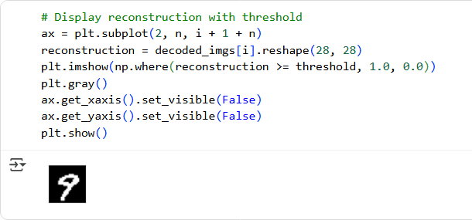

Result
Thus, an Autoencoder has been implemented using Keras / Tensorflow.

Ex No:8 OBJECT DETECTION WITH YOLO3
DATE:29/09/2025

Aim:
To build an object detection model with YOLO3 using Keras/TensorFlow.

Procedure:
- Download and load the dataset.
- Perform analysis and preprocessing of the dataset.
- Build a simple neural network model using Keras/TensorFlow.
- Compile and fit the model.
- Perform prediction with the test dataset.
- Calculate performance metrics.

Code:
import cv2
import matplotlib.pyplot as plt import numpy as np

# Define the paths to the YOLOv3 configuration, weights, and class names files cfg_file = '/content/yolov3.cfg'
weight_file = '/content/yolov3.weights' namesfile = '/content/coco.names'

# Load the YOLOv3 model
net = cv2.dnn.readNet(weight_file, cfg_file)

# Load class names
with open(namesfile, 'r') as f:
classes = f.read().strip().split('\n')

# Load an image for object detection image_path = '/content/hit.jpg' image = cv2.imread(image_path)

# Get the height and width of the image height, width = image.shape[:2]

# Create a blob from the image
blob = cv2.dnn.blobFromImage(image, 1/255.0, (416, 416), swapRB=True, crop=False) net.setInput(blob)

# Get the names of the output layers
layer_names = net.getUnconnectedOutLayersNames()

# Run forward pass

outs = net.forward(layer_names)

# Initialize lists to store detected objects' information class_ids = []
confidences = [] boxes = []

# Define a confidence threshold for object detection conf_threshold = 0.5

# Loop over the detections for out in outs:
for detection in out:
scores = detection[5:] class_id = np.argmax(scores) confidence = scores[class_id]
if confidence > conf_threshold:
# Object detected
center_x = int(detection[0] * width) center_y = int(detection[1] * height) w = int(detection[2] * width)
h = int(detection[3] * height)

# Rectangle
coordinates x = int(center_x - w / 2) y = int(center_y - h / 2)

class_ids.append(class_id) confidences.append(float(confidence)
) boxes.append([x, y, w, h])

# Apply non-maximum suppression to eliminate overlapping boxes nms_threshold = 0.4
indices = cv2.dnn.NMSBoxes(boxes, confidences, conf_threshold, nms_threshold)

# Draw bounding boxes and labels on the image for i in indices.flatten(): # flatten for compatibility x, y, w, h = boxes[i]
label = str(classes[class_ids[i]]) confidence = confidences[i]

cv2.rectangle(image, (x, y), (x + w, y + h), (0, 255, 0), 2)
cv2.putText(image, f'{label} {confidence:.2f}', (x, y - 10), cv2.FONT_HERSHEY_SIMPLEX, 0.8, (0, 255, 0), 2)

# Display the result in Jupyter Notebook plt.figure(figsize=(10, 8))
plt.imshow(cv2.cvtColor(image, cv2.COLOR_BGR2RGB)) plt.axis('off')
plt.show()

Output:
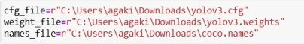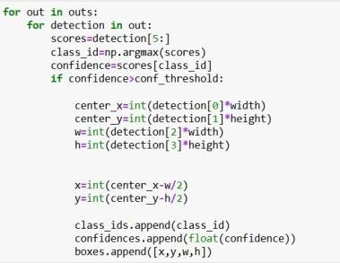
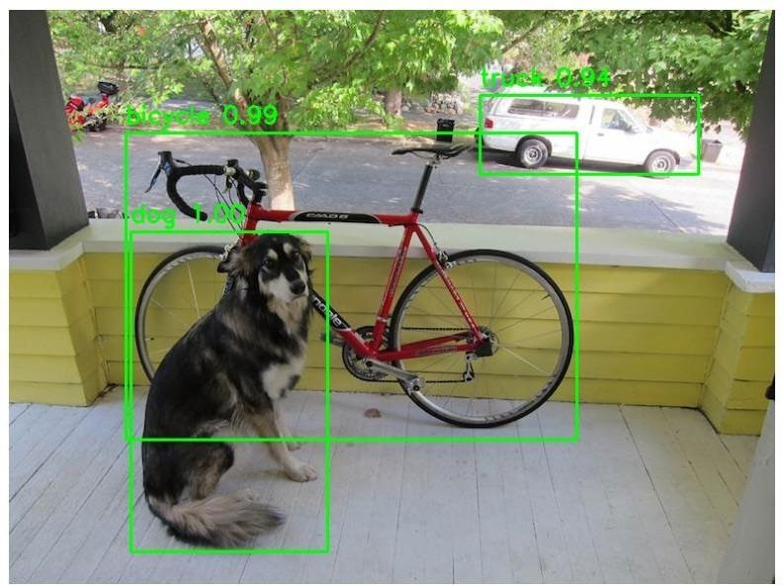

Result
Thus, object detection using YOLOV5 has been implemented successfully.

Ex No: 9 BUILD GENERATIVE ADVERSARIAL NEURAL NETWORK
DATE:29/09/2025

Aim:
To build a generative adversarial neural network using Keras/TensorFlow.

Procedure:
- Download and load the dataset.
- Perform analysis and preprocessing of the dataset.
- Build a simple neural network model using Keras/TensorFlow.
- Compile and fit the model.
- Perform prediction with the test dataset.
- Calculate performance metrics.

Code:

import numpy as np import tensorflow as tf
from tensorflow.keras.layers import Dense
from tensorflow.keras.models import Sequential from tensorflow.keras.optimizers import Adam from sklearn.datasets import load_iris
import matplotlib.pyplot as plt

# Load and Preprocess the Iris Dataset iris = load_iris()
x_train = iris.data

# Build the GAN model def build_generator():
model = Sequential()
model.add(Dense(128, input_shape=(100,), activation='relu')) model.add(Dense(4, activation='linear')) # Output 4 features return model

def build_discriminator():
model = Sequential()
model.add(Dense(128, input_shape=(4,), activation='relu')) model.add(Dense(1, activation='sigmoid'))
return model

def build_gan(generator, discriminator): discriminator.trainable = False
model = Sequential() model.add(generator) model.add(discriminator)

return model

generator = build_generator() discriminator = build_discriminator()
gan = build_gan(generator, discriminator)

# Compile the Models
generator.compile(loss='mean_squared_error', optimizer=Adam(0.0002, 0.5))
discriminator.compile(loss='binary_crossentropy', optimizer=Adam(0.0002, 0.5), metrics=['accuracy'])
gan.compile(loss='binary_crossentropy', optimizer=Adam(0.0002, 0.5))

# Training Loop epochs = 200
batch_size = 16

for epoch in range(epochs):
# Train discriminator
idx = np.random.randint(0, x_train.shape[0], batch_size) real_samples = x_train[idx]
fake_samples = generator.predict(np.random.normal(0, 1, (batch_size, 100)), verbose=0)

real_labels = np.ones((batch_size, 1)) fake_labels = np.zeros((batch_size, 1))

d_loss_real = discriminator.train_on_batch(real_samples, real_labels) d_loss_fake = discriminator.train_on_batch(fake_samples, fake_labels)

# Train generator
noise = np.random.normal(0, 1, (batch_size, 100)) g_loss = gan.train_on_batch(noise, real_labels)

# Print progress
print(f"Epoch {epoch}/{epochs} | Discriminator Loss: {0.5 * (d_loss_real[0] + d_loss_fake[0])} | Generator Loss: {g_loss}")

# Generating Synthetic Data
synthetic_data = generator.predict(np.random.normal(0, 1, (150, 100)), verbose=0)

# Create scatter plots for feature pairs plt.figure(figsize=(12, 8))
plot_idx = 1

for i in range(4):
for j in range(i + 1, 4): plt.subplot(2, 3, plot_idx)

plt.scatter(x_train[:, i], x_train[:, j], label='Real Data', c='blue', marker='o', s=30) plt.scatter(synthetic_data[:, i], synthetic_data[:, j], label='Synthetic Data', c='red', marker='x', s=30)
plt.xlabel(f'Feature {i + 1}') plt.ylabel(f'Feature {j + 1}') plt.legend()
plot_idx += 1

plt.tight_layout() plt.show()

Output:
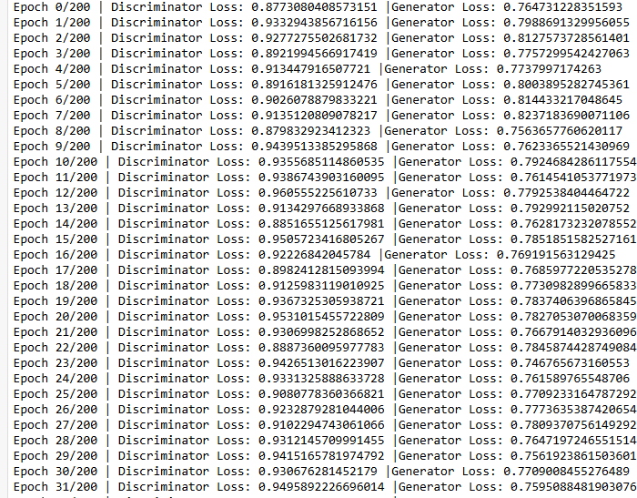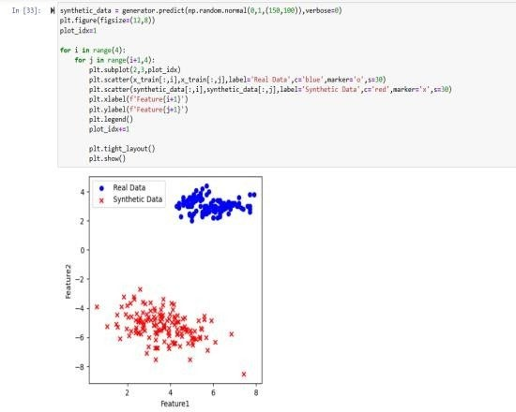

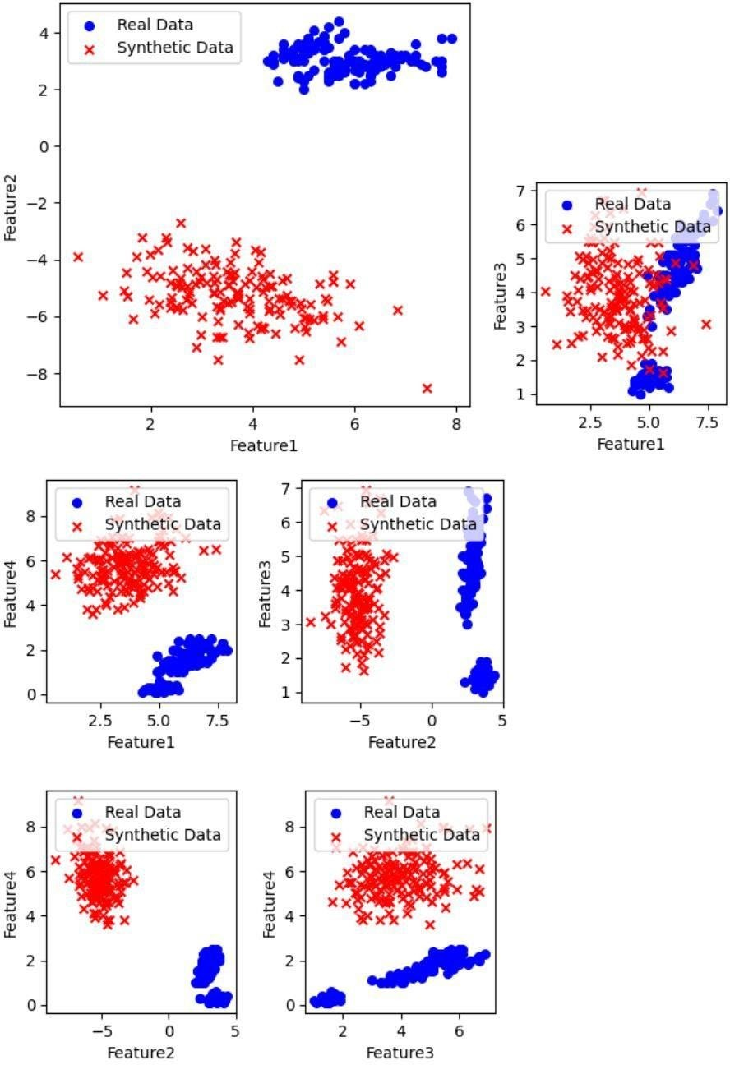

Result
Thus, a generative adversarial neural network using Keras / Tensorflow has been implemented successfully.

Ex No:10 MINI PROJECT
DATE:06/10/2025

BreedVision

Aim:
Dog Breed Identification using Deep Learning (ResNet18).

Code:
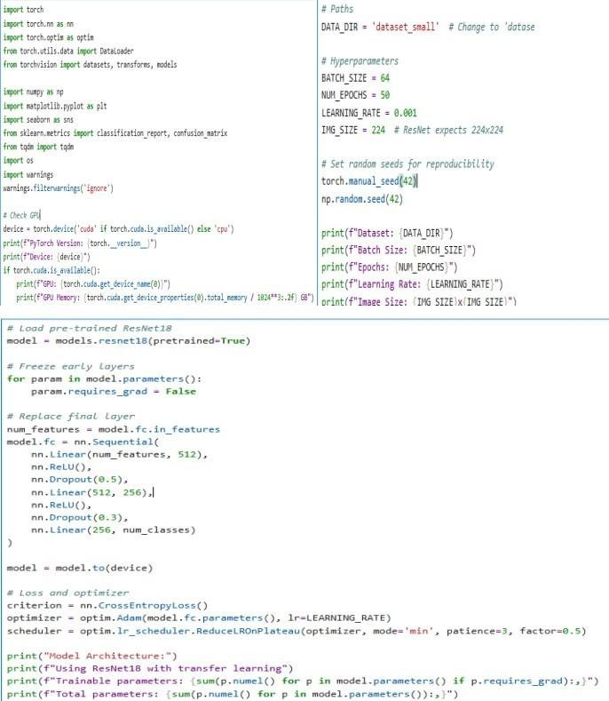

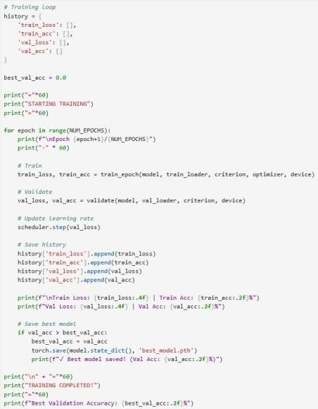

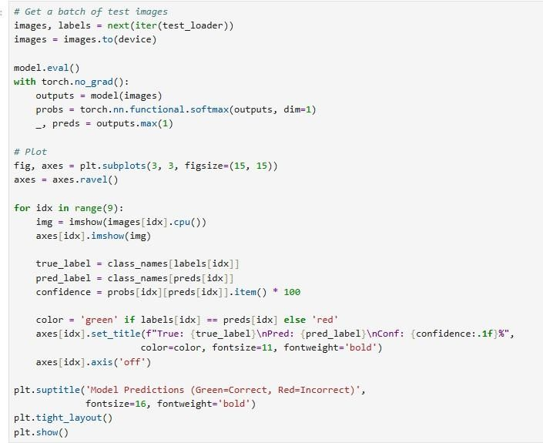

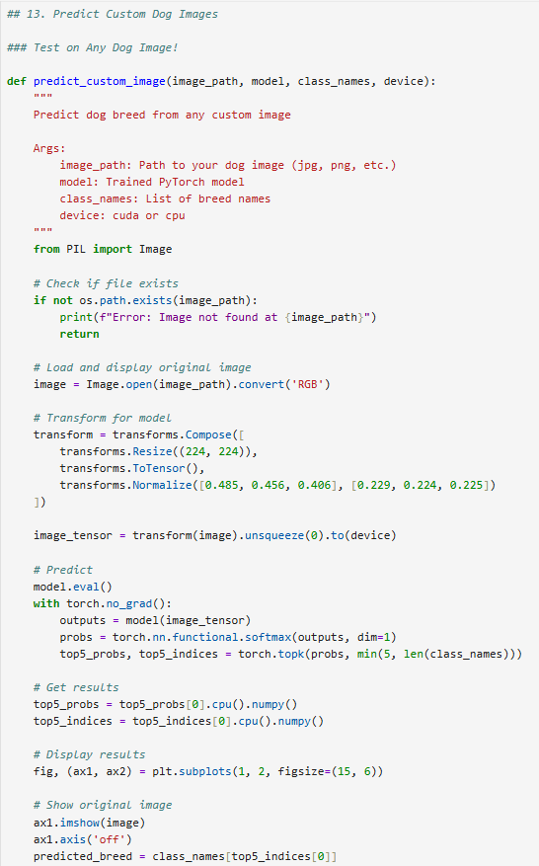

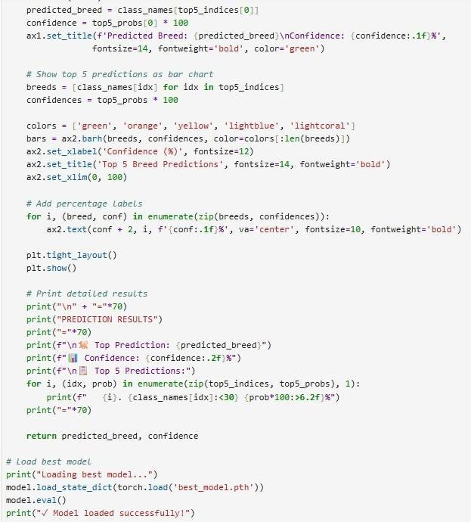

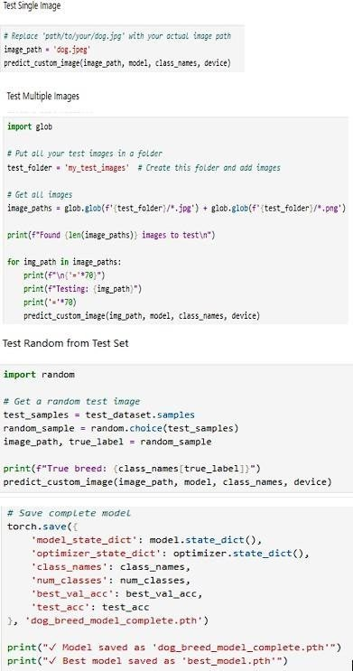

Output:
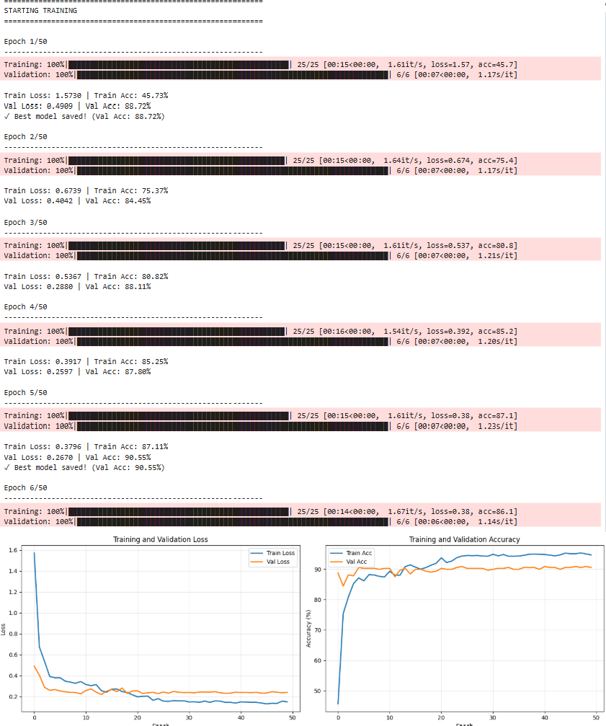

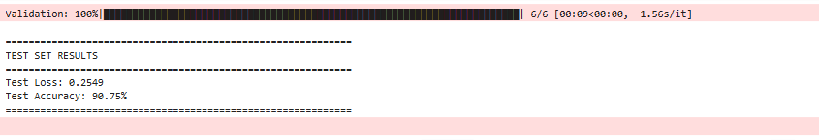

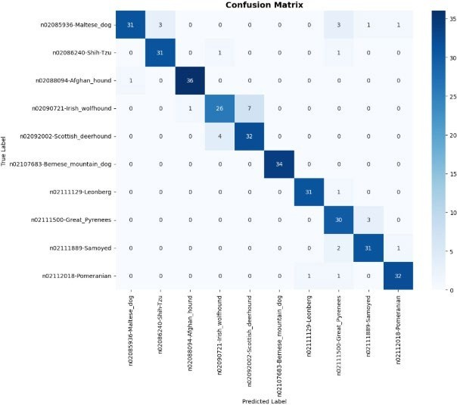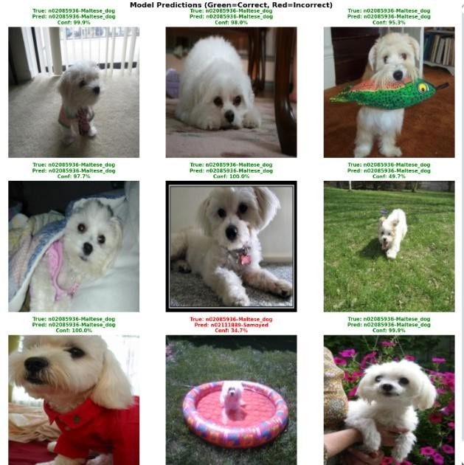

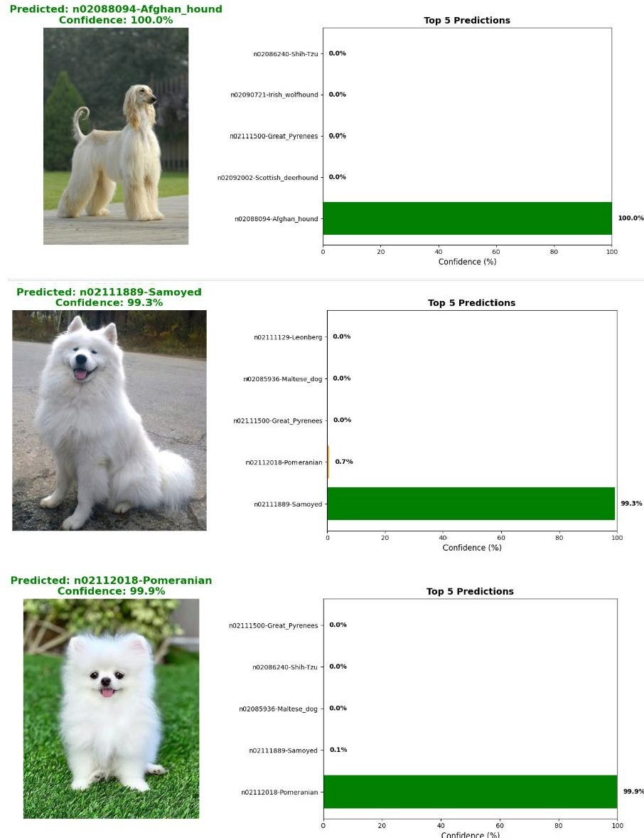

Result:
Thus, an Deep Learning model to identify different dog breeds has been implemented successfully.

