**Assessment Parameters**

* *Complete flow of the application with exception handling -70%*
* *Comments/best practice, coding standards- 10%*
* *Execution of the application (Output) – 20%*
* *ScreenShot should be submitted along with the solution*
* *The solution(Project) created by the trainee should have the name like AppName_Empid Ex:ABCCorp_675467*
* *Code with compilation errors will not be considered for evaluation*

**Problem Statement:** Income Tax Department needs an application where the salaried employee can view the TDS details.

**Architecture: MVC**

Develop a Spring Boot REST TDS Application that displays TDS information .

**Table Script:**

CREATE TABLE tds_master (

id NUMBER PRIMARY KEY,

deductor_name VARCHAR2(50) NOT NULL,

deductor_pan VARCHAR2(50) NOT NULL,

tds_deposited number NOT NULL);

INSERT INTO tds_master VALUES(1,'xyz finance LTD', 'AB192',1200);

INSERT INTO tds_master VALUES(2,'alpha software inc','AB193', 3200);

INSERT INTO tds_master VALUES(3,'TME Consultancy', 'CD897', 1500);

INSERT INTO tds_master VALUES(4,'Zenox Consultancy', 'XY192', 5500);

commit;

/

**Screen Prototype:**

Make use of POSTMAN to fetch the TDS details with given ID and display as given in the next screen with TDS details, if ID found in the database.

.

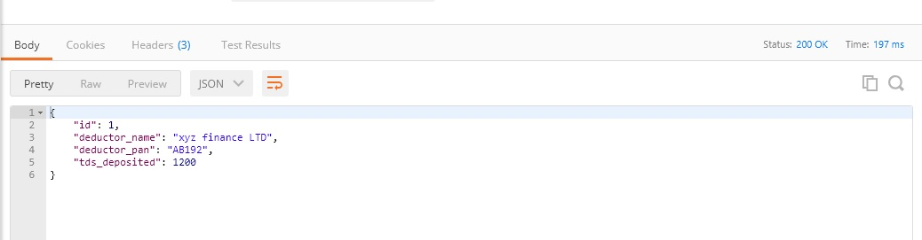

If the query not found in the databse below error Message should be displayed ..

Note :- use User Defined Exception for error handling .

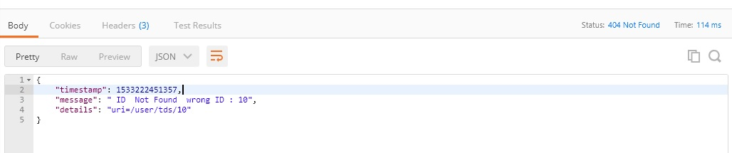

**Mark Distribution: [Marks:61]**

|  |  |  |
| --- | --- | --- |
| Home Page Design | | 2 |
| Mapping user actions to controller class method | | 4 |
| Correct class level annotations and auto wiring used | | 5 |
| Exception Handler | | 6 |
| Correct method signature and use of annotations in Controller class method | | 4 |
| Correct service and DAO layer method signatures | 4 |
| SPRING DATA JPA implementation and its query processing | | 20 |
| Success Message with TDS details | | 10 |
| Wrong ID message | | 6 |

**Application Architecture: [Marks:9]**

* **Mark Distribution:**

|  |  |
| --- | --- |
| Package structure according to coding standard | 3 |
| Service layer and DAO Layer interfaces created with proper delegation between the layers | 3 |
| Following Naming convention/coding standards | 3 |

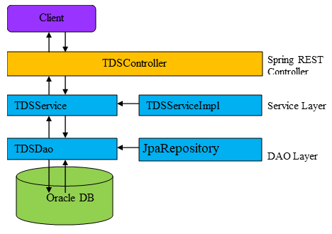

Note:

* Use Spring Data JPA functionality for retrieving data.
* Use Spring Global Exception handling for wrong ID
* Use appropriate package structure for each of the applications components.