AI-Driven Exploration and Prediction of Company Registration Trends with (RoC)

**Phase 3 – Development Part 1**

**Document submission**

**Project Title :**

**AI – Driven Exploration and prediction**

**Phase 3 Topic :**

**Read (loading) and Preprocessing given dataset**

**By**

**H.KISHORE KANNAN**

**922121106034**

**au922121106034**

**SSMIET**

**Introduction**

AI-Driven Exploration and Prediction of Company Registration Trends with the Registrar of Companies (RoC) involves leveraging artificial intelligence (AI) methodologies to analyze data related to company registrations maintained by the Registrar of Companies. The Registrar of Companies is an authoritative entity responsible for overseeing and maintaining the registry of companies within a specific jurisdiction.

By employing AI algorithms, this approach aims to extract valuable insights and forecast patterns from the data compiled by the RoC. These insights can aid in understanding trends, emerging patterns, and other significant aspects of company registrations, empowering stakeholders to make informed decisions in the business landscape.

The utilization of AI in this domain encompasses data collection, processing, exploratory data analysis, machine learning modeling, and predictive analytics to anticipate future trends in company registrations. Ultimately, this AI-driven approach enables proactive decision-making and strategic planning based on comprehensive analyses of registration trends and associated data.

**Overview**

**For Phase 3**

**1.Data collecting**

**2.Data Preprocessing**

**Analyzing Data**

**Statistics Summary**

**3.Exploratory Data Analysis (EDA)**

**Univariate Analysis**

**Bivariate Analysis**

**Multivariate Analysis**

**Data Collecting**

AI-Driven Exploration and Prediction of Company Registration Trends with the Registrar of Companies (RoC), the process of collecting data involves gathering relevant information from given sources to create a comprehensive dataset for analysis and modeling

**Given Data**

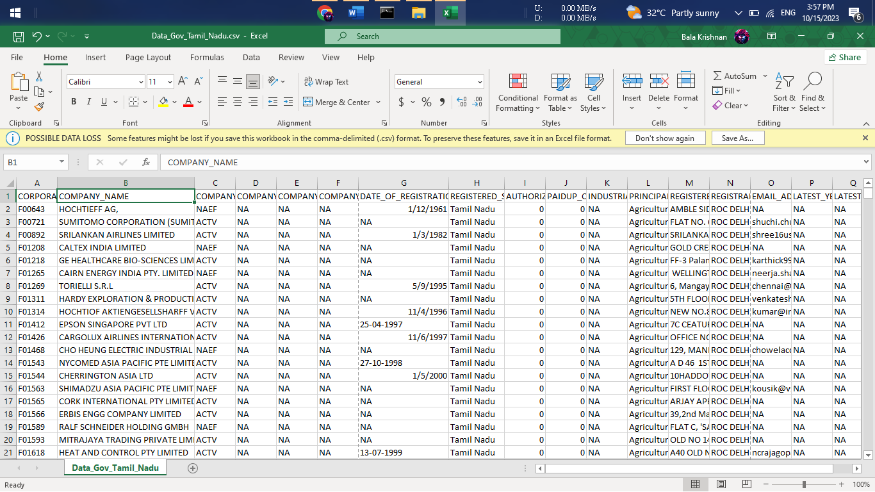

**Import Python library**

The first step involved in ML using python is understanding and playing around with our data using libraries

Import all libraries which are required for our analysis, such as Data Loading, Statistical analysis, Visualizations, Data Transformations, Merge and Joins, etc.

Pandas and Numpy have been used for Data Manipulation and numerical Calculations

Matplotlib and Seaborn have been used for Data visualizations.

**Program :**

import pandas as pd

import numpy as np

import matplotlib.pyplot as plt

import seaborn as sns

(Optional)

# to ignore warnings

import warnings

warnings.filterwarnings('ignore')

**Reading Dataset**

The Pandas library offers a wide range of possibilities for loading data into the pandas DataFrame from files like JSON, .csv, .xlsx, .sql, .pickle, .html, .txt, images etc.

Given data are available in a tabular format of CSV files. It is trendy and easy to access. Using the read_csv() function, data can be converted to a pandas DataFrame.

We have stored the data in the DataFrame data.

**Program**

data=pd.read_csv("Data_Gov_Tamil_Nadu.csv",encoding='latin-1')

df

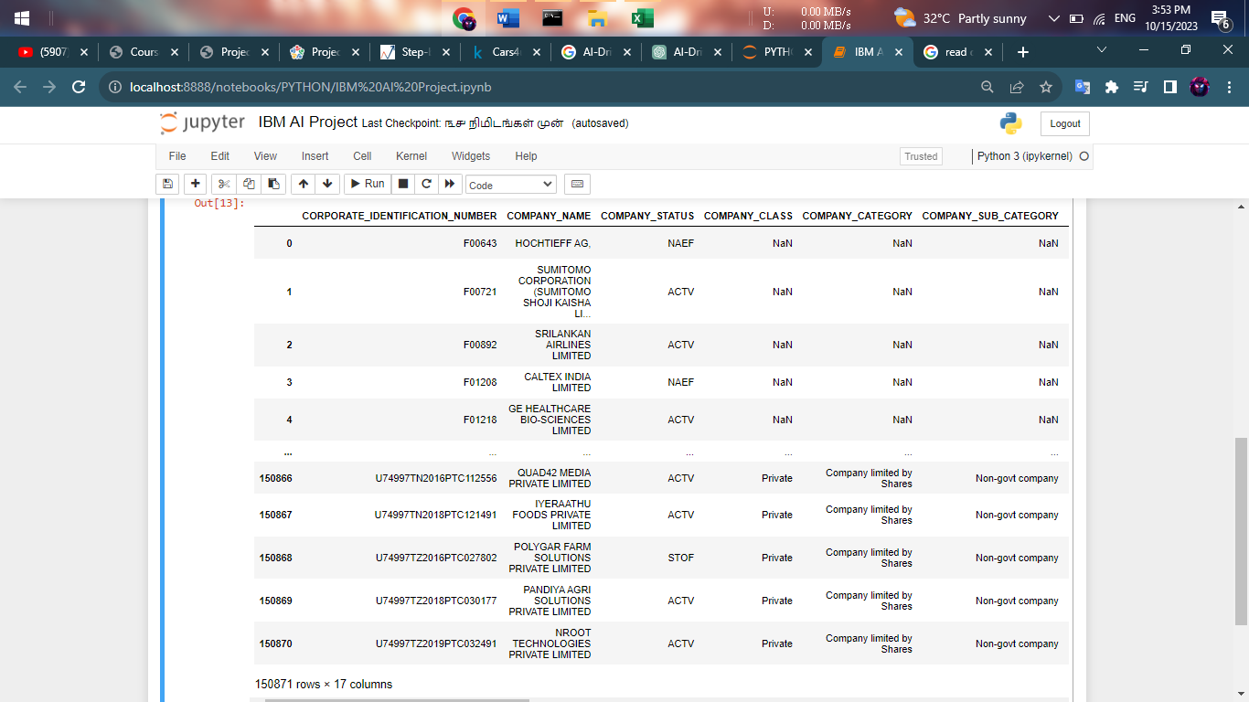

**Analyzing the Data**

**# head()** will display the top 5 observations of the dataset

df.head()

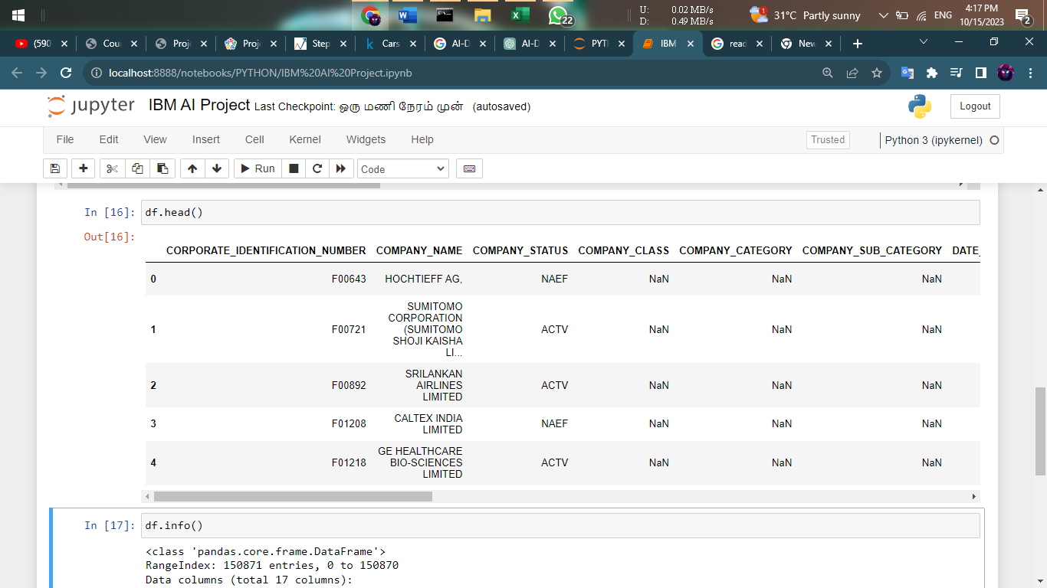

**# tail()** will display the last 5 observations of the dataset

df.tail()

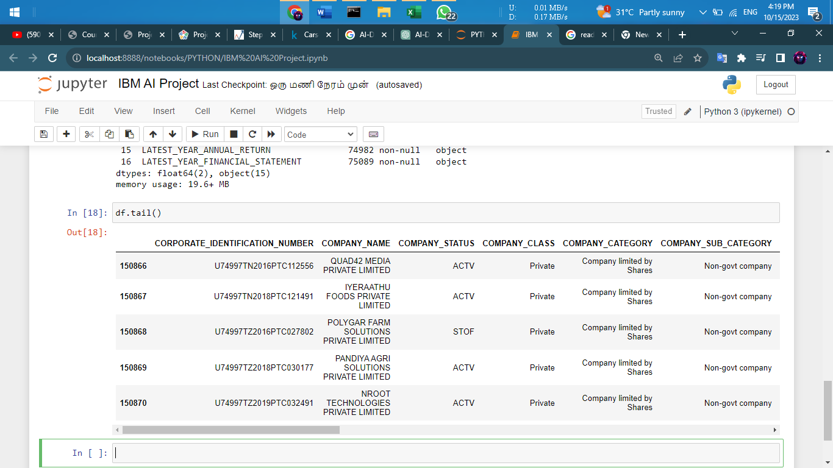

**# info()**helps to understand the data type and information about data, including the number of records in each column, data having null or not null, Data type, the memory usage of the dataset

df.info()

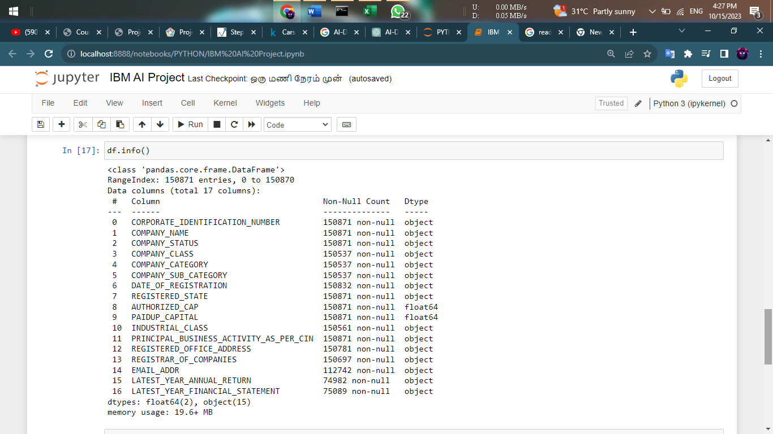

**Check for Duplication**

#### # nunique() based on several unique values in each column and the data description, we can identify the continuous and categorical columns in the data. Duplicated data can be handled or removed based on further analysis

#### df.nunique()

#### 

**Missing Values Calculation**

**# isnull()**is widely been in all pre-processing steps to identify null values in the data

# **data.isnull().sum()** is used to get the number of missing records in each column

df.isnull().sum()

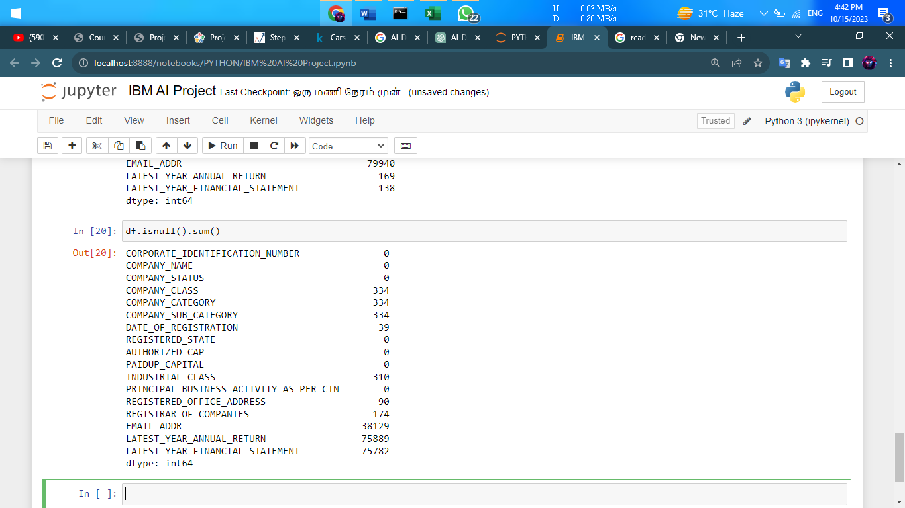

**Statistics Summary**

describe() function gives all statistics summary of data

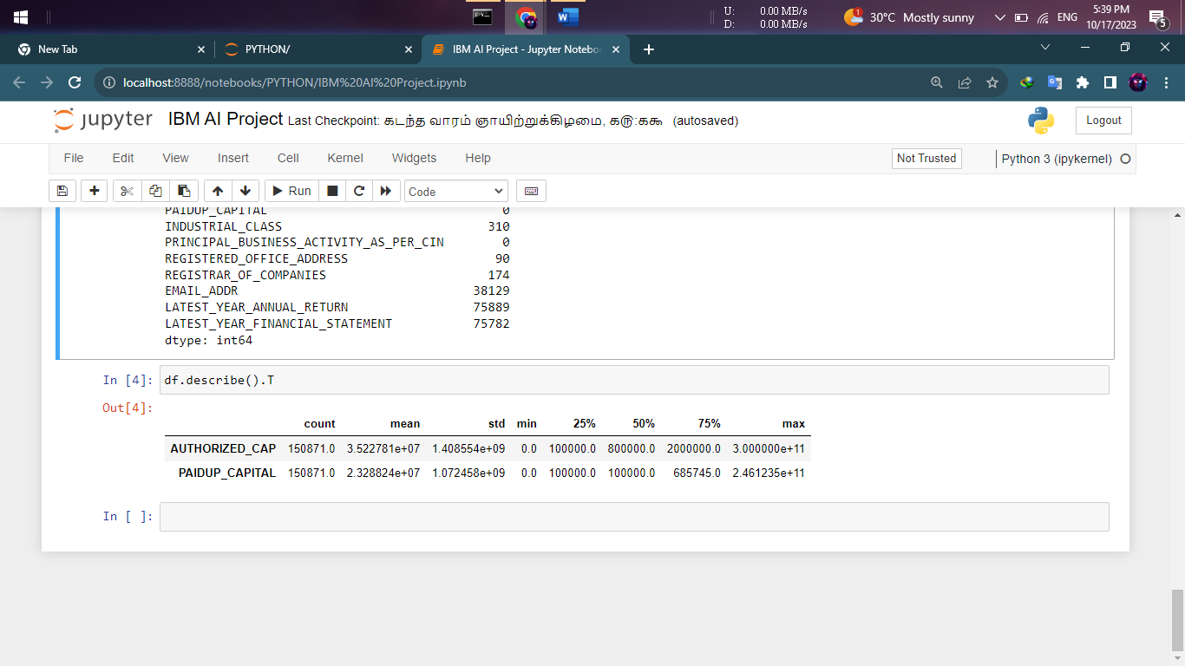

**#describe()**– Provide a statistics summary of data belonging to numerical datatype such as int, float Can include Count, Mean, Standard Deviation, median, mode, minimum value, maximum value, range, standard deviation, etc.

**Exploratory Data Analysis**

Exploratory Data Analysis refers to the crucial process of performing initial investigations on data to discover patterns to check assumptions with the help of summary statistics and graphical representations.

EDA can be leveraged to check for outliers, patterns, and trends in the given data.

EDA helps to find meaningful patterns in data.

EDA provides in-depth insights into the data sets to solve our business problems.

EDA gives a clue to impute missing values in the dataset

**EDA Univariate Analysis**

Analyzing the dataset by taking one variable at a time

**Program :**

# Select the specified columns for analysis

columns_for_analysis = ['CORPORATE_IDENTIFICATION_NUMBER', 'COMPANY_NAME', 'COMPANY_STATUS','COMPANY_CLASS', 'COMPANY_CATEGORY','COMPANY_SUB_CATEGORY','DATE_OF_REGISTRATION','REGISTERED_STATE','AUTHORIZED_CAP','PAIDUP_CAPITAL','INDUSTRIAL_CLASS','PRINCIPAL_BUSINESS_ACTIVITY_AS_PER_CIN','REGISTERED_OFFICE_ADDRESS','REGISTRAR_OF_COMPANIES','EMAIL_ADDR','LATEST_YEAR_ANNUAL_RETURN','LATEST_YEAR_FINANCIAL_STATEMENT']

# Subset the DataFrame with the selected columns

selected_df = df[columns_for_analysis]

# Display basic statistical summaries for numerical columns

print(selected_df.describe())

# Univariate analysis for categorical columns

for col in selected_df.select_dtypes(include='object'):

print(f'\n{col} Value Counts:\n{selected_df[col].value_counts()}\n')

**OUTPUT :**

AUTHORIZED_CAP PAIDUP_CAPITAL

count 1.508710e+05 1.508710e+05

mean 3.522781e+07 2.328824e+07

std 1.408554e+09 1.072458e+09

min 0.000000e+00 0.000000e+00

25% 1.000000e+05 1.000000e+05

50% 8.000000e+05 1.000000e+05

75% 2.000000e+06 6.857450e+05

max 3.000000e+11 2.461235e+11

CORPORATE_IDENTIFICATION_NUMBER Value Counts:

CORPORATE_IDENTIFICATION_NUMBER

F00643 1

U72900TN2008PTC067545 1

U72900TN2008PTC067391 1

U72900TN2008PTC067393 1

U72900TN2008PTC067405 1

..

U93090TZ2010PTC016187 1

U93090TZ2011PTC017199 1

U93090TZ2014PTC020864 1

U93090TZ2016NPL027599 1

U74997TZ2019PTC032491 1

Name: count, Length: 150871, dtype: int64

COMPANY_NAME Value Counts:

COMPANY_NAME

PATSEN BIOTEC PRIVATE LIMITED 3

PEARL PLANTATIONS PRIVATE LIMITED 3

SUPER ANALYSERS PRIVATE LIMITED 3

SRI VISHNU MARKETING PRIVATE LIMITED 3

TITAN WIRES PRIVATE LIMITED 3

..

YARYA SEKUR MARK PRIVATE LIMITED 1

ASSORT ENTERPRISES PRIVATE LIMITED 1

JUVAGO PRIVATE LIMITED 1

VGROW FACILITY SERVICES PRIVATE LIMITED 1

NROOT TECHNOLOGIES PRIVATE LIMITED 1

Name: count, Length: 150560, dtype: int64

COMPANY_STATUS Value Counts:

COMPANY_STATUS

ACTV 78689

STOF 64058

UPSO 3531

AMAL 1635

DISD 851

NAEF 732

ULQD 408

LIQD 389

CLLP 291

D455 164

CLLD 123

Name: count, dtype: int64

COMPANY_CLASS Value Counts:

COMPANY_CLASS

Private 137173

Public 11237

Private(One Person Company) 2127

Name: count, dtype: int64

COMPANY_CATEGORY Value Counts:

COMPANY_CATEGORY

Company limited by Shares 149924

Company Limited by Guarantee 598

Unlimited Company 15

Name: count, dtype: int64

COMPANY_SUB_CATEGORY Value Counts:

COMPANY_SUB_CATEGORY

Non-govt company 149181

Subsidiary of Foreign Company 1083

Guarantee and Association comp 140

State Govt company 109

Union Govt company 24

Name: count, dtype: int64

DATE_OF_REGISTRATION Value Counts:

DATE_OF_REGISTRATION

01-04-1956 190

20-09-2018 144

26-03-2019 91

26-02-2016 73

24-03-2016 71

...

23-09-1967 1

27-05-1968 1

07-02-1968 1

15-04-1968 1

06-05-2006 1

Name: count, Length: 13540, dtype: int64

REGISTERED_STATE Value Counts:

REGISTERED_STATE

Tamil Nadu 150871

Name: count, dtype: int64

INDUSTRIAL_CLASS Value Counts:

INDUSTRIAL_CLASS

74999 14809

72900 8121

72200 6093

74900 5232

65991 3934

...

17254 1

15315 1

31504 1

34209 1

24130 1

Name: count, Length: 1562, dtype: int64

PRINCIPAL_BUSINESS_ACTIVITY_AS_PER_CIN Value Counts:

PRINCIPAL_BUSINESS_ACTIVITY_AS_PER_CIN

Real estate renting and business activities 48697

Manufacturing 35757

Financial intermediation 13772

Wholesale and retail trade repair of motor vehicles motorcycles and personal and household goods 13681

Construction 9079

Agriculture & allied 7496

Transport storage and communications 6231

Other community social and personal service activities 4725

Hotels and restaurants 2673

Electricity gas and water supply 2459

Health and social work 2270

Education 1822

Mining and quarrying 1377

Extraterritorial organizations and bodies 781

Public administration and defence compulsory social security 27

Activities of private households as employers and undifferentiated production activities of private households 19

Unclassified 5

Name: count, dtype: int64

REGISTERED_OFFICE_ADDRESS Value Counts:

REGISTERED_OFFICE_ADDRESS

MADRAS 211

Sri sai subhodhaya ApartmentsNo.57/2B, East Coast Road, Thiruvanmiyur 58

Flat No 6J, Century Plaza, 560-562, Anna Salai,Teynampet 54

Times Partner No: 58Perambur Barracks Road 45

"R R LANDMARK"NO.1E-1 NAVA INDIA ROAD 44

...

NO.47, SOUTH REDDY STREET,ATHIPET, AMBATTUR 1

FLAT NO.10, SRI NARAYANA FLATS25, TILAK STREET, T.NAGAR 1

Plot No.52Sidco Industrial Estate,Alathur 1

22/160-AThengapattanam Road 1

139/1BPUDHUKOTTAI ROAD, MAPILLAI NAYAKKANPATTI 1

Name: count, Length: 142910, dtype: int64

REGISTRAR_OF_COMPANIES Value Counts:

REGISTRAR_OF_COMPANIES

ROC CHENNAI 122233

ROC COIMBATORE 28153

ROC DELHI 310

ROC HYDERABAD 1

Name: count, dtype: int64

EMAIL_ADDR Value Counts:

EMAIL_ADDR

ganravi@gmail.com 182

compliance@kanakkupillai.com 176

secretarial@stjohntrack.com 161

smrajunaidu@gmail.com 144

pcschn1@gmail.com 133

...

info@skymaxlogistics.com 1

vishnu2444@yahoo.com 1

rashahuljob@gmail.com 1

baskar.mrl@gmail.com 1

nroottechnologies@gmail.com 1

Name: count, Length: 79940, dtype: int64

LATEST_YEAR_ANNUAL_RETURN Value Counts:

LATEST_YEAR_ANNUAL_RETURN

31-03-2019 44168

31-03-2018 8816

31-03-2017 3149

31-03-2013 2514

31-03-2014 2329

...

24-03-2008 1

15-06-2009 1

30-03-2011 1

30-06-2016 1

31-01-2015 1

Name: count, Length: 169, dtype: int64

LATEST_YEAR_FINANCIAL_STATEMENT Value Counts:

LATEST_YEAR_FINANCIAL_STATEMENT

31-03-2019 44171

31-03-2018 9008

31-03-2017 3122

31-03-2013 2585

31-03-2014 2175

...

10-04-2009 1

24-05-2006 1

31-07-2006 1

24-03-2008 1

31-01-2015 1

Name: count, Length: 138, dtype: int64

**EDA Bivariate Analysis**

 Bivariate Analysis helps to understand how variables are related to each other and the relationship between dependent and independent variables present in the dataset.

For Numerical variables, Pair plots and Scatter plots are widely been used to do Bivariate Analysis.

A Stacked bar chart can be used for categorical variables if the output variable is a classifier. Bar plots can be used if the output variable is continuous

In our example, a pair plot has been used to show the relationship between two Categorical variables.

**Program :**

# Subset the DataFrame with the selected columns

selected_df = df[columns_for_analysis]

# Bivariate analysis: Numerical vs. Numerical (AUTHORIZED_CAP vs. PAIDUP_CAPITAL)

plt.figure(figsize=(8, 6))

sns.scatterplot(x='AUTHORIZED_CAP', y='PAIDUP_CAPITAL', data=selected_df)

plt.title('AUTHORIZED_CAP vs. PAIDUP_CAPITAL')

plt.xlabel('AUTHORIZED_CAP')

plt.ylabel('PAIDUP_CAPITAL')

plt.show()

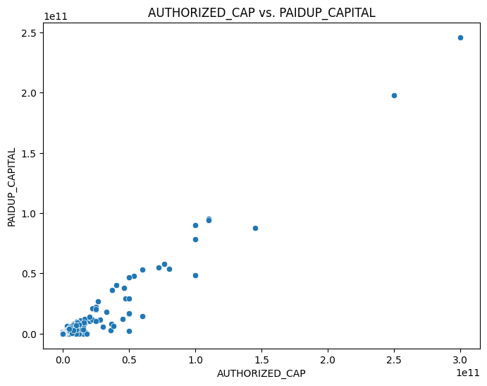

# Bivariate analysis: Categorical vs. Categorical (COMPANY_STATUS vs. REGISTERED_STATE)

crosstab = pd.crosstab(selected_df['COMPANY_STATUS'], selected_df['REGISTERED_STATE'])

crosstab.plot(kind='bar', stacked=True, figsize=(10, 6))

plt.title('COMPANY_STATUS vs. REGISTERED_STATE')

plt.xlabel('COMPANY_STATUS')

plt.ylabel('Count')

plt.xticks(rotation=45)

plt.show()

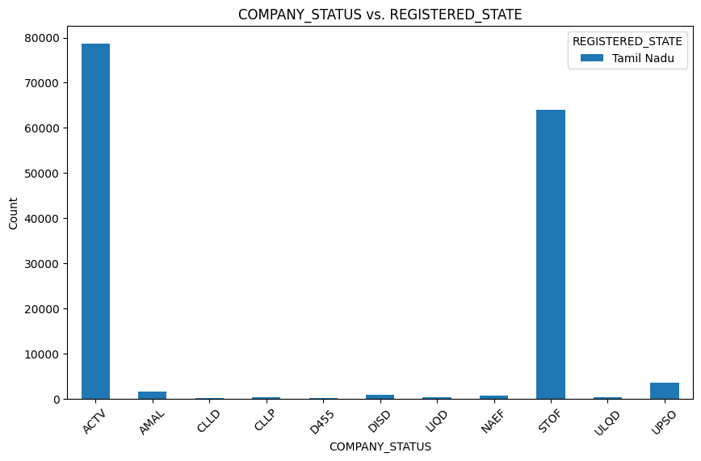

# Bivariate analysis: Categorical vs. Numerical (COMPANY_CATEGORY vs. AUTHORIZED_CAP)

plt.figure(figsize=(12, 6))

sns.boxplot(x='COMPANY_CATEGORY', y='AUTHORIZED_CAP', data=selected_df)

plt.title('COMPANY_CATEGORY vs. AUTHORIZED_CAP')

plt.xlabel('COMPANY_CATEGORY')

plt.ylabel('AUTHORIZED_CAP')

plt.xticks(rotation=45)

plt.show()

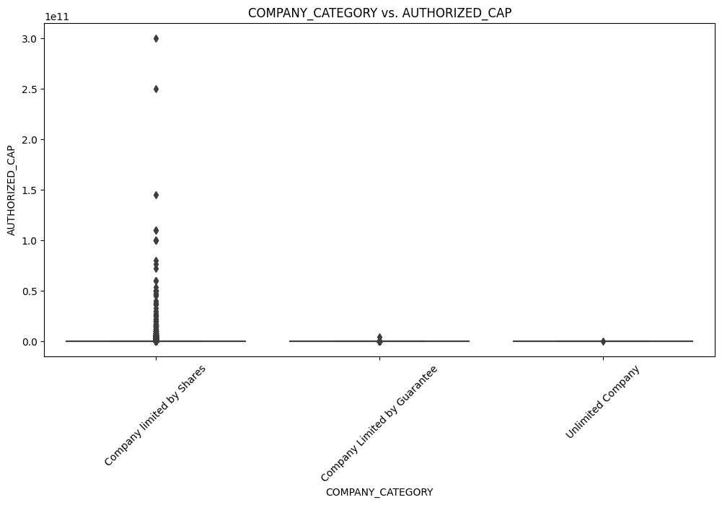

# Plot the pair plot

sns.pairplot(selected_df, diag_kind='kde', height=2.5)

plt.suptitle('Pair Plot for Selected Columns', y=1.02)

plt.show()

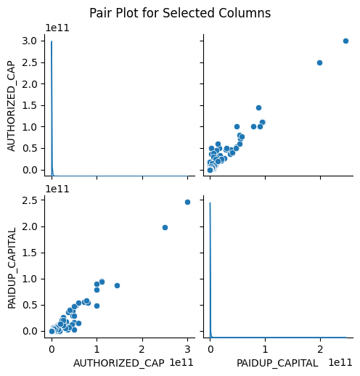

**EDA Multivariate Analysis**

 Multivariate analysis is one of the most useful methods to determine relationships and analyze patterns for any dataset.

A heat map is widely been used for Multivariate Analysis

Heat Map gives the correlation between the variables, whether it has a positive or negative correlation.

In our example heat map shows the correlation between the variables.

**Program :**

# Select the specified columns for analysis

columns_for_analysis = ['AUTHORIZED_CAP', 'PAIDUP_CAPITAL']

# Subset the DataFrame with the selected columns

selected_df = df[columns_for_analysis]

# Convert columns to numeric (if they're not already)

selected_df = selected_df.apply(pd.to_numeric, errors='coerce')

# Calculate the correlation matrix

correlation_matrix = selected_df.corr()

# Plot the heatmap

plt.figure(figsize=(6, 4))

sns.heatmap(correlation_matrix, annot=True, cmap='coolwarm', fmt='.2f', linewidths=0.5)

plt.title('Correlation Matrix Heatmap')

plt.show()

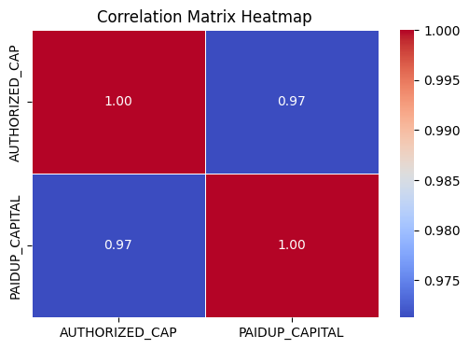

**Conclusion**

In the task of exploring and predicting company registration trends using data obtained from the Registrar of Companies (RoC), a comprehensive approach was adopted involving data collection, data preprocessing, and exploratory data analysis (EDA). Initially, data was collected from various sources including RoC records, financial data, industry information, and market indicators. This data encompassed essential attributes such as corporate identification numbers, company names, registration dates, financial figures, business activities, and more.

The subsequent step involved data preprocessing, where meticulous attention was given to handling missing values and converting data types to ensure consistency and accuracy in the dataset. Techniques such as imputation were utilized to manage missing data, and categorical variables were appropriately encoded to facilitate subsequent analysis. Furthermore, numerical features were scaled to a consistent range, while relevant date columns were transformed for improved insights.

Following data preprocessing, univariate analysis was conducted, scrutinizing individual features to grasp their distributions, frequencies, and unique values. This analysis shed light on the status and characteristics of companies, their registration dates, authorized and paid-up capital, and other crucial aspects. Moving to bivariate analysis, relationships between pairs of variables were explored, offering insights into potential correlations and patterns. Specifically, correlations between authorized capital and paid-up capital were studied, revealing interesting trends.

Finally, multivariate analysis was employed, focusing on understanding the interrelationships between multiple variables. A correlation matrix and heatmap were constructed, illuminating the associations between selected numeric features such as authorized capital and paid-up capital. The heatmap visually represented the strength and direction of these relationships, providing valuable insights for further analysis and predictions.

In conclusion, the seamless integration of data collection, preprocessing, and exploratory analysis enabled a holistic understanding of the company registration landscape. These foundational steps are pivotal in laying the groundwork for subsequent predictive modeling and informed decision-making in the realm of business and finance.