

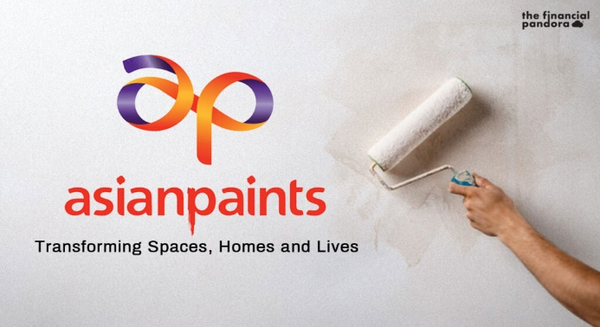

Project Name : asianpaints

**─**

## Kishore kumar.C

### Edureka presents

**Overview**

Asian Paints is India’s leading paint company with a group turnover of Rs 289 billion. The group has an enviable reputation in the corporate world for professionalism, fast track growth, and building shareholder equity. Asian Paints operates in 15 countries and has 26 paint manufacturing facilities in the world servicing consumers in over 60 countries. Besides Asian Paints, the group operates around the world through its subsidiaries - Asian Paints Berger, Apco Coatings, SCIB Paints, Taubmans, Asian Paints Causeway and Kadisco Asian Paints. Asian Paints manufactures wide range of paints for Decorative and Industrial use.

# Goals

1. Home page
2. Product page
3. Shop page
4. Detail page
5. Filters

# History

The company has come a long way since its small beginnings in 1942. It was set up as a partnership firm by four friends who were willing to take on the world's biggest, most famous paint companies operating in India at that time. Over the course of 25 years, Asian Paints became a corporate force and India's leading paints company. Driven by its strong consumer-focus and innovative spirit, the company has been the market leader in paints since 1967. Today, it is double the size of any other paint company in India. Asian Paints manufactures a wide range of paints for decorative and industrial use and also offers Wall Coverings, adhesives and services under its portfolio.

## Technologies:

1. Html
2. Css
3. Bootstrap

Github json link: https://github.com/Kishorekumar2410/Project_ap.git