**Division and Mod Concept:**

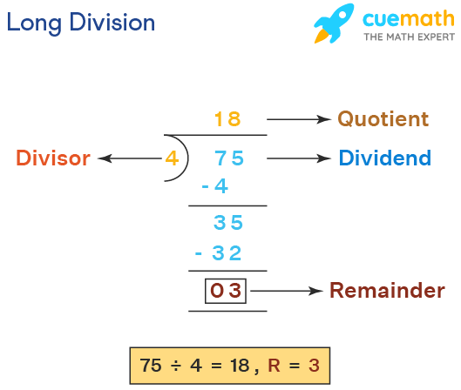

75 (Divident) / 4 (Divisor) = 18 (Quotient), 3 (Remainder/Mod Value)

75 (Divident) mod 4 (Divisor) = 3 (Remainder/Mod Value)

**Check If a Number is Odd or Even**

10 % 2 = 0

11 % 2 = 1

**C# While Loop:**

while loop loops through a block of code as long as a specified condition is True

while (*condition*)

{

*// code block to be executed*

}

**Example:**

int i = 0;

while (i < 5)

{

Console.WriteLine(i);

i++;

}

**C# Do/While Loop**

-A variant of While Loop.

The loop will execute the **code block once**, **before checking if the condition is true**, then it will repeat the loop as long as the condition is true.

do

{

*// code block to be executed*

}

while (*condition*);

**Example:**

int i = 0;  
do

{

Console.WriteLine(i);

i++;

}

while (i < 5);

**Array:**

[**https://www.w3schools.com/cs/cs_arrays.php**](https://www.w3schools.com/cs/cs_arrays.php)

**Default Methods and Properties:**

[**https://www.tutorialspoint.com/csharp/csharp_array_class.html**](https://www.tutorialspoint.com/csharp/csharp_array_class.html)

Arrays are used to store multiple values in a single variable, instead of declaring separate variables for each value.

**Declaration:**

string[] cars;

**Declaration and Initialization:**

int[] carNo = {1,2,3,4,5};

string[] carNames = {“BMW”,”Audi”};

string[] cars = new string[4]; //// Creates array with size

**string[] cars = new string[] {"Volvo", "BMW", "Ford", "Mazda"};**

**Properties:**

carNames.**Length** //// Returns the No of Elements in an Array

**Accessing an Array Value:**

string[] cars = new string[] {"Volvo", "BMW", "Ford", "Mazda"};

**Type 1: Using Index**

Console.WriteLine(cars[0]); //// Volvo

**Type 2: Using Index and ForLoop**

for (int i = 0; i < cars.Length; i++)

{

Console.WriteLine(cars[i]);

}

**IndexOutOfRange Exception:**

(i < cars.Length) ---CHECKING if the elements is inside the bounds of ARRAY to avoid IndexOutOfArange Exception

**Type 3: Using Each Element**

foreach (string i in cars)

{

Console.WriteLine(i);

}

**Default Methods:**

Array.Sort(arrayName); //// sorts the array elements in ascending order

Array.Reverse(arrayName); //// reverse an array order

Array.FindIndex(arrayName, instance => instance.Property > 1) //// Returns the Index of the Condition

Array.Find(arrayName, instance => instance.Property > 1) //// Returns the Person Object.

Array.IndexOf(arrayCollection, arrayInstance); //// Returns Index No

Example: int personDipakIndex = Array.FindIndex(people, people => people.Id == 1);

int[] arr = { 10, 20 ,30};

Array.Reverse(arr); //// Default Method to reverse an Array

int index = Array.FindIndex(arr, ar => ar == 10);

**Types of Arrays in C#:**  
Single dimensional array

Multi-dimensional array ---->

Jagged array: Whose rows and columns are not equal

Rectangular array: Whose rows and columns are equal

**Custom Array:**

class Person {

public string Name {

get;

set;

}

public int Age {

get;

set;

}

}

Person[] people = {

new Person {

Name = "Dipak", Age = 25

},

new Person {

Name = "Karan", Age = 30

},

new Person {

Name = "Pankaj", Age = 22

}

};

String:

A collection of characters.

string greeting = "Hello";

//// Length/Count of the String same as length

Console.WriteLine("The length" + greeting.Length); //// OUTPUT: 2

Default Methods:

string txt = "Hello World";

Console.WriteLine(txt.ToUpper()); // Outputs "HELLO WORLD"

Console.WriteLine(txt.ToLower()); // Outputs "hello world"

String Concatenation

The + operator can be used between strings to combine them. This is called concatenation:

string firstName = "John ";

string lastName = "Doe";

string name = firstName + lastName;

Console.WriteLine(name);

Default method:

string name = string.Concat(firstName, lastName);

String Interpolation:

Another option of string concatenation, is string interpolation, which substitutes values of variables into placeholders in a string. Note that you do not have to worry about spaces, like with concatenation:

string firstName = "John";

string lastName = "Doe";

string name = $"My full name is: {firstName} {lastName}";

Access Strings:

string myString = "Hello";

Console.WriteLine(myString[0]); // Outputs "H"

Default Methods:

myString.IndexOf(“H”);

Substring() Method

-Often combined with Index of to get the all the characters from the index

string name = "John Doe";

// Location of the letter D

int charPos = name.IndexOf("D");

// Get last name

string lastName = name.Substring(charPos);

// Print the result

Console.WriteLine(lastName);

To Analyze:

**Time Complexity** – O(1)  
**Space Complexity** – O(1)

Call By Value and Reference

Data types value and reference type

And mutable and immutable type

Datatypes which are call by value <https://dotnettutorials.net/lesson/call-by-value-and-call-by-reference-in-csharp/>

Access Modifiers