**Division and Mod Concept:**

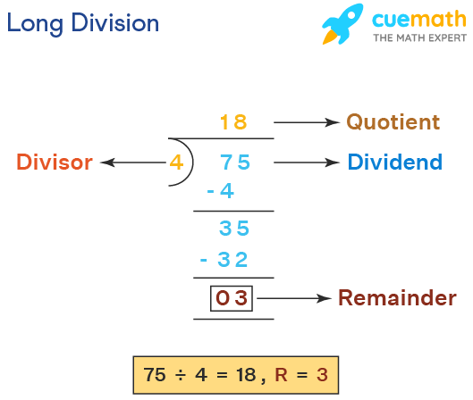

75 (Divident) / 4 (Divisor) = 18 (Quotient), 3 (Remainder/Mod Value)

75 (Divident) mod 4 (Divisor) = 3 (Remainder/Mod Value)

Check If a Number is Odd or Even

10 % 2 = 0

11 % 2 = 1

To Analyze:

**Time Complexity** – O(1)  
**Space Complexity** – O(1)

Call By Value and Reference

Datatypes which are call by value <https://dotnettutorials.net/lesson/call-by-value-and-call-by-reference-in-csharp/>