Name: M.KISHORE
Enroll No.: 2503A52704
Assignment: 2

Task 1: Statistical Summary for Survey Data

- Scenario:
You are a data analyst intern working with survey responses stored as numerical lists.

Task:
Use Google Gemini in Colab to generate a Python function that reads a list of numbers and calculates the mean, minimum, and maximum values.
Expected Output:
  - Correct Python function
  - Output shown in Colab
  - Screenshot of Gemini prompt and result
Prompt:
Generate a Python function that takes a list of numerical survey responses as input and calculates the mean, minimum, and maximum values. Return the results clearly. Also provide a sample input list and display the output in Google Colab.
Code:
def statistical_summary(data):
mean = sum(data) / len(data)
minimum = min(data)
maximum = max(data)

return mean, minimum, maximum

# Sample survey data
survey_data = [10, 20, 30, 40, 50]

mean, minimum, maximum = statistical_summary(survey_data)

print("Mean:", mean)
print("Minimum:", minimum)
print("Maximum:", maximum)
output:
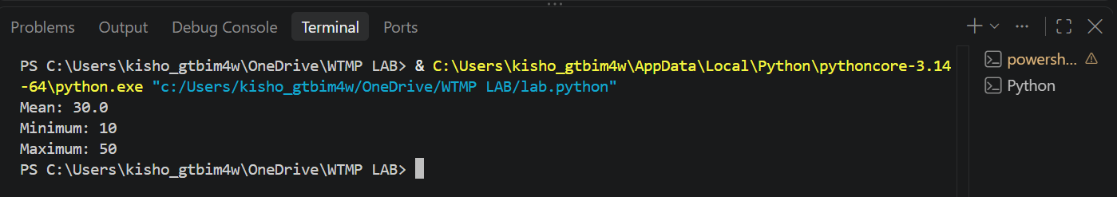

Task 2: Armstrong Number – AI Comparison

- Scenario:
You are evaluating AI tools for numeric validation logic.
- Task:
Generate an Armstrong number checker using Gemini and GitHub Copilot.
Compare their outputs, logic style, and clarity.

- Expected Output:
  - Side-by-side comparison table
  - Screenshots of prompts and generated code
Prompt:
Generate a Python program to check whether a given number is an Armstrong number or not. Create a function is_armstrong(n) that returns True if the number is an Armstrong number and False otherwise. Use the number of digits to calculate the sum of each digit raised to the power of the number of digits. Include sample inputs and outputs.
Code:
def is_armstrong(n):
digits = str(n)
power = len(digits)
total = sum(int(digit) ** power for digit in digits)
return total == n

# Sample test cases
print(is_armstrong(153))
print(is_armstrong(123))
print(is_armstrong(9474))
output:

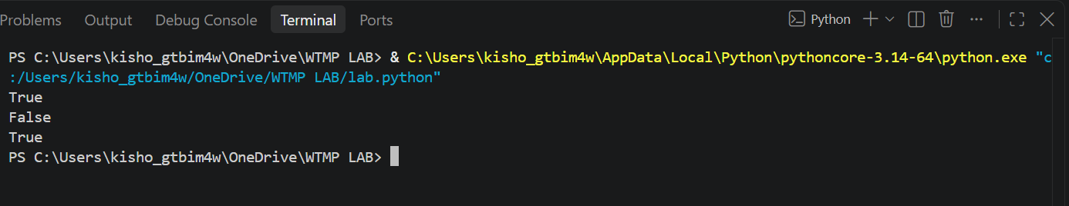
Task 3: Leap Year Validation Using Cursor AI
Scenario:
You are validating a calendar module for a backend system.
Task:
Use Cursor AI to generate a Python program that checks whether a given year is a leap year.
Use at least two different prompts and observe changes in code.
Expected Output:
  - Two versions of code
  - Sample inputs/outputs
  - Brief comparison
Prompt:
Generate a simple Python program that checks whether a given year is a leap year or not. Use a function is_leap_year(year) and return True for a leap year and False otherwise. Include sample inputs and outputs.
Code:
def is_leap_year(year):
if year % 400 == 0:
return True
elif year % 100 == 0:
return False
elif year % 4 == 0:
return True
else:
return False

print(is_leap_year(2024))
print(is_leap_year(2023))
output:

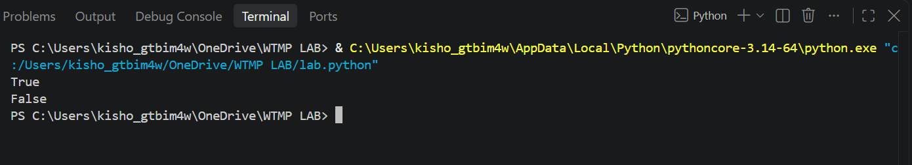

Task 4: Student Logic + AI Refactoring (Odd/Even Sum)
Scenario:
Company policy requires developers to write logic before using AI.
Task:
Write a Python program that calculates the sum of odd and even numbers in a tuple, then refactor it using any AI tool.
Expected Output:
  - Original code
  - Refactored code
  - Explanation of improvements
Prompt:
Refactor this Python program that calculates the sum of odd and even numbers in a tuple. Improve the code for readability, simplicity, and maintainability without changing the output. Use a function in the refactored code and provide the complete code.
Code:
def calculate_sums(numbers):
even_sum = sum(num for num in numbers if num % 2 == 0)
odd_sum = sum(num for num in numbers if num % 2 != 0)
return even_sum, odd_sum

numbers = (1, 2, 3, 4, 5, 6, 7, 8)

even_sum, odd_sum = calculate_sums(numbers)

print("Sum of even numbers:", even_sum)
print("Sum of odd numbers:", odd_sum)
output:

