LAB-12

NAME: M.KISHORE
ROLL.NO : 2503A52705
BATCH:-24

Task 1: Linear Search
Question:
Task Description #1: Linear Search
Implementation with AI Assistance
Task: Use an AI tool to generate a Python program that implements the Linear Search
algorithm.
Instructions:
Prompt AI to create a function linear_search(arr, target) that searches
for a target element in a list.
Return the index of the target element if found; otherwise, return -1.
Ask AI to include a docstring explaining the best-case, average-case, and
worst-case time complexities.
Test the function with different inputs, including an empty list and a target that
is not present.
Expected Output:
A working Python program implementing Linear Search.
Test cases with outputs.
A brief explanation of time complexity.
Prompt:
Write linear_search(arr, target) in Python. Return the index or -1, add a docstring with best/average/worst time complexity, and test normal, empty, and missing-target cases.
Code:
def linear_search(arr, target):
"""Best: O(1); Average: O(n); Worst: O(n)."""
for i, value in enumerate(arr):
if value == target:
return i
return -1
numbers = [10, 25, 30, 45, 50]
print("Target 30:", linear_search(numbers, 30))
print("Target 10:", linear_search(numbers, 10))
print("Target 99:", linear_search(numbers, 99))
print("Empty list:", linear_search([], 10))
Output:

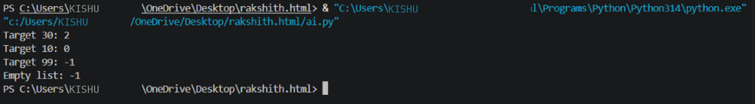

Explanation:
Linear Search checks items one by one. Best case is O(1); average and worst cases are O(n).
Task 2: Binary Search
Question
Task Description #2: Binary Search
Implementation with AI Optimization
Task: Use AI to generate an efficient Python program that implements Binary Search
on a sorted list.
Instructions:
Prompt AI to create a function binary_search(arr, target).
Use the iterative approach to find the target element.

Return the index if the element is found; otherwise, return -1.
Ask AI to explain why the input list must be sorted.
Include best-case, average-case, and worst-case time complexities.
Test the program with the first element, last element, middle element, and a
missing element.
Expected Output:
A working Binary Search program.
Test results for different target values.
An explanation of why Binary Search is more efficient than Linear Search for
large, sorted lists.
Prompt
Write iterative binary_search(arr, target) for a sorted list. Return the index or -1, document time complexity, and test first, middle, last, and missing targets.
Python Code
def binary_search(arr, target):
"""Best: O(1); Average: O(log n); Worst: O(log n).
The list must be sorted in ascending order.
"""
low, high = 0, len(arr) - 1
while low <= high:
mid = (low + high) // 2
if arr[mid] == target:
return mid
if arr[mid] < target:
low = mid + 1
else:
high = mid - 1
return -1
numbers = [10, 20, 30, 40, 50, 60, 70]
for target in [10, 40, 70, 45]:
print(target, "->", binary_search(numbers, target))
Output

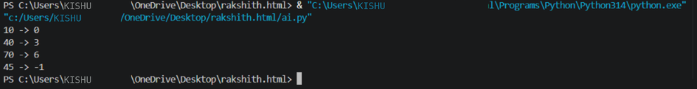

Explanation
Binary Search needs sorted data because it discards half of the search range each step. It runs in O(log n) average and worst-case time.
Task 3: Student Record Search System

Question
Task Description #3: Student Record Search
System
Scenario: A university maintains student records containing roll numbers, names, and
marks. Faculty members need to search for student records using roll numbers.
Student Task:
Use AI to recommend either Linear Search or Binary Search for searching
student roll numbers.
Implement both algorithms in Python.
Test the algorithms using a list of student roll numbers.
Compare the results when the roll numbers are stored in unsorted and sorted
order.
Explain the time complexity of both algorithms.
Expected Output:
Python functions for Linear Search and Binary Search.
Sample student records and test results.
A comparison table showing algorithm, input requirements, and time
complexity.
Justification for selecting the appropriate search algorithm.

Prompt
Create student records with roll number, name, and marks. Implement Linear and Binary Search by roll number, test unsorted and sorted records, and explain their time complexity.

Python Code
def linear_search(records, roll_no):
for i, student in enumerate(records):
if student["roll_no"] == roll_no:
return i
return -1
def binary_search(records, roll_no):
low, high = 0, len(records) - 1
while low <= high:
mid = (low + high) // 2
value = records[mid]["roll_no"]
if value == roll_no:
return mid
if value < roll_no:
low = mid + 1
else:
high = mid - 1
return -1
students = [
{"roll_no": 103, "name": "Kiran", "marks": 82},
{"roll_no": 101, "name": "Anu", "marks": 91},
{"roll_no": 105, "name": "Ravi", "marks": 76},
{"roll_no": 102, "name": "Meena", "marks": 88},
]
print("Unsorted Linear Search:", linear_search(students, 102))
sorted_students = sorted(students, key=lambda s: s["roll_no"])
print("Sorted Binary Search:", binary_search(sorted_students, 102))
print("Record:", sorted_students[binary_search(sorted_students, 102)])

Output

Explanation
Linear Search works on sorted or unsorted records in O(n) average/worst time. Binary Search needs sorted records and takes O(log n) average/worst time. For frequently searched sorted records, Binary Search is preferable.

Task 4: Library Book Search System

Question
Task Description #4: Library Book Search
System
Scenario: A college library maintains a list of book identification numbers. Students
and librarians need to find books quickly using their book IDs.
Student Task:
Use AI to generate a Python program that searches for a book ID using Linear
Search.
Implement Binary Search to search for the same book ID in a sorted list.
Test both algorithms when the book ID exists and when it does not exist.
Measure and compare the number of comparisons performed by each
algorithm.
Ask AI to explain which algorithm is suitable for a large, sorted collection of
book IDs.
Expected Output:
Working Python programs for both searching algorithms.
Test cases with search results.
A comparison of the number of comparisons performed.
A conclusion explaining the efficiency of each algorithm.

Prompt
Write Linear and Binary Search functions that return the index and comparison count. Test an existing and missing book ID, sorting the list for Binary Search.

Python Code
def linear_search_count(arr, target):
comparisons = 0
for i, value in enumerate(arr):
comparisons += 1
if value == target:
return i, comparisons
return -1, comparisons
def binary_search_count(arr, target):
low, high = 0, len(arr) - 1
comparisons = 0
while low <= high:
mid = (low + high) // 2
comparisons += 1
if arr[mid] == target:
return mid, comparisons
if arr[mid] < target:
low = mid + 1
else:
high = mid - 1
return -1, comparisons
books = [410, 125, 305, 220, 515, 180, 460]
sorted_books = sorted(books)
for target in [305, 999]:
print("Book ID:", target)
print("Linear:", linear_search_count(books, target))
print("Binary:", binary_search_count(sorted_books, target))

Output

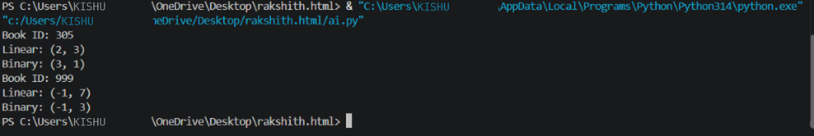

Explanation
Linear Search does not require sorting but may check every ID. Binary Search is more efficient for a large sorted collection because it runs in O(log n), compared with O(n) for Linear Search.

Task 5: Searching Algorithm Comparison and Optimization

Question
Task Description #5: Searching Algorithm
Comparison and Optimization
Scenario: An online shopping platform maintains product IDs for thousands of
products. The system must locate a product quickly when a customer enters a product
ID.
Student Task:
Use AI to generate Python implementations of Linear Search and Binary
Search.
Test both algorithms using the same collection of product IDs.
Compare the execution time and number of comparisons for different input
sizes.

Test the algorithms with the first element, middle element, last element, and an
element that does not exist.
Ask AI to suggest optimizations and explain the limitations of each algorithm.
Present the results in a table and justify which algorithm is appropriate for
sorted product IDs.
Expected Output:
Python implementations of both algorithms.
Test results for different input sizes.
A comparison table containing execution time, number of comparisons, and
time complexity.
A brief conclusion based on the experimental results.

Prompt
Write Linear and Binary Search functions that count comparisons. Test sorted product ID lists of sizes 100, 1000, and 10000 for first, middle, last, and missing targets. Measure execution time and print a comparison table.

Python Code
from time import perf_counter

def linear_search(arr, target):
count = 0
for i, value in enumerate(arr):
count += 1
if value == target:
return i, count
return -1, count

def binary_search(arr, target):
low, high, count = 0, len(arr) - 1, 0
while low <= high:
mid = (low + high) // 2
count += 1
if arr[mid] == target:
return mid, count
if arr[mid] < target:
low = mid + 1
else:
high = mid - 1
return -1, count

print("N Case Algorithm Index Comparisons Time(ms)")
for n in [100, 1000, 10000]:
products = list(range(n))
tests = [("first", products[0]), ("middle", products[n//2]),
("last", products[-1]), ("missing", -1)]
for case, target in tests:
for name, func in [("Linear", linear_search), ("Binary", binary_search)]:
start = perf_counter()
index, count = func(products, target)
elapsed = (perf_counter() - start) * 1000
print(n, case, name, index, count, f"{elapsed:.6f}")

Output

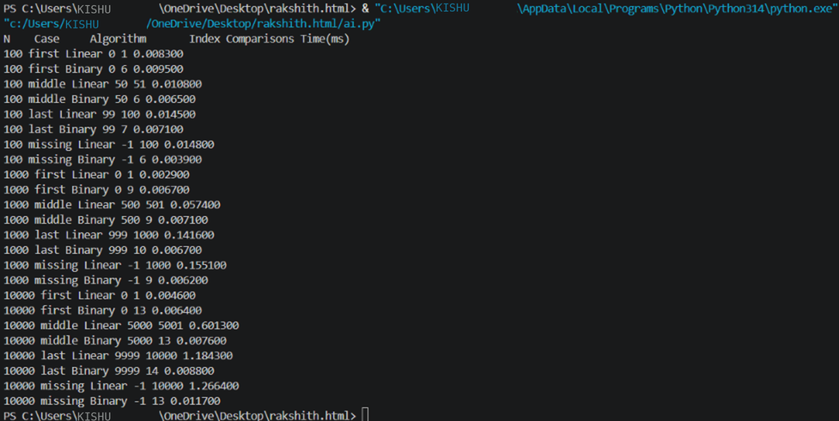

Explanation
Linear Search has O(n) average/worst time and works on unsorted data. Binary Search has O(log n) average/worst time but requires sorted data. Timings vary by computer; comparison counts are more consistent.

