AI Agent
Process Design Document

CLIENT NAME – Payment Processing Automation

Version 1.0

1. Document Revision History

This section records the history of significant changes to this document. Only the most significant changes are described here. The document version number denotes the document information changes. The version number will be increased by 1.0 if significant changes are made. The version number will be increased by 0.1 if minor changes are made to improve its readability without affecting its meaning or intent.

Version | Section/Page | Description | Author | Date
1.0 | New Document | Draft version for Payment Processing Automation Workflow | Author Name | 24/11/2025

2. Document Sign Off

The following table contains the people required to sign off and review this document and those who need the document for information only.

Name | Responsibility | Date

3. Requirement Summary

Stakeholders | Business Sponsor: Input needed  Business SME: Input needed  IT Lead: Input needed  IT Developer: Input needed
Objective | The AI Agent automates the payment processing workflow, aiming to improve efficiency and reduce manual effort. It integrates with relevant systems to streamline payment-related tasks.
Overview and Current State | Currently, the payment process involves manual steps, such as reviewing payment details, verifying information, and updating systems. This manual process is time-consuming and prone to errors, causing delays in payment processing and impacting overall operational efficiency.
Future State | • AI Agent extracts payment details from relevant sources to initiate processing  • AI Agent validates payment information against established rules to ensure accuracy  • AI Agent automatically updates systems with payment status for real-time tracking  • AI Agent generates reports on payment processing metrics for improved visibility  • AI Agent resolves discrepancies and exceptions based on predefined guidelines to minimize errors  • AI Agent adheres to compliance requirements throughout the payment lifecycle to ensure regulatory adherence
Systems Impacted | • Input Needed
Business Benefits | • Reduced manual effort  • Improved payment processing speed  • Enhanced accuracy  • Better visibility and reporting  • Increased operational efficiency
Risk & Control | Input needed
Volumes & Frequency | Input needed
Production Schedule | Input needed

4. Process Workflow

1. [Start/End] AI Agent logs into portal
2. [Process] Open Aetna Payment Info
3. [Process] Navigate Payment Sections
4. [Process] Wait For Page Load
5. [Process] Search Batch Validate Entry
6. [Process] Validate Next Payment
7. [Process] Copy Claim Number
8. [Process] Associate Adjust Claim
9. [Process] Close Payment Window
10. [Start/End] AI Agent completes process

5. Process Steps:

# | Steps | AI Agent Flow
Functionality #1: Open Aetna Payment Information
System/Application: file
1 | Open Aetna Payment Information | • The AI Agent opens the file containing Aetna settlement payment information.  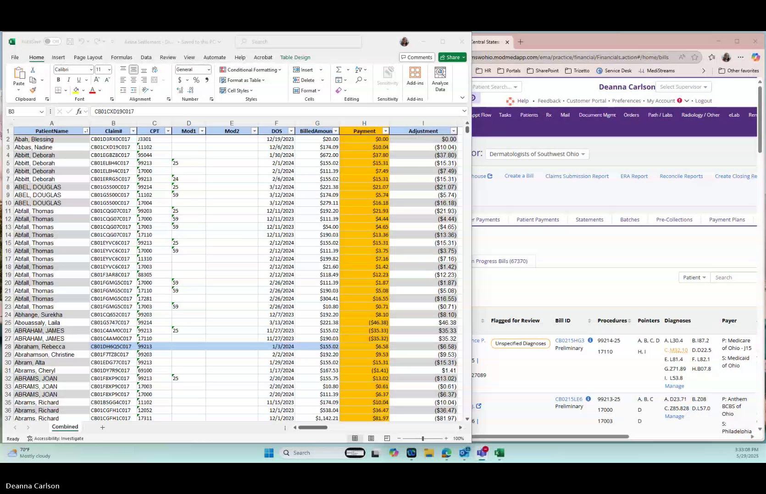
Functionality #2: Navigate Financials Payment Sections
System/Application: Mod Med
2 | Navigate Financials Payment Sections | • The AI Agent navigates to the Financials section in Mod Med.  • The AI Agent goes to the Payments section in Mod Med.  • The AI Agent verifies that a remit has already been created.  • The AI Agent filters for the check or transaction number of EFT Aetna reprocessing.  • The AI Agent opens the Payer Payment section in Mod Med.  • The AI Agent searches for "Aetna health plans" in the payer section in Mod Med.  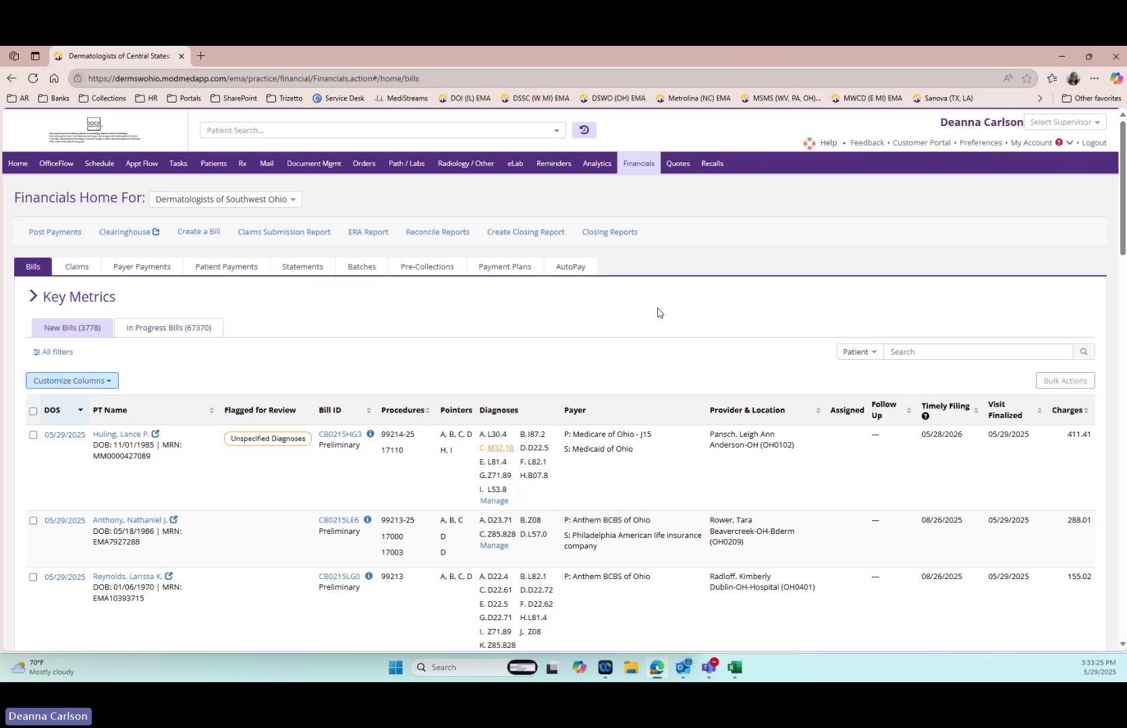
Functionality #3: Wait For Page Load
System/Application: page
3 | Wait For Page Load | • The AI Agent waits for the page to load.  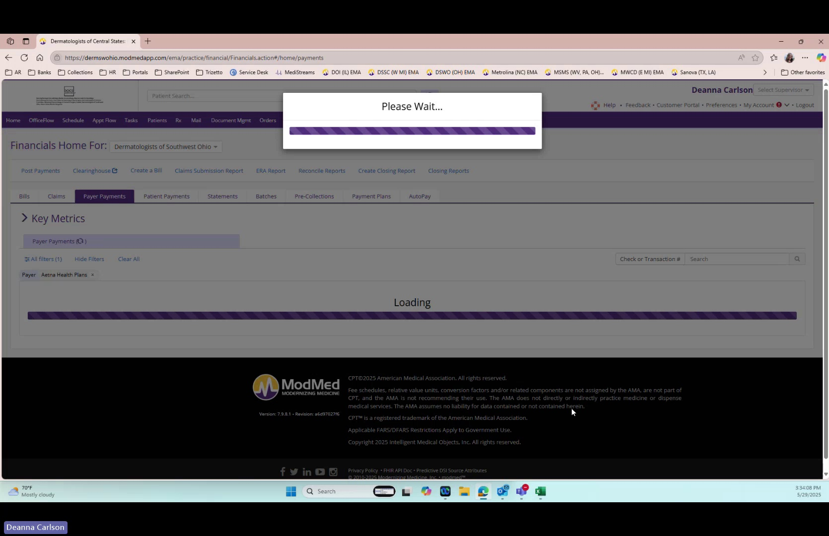
Functionality #4: Search Batch Validate Entry
System/Application: Mod Med
4 | Search Batch Validate Entry | • The AI Agent types "reprocessing" into the search field in Mod Med.  • The AI Agent hits the "Search" button.  • The AI Agent validates the batch is came a Canon Aetna file and this is the checker transaction number.  • The AI Agent clicks on the relevant entry in Mod Med.  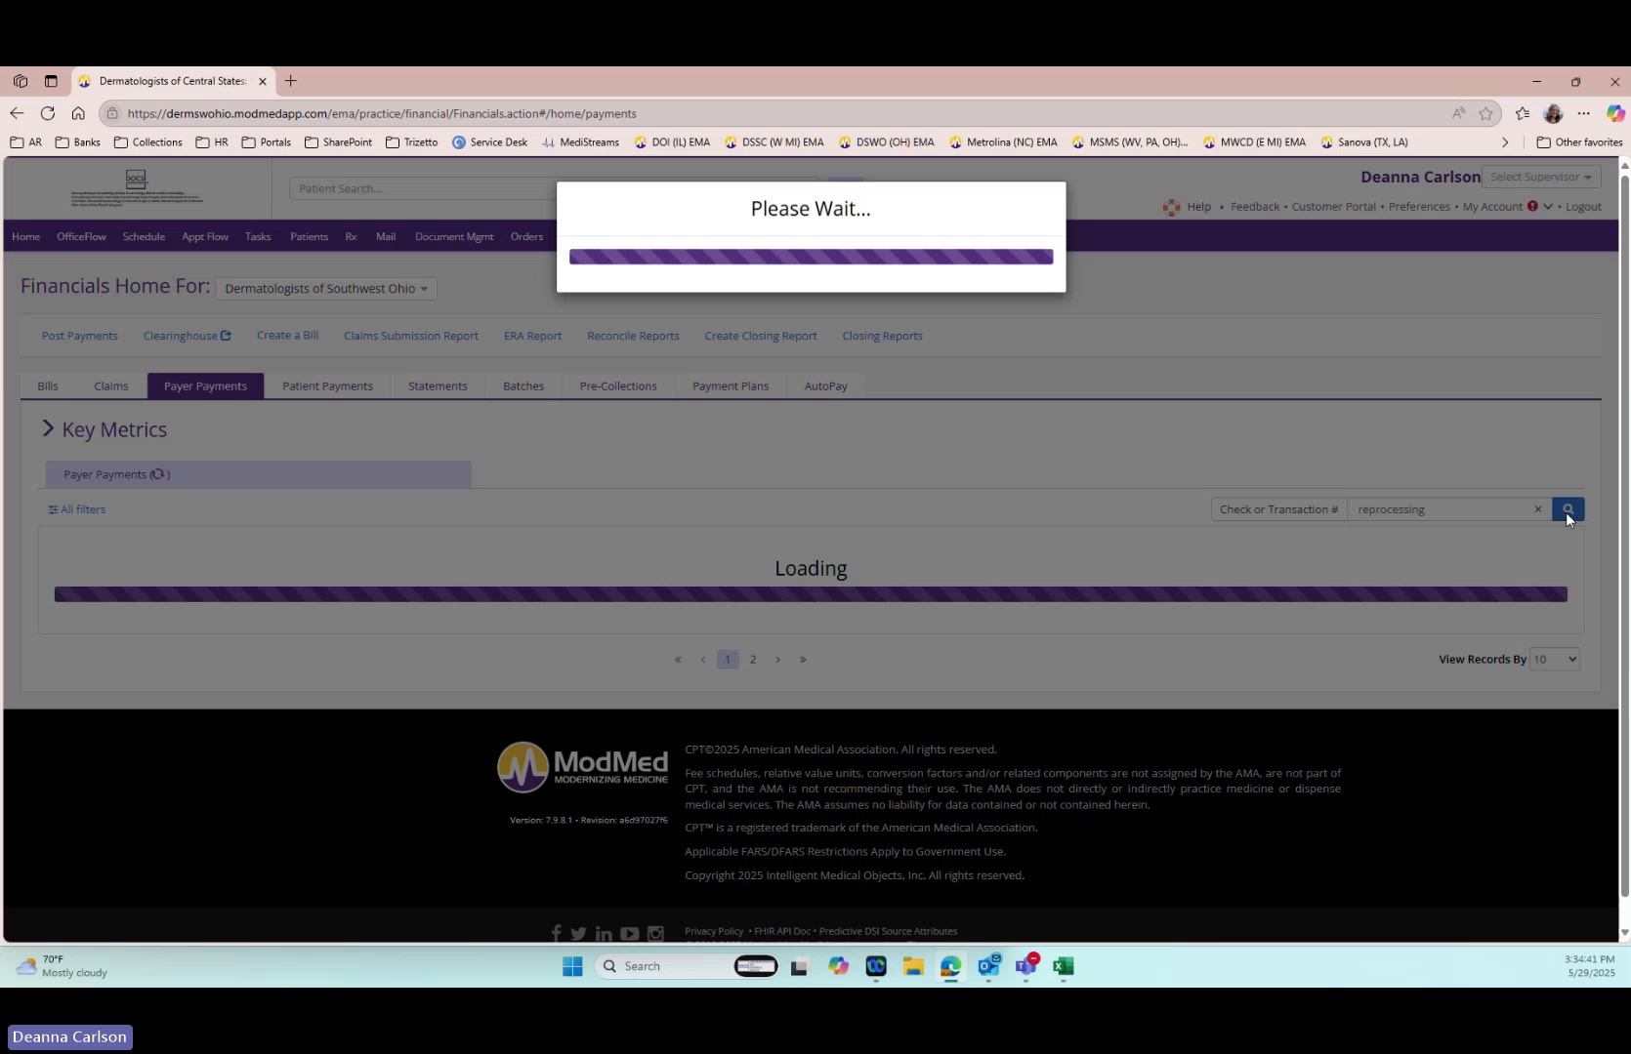
Functionality #5: Validate Next Payment
System/Application: spreadsheet
5 | Validate Next Payment | • The AI Agent skips any entry in the spreadsheet with a $0.00 payment.  • The AI Agent validates that the $10.04 payments have already been processed.  • The AI Agent identifies the next payment to be processed, which is $37.80.  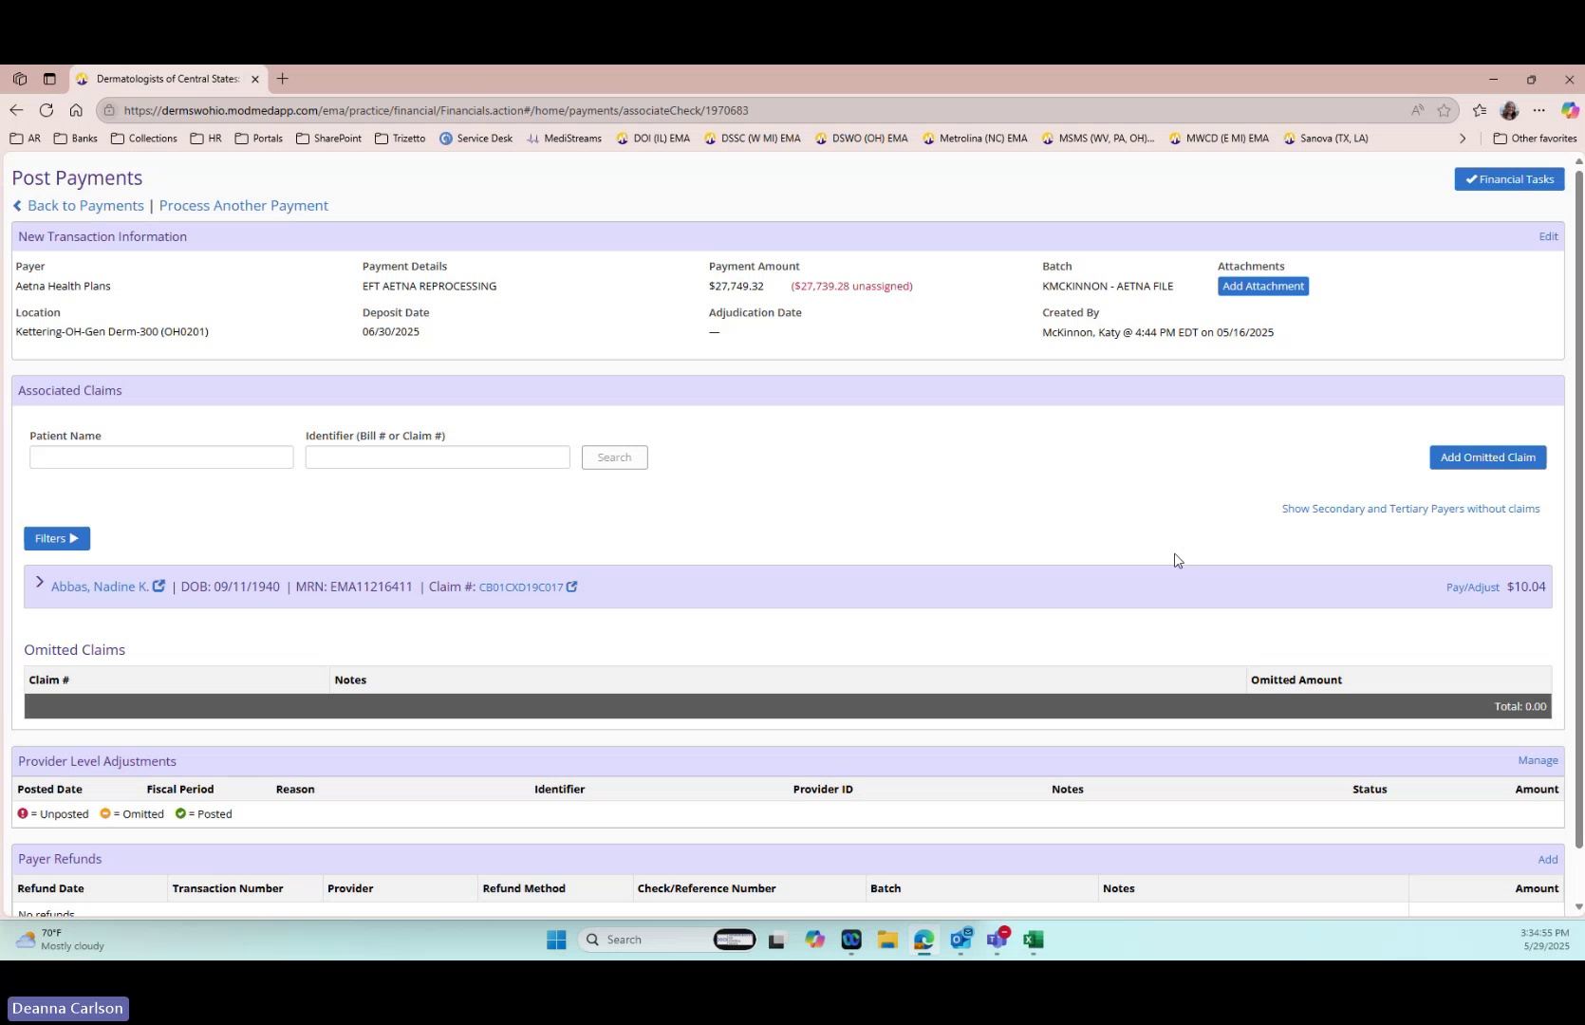
Functionality #6: Copy Claim Number
System/Application: spreadsheet
6 | Copy Claim Number | • The AI Agent copies the claim number from the spreadsheet.
Functionality #7: Associate Payment Adjust Claim
System/Application: Mod Med
7 | Associate Payment Adjust Claim | • The AI Agent goes to the "identifier bill number or claim number" field in Mod Med.  • The AI Agent enters the claim number into the search field in Mod Med.  • The AI Agent hits the "Search" button in Mod Med.  • The AI Agent validates that there is only one line item for this claim number.  • The AI Agent validates it's one EGB which is different than the two four this or the three for the same patient below.  • The AI Agent confirms the payment amount to be entered is $37.80.  • The AI Agent associates $37.80 to the claim and clicks the radio button to select it in Mod Med.  • The AI Agent associates the payment in Mod Med.  • The AI Agent locates the entry with the unposted amount in Mod Med.  • The AI Agent clicks "Pay / Adjust" in Mod Med.  • The AI Agent enters the amount $37.80, which matches with CPT code 95044 in Mod Med.  • The AI Agent validates the CPT code is 95044.  • The AI Agent enters $37.80 in the payment field in Mod Med.  • The AI Agent enters an ACO 45 adjustment for negative $37.80 in Mod Med.  • The AI Agent clicks the "Adjust" button in Mod Med.  • The AI Agent enters the current date as the posting date in Mod Med.  • The AI Agent clicks the "Post" button in Mod Med.  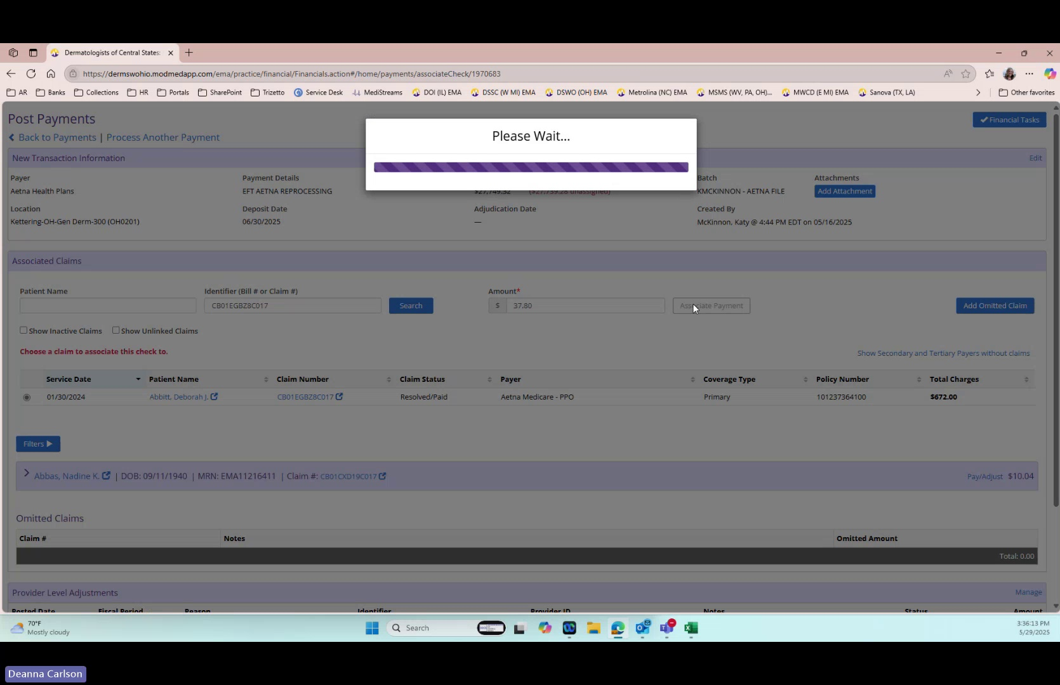
Functionality #8: Close Payment Window
System/Application: Mod Med
8 | Close Payment Window | • The AI Agent closes the payment window in Mod Med.  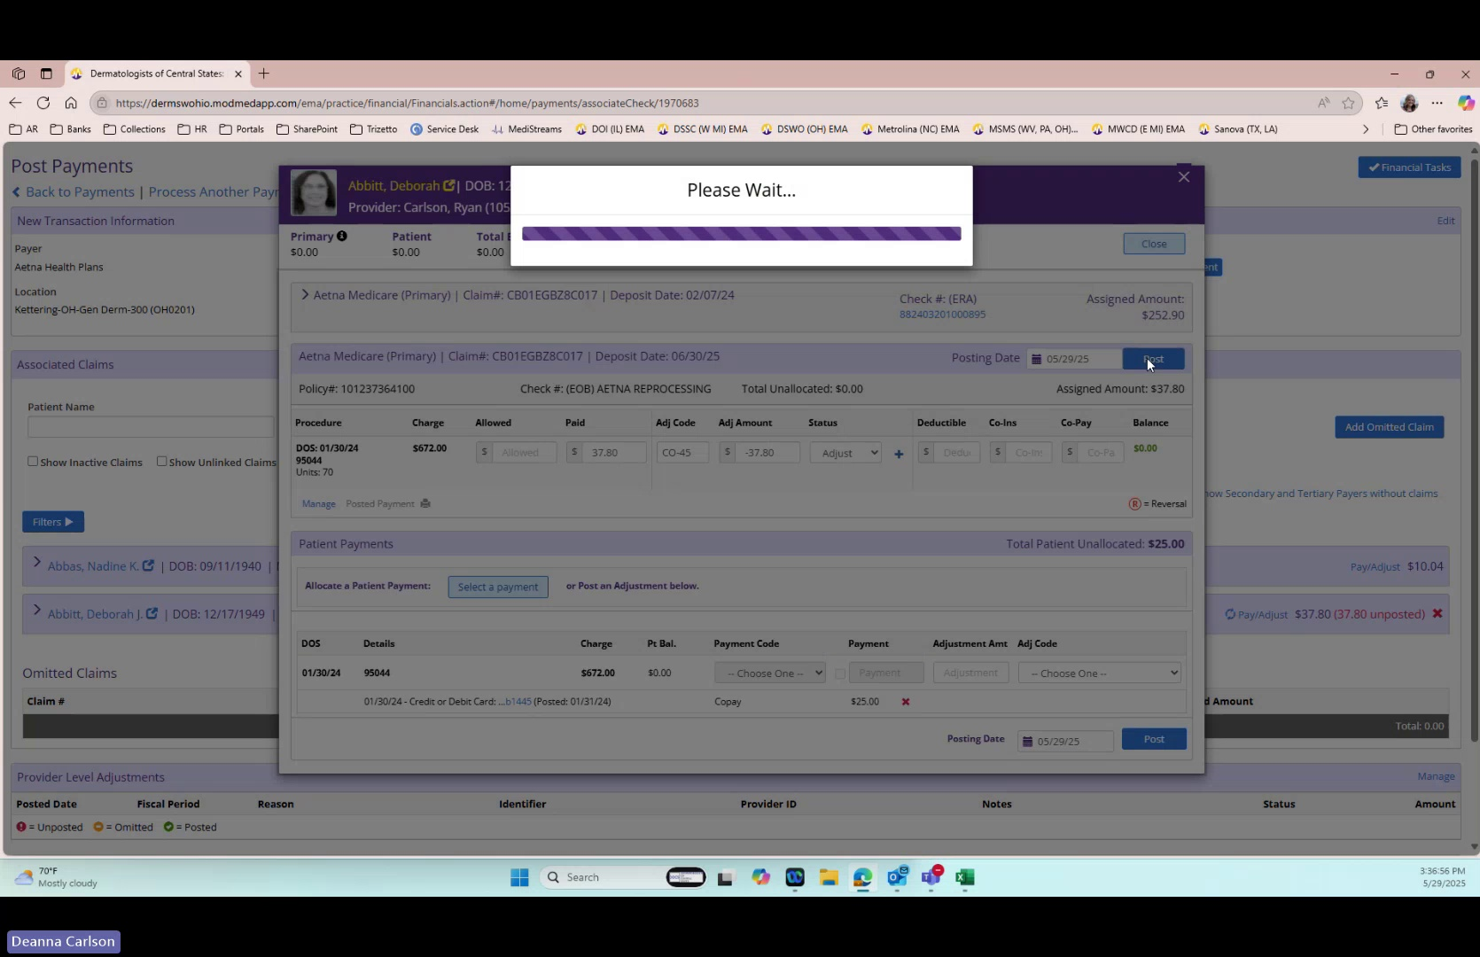
Functionality #9: Identify Add Claim Amounts
System/Application: spreadsheet
9 | Identify Add Claim Amounts | • The AI Agent identifies that the next claim has two line items in the spreadsheet.  • The AI Agent validates that these are the same claim number.  • The AI Agent adds the amounts together to get a total payment amount of $22.80.  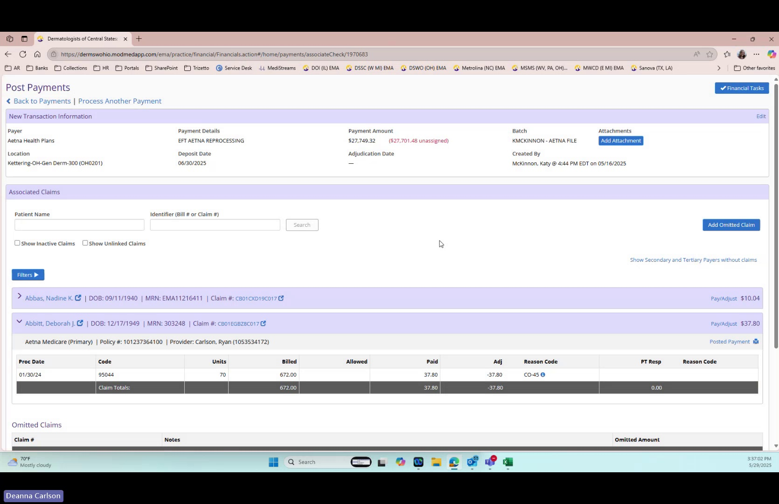
Functionality #10: Associate Payment Adjust Claim
System/Application: Mod Med
10 | Associate Payment Adjust Claim | • The AI Agent finds the claim in Mod Med.  • The AI Agent goes to the claim number search field in Mod Med.  • The AI Agent clicks the search icon.  • The AI Agent clicks on the corresponding entry in Mod Med.  • The AI Agent enters the total amount of $22.80 in Mod Med.  • The AI Agent associates the payment in Mod Med.  • The AI Agent finds the entry with the unposted amount in Mod Med.  • The AI Agent clicks the "Pay and Adjust" button in Mod Med.  • The AI Agent identifies the amount per line item in the spreadsheet.  • The AI Agent identifies that for the 99213 with a 25 modifier, the amount is $15.31 in Mod Med.  • The AI Agent enters $15.31 in the payment field for the 99213 line item in Mod Med.  • The AI Agent enters CO 45 with a -$15.31 adjustment for the 99213 line item in Mod Med.  • The AI Agent identifies that for the 17000 line item, the amount is $7.49 in Mod Med.  • The AI Agent enters $7.49 in the payment field for the 17000 line item in Mod Med.  • The AI Agent enters CO 45 with a negative $7.49 adjustment for the 17000 line item in Mod Med.  • The AI Agent enters the current date in the posting date field in Mod Med.  • The AI Agent clicks the "Post" button in Mod Med.  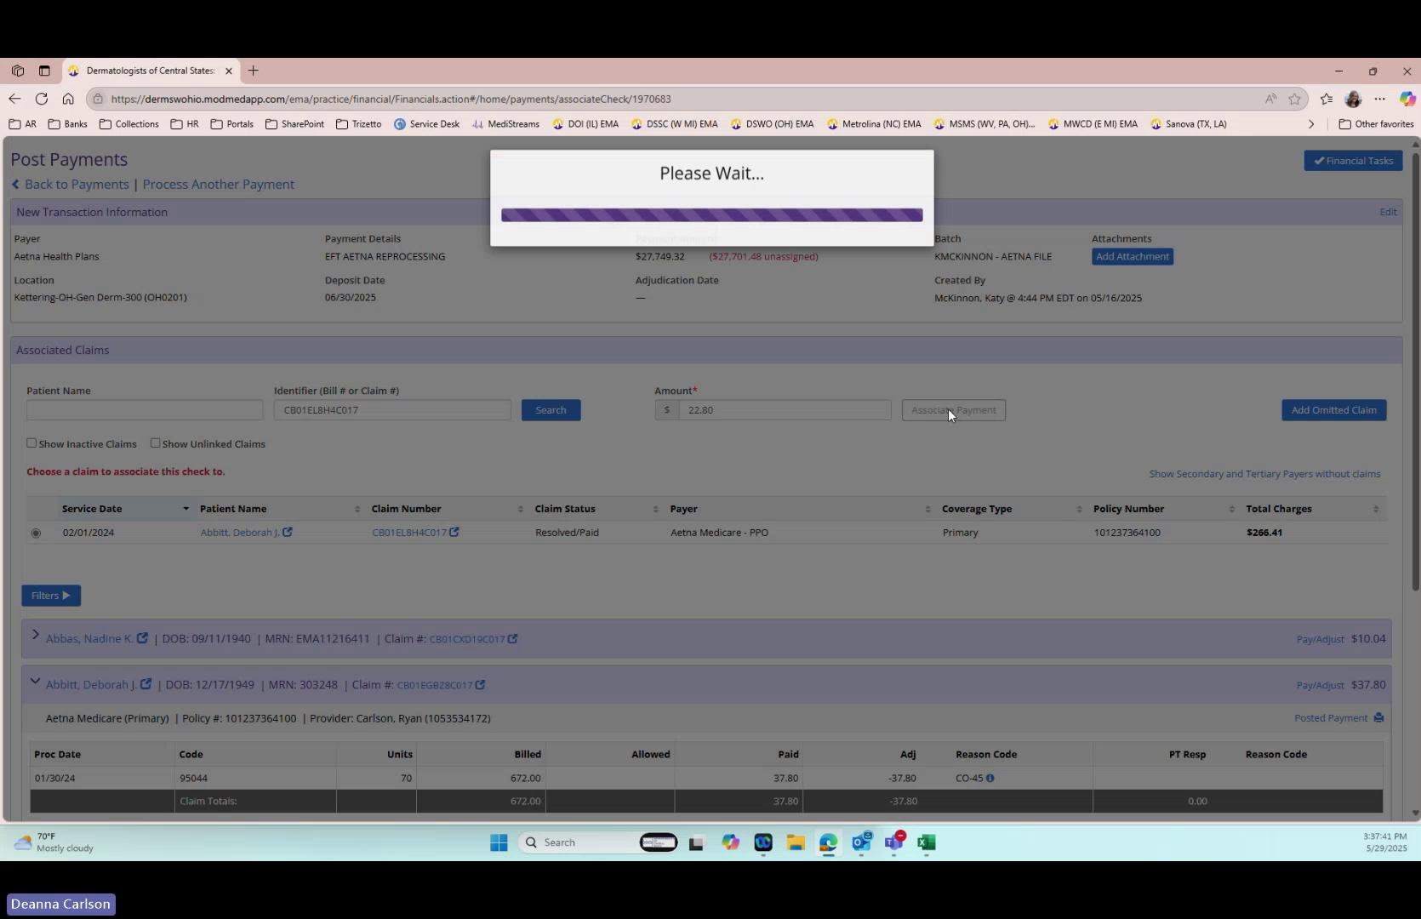
Functionality #11: Highlight Duplicate Claim Numbers
System/Application: spreadsheet
11 | Highlight Duplicate Claim Numbers | • The AI Agent highlights duplicate claim numbers in the spreadsheet in Mod Med.  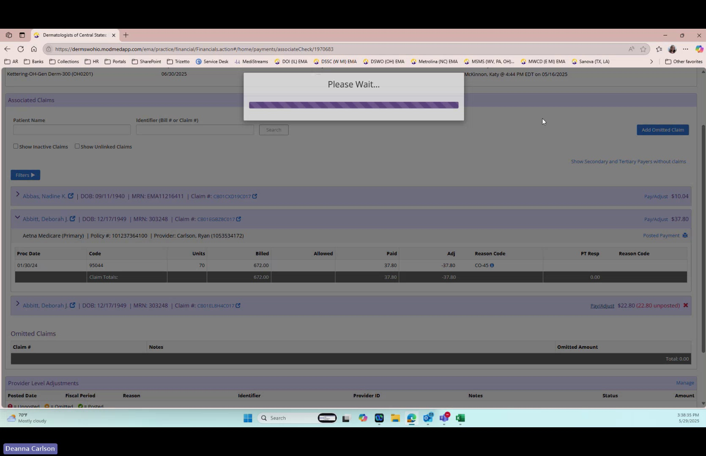
Functionality #12: Instruct Add Column Values
System/Application: spreadsheet
12 | Instruct Add Column Values | • The AI Agent instructs to add up the values in column H for the line items to get the total amount to associate with the payment.  