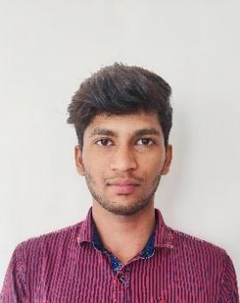
Kishorevel T
91-7397548216
kishorevelak@gmail.com
https://github.com/Kishorevel
https://www.linkedin.com/in/kishore-vel-5b39b6228
210, Sp nagar ,Sagunipalayam road, Dharapuram
CAREER OBJECTIVE :
Highly motivated and dedicated person seeking to launch a successful career. To learn and acquire new skills, with a strong work ethics and a passionate.
ACADEMIC BACKGROUND :
Qualifications | School College | Year of Passing | CGPA / Percentage
B.E  (Computer Science and Design) | Karpagam Academy of Higher Education | 2025 | 8.1% *
HSC | Veveaham Higher Secondary School | 2019 | 89%
SSLC | Thenmalar Higher Secondary School | 2016 | 85%

PROJECT DETAILS :
Title : Exam Hall Seating Arrangement
Description : Managed seating for exams, making sure everyone had space and followed the rules. Organized seats for different groups, focusing on efficiency and comfort. Helped everything run smoothly by communicating clearly and being there to assist.

TECHNICAL SKILLS :
- C
- JAVA
- PYTHON
- HTML, CSS
CERTIFICATIONS :
- Certified in C programming - Linkedin
- Certified in Html CSS - Coursera
- Certified in Dart – Springboard
PARTICIPATIONS :
- Attended a three day Hackathon in PSG Hack Fest 2022
- Attended a one day workshop in Unreal Engine
- Attended a one day workshop in Design Thinking
AREA OF INTERESTS :
- Web Development
- Software Testing
- Internet of Things
- Augmented and Virtual Reality
SOFT SKILLS :
- Leadership
- Adaptability
- Problem Solving
- Time management
LANGUAGES KNOWN :
- Tamil
- English

