***LAB Assignment – 1***

1. ***Write a program to print your first_name, middle_name, Last_name, DOB, class, Div,contact_number, email_id.***

**public class PersonalInfo {**

**public static void main(String[] args) {**

**String firstName = "Hadiya";**

**String middleName = "kishor";**

**String lastName = "G";**

**String dob = "18-08-2006";**

**String className = "Sy bca ";**

**String div = "D";**

**String contactNumber = "1234567890";**

**String emailId = "Kishor .doe@example.com";**

**System.out.println("First Name: " + firstName);**

**System.out.println("Middle Name: " + middleName);**

**System.out.println("Last Name: " + lastName);**

**System.out.println("Date of Birth: " + dob);**

**System.out.println("Class: " + className);**

**System.out.println("Division: " + div);**

**System.out.println("Contact Number: " + contactNumber);**

**System.out.println("Email ID: " + emailId);**

**}**

**}**

**Output:**

**First Name: Hadiya**

**Middle Name: kishor**

**Last Name: G**

**Date of Birth: 18-08-2006**

**Class: Sy bca**

**Division: D**

**Contact Number: 1234567890**

**Email ID: Kishor.doe@example.com**

1. **Write a program to demonstrate all data types.**

**public class alldatatype**

**{**

**public static  void main(String[] args)**

**{**

**byte byteValue = 120;**

**short shortValue = 32000;**

**int intValue = 100000;**

**long longValue = 1000000000L;**

**float floatValue = 3.14f;**

**double doubleValue = 3.14159;**

**char charValue = 'A';**

**boolean booleanValue = true;**

**String stringValue = "Hello, Java!";**

**System.out.println("Byte value: " + byteValue);**

**System.out.println("Short value: " + shortValue);**

**System.out.println("Int value: " + intValue);**

**System.out.println("Long value: " + longValue);**

**System.out.println("Float value: " + floatValue);**

**System.out.println("Double value: " + doubleValue);**

**System.out.println("Char value: " + charValue);**

**System.out.println("Boolean value: " + booleanValue);**

**System.out.println("String value: " + stringValue);**

**}**

**}**

**Output:**

**z**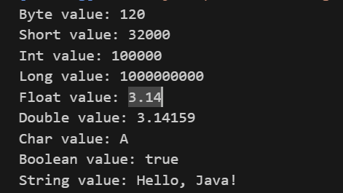

**3.** **Write a program to demonstrate all types of literals.**

public class alltypesofliterals.

{

    public static void main(String[] args)

    {

            int count=987;

            float floatValue = 3.14f;

                    double doubleValue = 3.14159;

            int hexval = 0x1F;

                int binary = 011010;

            int octalval=067;

            char alpha = 'A';

            String str = "Hello, World!";

            boolean boolval=true;

            String StruName=null;

            char ch1 = '\u0021';

            char ch2=1456;

            System.out.println("Integer Literal: " + count);

            System.out.println("Float Literal: " + floatValue);

                    System.out.println("Double Literal: " + doubleValue);

            System.out.println("Hexadecimal Literal: " + hexval);

            System.out.println("Binary Literal: " + binary);

            System.out.println("Octal Literal: " + octalval);

            System.out.println("Character Literal: " + alpha);

            System.out.println("String Literal: " + str);

            System.out.println("Boolean Literal: " + boolval);

            System.out.println("String Literal: " + StruName);

            System.out.println("Character Literal: " + ch1);

            System.out.println("Character Literal: " + ch2);

            System.out.println("\t" + "Black slash");

    }

}

Output:

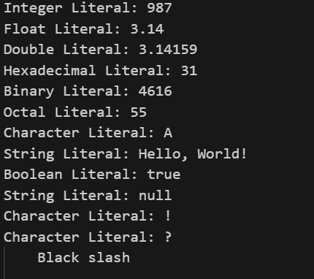

4.Write a program to calculate area of circle.

public class calculateareaofcircle {

    public static void main(String[] args) {

            float pi=3.14f;

            int r=35;

         System.out.println(pi*r*r);

    }

}

Output:



5. Write a program to perform all arithmetic operations. (+, - ,*, /, %)

public class arithmeticoperations {

     public static  void main(String[] argsa)

     {

         int a=89;

         int b=78;

         System.out.println("Addition :"+(a+b));

         System.out.println("Subtraction :"+(a-b));

         System.out.println("Multiapplication :"+(a*b));

         System.out.println("Division :"+(a/b));

         System.out.println("Modual :"+(a%b));

     }

}

Output:

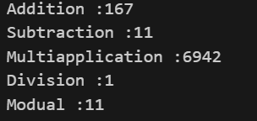

6. Write a program to calculate area of triangle.

public class areaotriangle {

     public static void main(String[] args)

     {

         int w=45;

         int l=89;

        int A;

        A=w*l;

        System.out.println("Area of tringle  :"+(A));

     }

}

Output:



7. Write a program to perform following arithmetic expression.

a. 10*10/5+3-1*4/2

public class arithmeticexpression {

     public static void main(String[] args)

     {

         System.out.println("arithmetic expression."+(10*10/5+3-1*4/2));

     }

}

Output:



8. Write a program to check whether the number is positive or negative or zero.

public class positiveOrNegative {

     public static  void main(String[] args)

     {

        int num=3;

        if(num>0)

        {

            System.out.println("Positive");

        }

        else if(num<0)

        {

             System.out.println("Negative");

        }

        else

        {

             System.out.println("Zero");

        }

     }

}

Output:



9. Write a program that takes a number (1-7) and prints the corresponding day of the week using a switch statement.

public class Switchcase {

     public static void main(String[] args)

     {

          int num=6;

         switch (num) {

             case 1 :

                 System.out.println("Monday");

                 break;

                 case 2:

                 System.out.println("Tuesday");

                 break;

                 case 3:

                  System.out.println("Wenesday");

                  break;

                  case 4:

                  System.out.println("Thursday");

                  break;

                  case 5:

                   System.out.println("Friday");

                   break;

                   case 6:

                   System.out.println("Saturday");

                   break;

                   case 7:

                   System.out.println("Sunday");

                   break;

                   default:

                     System.out.println("Enter the valid number");

                     break;

         }

     }

}

Output:



10. Write a program to print 1 to 100 number using do...while loop.

public class do_while {

      public static void main(String[] args)

      {

             int i=1;

                  do {

                     System.out.println(i);

                     i++;

                  } while (i<=100);

      }

}

Output:

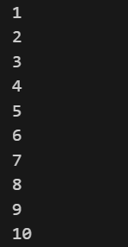

11. Write a program to print following pattern.

a.1

12

123

1234

12345

public class pattern1 {

     public static void main(String[] args)

     {

           for(int i=1; i<=5; i++)

           {

              for(int j=1; j<=i; j++)

              {

                  System.out.println(j);

              }

              System.out.println();

           }

     }

}

Output:

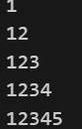

B. A

BB

CCC

DDDD

EEEEE

 public class patten2

 {

         public static void main(String[] args) {

             {

                  for(char i='A'; i<='E'; i++)

                  {

                     for(char j='A'; j<=i; j++)

                     {

                         System.out.println(i);

                     }

                     System.out.println();

                  }

             }

         }

 }

Output:

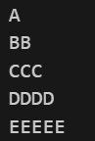

C.

A

ABA

ABCA

ABCDA

ABCDEA

public class patten3 {

      public static void main(String[] args) {

          {

             for(int i=1; i<=5; i++)

             {

                for(char j='A'; j<'A'+i; j++)

                {

                     System.out.print(j);

                }

                 System.out.println('A');

                 System.out.println();

             }

          }

      }

}

output:

