**LAB Assignment – 2**

1. Write a program to print numbers from 1 to 10, but stop printing when the number 7 is reached. Use the break statement to exit the loop when the number reaches 7.

class J1_Number

{

   public static void main(String[] args)

   {

            for (int i = 1; i <= 10; i++)

       {

                if (i == 7)

      {

                   break;

                }

                System.out.println(i);

             }

         }

}

Output:

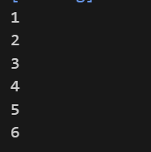

2. Write a program to print the numbers from 1 to 10, but skip the number 5. Use thecontinue statement to skip printing when the number is 5.

class J2_Number

{

     public static void main(String[] args)

     {

         for (int i = 1; i <= 10; i++)

         {

            if (i == 5)

            {

                continue;

            }

            System.out.println(i);

         }

    }

}

Output:

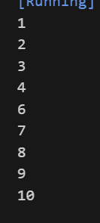

3. Write a program to calculate the sum of all the elements in a one-dimensional array of integers.

class J3_1DArray

{

     public static void main(String[] args)

     {

        int[] numbers = {1, 2, 3, 4, 5, 6, 7, 8, 9, 10};

        int sum = 0;

        for (int i = 0; i < numbers.length; i++)

        {

            sum += numbers[i];

        }

       System.out.println("The sum of the array elements is: " + sum);

    }

}

Output:



4. Write a program to calculate the sum of all elements in a jagged array of integers.

class J4_JaggedArray

{

     public static void main(String[] args)

     {

        int arr[][] ={

               {1,2,3,4}

            };

        int sum = 0;

        for (int i = 0; i < arr.length; i++)

        {

            for(int a:arr[i])

            {

               sum = sum + a;

            }

        }

        System.out.println("Sum of all the elements of an array: " + sum);

    }

}

output:



5. Write a program to create a Car class with the following attributes: brand (String),model (String), year (int) Define methods to set the values of these attributes and display the car's information.

class Method

{

    String brand;

    String model;

    int year;

    public void setBrand(String brand)

    {

        this.brand = brand;

    }

    public void setModel(String model)

    {

        this.model = model;

    }

    public void setYear(int year)

    {

        this.year = year;

    }

    public void displayCarInfo() {

        System.out.println("Car Information:");

        System.out.println("Brand is: " + brand);

        System.out.println("Model is: " + model);

        System.out.println("Year is: " + year);

    }

}

class Main

{

     public static void main(String[] args)

     {

        Method myCar = new Method();

        myCar.setBrand("Toyota");

        myCar.setModel("Corolla");

        myCar.setYear(2020);

        myCar.displayCarInfo();

    }

}

Output:

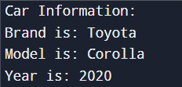

6. Write a programming to implement encapsulation in a Person class with the name,age, and address attributes and create getter and setter methods to access and update the private variables.

class Person

{

    private String name;

    private int age;

    private String address;

    public String getName()

    {

        return name;

    }

    public void setName(String name)

    {

        this.name = name;

    }

    public int getAge()

    {

        return age;

    }

    public void setAge(int age)

    {

        this.age = age;

    }

    public String getAddress()

    {

        return address;

    }

    public void setAddress(String address)

    {

        this.address = address;

    }

    public void displayPersonInfo()

    {

        System.out.println("Person Information:");

        System.out.println("Name: " + name);

        System.out.println("Age: " + age);

        System.out.println("Address: " + address);

    }

}

class Main

{

     public static void main(String[] args)

     {

        Person person = new Person();

        person.setName("Jenish Kidecha");

        person.setAge(19);

        person.setAddress("Rajkot");

        person.displayPersonInfo();

        System.out.println("\nAccessing values using getter methods:");

        System.out.println("Name is: " + person.getName());

        System.out.println("Age is: " + person.getAge());

        System.out.println("Address is: " + person.getAddress());

    }

}

Output:

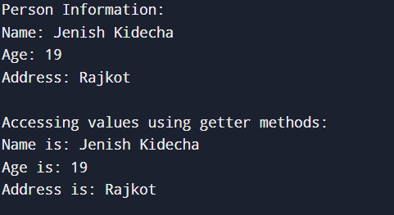

7. Write a program to demonstrate abstraction.

abstract class Animal

{

public abstract void sound();

public void sleep()

{

System.out.println("The animal is sleeping.");

}

}

class Dog extends Animal

{

public void sound()

{

System.out.println("The dog barks.");

}

}

class Cat extends Animal

{

public void sound()

{

System.out.println("The cat meows.");

}

}

class Main

{

public static void main(String[] args)

{

Animal myDog = new Dog();

myDog.sound();

myDog.sleep();

Animal myCat = new Cat();

myCat.sound();

myCat.sleep();

}

}

Output:

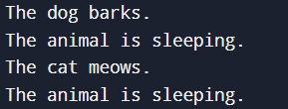

8. Write a program to demonstrate method overloading and method overriding.

class Program {

    static int add(int a, int b) {

        return a + b;

    }

    static Double add(Double a, Double b) {

        return a + b;

    }

}

class Parent {

    void print() {

        System.out.println("hello world");

    }

}

class Subclass extends Parent {

    @Override

    void print() {

        System.out.println("subclass");

    }

}

class Main {

    public static void main(String[] args) {

        System.out.println(Program.add(90, 78));

        System.out.println(Program.add(45.45, 23.88));

        Subclass s1 = new Subclass();

        s1.print();

    }

}

Output:

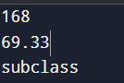

9. Demonstrate multilevel inheritance, where a class inherits from another class, which itself inherits from another class.

class Vehicle

{

    public void start()

    {

        System.out.println("The vehicle is starting.");

    }

}

class Car extends Vehicle

{

    public void drive()

    {

        System.out.println("The car is driving.");

    }

}

class ElectricCar extends Car

{

    public void charge()

    {

        System.out.println("The electric car is charging.");

    }

}

class Main

{

    public static void main(String[] args)

    {

        ElectricCar myElectricCar = new ElectricCar();

        myElectricCar.start();

        myElectricCar.drive();

        myElectricCar.charge();

    }

}

Output:

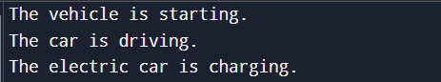

10. Demonstrate hierarchical inheritance, where multiple subclasses inherit from a single superclass.

class student

{

    public void information()

    {

       System.out.println("I am student of TNR collage...");

    }

}

 class teacher extends student

 {

    public void details ()

    {

       System.out.println("I am teacher of TNR collage....");

    }

 }

  class principal  extends student

  {

     public void info()

     {

       System.out.println("I am principal of TNR collage...");

     }

  }

  class Main

  {

     public static void main(String[] args)

     {

      principal  p1= new principal();

      p1.info();

      p1.information ();

      teacher t1= new teacher ();

      t1.details ();

      t1.information ();

     }

  }

Output:

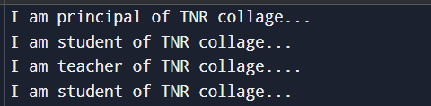

11. Write a program to demonstrate constructor.

class Main

{

   String name;

      Main()

      {

         System.out.println("the constructor...");

         name="Jenish Kidecha";

      }

      public static void main(String[] args)

      {

        Main obj =new Main();

        System.out.println("the name is :"+ obj.name);

      }

  }

Output:



12. Write a program to demonstrate constructor overloading.

class Main

{

    String name;

    int rollno = 5;

    Main()

    {

        System.out.println("The first constructor...");

        name = "Jenish Kidecha";

    }

    Main(String name)

    {

        System.out.println("The second constructor...");

        this.name = name;

    }

    public static void main(String[] args)

    {

        Main obj1 = new Main();

        System.out.println("The name is: " + obj1.name);

        System.out.println("The roll number is: " + obj1.rollno);

        Main obj2 = new Main("jenish kidecha");

        System.out.println("The name is: " + obj2.name);

        System.out.println("The roll number is: " + obj2.rollno);

    }

}

output:

