**COMP 2005 – Final Project**

Weicai Zhao

Vladimir Andrade

Uvwie Omafume

Clifford Bowe

**Overview**

The project implements an alternative to the Brightspace provided online quiz application. It supports authentication of various levels of access (student and instructor) and gives different options to the user, based on their current level of access. Instructors will have the option to create a quiz, which will take them through the process of designing their own, multiple choice quiz to be stored and accessed later. The instructor can also view results (specifically, the results that are for the instructor only to view, such as class participation or the grade histogram for a given quiz). The student will have the option to view quizzes, which will take them to a list of quizzes that are within the system and then allow them to take a quiz, if they are permitted to. They will also have the option to view results, specific to them.

**Main Functionality**

The functionality of each module is listed below; a more in depth description of the methods and functions used can be found within the docstrings of the given modules. Each module fulfills the minimum, mandatory requirements laid out in the requirements listed in the modified “COMP2005 Project Requirements Sheet.html” file included in the project folder.

1. Login
   * Users can create accounts at the log in page (instructor accounts need special permission to be created)
   * Users can log in with existing accounts and passwords
2. Persist
   * Provides methods to store data from the various modules into persistent storage
   * Provides methods to access the data stored by the various modules in persistent storage
3. Create Quiz
   * Allows only a user that’s marked as an “Instructor” to access the “Create Quiz” section of the app.
   * Provides the instructor with the ability to create a quiz, giving them control over all aspects of the quiz’s design (question text, choices, test due date, etc.)
   * Stores the created quiz in persistent storage using a method provided by the Persist module
4. Take Quiz
   * Allows only a user that’s marked as a “Student” to access the “Take Quiz” section of the app.
   * Retrieves the stored, created quiz data from persistent storage
   * Shows a student the list of created quizzes
   * Only allows a student to take quizzes that they are permitted to take
   * Only allows the student to take a quiz before its scheduled end date
   * Allows a student to pause the quiz and resume it at a later date
   * Stores the relevant quiz attempt data in persistent storage using a method provided by the Persist module
   * Allows students to take multiple attempts, up to the attempt limit of the quiz dictated by the Instructor
5. View Results/Automatic Grading
   * Allows the user to view results; results are displayed differently for “Instructors” and “Students”
   * Retrieves the Quiz Attempts information from persistent storage
   * Automatically grades and stores the graded quiz information internally
   * Stores the graded quiz information in persistent storage using a method provided by the Persist module

Each module, when implemented as intended, will interact with Flask and Jinja to display the appropriate information, based on the current web page attempting to be accessed and the user’s information.

**Use Case UML Diagram**

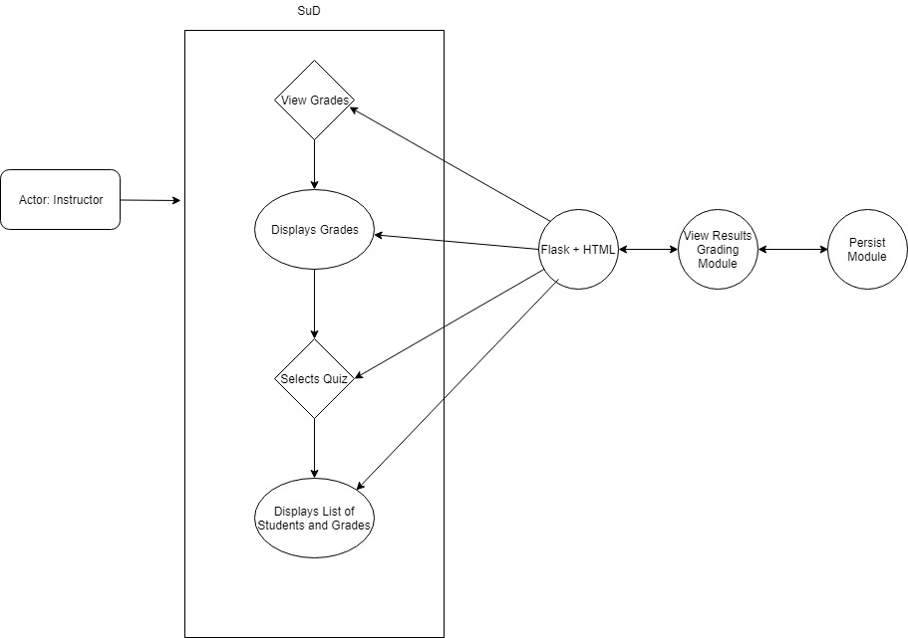

**Clear Connection between Module and Functionality**

The basis of my implementation is going to be the “_quiz_dict” dictionary member variable of my QuizResult object. When called, it will take the dictionary from Persist, supplied by the Take Quiz module, and iterate over it, adding each attempt’s information to the _quiz_dict dictionary, with the quiz names as keys and a list with the attempt data (student email, list of questions, list of choices, list of correct answers and list of student responses) for each individual attempt

Per the requirements list (<http://www.cs.mun.ca/~brown/cs2005/Notes/project/projrequirements.html>) each of my functions is tailored to satisfy a specific requirement, which should be clear from the naming of the function. For example, the ins_class_part function is meant to return the class participation as a percentage value to the instructor. The stu_quiz_grades function is meant to return a list of strings representing a summary of the student’s grades for a specific quiz. The naming convention makes the connection clear. The flask front end will then use these functions to display the appropriate data as needed.

**Description of Module Design**

The module is designed such that the information detailed in the mandatory requirements list is all linked to an individual function. For example, for the instructor to view the class average of a quiz, the ins_class_avg function exists and will be called to return the data for the histogram as a list. It will then be displayed through the flask and HTML based front end as required.

For the purposes of implementation, ToD would simply need to verify that the dictionary being received from the Persist module is of the proper format below:

Take_Quiz_Export_Dict

Keys: Student Emails

Values: Dictionaries

Keys: Quiz Names

Values: Quiz Attempt Objects

The quiz attempt object structure is laid out in the Take Quiz documentation.

The flask front end, once fully constructed, will simply call the functions as needed to display the required data for the given web pages.