MICROSERVICES
Background
In 1972 concepts of modularity and information hiding were introduced. Later on the concept of modular software development rose with the principal of decomposing a large,complex software system into “loosely coupled, highly cohesive” which communicated through internal interface. In simple terms, “loosely coupled” means the dependency between modules should be very low and “highly cohesive” means that one module should focus on single or similar functionality. Another Software Architecture pattern became very popular during the 1990s to develop business applications: Layered Architecture. A business web Application is divided into several layers: Presentation, Business, Database layers.

Monolithic Architecture
A monolithic architecture is built as one large system and is usually one code-base. A monolith is often deployed all at once, both front and end code together, regardless of what was changed. In a monolith, server side application logic, front end client side logic, background jobs, etc, are all defined in the same massive code base. The upshot: if developers want to make any changes or updates, they need to build and deploy the entire stack all at once. Contrary to what you might think, a monolith isn’t a dated architecture that we need to leave in the past. In certain circumstances, a monolith is ideal.
Monoliths are favorable when:
1) The technical/developer team is very small
2) The service is simple to think of as a whole.
3) The service requires very high efficiency, where network calls are avoided as much as possible.
4) All developers must have context of all services.
5) Simple to deploy. Another advantage associated with the simplicity of monolithic apps is easier deployment. When it comes to monolithic applications, you do not have to handle many deployments – just one file or directory.

Microservice Architecture
"Microservices" - another new term on the crowded streets of software architecture. A microservices architecture is an app, built as a suite of small services, each with their own code-base. These services are built around specific capabilities and are usually independently deployable. The microservice architectural style is an approach to developing a single application as a suite of small services, each running in its own process and communicating with lightweight mechanisms, often an HTTP resource API. These services are built around business capabilities and independently deployable by fully automated deployment machinery. There is a bare minimum of centralized management of these services.
Advantages of microservices:
1) Independent components. Firstly, all the services can be deployed and updated independently, which gives more flexibility. Secondly, a bug in one microservice has an impact only on a particular service and does not influence the entire application. Also, it is much easier to add new features to a microservice application than a monolithic one.
2) Easier understanding. Split up into smaller and simpler components, a microservice application is easier to understand and manage. You just concentrate on a specific service that is related to a business goal you have.
3) Better scalability. Another advantage of the microservices approach is that each element can be scaled independently. So the entire process is more cost- and time-effective than with monoliths when the whole application has to be scaled even if there is no need in it. In addition, every monolith has limits in terms of scalability, so the more users you acquire, the more problems you have with your monolith. Therefore, many companies, end up rebuilding their monolithic architectures.

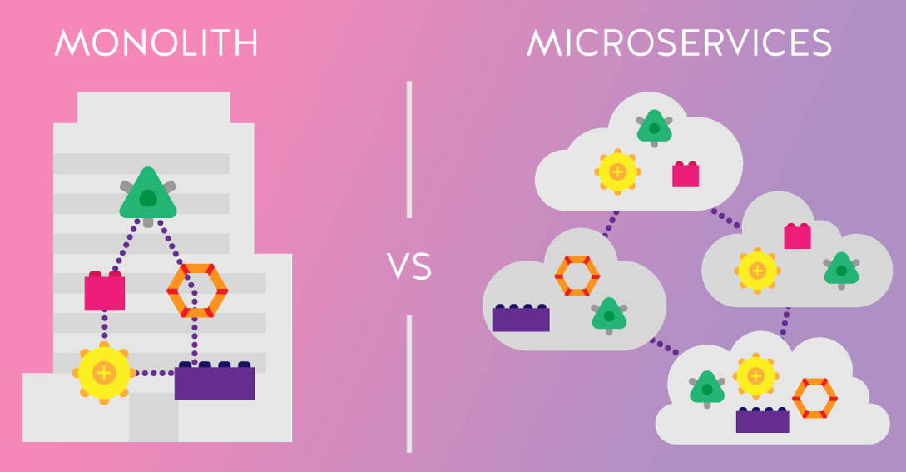
In conclusion,
Adopting a microservices architecture is not a one-size-fits-all approach. Despite being less and less popular, a monolith has its strong and durable advantages which work better for many use cases.
If your business idea is fresh and you want to validate it, you should start with a monolith. With a small engineering team aiming to develop a simple and lightweight application, there is no need to implement microservices. This way, a monolithic application will be much easier to build, make changes, deploy, and provide testing.
The microservices architecture is more beneficial for complex and evolving applications. It offers effective solutions for handling a complicated system of different functions and services within one application. Microservices are ideal when it comes to the platforms covering many user journeys and workflows. But without proper microservices expertise, applying this model would be impossible.

