**Reverse Bidding Web Application**

*by*

**Nagendran K -19BEC1042**

**Kishore N -19BEC1069**

**Madan S -19BEC1158**

**Stanley Kingston -19BEC1254**

**Prassanth A -19BEC1327**

**Sanjay S -19BEC1370**

*A project report submitted to*

**Dr. HEMANTH C**

**SCHOOL OF ELECTRONICS ENGINEERING**

*in fulfilment of the requirements for the course of*

**ECE1901**

**TECHNICAL ANSWERS FOR REAL WORLD PROBLEMS**

*in*

**B.Tech. ELECTRONICS AND COMMUNICATION ENGINEERING**



**Vandalur – Kelambakkam Road**

**Chennai – 600127**

**APRIL 2022**

**BONAFIDE CERTIFICATE**

Certified that this project report entitled “***Reverse Bidding Web Application***” is a bonafide work of **Nagendran K -19BEC1042, Kishore N -19BEC1069, Madan S -19BEC1158, Stanley Kingston -19BEC1254, Prassanth A -19BEC1327, Sanjay S -19BEC1370** who carried out the Project work under my supervision and guidance for **ECE1901- Technical Answers for Real World Problems.**

**Dr. Hemanth C**

Associate Professor Senior

School of Electronics Engineering (SENSE),

VIT University, Chennai

Chennai – 600 127.

**ABSTRACT**

This project is basically a webapp created to benefit both consumers and providers (blue collar servicemen) through a concept called reverse bidding.

In this, the consumer posts about the kind of service he/she wants and quotes the initial amount (base price) now, the registered blue collar service providers bid in reverse order of amount from the base price.

Finally, the service goes to whoever bids the least of all amounts. This is an open auction so everyone knows the current and previous bids exactly.

Blue collar refers to the working class who performs manual labor requiring jobs, which may require skilled or unskilled work of physical nature. Blue Collar employees are primarily workers who are engaged in manual labor. They are mainly involved in manufacturing, processing, construction, warehousing, maintenance and other types of physical work. Some of the blue collar work is skilled while other work is unskilled in nature and is usually not performed in an office environment. The type of work for a blue collared worker is mainly related to something being manufactured, physically built or maintained. The term "blue collar" is one of the types of occupations, others being “white collar” and “Pink collar”.

The job may be of various kinds ranging from manufacturing, mining, construction, mechanical, maintenance, technical installation or any other job of similar sort. Some blue-collar occupations require highly skilled personnel, preferably who have some sort of training and certification. Other jobs may have no such requirement. Often something is physically being built or maintained. Payment of wages for blue collar workers is mostly set at hourly rates or daily rates, but some skilled professionals are paid at the completion of a project or monthly wages. Most of the Blue collar employees are required to wear uniforms that are durable in nature. The uniforms are mostly blue in color because grease stains are not very visible on blue cloth and the cloth appears to be cleaner.

In this project we are constructing a webapp for blue collar related services. In this, the customer posts the kind of service needed and the servicemen reverse bid to acquire that particular service by reverse bidding from that quoted amount.

**ACKNOWLEDGEMENT**

We wish to express our sincere thanks and deep sense of gratitude to our project guide, **Dr. Hemanth C,** Associate Professor Senior, School of Electronics Engineering, for his consistent encouragement and valuable guidance offered to us in a pleasant manner throughout the course of the project work.

We are extremely grateful to Dr. Sivasubramanian. A, Dean of School of Electronics Engineering, VIT Chennai, for extending the facilities of the School towards our project and for his unstinting support.

We express our thanks to our Head of the Department **Dr. Vetrivelan P** for his support throughout the course of this project.

We also take this opportunity to thank all the faculty of the School for their support and their wisdom imparted to us throughout the course. We thank our parents, family, and friends for bearing with us throughout the course of our project and for the opportunity they provided us in undergoing this course in such a prestigious institution.

  

**NAGENDRAN K KISHORE N MADAN S**

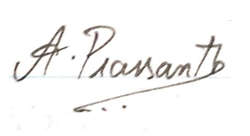

**STANLEY KINGSTON S PRASSANTH A SANJAY S**

**TABLE OF CONTENTS**

|  |  |  |  |
| --- | --- | --- | --- |
| **Sl. no** |  | **Title** | **Page no** |
|  |  | ABSTRACT | 3 |
|  |  | ACKNOWLEDGMENT | 4 |
| 1 |  | INTRODUCTION |  |
|  | 1.1 | OBJECTIVES | 6 |
|  | 1.2 | LITERATURE SURVEY | 6 |
|  | 1.3 | NOVELTY OF THE SYSTEM | 9 |
|  |  | DESIGN AND IMPLEMENTATION |  |
| 2 | 2.1 | DESIGN APPROACH | 10 |
|  | 2.2 | BLOCK DIAGRAM OF SYSTEM | 11 |
|  | 2.3 | CONSTRAINTS & CONTINGENCY | 12 |
|  | 2.4 | SOFTWARE SPECIFICATION | 13 |
|  | 2.5 | REQUIREMENTS | 14 |
|  |  | IMPLEMENTATION AND ANALYSIS |  |
| 3 | 3.1 | SYSTEM IMPLEMENTATION | 17 |
|  | 3.2 | RESULT & INFERENCE | 19 |
| 4 |  | COST ANALYSIS | 25 |
| 5 |  | CONCLUSION AND FUTURE WORK | 26 |
| 6 |  | REFERENCES | 27 |
|  |  | BIODATA | 28 |

**CHAPTER-1**

**INTRODUCTION**

* Reverse bidding is a type of negotiation process used in Strategic Sourcing; and is exactly the opposite of a forward auction.
* Ebay auctions are forward auctions initiated by the Seller in which the Buyer bids the price up. In a reverse auction, the roles are reversed, the auction is initiated by the Buyer and the Supplier bids in real time driving the price down.
* It is a type of competitive bidding conducted on reverse auction websites, which is suitable when the only point being negotiated between the Buyer and the Supplier is price.
* Always ensure that all other points such as supplier capability, quality of service, timelines of delivery, financial stability, etc. have already been confirmed as per your satisfaction.
  1. **OBJECTIVES**

The objective of the project as follows:

* To provide cost efficient services with proper quality checks through reverse bidding
* To bring in all blue-collar jobs into a common platform
* To provide exposure/opportunities to small scale companies/service providers
* To create a common platform for any reverse bidding related application
* To get quality service in minimal cost from customers point of view.
  1. **LITERATURE SURVEY**

**GOVERNMENT-TO BUSINESS (G2B) REVERSE AUCTIONS SYSTEM:**

**Megat S. ZulkifliPutra and Mohd Fuaad** **Said** published a paper on this G2B Reverse Auction system. The Government-to-Business (G2B) reverse auctions is an innovative procurement auctions for the public sector(Carter et al., 2004). G2B reverse auctions is defined as an online and real-time auction between a buying party and two or more suppliers hosted by a single buyer to outsource products and/or services, in which multiple pre-qualified suppliers compete for the buyer’s bids (Emiliani, 2004). Government-to-Business (G2B) reverse auctions is an inter-organizational information system (IOS) with which participating buyers (governments) and sellers employ electronic markets for transactions.

**EXTRACTING AND VISUALIZING TRUST RELATIONSHIPS FROM ONLINE AUCTION FEEDBACK COMMENTS:**

**Evrim, V** states that, Buyers and sellers in online auctions are faced with the task of deciding who to entrust their business to based on a very limited amount of information. Current trust ratings on eBay average over 99% positive and are presented as a single number on a user’s proﬁle. This paper presents a system capable of extracting valuable negative information from the wealth of feedback comments one Bay, computing personalized and feature-based trust and presenting this information graphically.

**SIMULATING REVERSE AUCTION BIDDING OF CONSTRUCTION CONTRACTS:**

**Dr. Khaled Nassar** proposes a construction-specific model for negotiation between agents representing contractors in a Reverse Auction Bid (RAB) is presented. RAB is a fairly new electronic bidding model where contractors bid on a particular contract by iteratively lowering their bids. We specifically present a model that can deal with many-parties, single issue, multiple-encounter negotiations. A computerized system is developed to test the model.

**BIDDING DYNAMICS IN B2B REVERSE AUCTIONS:**

**Mithas, Sunil** published this paper. In this paper, we study the influence of bidding dynamics on the final outcome of the auctions. This is an issue that is often acknowledges by B2B auction providers and bidders as a key factor in explaining the success or failure of such auctions, but it has thus far escaped theoretical scrutiny. A rich dataset of reverse auctions conducted in the automotive industry for procurement and sourcing is used. The data contains the bidding trajectories of all the bidders participating in an auction and investigation of this unique data opens up unprecedented opportunities to pose new questions that researchers did not or could not ask before (Jank and Shmueli 2006).

**FINDMYSTAY'S REVERSE BIDDING FOR A HOTEL ROOM**Launched in 2013, Findmystay is a reverse bidding hotel booking platform which lets customers offer their best price to a hotel as against going by the published rate on other booking portals. While bidding, one typically quotes higher than the reserve price. In reverse bidding, one bids as low as possible against the reserve price, which is the hotel’s ‘best price’ on other portals. Consumers, claims Khetrapal, can save up to 50% as compared to the offers that are usually flagged as the ‘best’.

# INTERORGANIZATIONAL RELATIONSHIPS AND BIDDING BEHAVIOR IN INDUSTRIAL ONLINE REVERSE AUCTIONS:

[**Sandy D. Jap**](https://journals.sagepub.com/doi/abs/10.1509/jmkr.45.5.550)**, &** [**Ernan Haruvy**](https://journals.sagepub.com/doi/abs/10.1509/jmkr.45.5.550) Published October 1, 2008 is about (1) the impact of the supplier's relationship propensity before the auction on the supplier's bidding aggressiveness in the auction (in terms of the number of bids it submits, the rate at which the bids are submitted, and the price concessions offered) and (2) the impact of bidding behaviors in the auction on the buyer–supplier relationship after auction through longitudinal survey data from 12 online reverse auctions across various product categories.

**AN ANALYSIS OF BIDDING ACTIVITY IN ONLINE AUCTIONS:**

**Vasudeva Akula, Daniel A Menascé**(International Conference on Electronic Commerce and Web Technologies, 206-217, 2004) states that Online auctions are rapidly becoming one of the significant forms of electronic commerce to buy and sell goods and services. This form of electronic commerce has unique workflows that do not exist in other forms of e-commerce infrastructures. Bidding activity is one of the most important transactions in online auction sites and trends within bidding activity can be used to design business-oriented metrics and resource management techniques specific to online auction sites. This paper provides an analysis of bidding activity of online auction sites including i) popularity of bidders, sellers, and winners, ii) bidding activity within different auction price ranges, and iii) arrival rate of new bidders and bidding activity within groups of auctions with the same unique number of bidders.

**REVERSE AUCTION BIDDING IN TRANSPORT OF GOODS:**

**Vladimir Despotović interCLEAN d.o.o., Belgrade, Republic of Serbia** In order to achieve business requests such as shorten the time of booking the transport of goods at a fair price with best delivery dates specific methodologies need to be applied. This paper presents an application of the reverse auction bidding methodology in booking international transport of

goods. It is the real inter CLEAN Serbia case described from an idea, proof of concept and concluding remarks. This may be used as an example in other businesses and companies in

order to improve transport procurement.

**INTERORGANIZATIONAL RELATIONSHIPS AND BIDDING BEHAVIOR IN INDUSTRIAL ONLINE REVERSE AUCTIONS:**

**Sandy D. Jap, Ernan Haruvy** The authors model the impact of the supplier's relationship propensity before the auction on the supplier's bidding aggressiveness in the auction (in terms of the number of bids it submits, the rate at which the bids are submitted, and the price concessions offered) and the impact of bidding behaviours in the auction on the buyer–supplier relationship after auction through longitudinal survey data from 12 online reverse auctions across various product categories. The results suggest that incumbency, many bidders, and a willingness to make specific investments lead to less aggressive bidding, whereas the total number of bids from competing suppliers increases aggressiveness. In turn, aggressive bidding behaviour reduces suppliers' disposition toward developing a relationship with the buyer and sours incumbent satisfaction with the relationship. Finally, auctions that are longer in duration can improve the relationship but may risk bidding competition. Collectively, the results suggest that pricing and relationships are intertwined and traded off against each other in complex ways and that the auction does not operate in isolation of key organizational variables.

**BIDDING DECISION IN REVERSE AUCTION SOLVED BY FUZZY MATHEMATICAL PROGRAMMING AND GENETIC ALGORITHM:**

**Department of Information Management, Tamkang University 151 Ying-chuan Road, Tamsui, Taipei County, Taiwan** This study proposes a mixed-integer programming with fuzzy constraints for solving the bidding problem in a reverse auction environment. Suppliers’ optimum bid price is determined through the compromise between profitability of the bid and possibility to win the contract. The proposed model embeds the advanced available-to-promise (AATP) concept in order to support accurate computation of profit and customer order promising. Moreover, the feasible bid price is constrained by a fuzzy upper bound to model the decision-maker's subjective judgment. A genetic algorithm is formulated to solve the problem. Performance of the proposed approach is evaluated through computer simulated experiments.

**INTEGRATED E-BIDDING FRAMEWORK FOR CONSTRUCTION:**

**Moath Al Yahya, Martin Skitmore, Adrian Bridge, Madhav Nepal, David Cattell. (2018) e-Tendering readiness in construction: the posterior model. Construction Innovation** Currently, online bidding processes applied in construction projects are not intelligent enough to complete the loop of the bidding process and do not effectively help share electronic transmittals among the parties as they lack integrated approaches in communicating between different systems, formats and applications. This paper proposes an integrated online framework for this purpose first by studying the drawbacks and loopholes in the existing online systems in construction bidding and then identifying the key determinants that improve the electronic bidding process and simultaneously offer an integrated approach. The framework incorporates major features which are considered traditionally less practical in the construction industry, especially, standardization, transparency and reverse auctioning. The system was derived from both an analysis of the literature and a case study of the online bidding process being practiced at MDOT (Michigan Department of Transportation). An oral assessment of the system by the peers of the MDOT indicates that a standardized system incorporating reverse auctioning will greatly reduce the cost and time required to process the data and help transact the bid related documents and information without any loss and distortions. The framework can be used to design electronic bidding systems for different settings in the construction industry.

**BIDDING DECISIONS WITH NONEQUILIBRIUM STRATEGIC THINKING IN REVERSE AUCTIONS:**

**College of Information Science and Engineering, State Key Laboratory of Synthetical Automation for Process Industries, Northeastern University, Shenyang, 110819, Liaoning, People’s Republic of China Xiaohu Qian & Min Huang** This paper considers decisions of bidders with bounded rationality in different thinking levels for a first-price sealed-bid reverse auction. To characterize the nonequilibrium strategic thinking, we construct a mathematical model that incorporates the “level-k decision rule” to iteratively derive closed-form solutions. Then the effects of bidders’ heterogeneous beliefs of thinking levels on their bid prices and expected payoffs are investigated. We find that under some assumptions, bidders will exhibit oscillating behavior in their bid prices and expected profits in terms of thinking levels. When the thinking level tends to infinity, the bid prices and expected profits converge to those in the conventional analysis with perfectly rational bidders. An interesting finding from theoretical analysis verified by numerical experiments is that any bidder with a thinking level above two should bid according to level-2 bidder’s strategy to achieve the highest expected profit, and in this case the buyer will pay no more than level-2 bidder’s bid price.

**AN ANALYSIS OF BIDDING ACTIVITY IN ONLINE AUCTIONS:**

**Vasudeva Akula, Daniel A Menascé** International Conference on Electronic Commerce and Web Technologies, 206-217, 2004Online auctions are rapidly becoming one of the significant forms of electronic commerce to buy and sell goods and services. This form of electronic commerce has unique workflows that do not exist in other forms of e-commerce infrastructures. Bidding activity is one of the most important transactions in online auction sites and trends within bidding activity can be used to design business-oriented metrics and resource management techniques specific to online auction sites. This paper provides an analysis of bidding activity of online auction sites including i) popularity of bidders, sellers, and winners, ii) bidding activity within different auction price ranges, and iii) arrival rate of new bidders and bidding activity within groups of auctions with the same unique number of bidders.

* 1. **NOVELTY OF THE SYSTEM**

This is a one-of-a-kind product where both the consumers and providers are reaping high rewards by accessing this platform for their needs. Existing systems don’t have this kind of reverse bidding concept. There, there is a fixed rate set by the providers and it varies according to time and manpower required. Here, we are creating a level playing field so that many providers come and bid their lowest amount possible which leaves both consumer and provider highly satisfied at the end.

**CHAPTER 2**

**DESIGN & REQUIREMENTS**

This Chapter describes the methodology, design and constraints of the reverse bidding system.

**2.1 DESIGN APPROACH**

**Problem Definition:**

The major issue faced in blue-collar jobs is the lack of awareness of new opportunities. In most cases large scale vendors are the ones with a lot of exposure & opportunities and the small scale or upcoming vendors often go unnoticed. In the customers’ end, they find it difficult to get cost efficient services. In most cases, there is a compromise in quality if the service rate is cheap.

**Proposed Solution:**

The solution we have developed is a **Web Application based on Reverse Bidding.** The main objective is to create a common platform for all blue-collar jobs based on reverse bidding. This platform helps to provide equal opportunities for small scale companies and service providers. On the customers’ point-of-view, due to the concept of reverse bidding he/she can be provided cost efficient services.

**UML Diagram:**

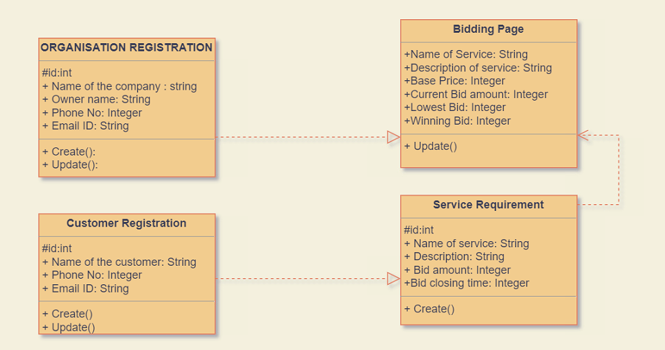

**2.2 BLOCK DIAGRAM OF SYSTEM**

# Flowcharts:

# CUSTOMER SIDE SERVICE PROVIDER

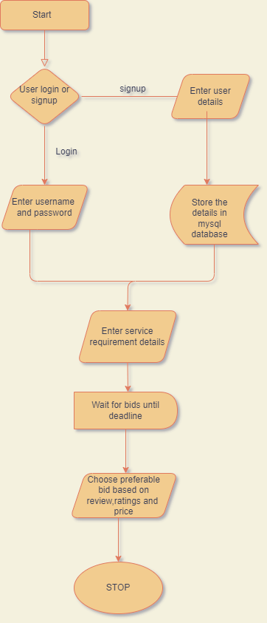 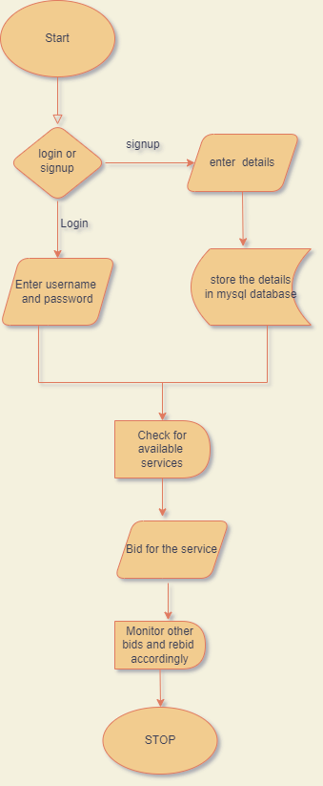

**2.3 CONSTRAINTS & CONTINGENCY**

**CONSTRAINTS**

As Forward Bidding requires a lot of potential buyers, Reverse Bidding on the other hand needs more sellers to maintain the integrity of the competitive market. In a rush to obtain the lowest bid, the buyer might go for the cheapest service with less regard for the quality and compatibility of the product. In such case, the buyer ends up buying a substandard service which might not have all the features as per his minimal requirements. Just as in regular bidding, a reverse bidding puts pressure on the bidder to outdo their competition. This might mean throwing in added services or cutting prices so low that it eliminates profits.

Of course, depending on the project`s requirements some risks are uncertain, unexpected, and cannot be 100% predictable. Since we are creating a web app-based project, Due to the very nature of HTTP, which is clear text, attackers find it very easy to modify the parameters and execute functionality that was not intended to be executed as a function of the application. There are known vulnerabilities that simple programming practices can reduce.

**CONTINGENCY PLAN**

A contingency plan should be tied to being able to recover your application if disaster strikes. The source code we use is our property and also the output of your development process. You will want to keep a back-up of your source code in a safe place.

Data is constantly being written, edited, and deleted. Therefore, your database is usually the component that needs to be backed-up on the most frequent basis since it’s the part that changes most frequently. In a worst-case scenario, we can use the source code to re-launch your application. It is important to come up with a recovery plan if something bad happens to your server. This could include hardware failure, server software failure etc.

**2.4 SOFTWARE SPECIFICATIONS**

The software specification used to build this website we got study to the following topics and how it is used in industry

* **HTML (Hyper Text Markup Language)**

HTML is the basic structure of web pages and web applications which makes the content semantic to the web browser. It consists of sequential tags which have an opening and a closing, and structurally a keyword enclosed by Angle Brackets.

Ex: <strong></strong>

* **CSS (Cascading Style Sheets)**

CSS is the styling language which is used to decorate the HTML markup of a web page. Without CSS, a web page would look nothing but a large white page having some unordered text and image on it. CSS is the thing that makes the page ideally how we want.

* **Scripting Languages**

HTML and CSS are nothing without scripting languages because they are not interactive. To make a dynamic web page which will respond to users, you need languages like JavaScript and jQuery. Server-side languages like PHP, Python and Ruby might also be needed over time.

* **Database Management**

To store, manage and access user-input data of a website, a large table of information is considered which is called a database. A Database Management System like MySQL, MongoDB and PostgreSQL is used in the server-side to do this job efficiently.

* **FTP (File Transfer Protocol)**

FTP is used to transfer a website’s source files to its hosted server more easily. There are web based as well as computer software based FTP clients that can be used to upload one’s files to the server computer.

**2.5 REQUIREMENTS**

Initial Requirements:

● Frontend Developers: Front-end web development, also known as client-side development, is the practice of producing HTML, CSS and JavaScript for a website or Web Application so that a user can see and interact with them directly. The challenge associated with front end development is that the tools and techniques used to create the front end of a website change constantly and so the developer needs to constantly be aware of how the field is developing.

The objective of designing a site is to ensure that when the users open up the site they see the information in a format that is easy to read and relevant. This is further complicated by the fact that users now use a large variety of devices with varying screen sizes and resolutions thus forcing the designer to take into consideration these aspects when designing the site. They need to ensure that their site comes up correctly in different browsers (cross-browser), different operating systems (cross-platform) and different devices (cross-device), which requires careful planning on the side of the developer.

Backend developers: A back-end developer is a type of programmer who creates the logical back-end and core computational logic of a website, software or information system. The developer creates components and features that are indirectly assessed by a user through a front-end application or system.

Back-end developers primarily develop and maintain the core functional logic and operations of a software application or information system. The key job role of a back-end developer is to ensure that the data or services requested by the front-end system or software are delivered through programmatic means. Back-end developers also create and maintain the entire back-end of a system, which consists of the core application logic, databases, data and application integration, API and other back-end processes. Moreover, a back-end developer performs the testing and debugging of any back-end application or system.

● Database Administrator: A database administrator (DBA) is the information technician responsible for directing or performing all activities related to maintaining a successful database environment. A DBA makes sure an organization's database and its related applications operate functionally and efficiently.

It is important to employ one or more database administrators to ensure that applications have ongoing, uninterrupted access to data. Most modern organizations of every size use at least one DBMS, and therefore the need for database administrators is greater today than ever before.

The DBA is responsible for understanding and managing the overall database environment. By developing and implementing a strategic blueprint to follow when deploying databases within their organization, DBAs are instrumental to the ongoing efficacy of modern applications that rely on databases for data storage and access.

Without the DBA's oversight, it is inevitable that application and system outages, downtime and slowdowns will occur. Problems such as these result in business outages that can negatively affect revenue, customer experience and company reputation.

DBAs are the subject matter experts for database management systems and all related topics, including DBMS implementation and configuration; database design; SQL coding; data extraction, transformation and loading (ETL); test data management; problem resolution; data integrity; database security; optimization; and database backup and recovery.

Database administration is a vital component of the IT environment for any organization that relies on one or more database management systems.

● QA Tester : Quality assurance (QA) is a way of preventing mistakes and defects in manufactured products and avoiding problems when delivering products or services to customers; which ISO 9000 defines as "part of quality management focused on providing confidence that quality requirements will be fulfilled".This defect prevention in quality assurance differs subtly from defect detection and rejection in quality control and has been referred to as a shift left since it focuses on quality earlier in the process (i.e., to the left of a linear process diagram reading left to right).

The terms "quality assurance" and "quality control" are often used interchangeably to refer to ways of ensuring the quality of a service or product. For instance, the term "assurance" is often used as follows: Implementation of inspection and structured testing as a measure of quality assurance in a television set software project at Philips Semiconductors is described. The term "control", however, is used to describe the fifth phase of the define, measure, analyze, improve, control (DMAIC) model. DMAIC is a data-driven quality strategy used to improve processes.

Quality assurance comprises administrative and procedural activities implemented in a quality system so that requirements and goals for a product, service or activity will be fulfilled. It is the systematic measurement, comparison with a standard, monitoring of processes and an associated feedback loop that confers error prevention. This can be contrasted with quality control, which is focused on process output.

Quality assurance includes two principles: "fit for purpose" (the product should be suitable for the intended purpose); and "right first time" (mistakes should be eliminated). QA includes management of the quality of raw materials, assemblies, products and components, services related to production, and management, production and inspection processes. The two principles also manifest before the background of developing (engineering) a novel technical product: The task of engineering is to make it work once, while the task of quality assurance is to make it work all the time.

To sum up the requirements:

**❖** Software:

➢ Frontend: HTML, CSS, JavaScript

➢ Backend: PHP

➢ Database: MySQL

❖ Hardware: PC / Laps with required specs for development and maintenance

❖ Human Resources:

➢ Development: Web Developers

➢ Testing and Maintenance: Outsourced to service-based companies

**CHAPTER 3**

**IMPLEMENTATION AND ANALYSIS**

This section describes system implementation and results with inferences.

**3.1 SYSTEM IMPLEMENTATION**

**TRIPLE DES:**

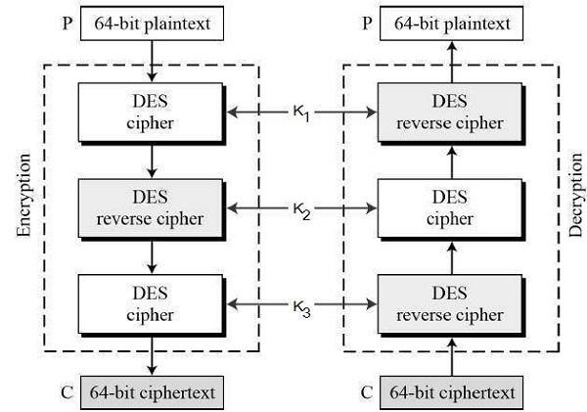

In [cryptography](https://en.wikipedia.org/wiki/Cryptography), Triple DES (3DES or TDES), officially the Triple Data Encryption Algorithm (TDEA or Triple DEA), is a [symmetric-key](https://en.wikipedia.org/wiki/Symmetric-key_algorithm) [block cipher](https://en.wikipedia.org/wiki/Block_cipher), which applies the [DES](https://en.wikipedia.org/wiki/Data_Encryption_Standard) cipher algorithm three times to each data block. The Data Encryption Standard's (DES) 56-bit key is no longer considered adequate in the face of modern cryptanalytic techniques and supercomputing power. A [CVE](https://en.wikipedia.org/wiki/Common_Vulnerabilities_and_Exposures) released in 2016, [CVE-2016-2183](https://nvd.nist.gov/vuln/detail/CVE-2016-2183) disclosed a major security vulnerability in [DES](https://en.wikipedia.org/wiki/Data_Encryption_Standard) and 3DES encryption algorithms. This [CVE](https://en.wikipedia.org/wiki/Common_Vulnerabilities_and_Exposures), combined with the inadequate key size of [DES](https://en.wikipedia.org/wiki/Data_Encryption_Standard) and 3DES, [NIST](https://en.wikipedia.org/wiki/NIST) has deprecated [DES](https://en.wikipedia.org/wiki/Data_Encryption_Standard) and 3DES for new applications in 2017, and for all applications by 2023.

**RC4:**

In [cryptography](https://en.wikipedia.org/wiki/Cryptography), RC4 (Rivest Cipher 4 also known as ARC4 or ARCFOUR meaning Alleged RC4, see below) is a [stream cipher](https://en.wikipedia.org/wiki/Stream_cipher). While it is remarkable for its simplicity and speed in software, multiple vulnerabilities have been discovered in RC4, rendering it insecure. It is especially vulnerable when the beginning of the output [keystream](https://en.wikipedia.org/wiki/Keystream) is not discarded, or when non-random or related keys are used. Particularly problematic uses of RC4 have led to very insecure [protocols](https://en.wikipedia.org/wiki/Cryptographic_protocol) such as [WEP](https://en.wikipedia.org/wiki/Wired_Equivalent_Privacy).

As of 2015, there is speculation that some state cryptologic agencies may possess the capability to break RC4 when used in the [TLS protocol](https://en.wikipedia.org/wiki/Transport_Layer_Security).[[6]](https://en.wikipedia.org/wiki/RC4#cite_note-Leyden20130906-6) [IETF](https://en.wikipedia.org/wiki/IETF) has published RFC 7465 to prohibit the use of RC4 in TLS; [Mozilla](https://en.wikipedia.org/wiki/Mozilla) and [Microsoft](https://en.wikipedia.org/wiki/Microsoft) have issued similar recommendations.

A number of attempts have been made to strengthen RC4, notably Spritz, RC4A, [VMPC](https://en.wikipedia.org/wiki/Variably_Modified_Permutation_Composition), and RC4+.

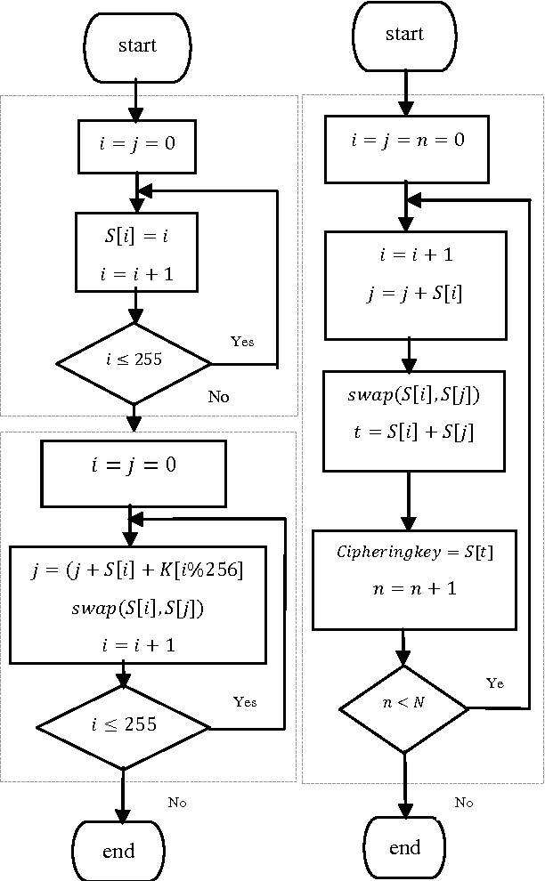

**AES:**

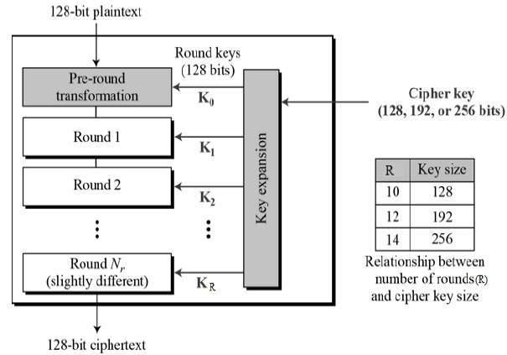

The Advanced Encryption Standard (AES), also known by its original name Rijndael is a specification for the [encryption](https://en.wikipedia.org/wiki/Encryption) of electronic data established by the U.S. [National Institute of Standards and Technology](https://en.wikipedia.org/wiki/National_Institute_of_Standards_and_Technology) (NIST) in 2001.

AES is a variant of the Rijndael [block cipher](https://en.wikipedia.org/wiki/Block_cipher) developed by two [Belgian](https://en.wikipedia.org/wiki/Belgium) cryptographers, [Joan Daemen](https://en.wikipedia.org/wiki/Joan_Daemen) and [Vincent Rijmen](https://en.wikipedia.org/wiki/Vincent_Rijmen), who submitted a proposal to NIST during the [AES selection process](https://en.wikipedia.org/wiki/Advanced_Encryption_Standard_process). Rijndael is a family of ciphers with different key and block sizes. For AES, NIST selected three members of the Rijndael family, each with a block size of 128 bits, but three different key lengths: 128, 192 and 256 bits.

AES has been adopted by the [U.S. government](https://en.wikipedia.org/wiki/Federal_government_of_the_United_States). It supersedes the [Data Encryption Standard](https://en.wikipedia.org/wiki/Data_Encryption_Standard) (DES), which was published in 1977. The algorithm described by AES is a [symmetric-key algorithm](https://en.wikipedia.org/wiki/Symmetric-key_algorithm), meaning the same key is used for both encrypting and decrypting the data.

In the United States, AES was announced by the NIST as U.S. [FIPS](https://en.wikipedia.org/wiki/Federal_Information_Processing_Standard) PUB 197 (FIPS 197) on November 26, 2001. This announcement followed a five-year standardization process in which fifteen competing designs were presented and evaluated, before the Rijndael cipher was selected as the most suitable.

AES is included in the [ISO](https://en.wikipedia.org/wiki/International_Organization_for_Standardization)/[IEC](https://en.wikipedia.org/wiki/International_Electrotechnical_Commission) [18033-3](https://en.wikipedia.org/wiki/List_of_International_Organization_for_Standardization_standards,_18000-19999) standard. AES became effective as a U.S. federal government standard on May 26, 2002, after approval by the U.S. [Secretary of Commerce](https://en.wikipedia.org/wiki/United_States_Secretary_of_Commerce). AES is available in many different encryption packages, and is the first (and only) publicly accessible [cipher](https://en.wikipedia.org/wiki/Cipher) approved by the U.S. [National Security Agency](https://en.wikipedia.org/wiki/National_Security_Agency) (NSA) for [top secret](https://en.wikipedia.org/wiki/Classified_information) information when used in an NSA approved cryptographic module.

**3.2 RESULTS AND INFERENCES**

**PART A – SERVICE PROVIDER SIDE WEBPAGE**

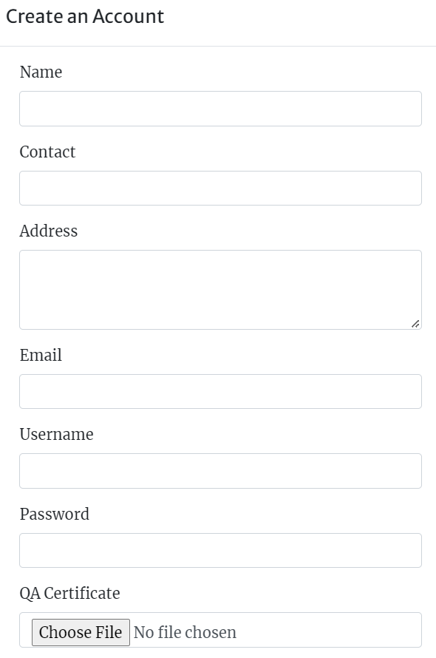

**FIG 1 : SIGNUP FORM**

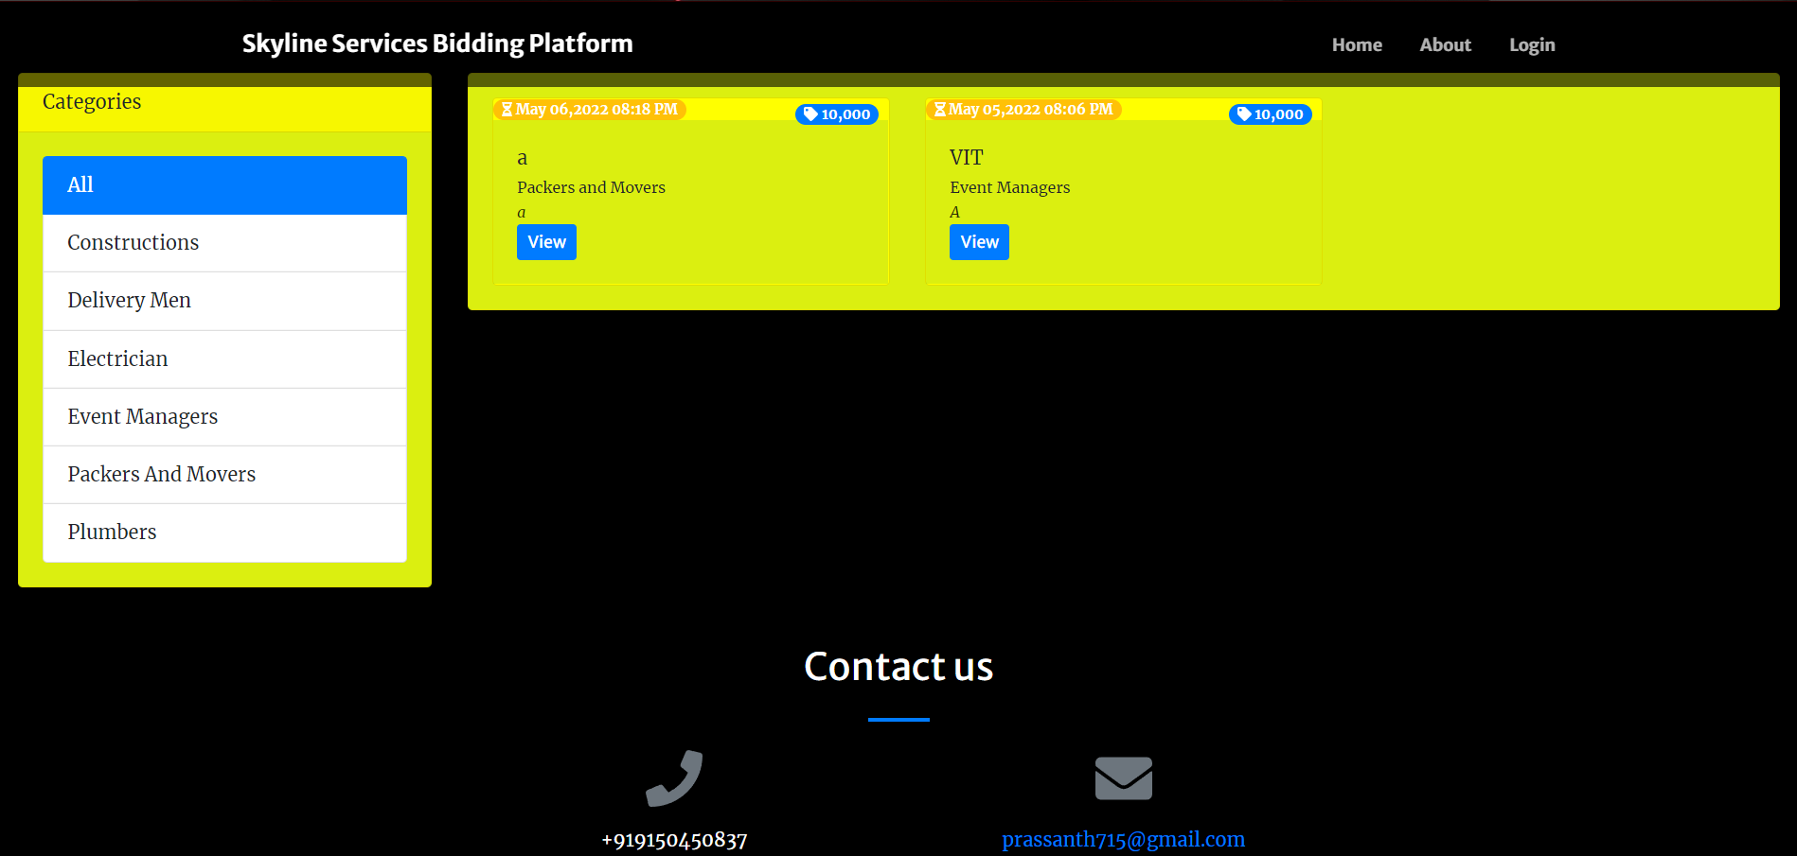

**FIG 2 : HOMEPAGE**

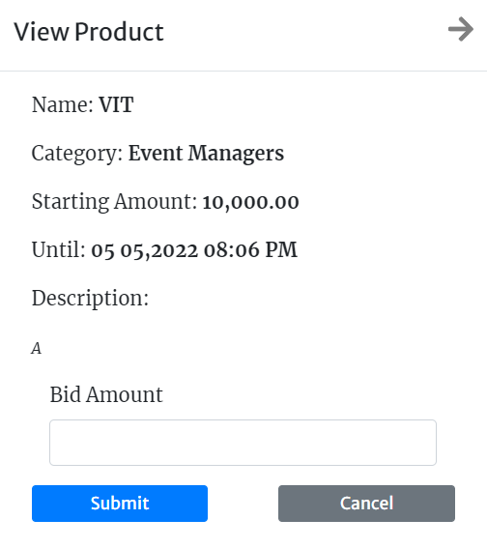

**FIG 3 : BIDDING PORTAL**

**PART B – CONSUMER SIDE WEBPAGE**

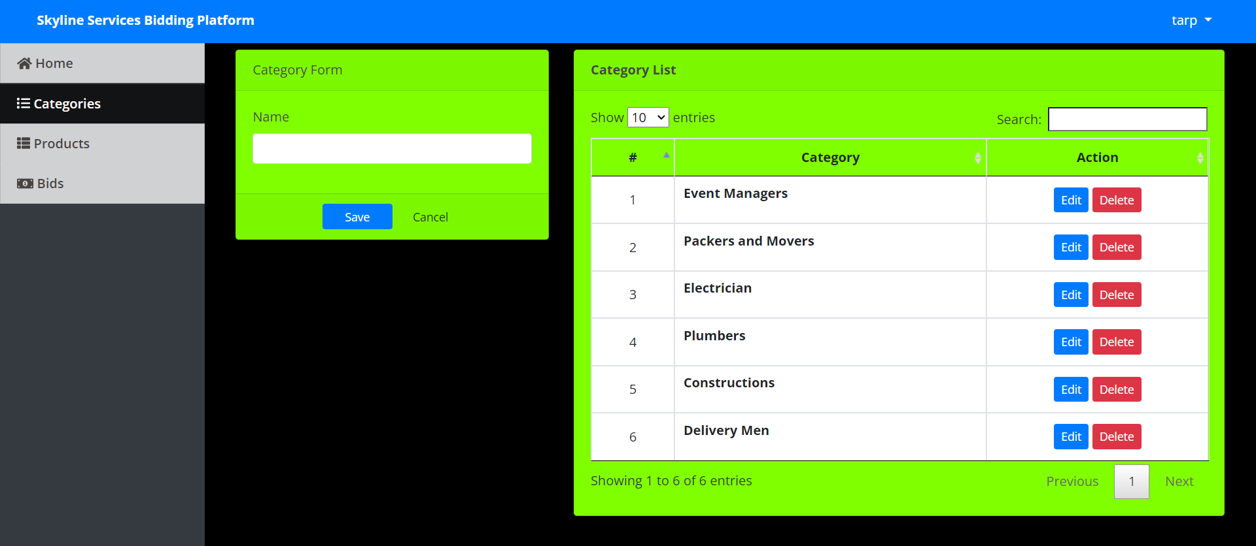

**FIG 4 : CATEGORY OF SERVICES PAGE**

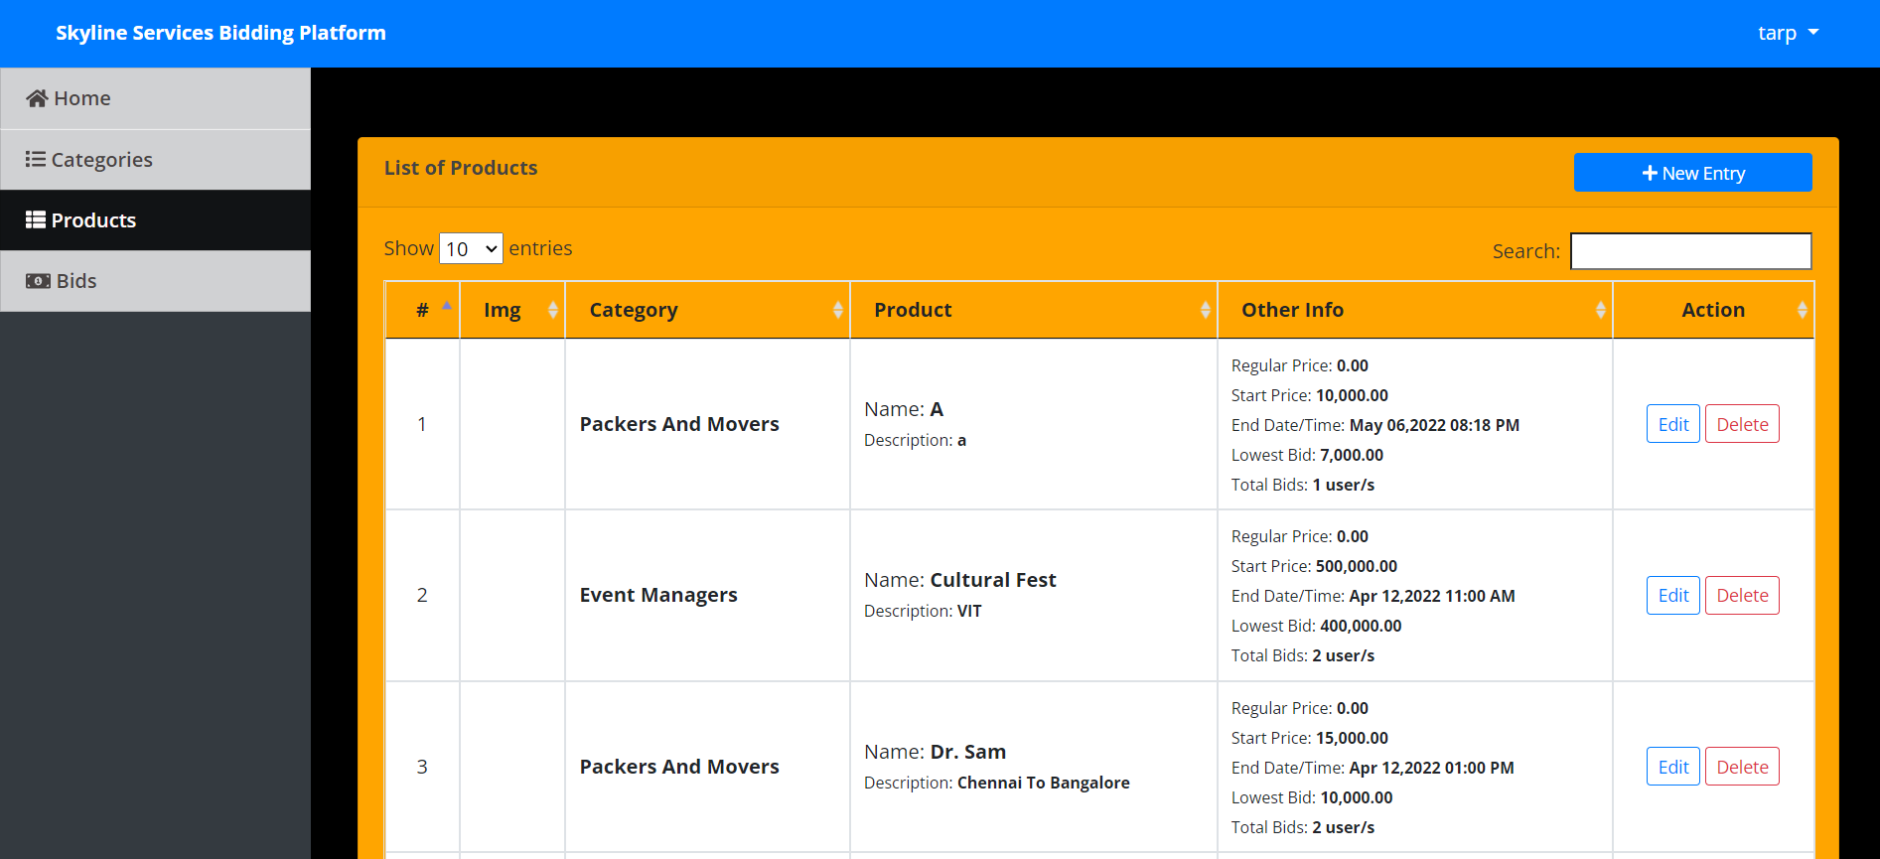

**FIG 5 : SUMMARY OF SERVICES**

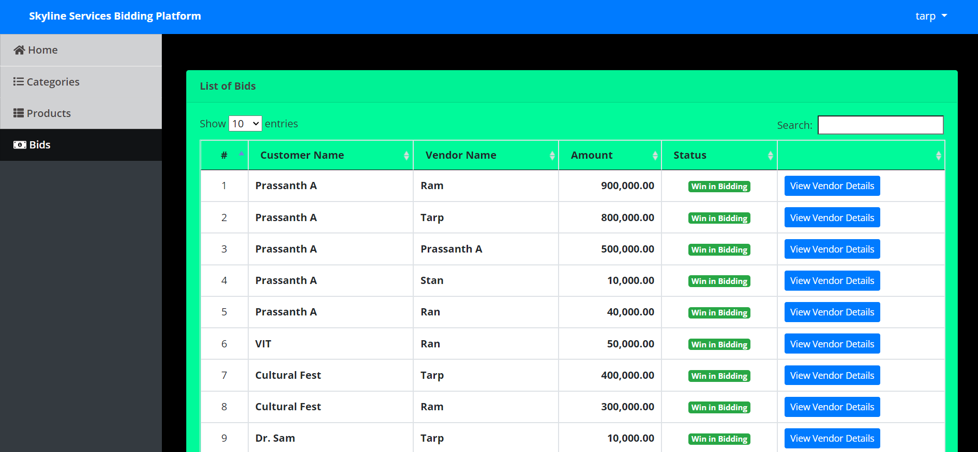

**FIG 6 : SUMMARY OF CURRENT AND WINNING BIDS**



**FIG 7 : VENDOR DETAIL OF THE ONES WHO MADE A BID**

**PART C – DATABASE**

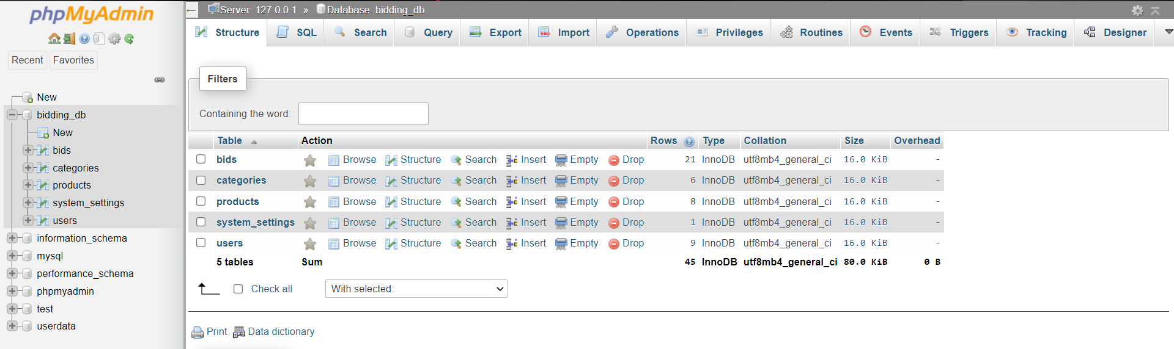

**FIG 8 : OVERALL DATABASE OF WEBSITE**

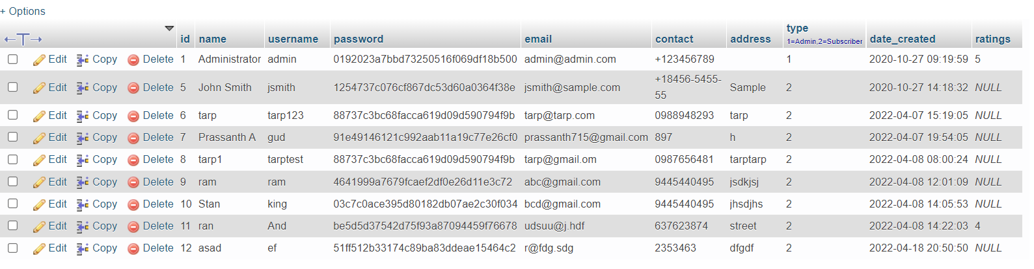

**FIG 9 : SERVICE PROVIDER DATABASE**

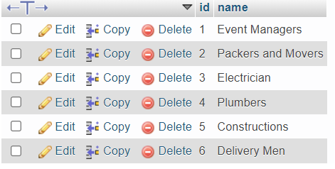

**FIG 10 : DATABASE OF CATEGORIES**

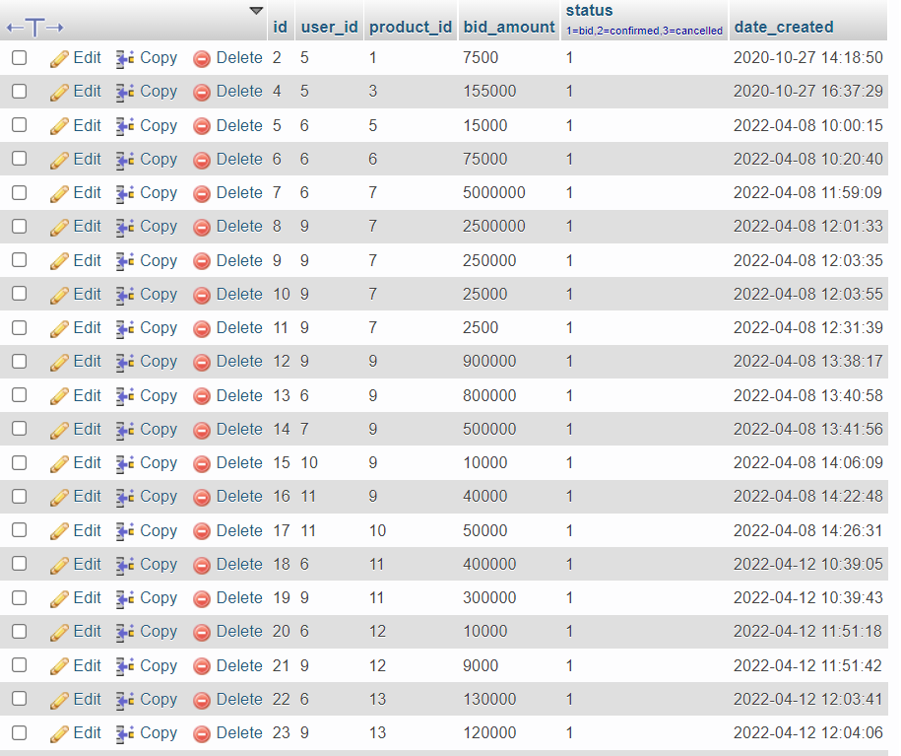

**FIG 11 : DATABASE OF BIDS**

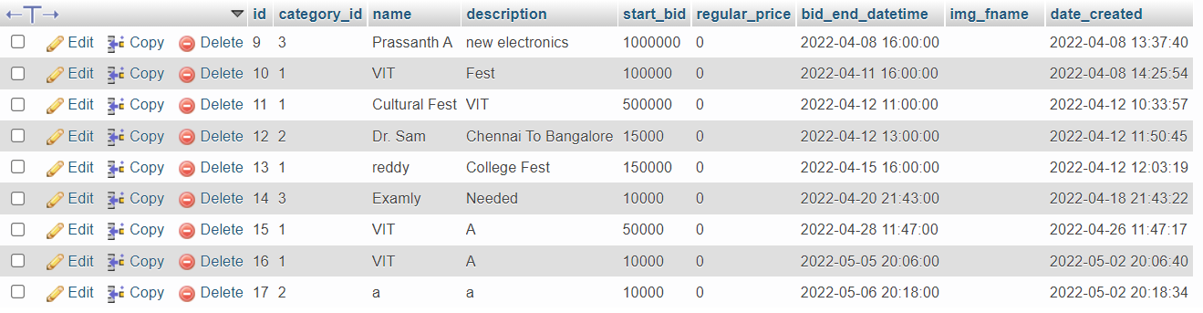

**FIG 12 : DATABASE OF SERVICE REQUIRMENTS POSTED**



**FIG 13 : DATABASE OF BASIC WEBSITE INFO**

**CHAPTER 4**

**COST ANALYSIS**

|  |  |
| --- | --- |
| **Activity** | **Cost** |
| Web hosting | Cost: $75 – $100 per month |
| Website design | $2,000–$8,000 |
| Testing | $2,000–$5,000 |
| SEO | $300–$1,500 per month |
| MVP development cost | $8,000–$30,000 |
| Server building and maintenance cost | Depends on the scale |

**CHAPTER 5**

**5.1 CONCLUSION**

In our project, a basic reverse bidding platform has been designed and implemented which can be used to for any type of contract to provide cost efficient services for customers. This website is beneficial for service providers who are new to the field as they can view all available opportunities in the portal. This platform provides customers a wide range of options in terms of service providers as there is a large supplier market available. Multiple suppliers and customers are brought together into a common constructive platform which can be accessed at ease. The process occurs in real-time; the auctions are concluded within the stipulated time. For quality assurance, government approved certificates and customer feedback can be considered as major factors. The standards and procedures defined by a quality assurance program help prevent product defects before they arise. Quality assurance is a crucial aspect of this product as we can’t compromise on the quality for cost efficient services.

* 1. **FUTURE WORK**

This product can be extended in a large scale where we can add several other services like buying and selling vehicles, in real-estate, etc. The applications of reverse bidding are very vast. For quality assurance, centers can be setup across the country to verify the quality of services provided. We can extend this application to include individual labor like mechanics, electricians, plumbers, etc. where a customer can raise a request for a certain individual service and nearby service providers can accept the offer and attend to the issue. This will be more beneficial when we are relocating to a new neighborhood or when we are in the middle of nowhere and we need such services.

**REFERENCES**

* Ma, B., Zhou, Z., Bashir, M. F., & Huang, Y. (2020). A multi-attribute reverse auction model on margin bidding. *Asia-Pacific Journal of Operational Research*, *37*(06), 2050032.
* Koirala, R. C., Dahal, K., Matalonga, S., & Rijal, R. (2019, August). A supply chain model with blockchain-enabled reverse auction bidding process for transparency and efficiency. In *2019 13th International Conference on Software, Knowledge, Information Management and Applications (SKIMA)* (pp. 1-6). IEEE.
* Ding, M., Eliashberg, J., Huber, J., & Saini, R. (2005). Emotional bidders—An analytical and experimental examination of consumers' behavior in a priceline-like reverse auction. *Management Science*, *51*(3), 352-364.
* Yuan, S., Wang, J., & Zhao, X. (2013, August). Real-time bidding for online advertising: measurement and analysis. In *Proceedings of the seventh international workshop on data mining for online advertising* (pp. 1-8).
* Turban, E. (1997). Auctions and bidding on the Internet: An assessment. Electronic Markets, 7(4), 7-11.
* Dholakia, U. M., & Simonson, I. (2005). The effect of explicit reference points on consumer choice and online bidding behavior. *Marketing Science*, *24*(2), 206-217.
* Ariely, D., & Simonson, I. (2003). Buying, bidding, playing, or competing? Value assessment and decision dynamics in online auctions. *Journal of Consumer psychology*, *13*(1-2), 113-123.

**BIODATA**

Name: Nagendran K

Mobile: 93607 98026

Email: nagendran.2019@vitstudent.ac.in

Name: Kishore N

Mobile: 94444 51707

Email: kishore.n2019@vitstudent.ac.in

Name: Madan S

Mobile: 98846 99978

Email: madan.s2019@vitstudent.ac.in

Name: Stanley Kingston S

Mobile: 94454 40495

Email: [stanleykingston.s2019@vitstudent.ac.in](mailto:stanleykingston.s2019@vitstudent.ac.in)

Name: Prassanth A

Mobile:91504 50837

Email: [prassanth.a2019@vitstudent.ac.in](mailto:prassanth.a2019@vitstudent.ac.in)

Name: Sanjay S

Mobile: 89393 25043

Email: [sanjay.s2019b@vitstudent.ac.in](mailto:sanjay.s2019b@vitstudent.ac.in)