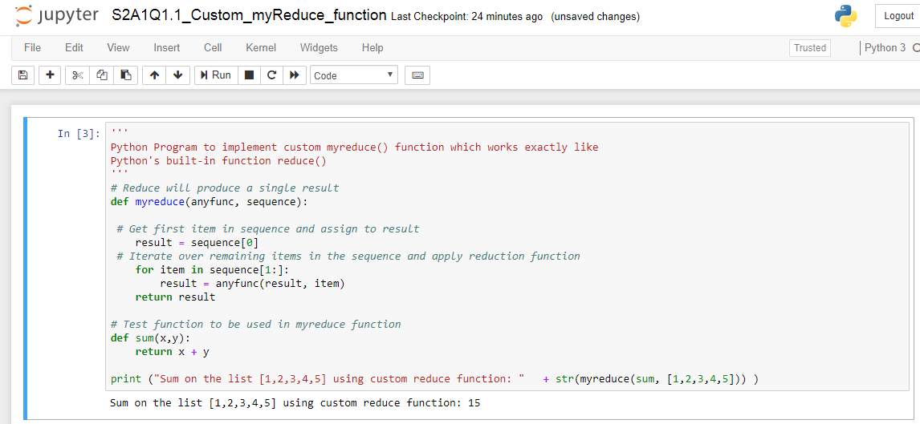

'''

Python Program to implement custom myreduce() function which works exactly like

Python's built-in function reduce()

'''

# Reduce will produce a single result

def myreduce(anyfunc, sequence):

# Get first item in sequence and assign to result

result = sequence[0]

# Iterate over remaining items in the sequence and apply reduction function

for item in sequence[1:]:

result = anyfunc(result, item)

return result

# Test function to be used in myreduce function

def sum(x,y):

return x + y

print ("Sum on the list [1,2,3,4,5] using custom reduce function: " + str(myreduce(sum, [1,2,3,4,5])) )