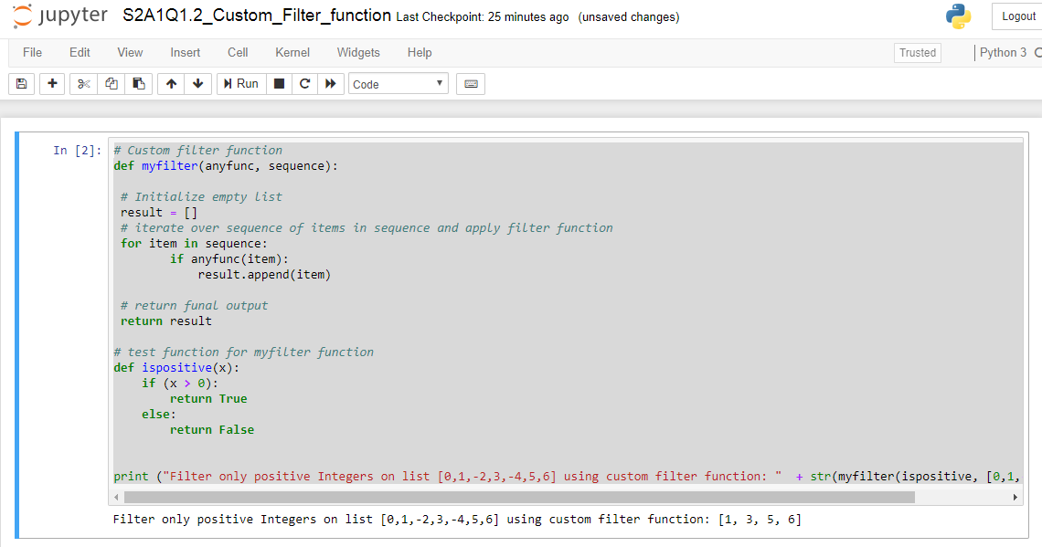

# Custom filter function

def myfilter(anyfunc, sequence):

# Initialize empty list

result = []

# iterate over sequence of items in sequence and apply filter function

for item in sequence:

if anyfunc(item):

result.append(item)

# return funal output

return result

# test function for myfilter function

def ispositive(x):

if (x > 0):

return True

else:

return False

print ("Filter only positive Integers on list [0,1,-2,3,-4,5,6] using custom filter function: " + str(myfilter(ispositive, [0,1,-2,3,-4,5,6])))