PROJECT DESCRIPTION:- The Project aims to display Vehicle Sales Data of Different Countries of the World. The dataset contains various attributes of the Sales data ranging from year 2003 to 2005. The Dataset is stored in the form of CSV file and the project aims to stage it to HDFS and further analysis is to be performed using HIVE.

DESCRIPTION OF DATASET:- The dataset contains almost 2900 rows and 21 columns(attributes) about the vehicle sales data. The Unique attributes of the dataset and their data-types are :

- ORDERNUMBER int,
- QUANTITYORDERED int,
- PRICEEACH float,
- ORDERLINENUMBER int,
- SALES float,
- STATUS string,
- QTR_ID int,
- MONTH_ID int,
- YEAR_ID int,
- PRODUCTLINE string,
- MSRP int,
- PRODUCTCODE string,
- PHONE string,
- CITY string,
- STATE string,
- POSTALCODE string,
- COUNTRY string,
- TERRITORY string,
- CONTACTLASTNAME string,
- CONTACTFIRSTNAME string,
- DEALSIZE string

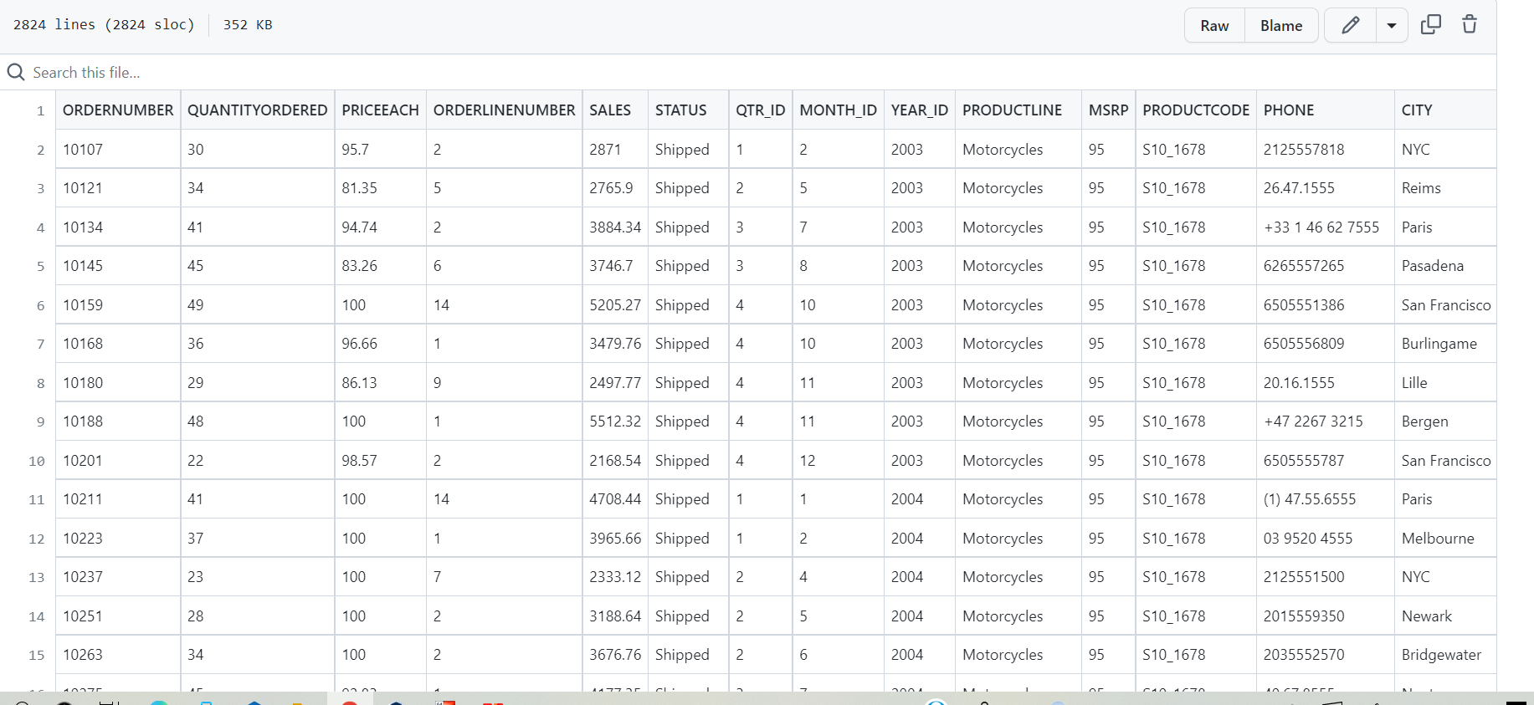
The glimpse of the dataset is shown above.

PROBLEM STATEMENT:-
- Store raw data into hdfs location

- Create a internal hive table "sales_order_csv" which will store csv data sales_order_csv .. make sure to skip header row while creating table

- Load data from hdfs path into "sales_order_csv"

- Create an internal hive table which will store data in ORC format "sales_order_orc"

- Load data from "sales_order_csv" into "sales_order_orc".

Placing the given Dataset in the HDFS:- Step1 - Create a Directory in HDFS, ensuring all the daemons are started.

hadoop fs -mkdir /user/hive/project

Step2 - Copy the Dataset from local to HDFS directory.

hadoop fs -copyFromLocal /home/cloudera/Downloads/
Sales_order_data.csv /user/hive/project/sales_order_data.csv
Creating The Database: Create a database named ‘hive_assignment’, and use it for further purpose.

- Create database hive_assignment;
- Use hive_assignment;

Creating the internal hive table : After creating database , we have to create an internal table.

create table sales_order_data_csv
(ORDERNUMBER int, QUANTITYORDERED int,
PRICEEACH float, ORDERLINENUMBER int,
SALES float, STATUS string,
QTR_ID int, MONTH_ID int,
YEAR_ID int, PRODUCTLINE string,
MSRP int, PRODUCTCODE string,
PHONE string, CITY string,
STATE string, POSTALCODE string,
COUNTRY string, TERRITORY string,
CONTACTLASTNAME string,
CONTACTFIRSTNAME string, DEALSIZE string)
row format delimited
fields terminated by ','
tblproperties("skip.header.line.count"="1");

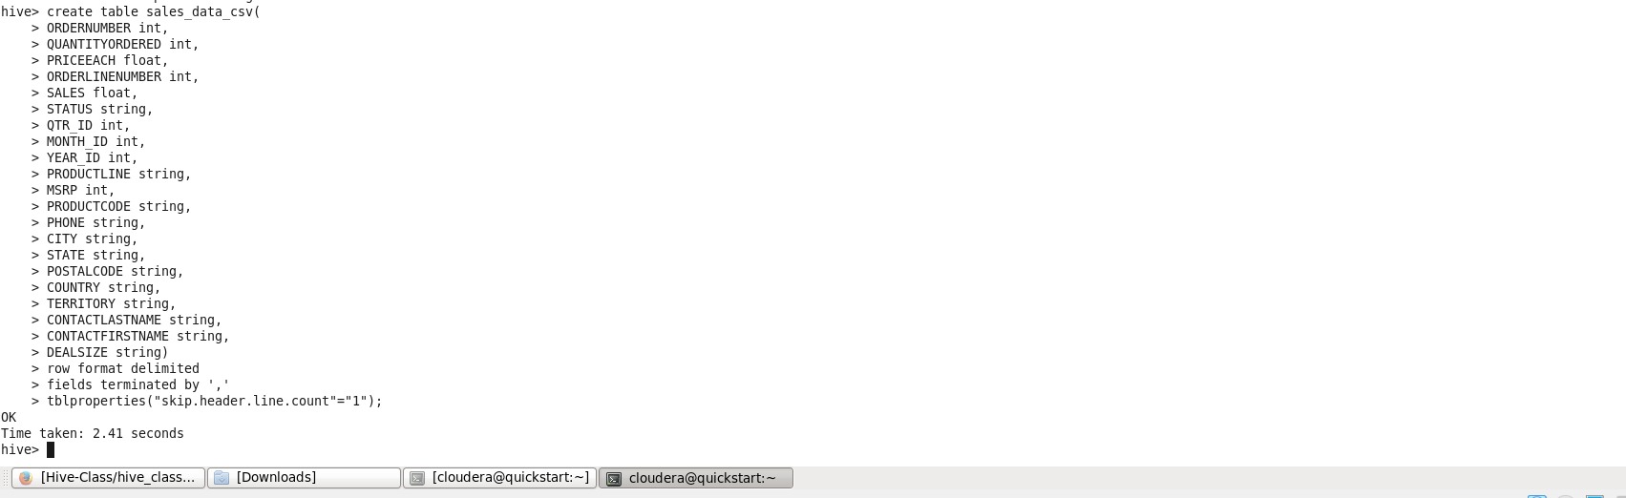
Creating Internal table

Loading data from HDFS path to the table created: After creating the table sales_order_csv, we have to load the data content inside it.
load data local inpath ‘/home/cloudera/Downloads/sales_order
_data.csv’ into table sales_order_data.csv;

Create an internal hive table which will store data in ORC format "sales_order_orc" :

create table sales_data_orc
(ORDERNUMBER int, QUANTITYORDERED int,
PRICEEACH float, ORDERLINENUMBER int,
SALES float, STATUS string,
QTR_ID int, MONTH_ID int,
YEAR_ID int, PRODUCTLINE string,
MSRP int, PRODUCTCODE string,
PHONE string, CITY string,
STATE string, POSTALCODE string,
COUNTRY string, TERRITORY string,
CONTACTLASTNAME string,
CONTACTFIRSTNAME string, DEALSIZE string)
Stored as orc;

Load data from "sales_order_csv" into "sales_order_orc": Now loading the content from csv table to orc table.
From sales_order_data.csv insert overwrite table sales_data_orc select *;

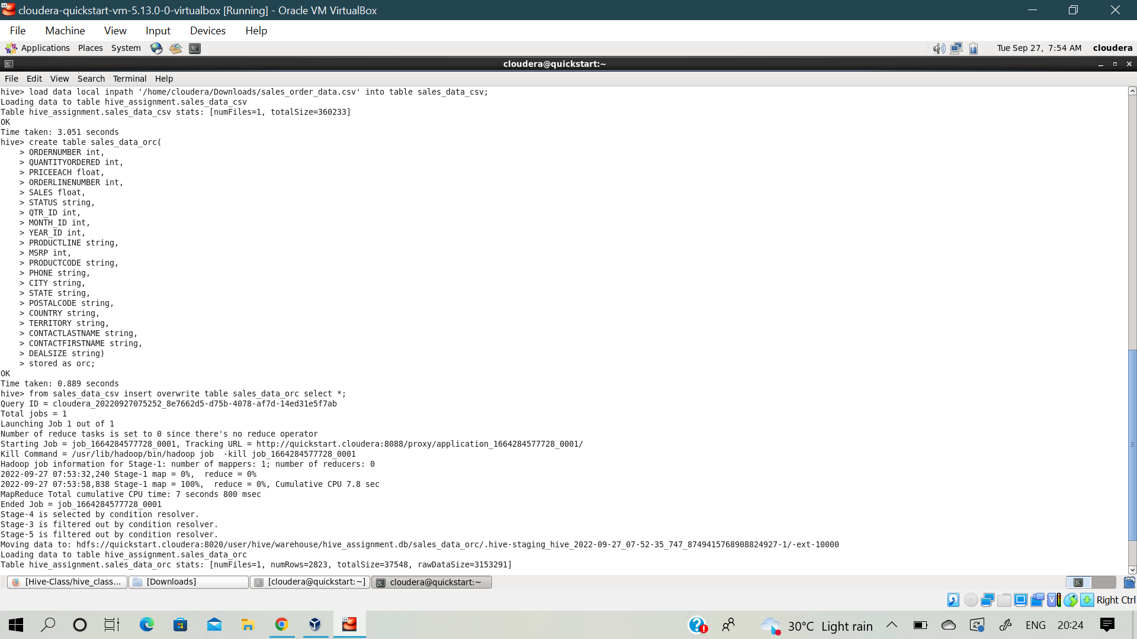
The above figure depicts the successful loading of data from csv table to sales_data_orc table. Now that the data is loaded in Hive table, further analysis is to be performed in Hive shell.

PROBLEM SCENARIO:
Below are some problem statements that are to be executed using Hive commands on the sales_orc table.

- Calculate total sales per year.

Select sum(sales) , year_id from sales_data_orc
group by year_id;

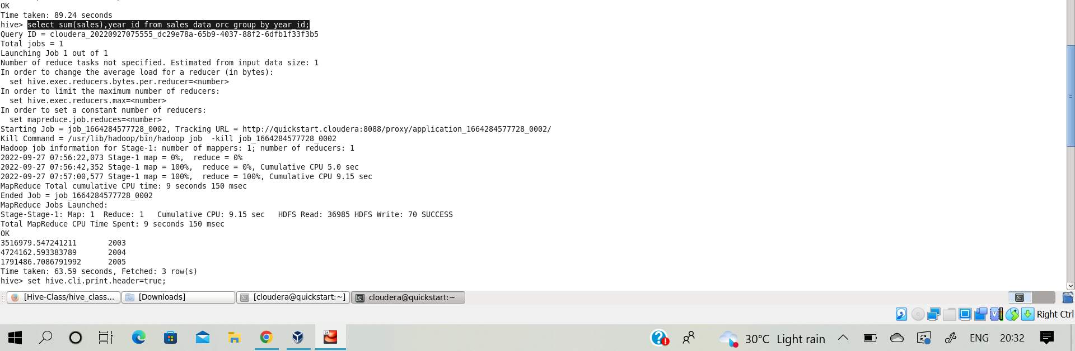

After running the above query , we got the desired output of total sales year wise.
Total Sales | Year
3516979.5472 | 2003
47224162.5933 | 2004
1791486.7086 | 2005

From the output, it can be concluded that the year 2004 had the highest amount of sales in comparison to other two years.

- Find a product for which maximum orders were placed.

Select PRODUCTLINE, Count(QUANTITYORDERED) as count From sales_data_orc
Group by PRODUCTLINE
Order by count Desc limit 3;

After running the above query , the output is:
PRODUCTLINE | MAXIMUM
Classic Cars | 967
Vintage Cars | 607
Motorcycles | 331

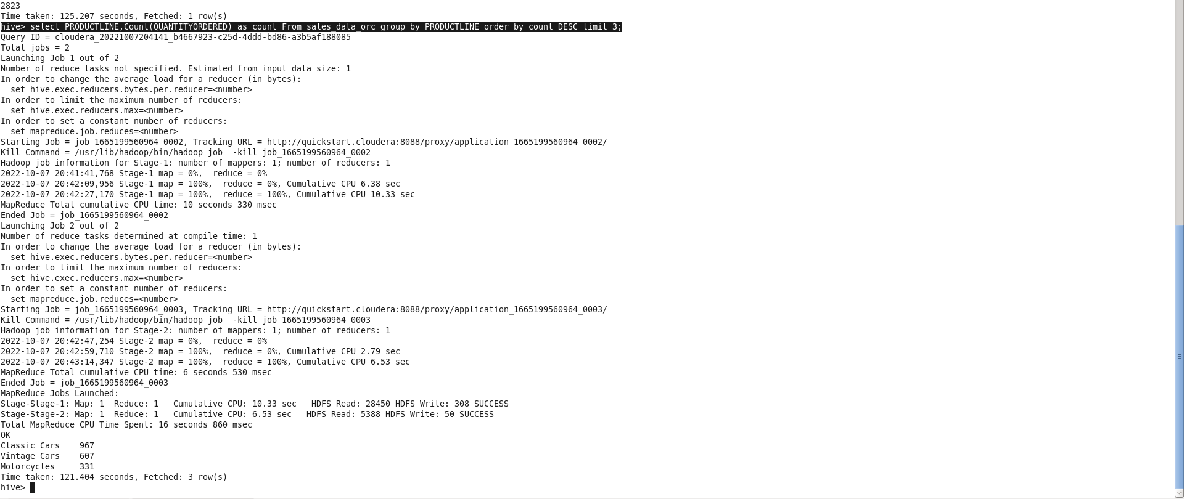
Here, it can be concluded that Classic cars were sold mostly in the year of 2003 - 2005 across different parts of the world.

- Calculate Total sales for each quarter.
Select sum(SALES) as Total, QTR_ID from sales_data_orc
Group by QTR_ID;

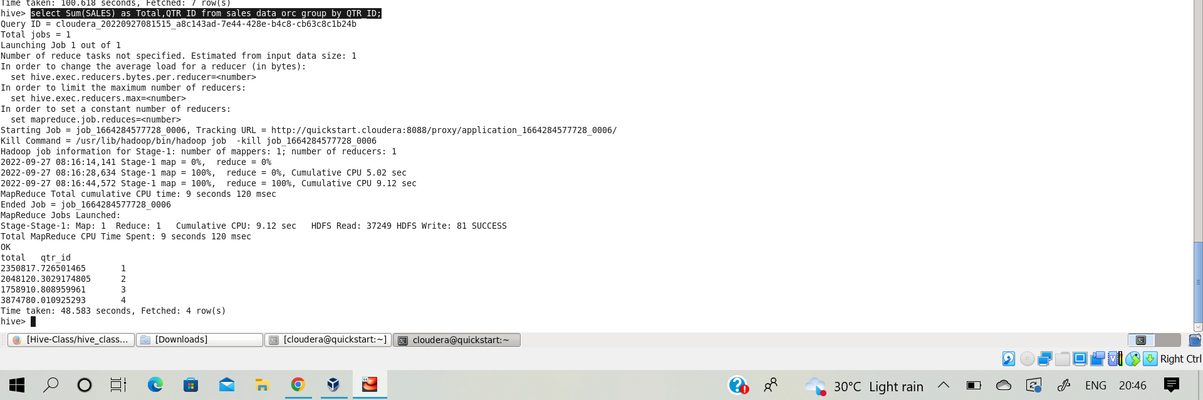

The result of the above query is shown in the above image. It can be concluded that the last quarter_id has the most amount of sales.

Total | Qtr_Id
2350817.726 | 1
2048120.302 | 2
1758910.808 | 3
3874780.010 | 4
- In which quarter sales was minimum:
Select sum(SALES) as Sum, QTR_ID,YEAR_ID
from sales_data_orc
Group by QTR_ID,YEAR_ID
Order by sum Asc limit 3;

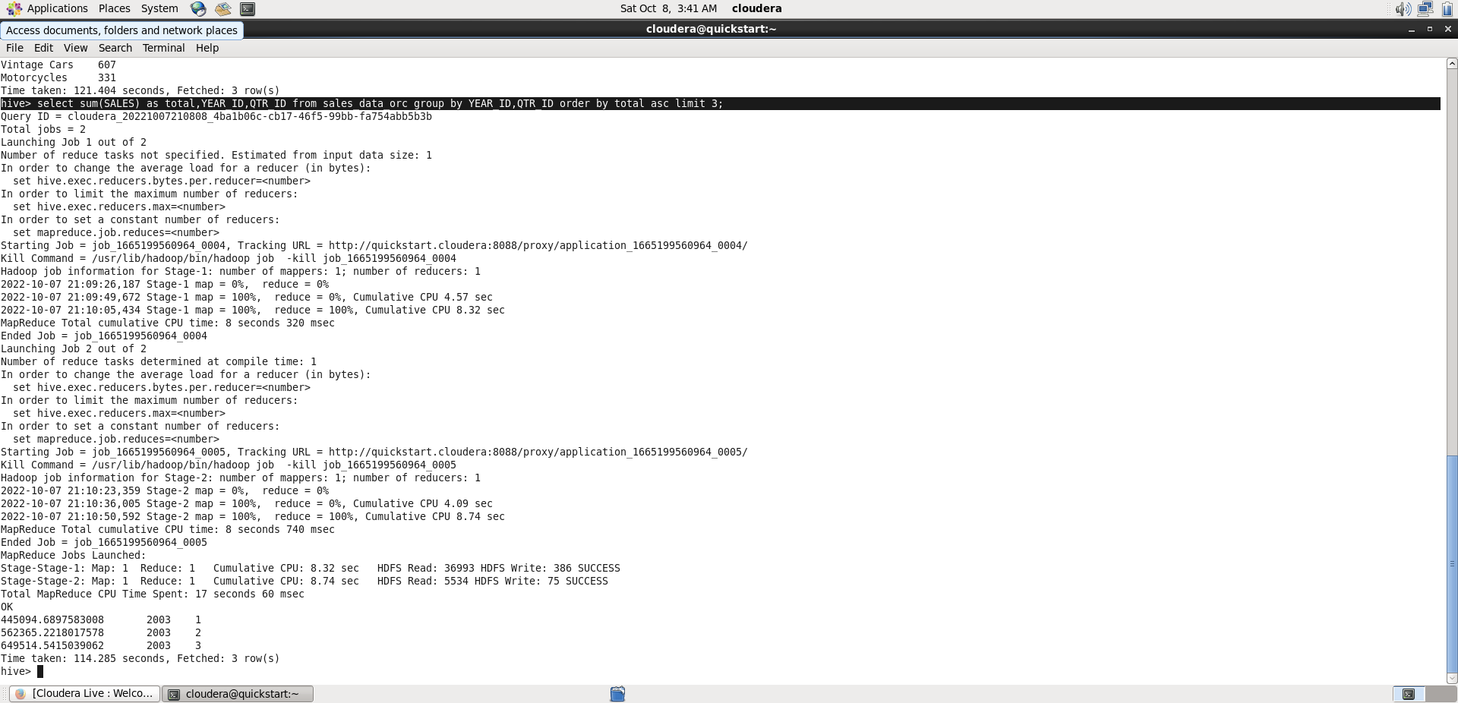

From the above output, Quarter Id 1 in year 2003 has the minimum amount of Sales recorded of value “445094.68”.

- In which Country Sales was Maximum and in which country sales was minimum.

Select max(SALES) as Min_Max, COUNTRY
From Sales_data_orc group by COUNTRY
Order by Min_Max DESC limit 1
UNION ALL
Select Min(SALES) as Min_Max,COUNTRY
From Sales-data_orc group by COUNTRY
Order by Min_Max ASC limit 1;

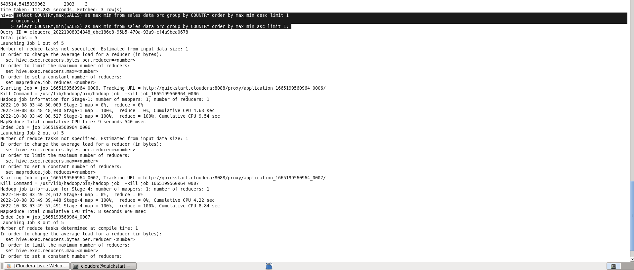

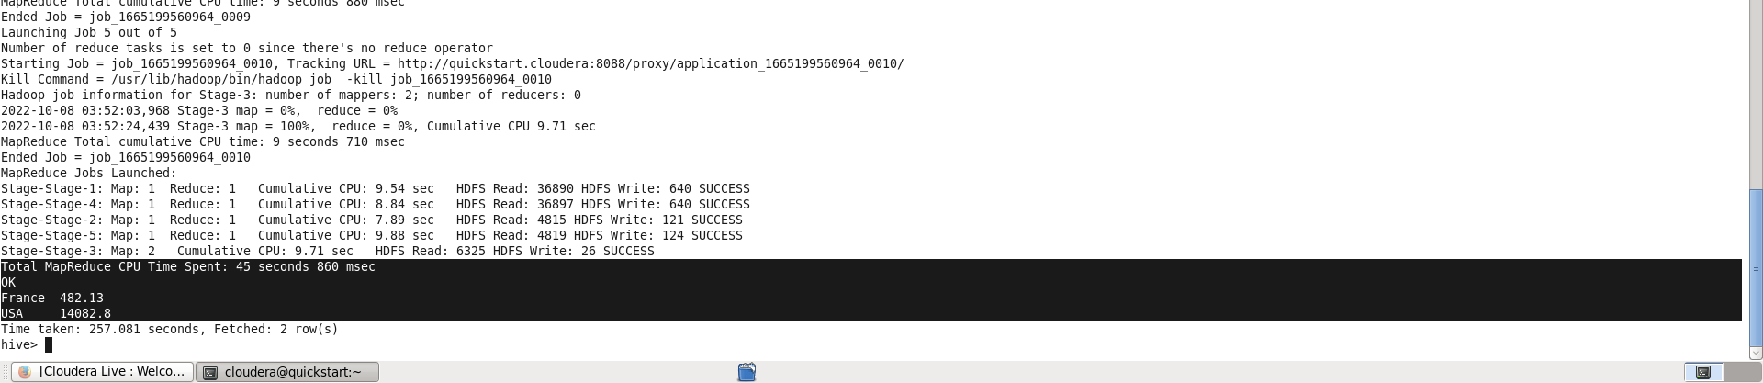
The above two image depicts the final output. The Country of USA has the maximum amount of Sales of value “14082.8” while the Country of France has lowest amount of Sales recorded which was “482.3”.

- Calculate Quarterly Sales For each City.
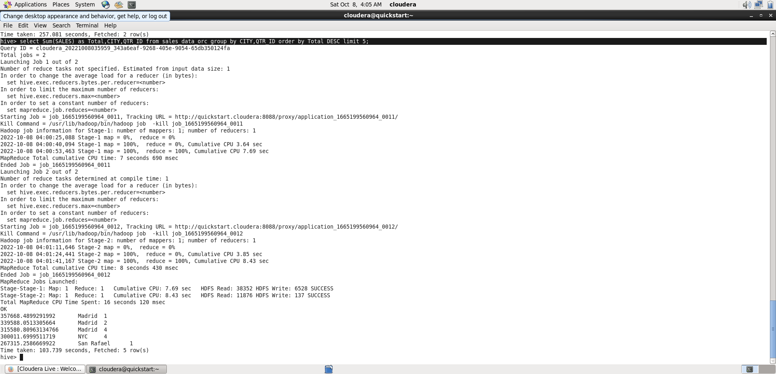

Select Sum(SALES) as Total , City,QTR_ID
From sales_data_orc
Group by City,QTR_ID
Order by Total Desc Limit 5;

The Top 5 sales city-wise recorded were:
Total | City | QTR_ID
357668.48 | Madrid | 1
339588.05 | Madrid | 2
315580.80 | Madrid | 4
300011.69 | NYC | 4
267315.25 | San Rafael | 1

- Find the Month for each year in which maximum number of Quantities were sold.

Select MONTH_ID,Count(QUANTITYORDERED) as Count
From Sales_data_orc
Group by MONTH_ID
Order by Count Desc limit 5;

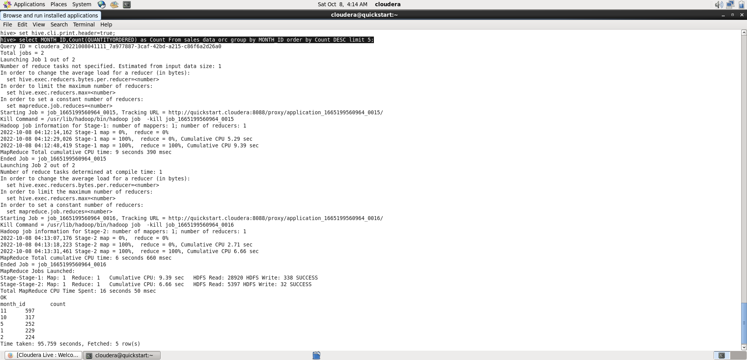

Month_id | Count
11 | 597
10 | 317
5 | 252
1 | 229
2 | 224

- Show Distinct Countries from the dataset
