**HOD401**

**Nguyen Cong Thanh**

**SE130443**

**IA1301**

**Proj 2 : HTTP request with python**

Grab http header banner

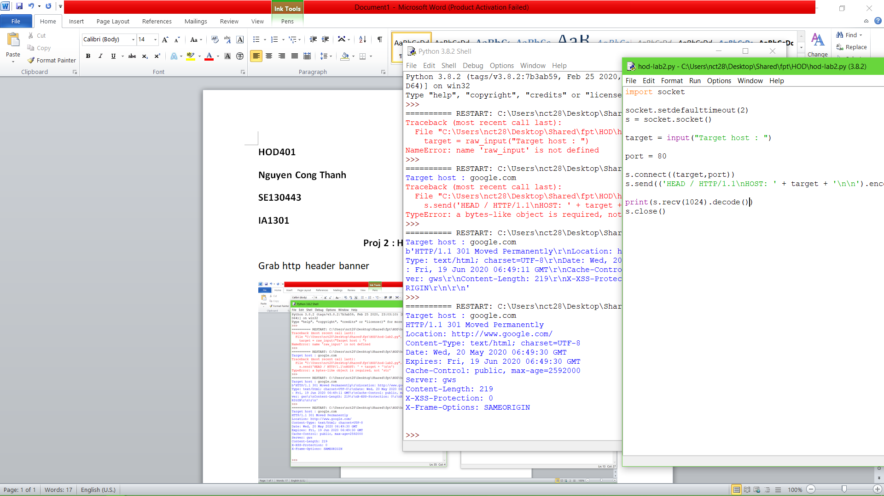

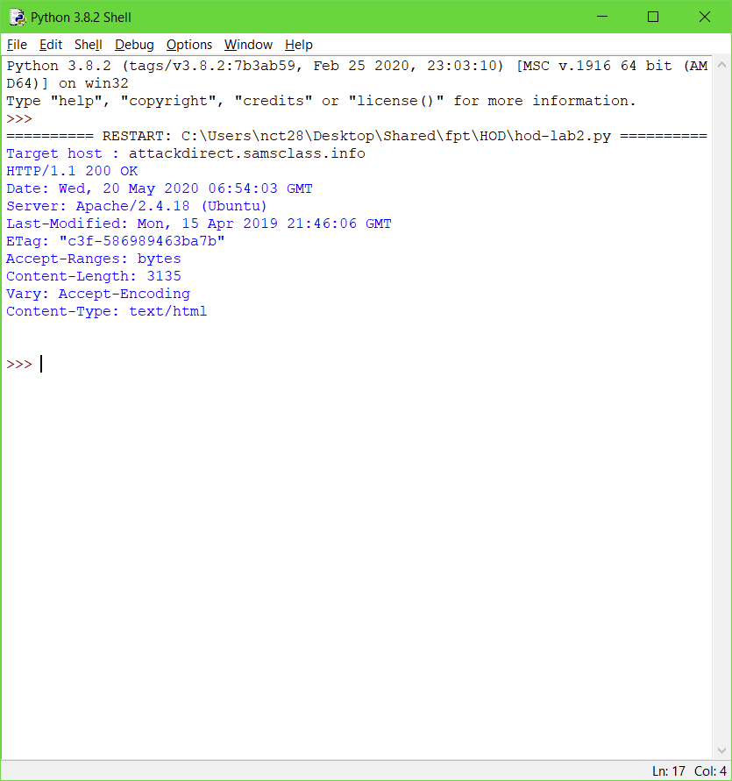

Resquests capture POST method

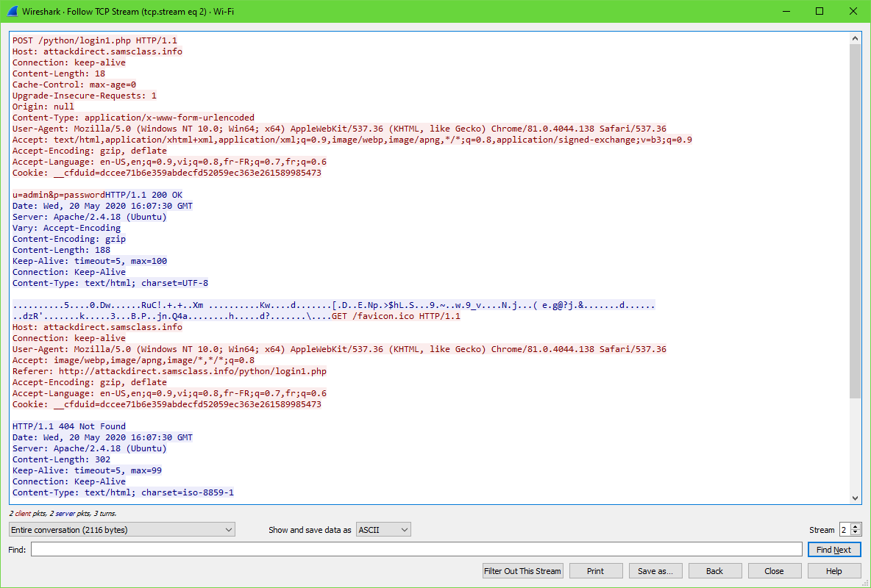

Replicate the post request and send

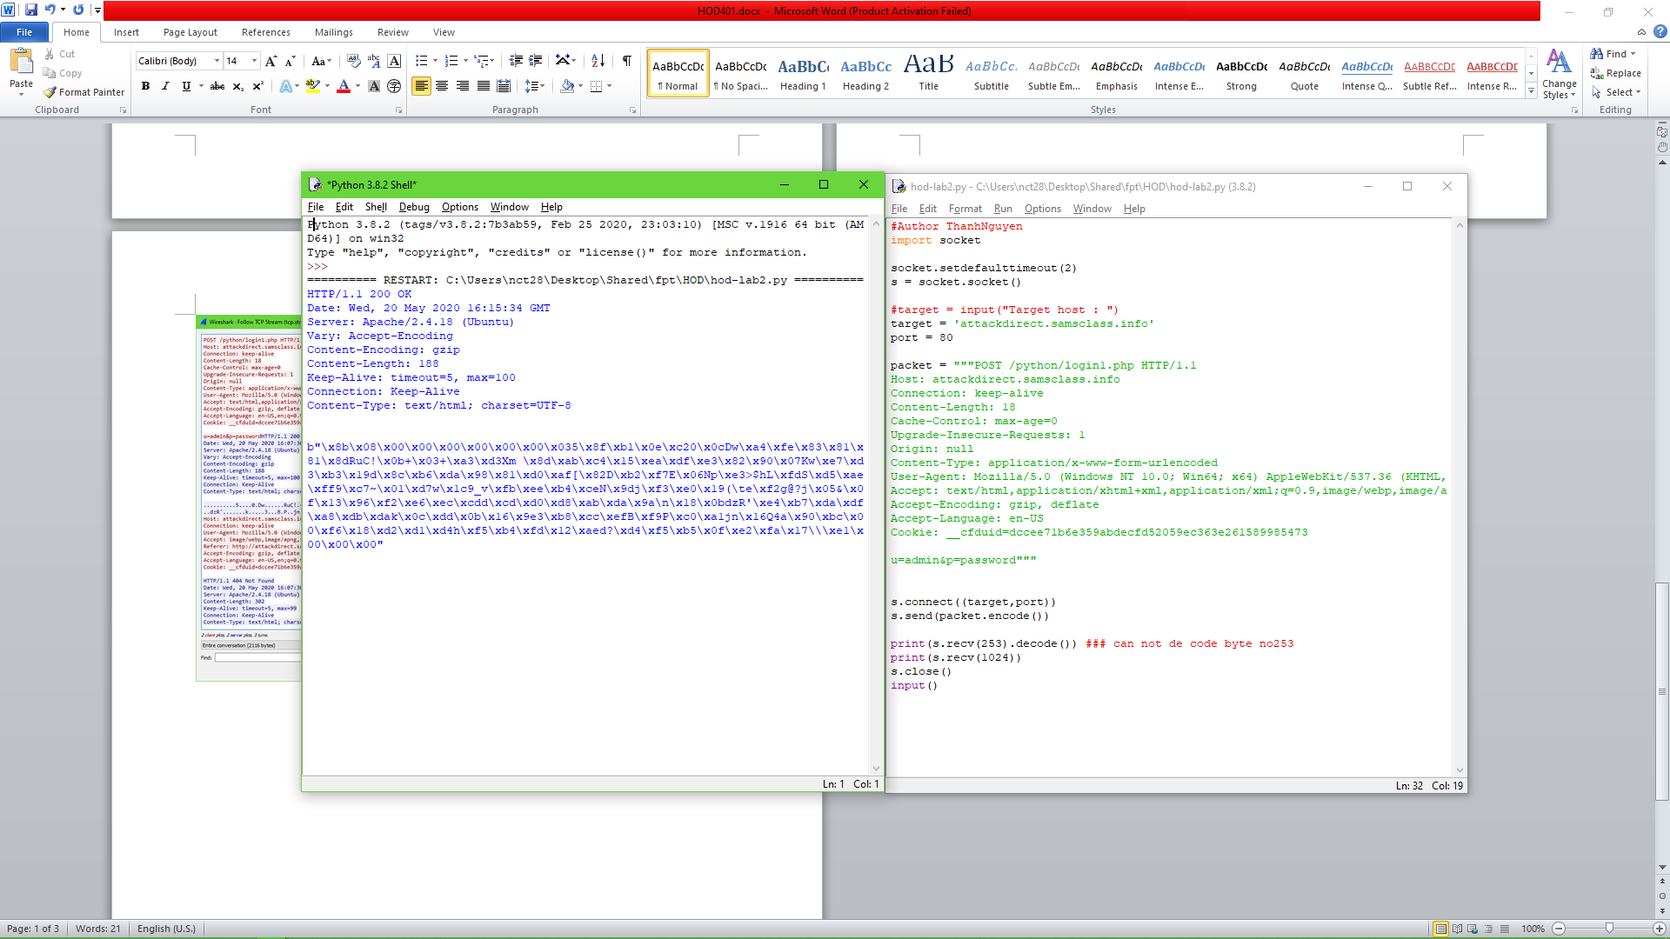

After remove Accept-Encoding: gzip header

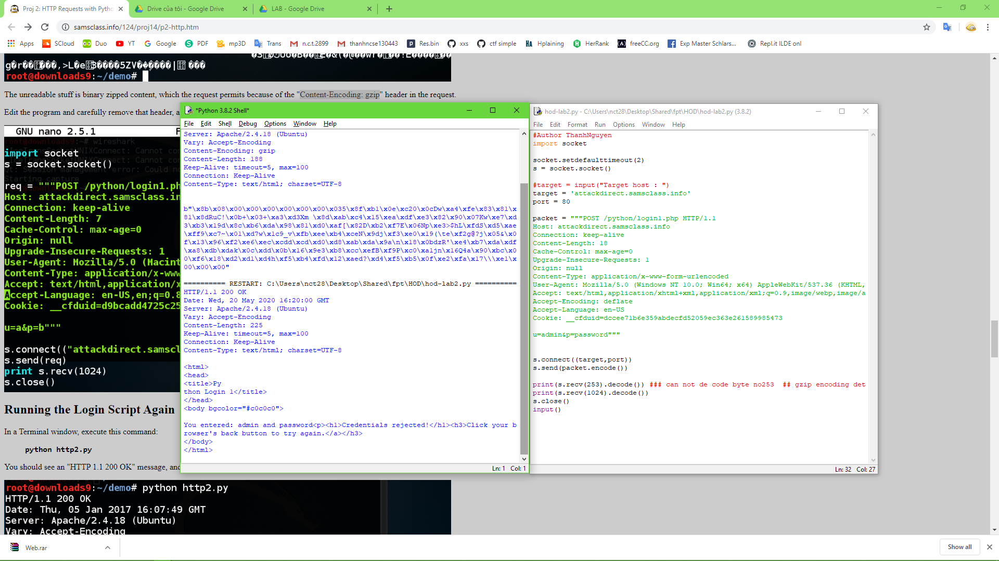

Making credential vairable by edit Content-Length header

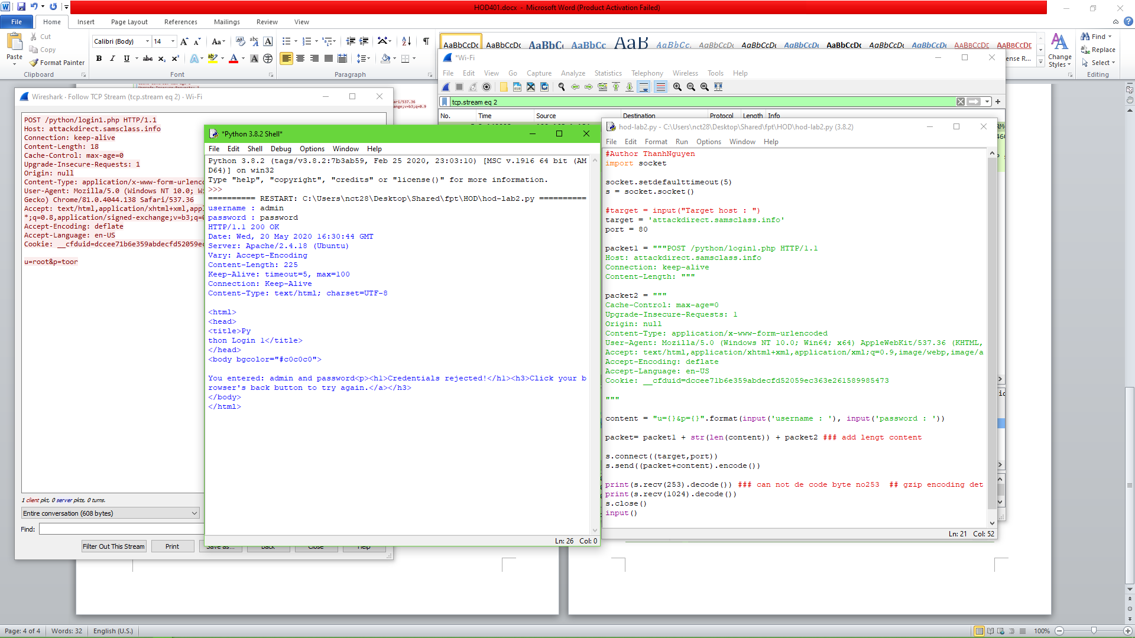

String value loop and Integer loop

