**Practice Exam**

Implement a 100-element array management program that includes students' **name** , **scores** and **address**. The file ***students1.txt*** already has data of some students. Start the program: must call the function to read file. Before the end of the program: must call the function to write file ***students2.txt***. The program appears with the menu as follows:

1. Add a student into the list
2. Print out the all list
3. Search student by name
4. Search student by score
5. Sort the student list in **descending** order by score
6. Exit.

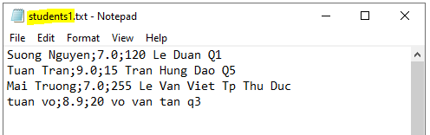

Hướng dẫn nộp bài: Nguyễn Đăng Khoa có mã số sinh viên SE1600000

Đặt tên file bài làm **NguyenDangKhoa-SE160000.c**

Nộp 1 file này lên lms mục PE cùng chỗ với đề thi ->click Submit.

Sinh viên kiểm tra lại bài thật kĩ trước khi rời khỏi lms.

***** Chúc các em thi tốt *****