Program Structure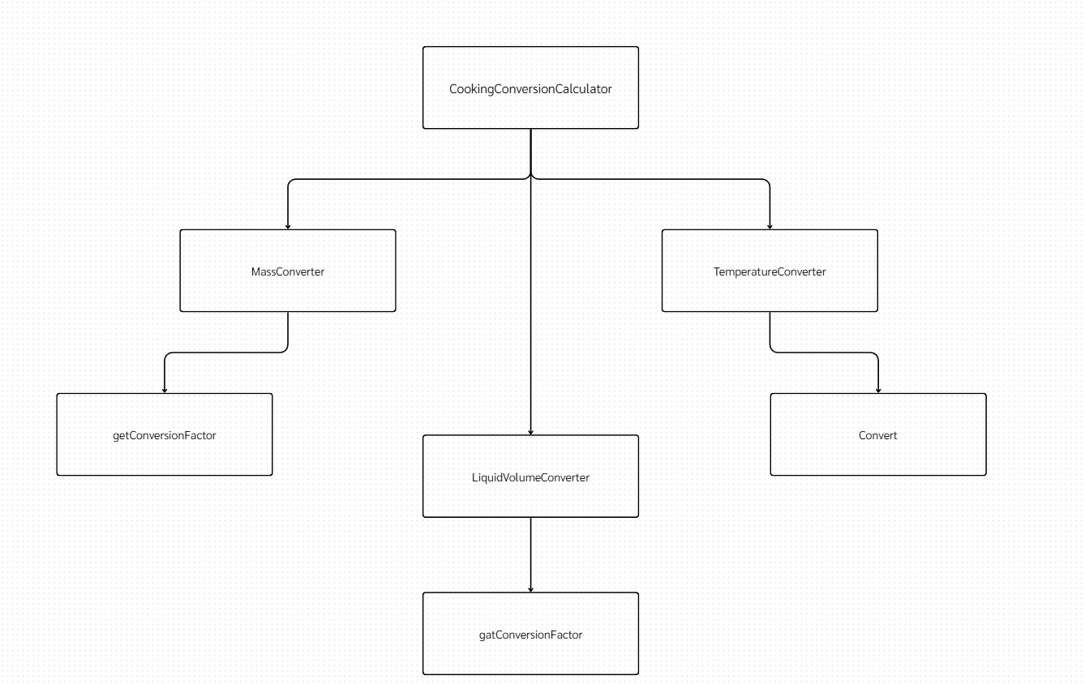
Top-down Integration
Unit under test | List of Stubs/Drivers | Input  Choice | Value | From  Unit | To  Unit | result | Stub’s return value | Expected results | Actual results | Pass/Fail/No run
TD-T1  CookingConversion  Calculator.convert | Stub Temperature  Converter.convert | temperature | 86 | F | C | 30.00 | 999.88 | 999.88 | 30.00 | Fail
TD-M1  CookingConversion  Calculator.convert | Stub MassConverter .convert | mass | 7 | tbsp | gram | 56.00 | 222.23 | 222.23 | 56.00 | Faill
TD-L1  CookingConversion  Calculator.convert | Stub LiquidVolume  Converter.convert | liquid | 2 | L | quart | 2.11 | 123.46 | 123.46 | 2.11 | Fail
TD-U1  CookingConversion  Calculator.convert | - | viscosity | - | - | any | 0.00 | - | 0.00 | 0.00 | Pass
Bottom-up Integration
Unit under test | List of Stubs/Drivers | Input  Choice | Value | From  Unit | To  Unit | Stub’s return value | Expected results | Actual results | Pass/Fail/No run
BU-MASS-1 | Drivers :JUnit test | mass | 0.5 | cup | gram | - | 62.50 | 62.50 | Pass
BU-MASS-2 | Drivers :JUnit test | mass | 3 | tbsp | gram | - | 24.00 | 24.00 | Pass
BU-MASS-3 | Drivers :JUnit test | mass | 10 | oz | gram | - | 283.49 | 283.49 | Pass
BU-MASS-4 | Drivers :JUnit test | mass | 3 | Ib | Kg | - | 1.36 | 1.36 | Pass
BU-MASS-5 | Drivers :JUnit test | mass | 750 | gram | Oz | - | 26.45 | 26.45 | Pass
BU-MASS-6 | Drivers :JUnit test | mass | 5 | kg | Ib | - | 11.02 | 11.02 | Pass
BU-LIQ-1 | Drivers :JUnit test | liquid | 2 | Cup | ml | - | 500.00 | 500.00 | Pass
BU-LIQ-2 | Drivers :JUnit test | liquid | 1.5 | Cup | oz | - | 12.00 | 12.00 | Pass
BU-LIQ-3 | Drivers :JUnit test | liquid | 3 | Tbsp | ml | - | 45.00 | 3.00 | Fail
BU-LIQ-4 | Drivers :JUnit test | Liquid | 2 | Oz | ml | - | 59.14 | 59.14 | Pass
BU-LIQ-5 | Drivers :JUnit test | Liquid | 2 | Pint | Ml | - | 946.35 | 946.35 | Pass
BU-LIQ-6 | Drivers :JUnit test | liquid | 2 | Quart | L | - | 1.89 | 1.89 | Pass
BU-LIQ-7 | Drivers :JUnit test | liquid | 250 | Ml | oz | - | 8.45 | 8.45 | Pass
BU-LIQ-8 | Drivers :JUnit test | liquid | 2 | L | pint | - | 4.22 | 4.22 | Pass
BU-LIQ-9 | Drivers :JUnit test | liquid | 2 | L | quart | - | 2.11 | 2.11 | Pass
BU-LIQ-10 | Drivers :JUnit test | liquid | 3 | L | gallon | - | 0.79 | 0.79 | Pass
BU-TEMP-1 | Drivers :JUnit test | temperature | 68 | F | C | - | 20.00 | 0.00 | Fail
BU-TEMP-2 | Drivers :JUnit test | temperature | 104 | F | C | - | 40.00 | 0.00 | Fail
BU-TEMP-3 | Drivers :JUnit test | temperature | 20 | C | F | - | 68.00 | 0.00 | Fail
BU-TEMP-4 | Drivers :JUnit test | temperature | -40 | C | F | - | -40.00 | 0.00 | Fail
BU-TEMP-5 | Drivers :JUnit test | temperature | 14 | F | C | - | -10.00 | 0.00 | Fail
BU-CALC-1 | Drivers :JUnit test | mass | 3 | Kg | Ib | - | 6.61 | 6.61 | Pass
BU-CALC-2 | Drivers :JUnit test | liquid | 2 | quart | L | - | 1.89 | 1.89 | Pass
BU-CALC-3 | Drivers :JUnit test | temperature | 68 | F | C | - | 20.00 | 0.00 | Fail
BU-CALC-4 | Drivers :JUnit test | temperature | 104 | F | C | - | 40.00 | 0.00 | Fail
BU-CALC-5 | Drivers :JUnit test | pressure | - | - | any | - | 0.00 | 0.00 | Pass

