TimerCube
By Kit
User Guide

ESP32-S3 Matrix Edition
Toastmasters Speech Timer

Contents
Contents 2
1. Overview 3
How it works 3
The LED matrix 3
Navigation 4
2. First-Time Setup 5
Step 1 — Connect to the device hotspot 5
Step 2 — Enter your Wi-Fi network details 5
Step 3 — Verify the connection 5
Customising the hotspot credentials 6
3. Timer Page 7
The clock display 8
Start, Stop and Reset 8
Colour thresholds 8
Presets 8
Speaker selector 9
Manual light control 9
Keyboard shortcuts 10
4. Speakers Page 11
Toolbar buttons 11
Speaker table columns 11
Adding and editing speakers 11
Recording actual times 12
5. Report Page 13
Report columns 13
Status badges 13
Refreshing and printing 13
6. Settings Page 15
Display Brightness 15
Wi-Fi Networks 15
Hotspot (Fallback AP) 15
Connection Info 16
Reboot Device 16
7. QR Codes 17

Overview
TimerCube is a compact, wireless speech-timing device built on an ESP32-S3 microcontroller with an 8 × 8 RGB LED matrix. It is designed for use at Toastmasters meetings and other events where speakers must stay within defined time limits.

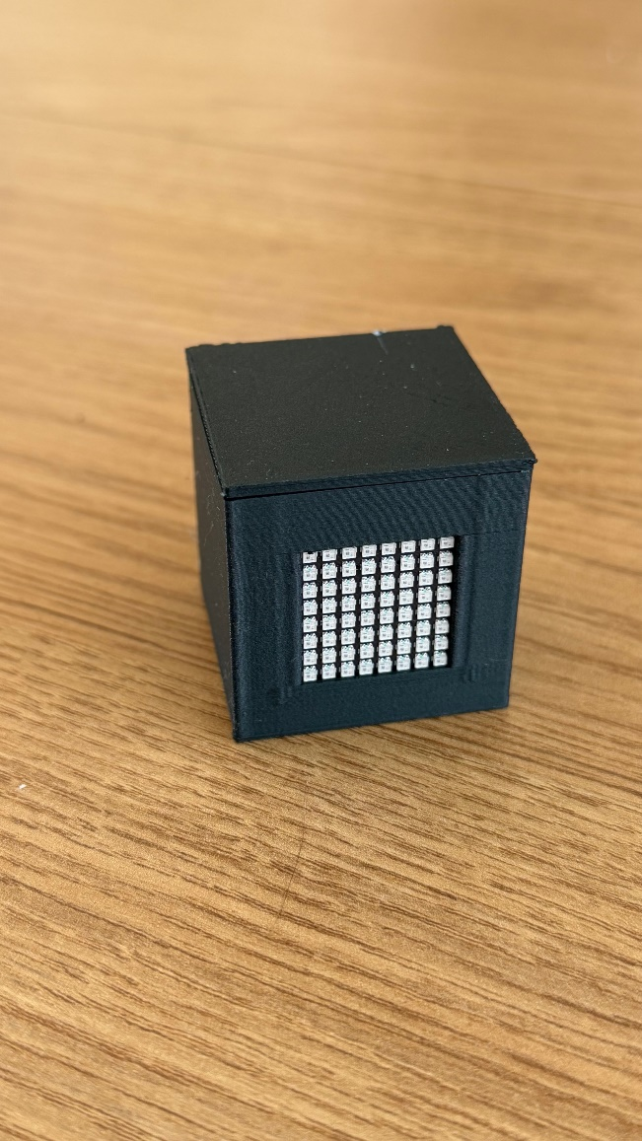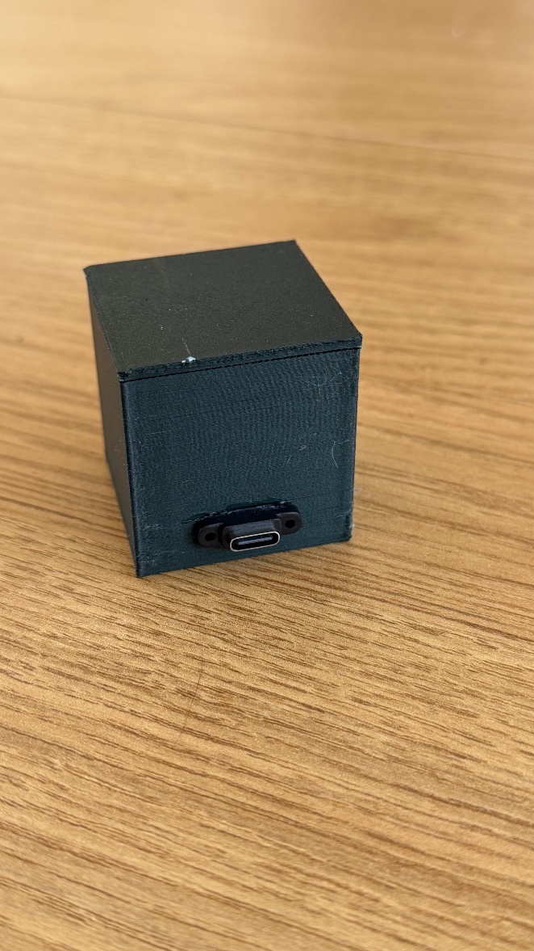

How it works
The device connects to your local Wi-Fi network and hosts a small web application that any phone, tablet or laptop on the same network can open in a browser. From that page you can:
- Start, stop and reset a countdown timer.
- Load preset time thresholds for different speech types.
- Assign individual speakers and record their actual times.
- Display a colour signal on the LED matrix (green, amber, red, or flashing red) visible to the speaker at the front of the room.
- Review a printable timing report at the end of a session.

The LED matrix
The 8 × 8 matrix on the front of the device provides at-a-glance timing signals:
Display | Meaning
Green | Speaker is within the green zone
Amber | Speaker is in the amber zone
Red | Speaker has entered the red zone
Red flashing | Speaker has exceeded the flash threshold — time is up
Blue dot | Timer is running but no colour threshold has been reached yet
Off | Timer is stopped

When the device is idle and no browser is connected, the matrix scrolls the device IP address so you can find the web interface.

Navigation
The web interface has four pages, accessible from the navigation bar at the top of every page:
- Timer — run the timer and control the light
- Speakers — manage the list of speakers for a session
- Report — view and print the session timing summary
- Settings — configure Wi-Fi, brightness, and device options

First-Time Setup
Out of the box the device has no Wi-Fi credentials saved, so it starts its own wireless hotspot (Access Point). Use this hotspot to enter your home or club network details.

Step 1 — Connect to the TimerCube’s hotspot
- Connect power to the USB-C connector on the rear of the TimerCube, it will power up.
- The LED matrix will flash "AP" in amber, indicating Access Point mode is active.
- On your phone or laptop, open Wi-Fi settings and join the network named TimerCube. There is a QR Code for this in section 8.
- When prompted for a password, enter: toastmaster
- Most phones will automatically show a sign-in page. If this does not appear, open a browser and visit: http://192.168.4.1/. There is a QR Code for this address in section 8.

TIP | Once a browser connects to the device, the LED matrix stops scrolling "AP" and the matrix clears.  The IP address to use in AP mode is always 192.168.4.1.

Step 2 — Enter your Wi-Fi network details
The browser will open on the Settings page. Scroll to the Wi-Fi Networks section.
- Click the + Add button to the right of the Wi-Fi Networks heading.
- An edit panel will appear with three fields:
  - SSID — type the exact name of your Wi-Fi network.
  - Password — type the network password.
  - Static IP (optional) — leave blank to obtain an address automatically via DHCP, or enter a fixed IP address such as 192.168.1.100 if you prefer.
- Click Apply to confirm the entry.
- If you need to add a second network (for example a backup), click + Add again and repeat.
- Click Save & Connect at the bottom of the Wi-Fi Networks section.
- The device will save your settings and reconnect. The message "Saved. Reconnecting Wi-Fi…" will appear briefly.

Step 3 — Verify the connection
After the device reconnects to your home network:
- The LED matrix will scroll the new IP address (for example: IP-192:168:1:150).
- Open the Settings page. The Connection Info section will show Mode: client and the assigned IP address.
- Make a note of the URL shown, for example http://192.168.1.150/ — this is the address you will use on future visits.

TIP | If the device cannot find any saved network it will automatically fall back to hotspot mode.  Reconnect to the TimerCube Wi-Fi and visit 192.168.4.1 to update the settings.

Customising the hotspot credentials
You can change the device’s own hotspot name and password in the Hotspot (fallback AP) section of the Settings page. This is useful if you want a more descriptive name for your club’s device. Leave the password field blank to create an open (unsecured) network.

Using the TimerCube
Once the TimerCube has been set up, as described in section 2, use the following procedure to connect to it and use it.

Step 1 — Power the TimerCube
- Connect power from a power bank or USB charger. to the USB-C connector on the rear of the TimerCube, it will power up.
- The LED matrix will flash "S" in blue, indicating it is searching for the network.
- The LED matrix will flash "C" in green, indicating it is connecting to the network.
- The LED matrix will then show the IP address of control webpage.

Step 2 — Access the webpage of the TimerCube
- Using a PC or mobile device, open a browser.
- Enter ‘TimerCube.local’ into the browser and wait ten seconds for it to connect. If you are using a phone, scanning the QR Code in section 8 of this document should get the browser to open the page.
- If your device does not connect use the IP address that is displayed on the TimerCube. It will show IP: xxx:xxx:x:x. Type into the device xxx.xxx.x.x separating the digits with a dot (.). The numbers may be 1 to 3 digits long. Again, wait for ten seconds for the control page to appear.
- Once the webpage appears, click on the green button. The IP address should be replaced by a green light. Click on the off button to turn the light off.

Timer Page
The Timer page is the main control screen. Open it by clicking Timer in the navigation bar.

The clock display
The large display at the top of the page shows the elapsed time in M:SS format (for example 2:34 for two minutes and 34 seconds). The background colour of the display changes to match the current signal colour sent to the LED matrix.

Start, Stop and Reset
Three buttons control the timer:
- Start — begins counting from the current time. The button label changes to "Running…" while the timer is active.
- Stop — pauses the timer at the current elapsed time.
- Reset — sets the elapsed time back to 0:00.

Colour thresholds
The timer automatically changes the LED matrix colour when the elapsed time crosses each threshold:
Threshold crossed | Effect
Green | LED matrix fills with green
Amber | LED matrix fills with amber
Red | LED matrix fills with red
Flash | LED matrix flashes red — the over-time alarm

The active thresholds are shown in small coloured text below the clock. If all thresholds are set to zero the display shows "Manual mode" and no automatic colour changes occur.

Presets
Ten preset configurations are shown below the controls. Click any preset to load the associated thresholds instantly. The active preset is highlighted with a green border.
Preset |  | Green / Amber / Red / Flash
1 Minute | — | 0:00 / 0:00 / 1:00 / 10:00
Table Topics | — | 1:00 / 1:30 / 2:00 / 2:30
Evaluations | — | 2:00 / 2:30 / 3:00 / 3:30
Icebreaker | — | 4:00 / 5:00 / 6:00 / 6:30
5–7 Minutes | — | 5:00 / 6:00 / 7:00 / 7:30
10 Minutes | — | 8:00 / 9:00 / 10:00 / 10:30
12 Minutes | — | 10:00 / 11:00 / 12:00 / 12:30
15 Minutes | — | 13:00 / 14:00 / 15:00 / 15:30
20 Minutes | — | 16:00 / 18:00 / 20:00 / 20:30
Manual | — | All thresholds off

Speaker selector
The Speaker dropdown, just below the presets, lists the speakers you have added on the Speakers page. When you choose a name:
- The timer automatically loads that speaker's preset thresholds.
- When you press Stop after the timer has been running, the elapsed time is recorded as the speaker's Actual time on the Speakers page.

Manual light control
The five Manual light buttons let you set the LED matrix colour directly, regardless of the timer state:
Button | Effect
Off | Turn the matrix off
Green | Solid green
Amber | Solid amber
Red | Solid red
Flash | Flashing red alarm

Keyboard shortcuts
When the cursor is not inside a text field, the following keys can be used to control the timer and lights from a laptop or desktop:
Key | Action
Space | Start
S | Stop
R | Reset
G | Green light
A | Amber light
X | Red light
F | Flash
C | Clear (Off)

Speakers Page
The Speakers page lets you build the running order for a meeting. Each row holds one speaker’s name, their time allowances, and their recorded actual time.

Toolbar buttons
Button | Action
+ Add Row | Appends a new blank speaker row to the end of the list
Save | Writes all speaker data to the device’s storage
Clear Actuals | Resets all Actual times to blank, ready for a new event with the same speakers
Clear List | Deletes all speakers after a confirmation prompt

Speaker table columns
Column | Description
# | Auto-numbered position in the running order
Name | The speaker’s name (editable text field)
Preset | Links to one of the ten presets; changing this updates the four threshold fields automatically
Green | Green-light threshold in M:SS format (editable)
Amber | Amber-light threshold in M:SS format (editable)
Red | Red-light threshold in M:SS format (editable)
Flash | Flash-alarm threshold in M:SS format (editable)
Actual | Time automatically recorded when the timer is stopped with this speaker selected (read-only)
✕ | Removes this speaker from the list

Adding and editing speakers
- Click + Add Row. A new blank row appears at the bottom of the table.
- Click the Name field and type the speaker's name.
- Choose a Preset from the dropdown. The Green, Amber, Red, and Flash fields will fill in automatically.
- If the speaker needs different times, click any of the threshold fields and type a new value in M:SS format (for example 2:30 for two minutes and thirty seconds).
- Click Save when you have finished editing all rows.

Recording actual times
During the meeting, select the current speaker from the Speaker dropdown on the Timer page before starting the timer. When you press Stop, the TimerCube will automatically fill in that speaker’s Actual column on the Speakers page.
At the end of the meeting, you can click Clear Actuals to wipe the recorded times while keeping the speaker list, ready to time the same speakers at a future meeting.

Report Page
The Report page provides a read-only summary of all speakers and their timing results. It is designed to be printed and given to the General Evaluator or meeting organiser.

Report columns
Column | Content
# | Speaker number
Speaker | Speaker name
Green | Green threshold
Amber | Amber threshold
Red | Red threshold
Flash | Flash threshold
Actual | Recorded time (or — if not yet timed)
Status | Colour-coded performance badge

Status badges
The Status column gives an instant visual assessment of each speaker’s performance:
Badge | Meaning
Not timed | No actual time has been recorded yet
Under | The speaker finished before reaching the green threshold
Green | Actual time fell in the green zone (green or above, below amber)
Amber | Actual time fell in the amber zone
Red | Actual time fell in the red zone
Over | The speaker exceeded the flash threshold

Refreshing and printing
- Click Refresh (↻) to reload the latest data from the device.
- Click Print to open the browser print dialog. The toolbar, navigation bar, and status line are hidden in the print layout, and the background is set to white for a clean result.

Settings Page
The Settings page covers Language, display brightness, Wi-Fi configuration, and device management.

User Interface Language
This section provides a way to switch the language of the user interface. Pick the required language from the drop-down menu, then click ‘Save’. Pages made need to be refreshed to switch language. The new setting will be used next time the system is started.

Display Brightness
The brightness slider adjusts the LED matrix intensity from 0 % (off) to 100 % (maximum). The current value is shown next to the slider label. Changes take effect immediately and are saved automatically.

Wi-Fi Networks
This section lists all saved networks in priority order. The device tries each network in sequence when it powers on, starting from the top.

Adding a network
- Click + Add to the right of the section heading.
- Fill in the SSID (network name) and Password fields.
- Optionally enter a Static IP address if you want the device to use a fixed address on this network. Leave blank for automatic (DHCP) assignment.
- Click Apply to confirm.

Managing existing networks
Each saved network has four controls:
- Edit — opens the edit panel to change the SSID, password, or static IP.
- ↑ / ↓ — moves the network up or down in the priority order.
- ✕ — removes the network from the list.

Saving changes
Click Save & Connect after making any changes to the network list. The device will write the new settings to storage and attempt to reconnect immediately. The message "Saved. Reconnecting Wi-Fi…" confirms the save was successful.

Hotspot (Fallback AP)
These credentials define the device’s own wireless hotspot, which activates automatically if no saved network is reachable.
Field | Description
SSID | The hotspot network name. Default: TimerCube
Password | The hotspot password. Default: toastmaster. Leave blank to create an open network.

Changes to these fields take effect the next time the device enters hotspot mode. Click Save & Connect to persist them.

Connection Info
This read-only section shows the current network state:
Field | Meaning
Mode | "client" when connected to a Wi-Fi network, "ap" when running as a hotspot
IP address | The device’s current IP address
URL | The full web address for the interface on this network
AP SSID | The current hotspot network name

Reboot Device
Clicking Reboot Device shows a confirmation prompt. Confirming will restart the ESP32. The browser will disconnect briefly while the device reboots, then reconnect automatically.

QR Codes
The following QR Codes may be useful to quickly connect to the Access Point and the web page of the system.
The first QR Code can be used to connect to the Access Point when the TimerCube is flashing ‘AP’. The other two QR Codes can be used to point the browser at the webpage of the user interface.

