GlasshouseTrials_Pcontorta

Krisztian Nemeth

2024-03-05

## R Markdown

GlasshouseTrial_Pcontorta <- read.delim("GlasshouseTrial_Pcontorta.txt")  
  
GlasshouseTrial_Pcontorta$Adjusted.Height..mm. <- as.numeric(GlasshouseTrial_Pcontorta$Adjusted.Height..mm.)  
  
GlasshouseTrial_Pcontorta$DBB..mm. <- as.numeric(GlasshouseTrial_Pcontorta$DBB..mm.)

## Warning: NAs introduced by coercion

GlasshouseTrial_Pcontorta$Type <- as.factor(GlasshouseTrial_Pcontorta$Type)  
  
GlasshouseTrial_Pcontorta$Provenance <- as.factor(GlasshouseTrial_Pcontorta$Provenance)  
  
GlasshouseTrial_Pcontorta$Collection.site..UK. <- as.factor(GlasshouseTrial_Pcontorta$Collection.site..UK.)

my_comparisons <- list( c("Origin", "Plantation"), c("Origin", "Regeneration"), c("Plantation", "Regeneration") )  
  
  
###Height   
  
TypePlot_Height <- ggplot(GlasshouseTrial_Pcontorta, aes(x=Type, y=Adjusted.Height..mm., fill=Type)) +  
 geom_boxplot(alpha=0.7) +  
 theme(legend.position="none") +  
 scale_fill_brewer(palette="Set1") +  
 xlab("Seed source") + ylab("Height (mm)") +  
 stat_compare_means(method= "t.test", comparisons = my_comparisons, label.y = c(80, 90, 100), hide.ns = TRUE) +  
 stat_compare_means(method= "anova", label.y = 100)  
TypePlot_Height

## Warning: Removed 125 rows containing non-finite values (`stat_boxplot()`).

## Warning: Removed 125 rows containing non-finite values (`stat_signif()`).

## Warning: Removed 125 rows containing non-finite values  
## (`stat_compare_means()`).

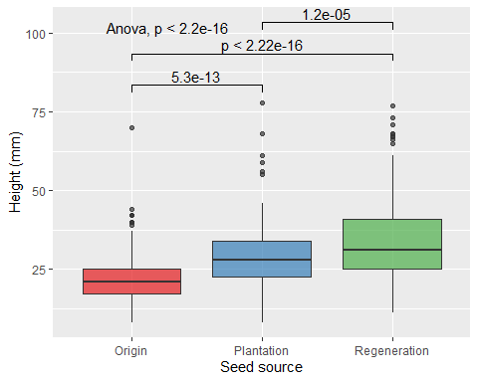

##DBB  
TypePlot_DBB <- ggplot(GlasshouseTrial_Pcontorta, aes(x=Type, y=DBB..mm., fill=Type)) +  
 geom_boxplot(alpha=0.7) +  
 theme(legend.position="none") +  
 scale_fill_brewer(palette="Set1") +  
 xlab("Seed source") + ylab("DBB (mm)") +  
 stat_compare_means(method= "t.test", comparisons = my_comparisons, label.y = c(0.90, 1, 1.1), hide.ns = TRUE) +  
 stat_compare_means(method= "anova", label.y = 1.1)  
TypePlot_DBB

## Warning: Removed 27 rows containing non-finite values (`stat_boxplot()`).

## Warning: Removed 27 rows containing non-finite values (`stat_signif()`).

## Warning: Removed 27 rows containing non-finite values (`stat_compare_means()`).

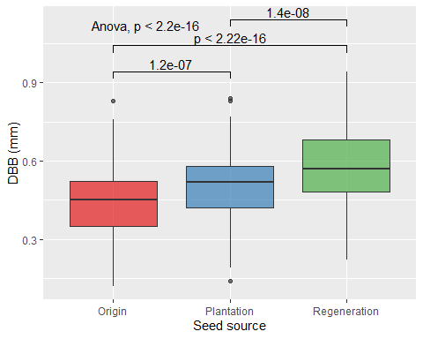

TypePlot_ProportionMortality <- ggplot(GlasshouseTrial_Pcontorta) +  
 aes(x = Type, fill = Status, by = Type) +  
 geom_bar(position = "fill", alpha=0.7) +  
 geom_text(stat = "prop", position = position_fill(.5)) +  
 xlab("Type") + ylab("Proportion") +  
 scale_fill_brewer(palette = "Set1", name="Status")  
TypePlot_ProportionMortality

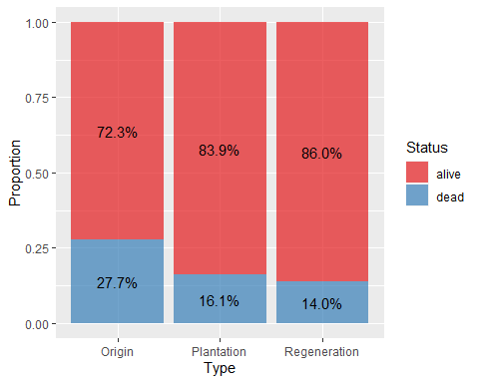

TypePlot_CountMortality <- ggplot(GlasshouseTrial_Pcontorta) +  
 aes(x = Type, fill = Status, by = Type) +  
 geom_bar(alpha=0.7) +  
 geom_text(stat = "prop", position = position_stack(.5)) +  
 xlab("Type") + ylab("Count") +  
 scale_fill_brewer(palette = "Set1", name="Status")  
TypePlot_CountMortality

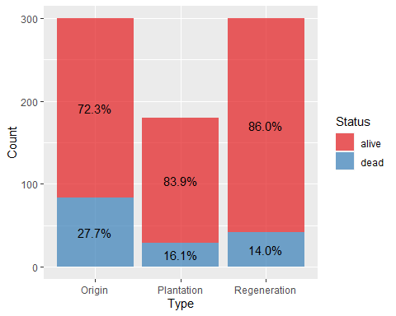

## Warning: Removed 125 rows containing non-finite values (`stat_boxplot()`).

## Warning: Removed 125 rows containing non-finite values  
## (`stat_compare_means()`).

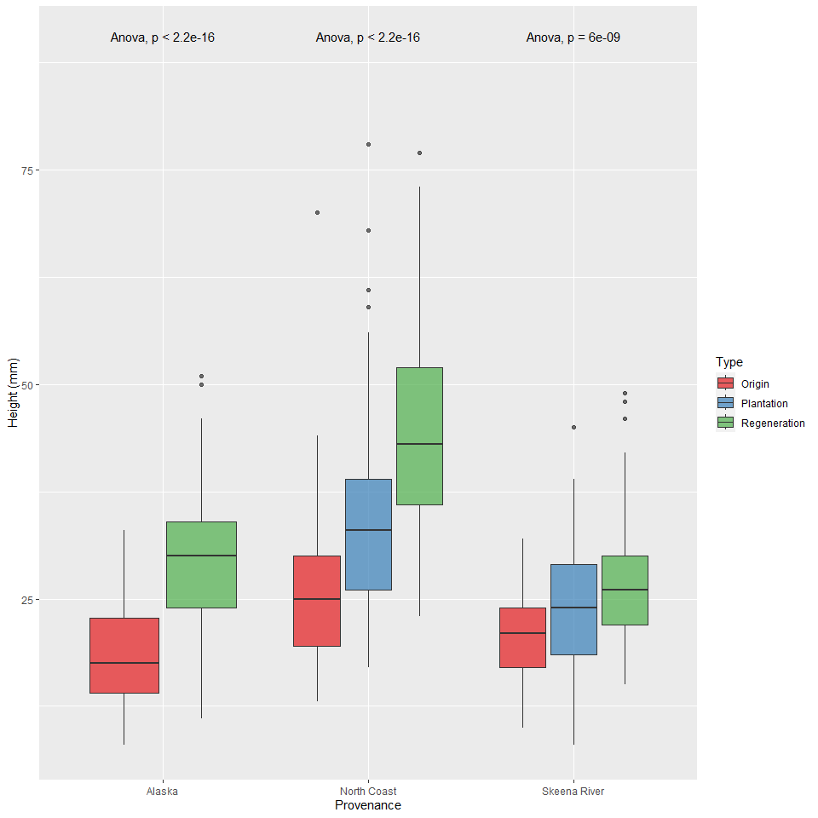

## Warning: Removed 27 rows containing non-finite values (`stat_boxplot()`).

## Warning: Removed 27 rows containing non-finite values (`stat_compare_means()`).

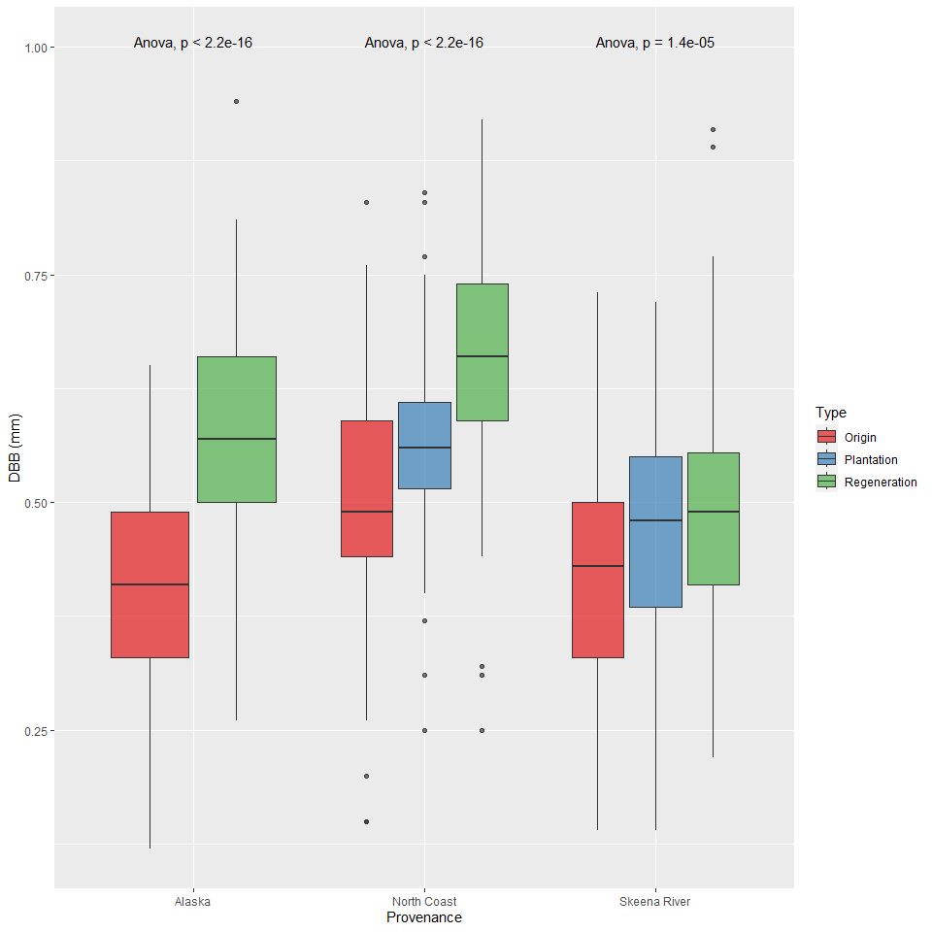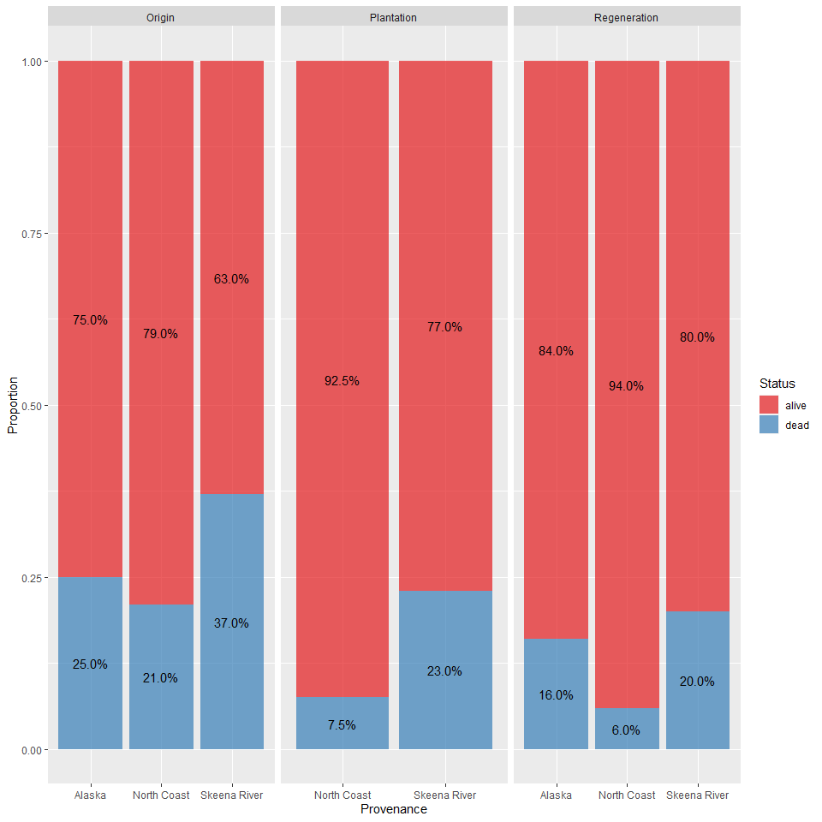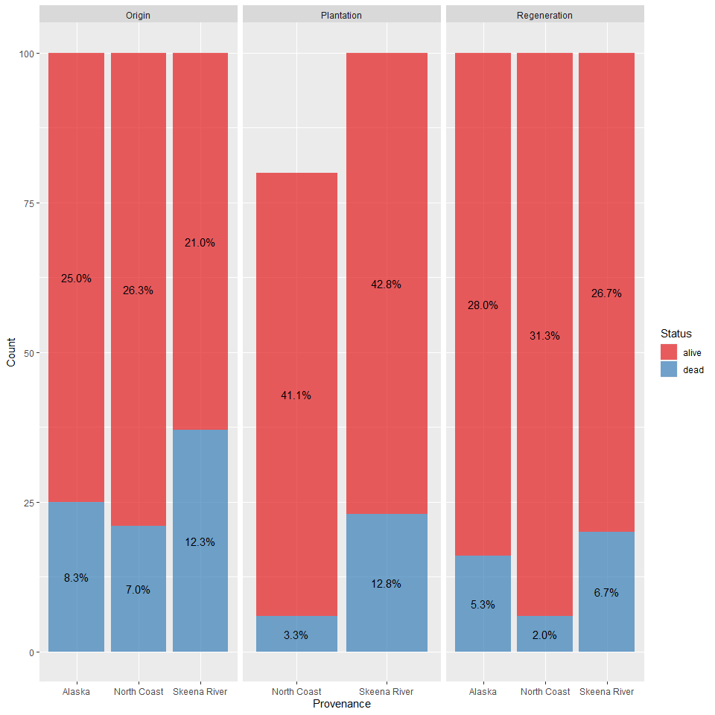

###Height   
  
GlasshouseTrial_Pcontorta_UKCollections <- GlasshouseTrial_Pcontorta[which(GlasshouseTrial_Pcontorta$Type %in% c("Plantation", "Regeneration")), ]  
  
CollectionSitePlot_Height <- ggplot(GlasshouseTrial_Pcontorta_UKCollections, aes(x=Collection.site..UK., y=Adjusted.Height..mm., fill=Collection.site..UK.)) +  
 geom_boxplot(alpha=0.7) +  
 theme(legend.position="none") +  
 scale_fill_brewer(palette="Set1") +  
 xlab("Collection Site (UK)") + ylab("Height (mm)") +  
 stat_compare_means(method = "t.test",label.x = 1.5, label.y = 80)   
CollectionSitePlot_Height

## Warning: Removed 51 rows containing non-finite values (`stat_boxplot()`).

## Warning: Removed 51 rows containing non-finite values (`stat_compare_means()`).

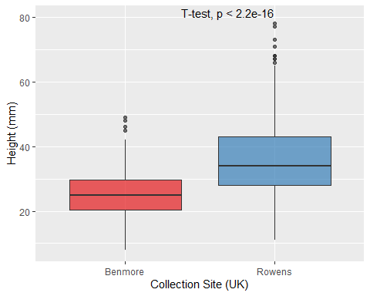

##DBB  
  
CollectionSitePlot_DBB <- ggplot(GlasshouseTrial_Pcontorta_UKCollections, aes(x=Collection.site..UK., y=DBB..mm., fill=Collection.site..UK.)) +  
 geom_boxplot(alpha=0.7) +  
 theme(legend.position="none") +  
 scale_fill_brewer(palette="Set1") +  
 xlab("Collection Site (UK)") + ylab("DBB (mm)") +  
 stat_compare_means(method = "t.test",label.x = 1.5, label.y = 1)   
CollectionSitePlot_DBB

## Warning: Removed 7 rows containing non-finite values (`stat_boxplot()`).

## Warning: Removed 7 rows containing non-finite values (`stat_compare_means()`).

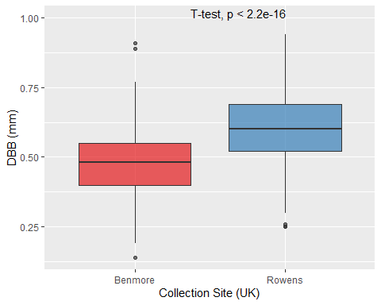

CollectionSitePlot_ProportionMortality <- ggplot(GlasshouseTrial_Pcontorta_UKCollections) +  
 aes(x = Collection.site..UK., fill = Status, by = Collection.site..UK.) +  
 geom_bar(position = "fill", alpha=0.7) +  
 geom_text(stat = "prop", position = position_fill(.5)) +  
 xlab("Collection site( )UK)") + ylab("Proportion") +  
 scale_fill_brewer(palette = "Set1", name="Status")  
CollectionSitePlot_ProportionMortality

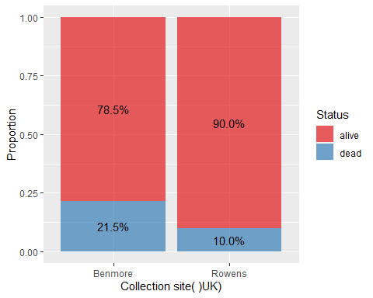

CollectionSitePlot_CountMortality <- ggplot(GlasshouseTrial_Pcontorta_UKCollections) +  
 aes(x = Collection.site..UK., fill = Status, by = Collection.site..UK.) +  
 geom_bar(alpha=0.7) +  
 geom_text(stat = "prop", position = position_stack(.5)) +  
 xlab("Collection site (UK)") + ylab("Count") +  
 scale_fill_brewer(palette = "Set1", name="Status")  
CollectionSitePlot_CountMortality

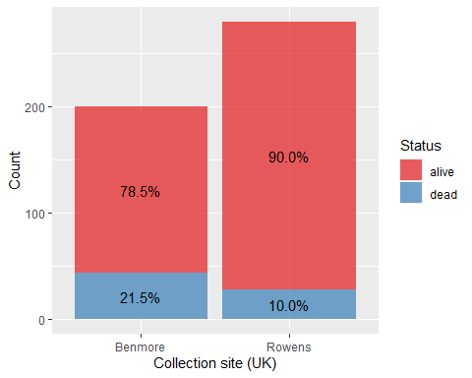

Add a new chunk by clicking the *Insert Chunk* button on the toolbar or by pressing *Ctrl+Alt+I*.

When you save the notebook, an HTML file containing the code and output will be saved alongside it (click the *Preview* button or press *Ctrl+Shift+K* to preview the HTML file).

The preview shows you a rendered HTML copy of the contents of the editor. Consequently, unlike *Knit*, *Preview* does not run any R code chunks. Instead, the output of the chunk when it was last run in the editor is displayed.