GlasshouseTrials_Psylvestris

Krisztian Nemeth

2024-03-06

## newLEAF WP3 Glasshouse Trials

### Pinus sylvestris

Trees all come from Poland, where three source populations each growing on different soil types, low, medium and high fertility. All originate from the same source population (Old Growth Forest). All seeds germinated on medium fertility soil and then transplanted to either low medium or high fertility soil to grow out.

GlasshouseTrial_Psylvestris <- read.delim("GlasshouseTrial_Psylvestris.txt")  
  
GlasshouseTrial_Psylvestris$Soil.Final <- factor(GlasshouseTrial_Psylvestris$Soil.Final , levels=c("L", "M", "H"))  
  
GlasshouseTrial_Psylvestris$Family.group.final <- factor(GlasshouseTrial_Psylvestris$Family.group.final , levels=c("O", "L", "M", "H"))  
  
my_comparisons <- list( c("L", "M"), c("M", "H"), c("L", "H") )  
  
GlasshouseTrial_Psylvestris$Height.adjusted..mm. <- as.numeric(GlasshouseTrial_Psylvestris$Height.adjusted..mm.)

HeightPlot <- ggplot(GlasshouseTrial_Psylvestris, aes(x=Soil.Final, y=Height.adjusted..mm., fill=Soil.Final)) +  
 geom_boxplot(alpha=0.7) +  
 theme(legend.position="none") +  
 scale_fill_brewer(palette="Set1") +  
 xlab("Soil Fertility") + ylab("Height (mm)") +  
 stat_compare_means(method= "t.test", comparisons = my_comparisons, label.y = c(80, 85, 90)) +  
 stat_compare_means(method= "anova", label.y = 100)  
HeightPlot

## Warning: Removed 19 rows containing non-finite values (`stat_boxplot()`).

## Warning: Removed 19 rows containing non-finite values (`stat_signif()`).

## Warning: Removed 19 rows containing non-finite values (`stat_compare_means()`).

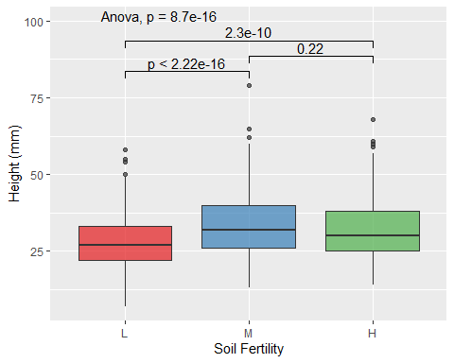

Figure 1: Seedling height (mm) across soil fertility categories (Low, Medium, and High). A total of 1132 seedlings were analysed. Boxplots depict the distribution of seedling heights within each soil fertility category. The colours represent different soil fertility categories. Statistical comparisons were conducted using t-tests and ANOVA.

GlasshouseTrial_Psylvestris$DBB..mm..01.02.24 <- as.numeric(GlasshouseTrial_Psylvestris$DBB..mm..01.02.24)

## Warning: NAs introduced by coercion

DiameterPlot <- ggplot(GlasshouseTrial_Psylvestris, aes(x=Soil.Final, y=DBB..mm..01.02.24, fill=Soil.Final)) +  
 geom_boxplot(alpha=0.7) +  
 theme(legend.position="none") +  
 scale_fill_brewer(palette="Set1") +  
 xlab("Soil Fertility") + ylab("DBB (mm)") +  
 stat_compare_means(method= "t.test", comparisons = my_comparisons, label.y = c(1.3, 1.4, 1.5)) +  
 stat_compare_means(method= "anova", label.y = 1.6)  
DiameterPlot

## Warning: Removed 9 rows containing non-finite values (`stat_boxplot()`).

## Warning: Removed 9 rows containing non-finite values (`stat_signif()`).

## Warning: Removed 9 rows containing non-finite values (`stat_compare_means()`).

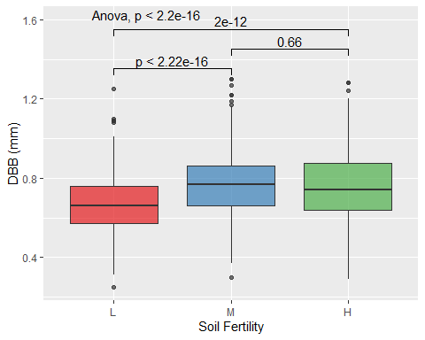

Figure 2: Seedling diameter by base (DBB) (mm) across soil fertility categories (Low, Medium, and High). A total of 1132 seedlings were analysed. Boxplots depict the distribution of seedling DBB within each soil fertility category. The colours represent different soil fertility categories. Statistical comparisons were conducted using t-tests and ANOVA.

## Warning: Removed 19 rows containing non-finite values (`stat_boxplot()`).

## Warning: Removed 19 rows containing non-finite values (`stat_compare_means()`).

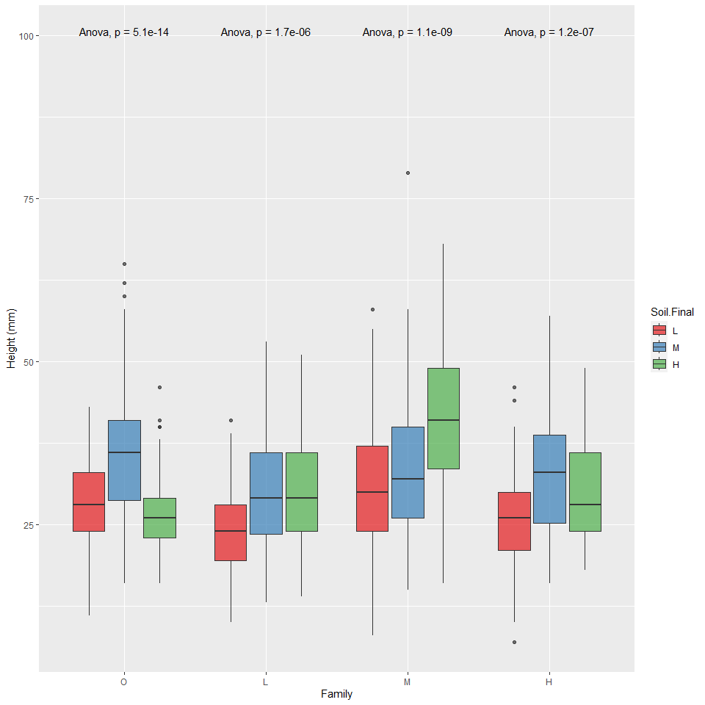

Figure 3: Seedling height (mm) across seed source families (Old growth forest, Low fertility forest, Medium fertility forest, and High fertility forest. A total of 1132 seedlings were analysed. Boxplots depict the distribution of seedling heights within each soil fertility category. The colours represent different soil fertility categories. Statistical comparisons were conducted using ANOVA.

## Warning: Removed 9 rows containing non-finite values (`stat_boxplot()`).

## Warning: Removed 9 rows containing non-finite values (`stat_compare_means()`).

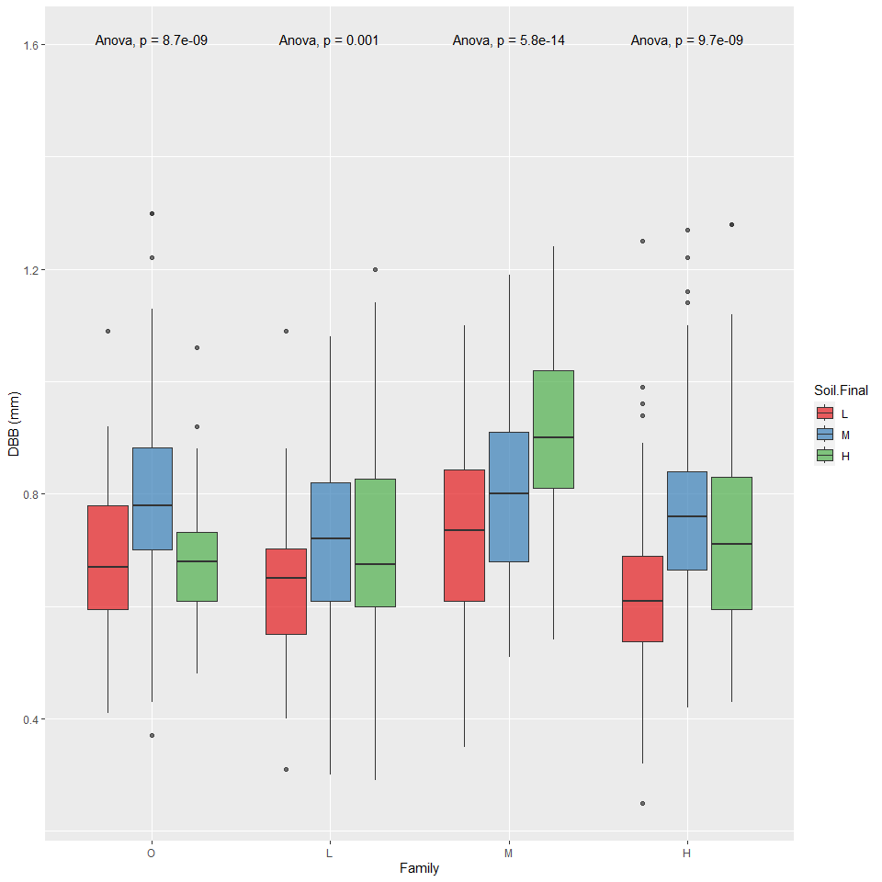

Figure 4: Seedling diameter by base (DBB) (mm) across seed source families (Old growth forest, Low fertility forest, Medium fertility forest, and High fertility forest. A total of 1132 seedlings were analysed. Boxplots depict the distribution of seedling heights within each soil fertility category. The colours represent different soil fertility categories. Statistical comparisons were conducted using ANOVA.

X axis: O = old forest (where the seed was sourced for all other forests, and which is the original (natural stand). L = low fertility, M = moderate, H = high (fertility of the soil in the forest environment) Don’t have info for the fertility of the soil in the old forest, but would be useful to have as a baseline. - Annika

Legend: Soil fertility that seedling has been grown out in.

HeightPlot <- ggplot(GlasshouseTrial_Psylvestris, aes(x=Family.group.final, y=Height.adjusted..mm., fill=Family.group.final)) +  
 geom_boxplot(alpha=0.7) +  
 theme(legend.position="none") +  
 scale_fill_brewer(palette="Set1") +  
 xlab("Family") + ylab("Height (mm)") +  
 stat_compare_means(label = "p.signif", method = "t.test",  
 ref.group = ".all.", hide.ns = TRUE) +  
 stat_compare_means(method= "anova", label.y = 100)  
HeightPlot

## Warning: Removed 19 rows containing non-finite values (`stat_boxplot()`).

## Warning: Removed 19 rows containing non-finite values (`stat_compare_means()`).  
## Removed 19 rows containing non-finite values (`stat_compare_means()`).

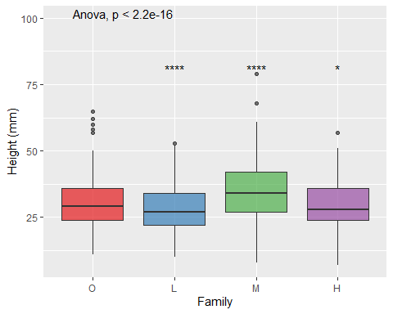

Figure 5: Seedling height (mm) across seed source families (Old growth forest, Low fertility forest, Medium fertility forest, and High fertility forest. A total of 1132 seedlings were analysed. Boxplots depict the distribution of seedling heights within each soil fertility category. The colours represent different seed source families. Statistical comparisons were conducted using ANOVA.

GlasshouseTrial_Psylvestris$DBB..mm..01.02.24 <- as.numeric(GlasshouseTrial_Psylvestris$DBB..mm..01.02.24)  
  
DiameterPlot <- ggplot(GlasshouseTrial_Psylvestris, aes(x=Family.group.final, y=DBB..mm..01.02.24, fill=Family.group.final)) +  
 geom_boxplot(alpha=0.7) +  
 theme(legend.position="none") +  
 scale_fill_brewer(palette="Set1") +  
 xlab("Family") + ylab("DBB (mm)") +  
 stat_compare_means(label = "p.signif", method = "t.test",  
 ref.group = ".all.", hide.ns = TRUE) +  
 stat_compare_means(method= "anova", label.y = 1.6)  
DiameterPlot

## Warning: Removed 9 rows containing non-finite values (`stat_boxplot()`).

## Warning: Removed 9 rows containing non-finite values (`stat_compare_means()`).  
## Removed 9 rows containing non-finite values (`stat_compare_means()`).

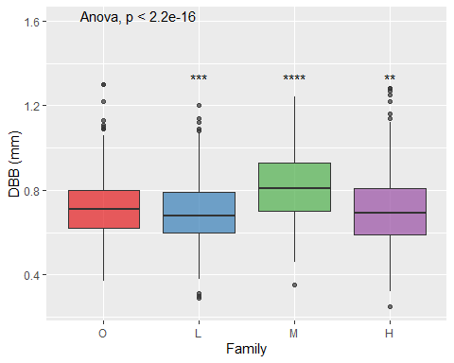

Figure 6: Seedling diameter by base (DBB) (mm) across seed source families (Old growth forest, Low fertility forest, Medium fertility forest, and High fertility forest. A total of 1132 seedlings were analysed. Boxplots depict the distribution of seedling heights within each soil fertility category. The colours represent different seed source families. Statistical comparisons were conducted using ANOVA.

O = old forest (where the seed was sourced for all other forests, and which is the original (natural stand). L = low fertility, M = moderate, H = high (fertility of the soil in the forest environment) Don’t have info for the fertility of the soil in the old forest, but would be useful to have as a baseline. - Annika