GlasshouseTrials_Theterophylla

Krisztian Nemeth

2024-03-06

## R Markdown

GlasshouseTrial_Theterophylla <- read.delim("GlasshouseTrial_Theterophylla.txt")  
  
GlasshouseTrial_Theterophylla$Height..mm. <- as.numeric(GlasshouseTrial_Theterophylla$Height..mm.)  
  
GlasshouseTrial_Theterophylla$DBB..mm. <- as.numeric(GlasshouseTrial_Theterophylla$DBB..mm.)

## Warning: NAs introduced by coercion

#GlasshouseTrial_Theterophylla$status <- as.factor(GlasshouseTrial_Theterophylla$status)  
  
GlasshouseTrial_Theterophylla$Type <- as.factor(GlasshouseTrial_Theterophylla$Type)  
  
GlasshouseTrial_Theterophylla$Provenance <- as.factor(GlasshouseTrial_Theterophylla$Provenance)  
  
GlasshouseTrial_Theterophylla$Collection.site..UK. <- as.factor(GlasshouseTrial_Theterophylla$Collection.site..UK.)  
  
GlasshouseTrial_TheterophyllaExtra <- GlasshouseTrial_Theterophylla[GlasshouseTrial_Theterophylla$Trial == "Extra", ]  
  
GlasshouseTrial_Theterophylla <- GlasshouseTrial_Theterophylla[GlasshouseTrial_Theterophylla$Trial == "Main", ]

###Height   
  
OriginPlot_Height <- ggplot(GlasshouseTrial_Theterophylla, aes(x=Type, y=GlasshouseTrial_Theterophylla$Height..mm., fill=Type)) +  
 geom_boxplot(alpha=0.7) +  
 theme(legend.position="none") +  
 scale_fill_brewer(palette="Set1") +  
 xlab("Seed source") + ylab("Height (mm)") +  
 stat_compare_means(method = "t.test",label.x = 1.5, label.y = 45)   
  
OriginPlot_Height

## Warning: Removed 69 rows containing non-finite values (`stat_boxplot()`).

## Warning: Removed 69 rows containing non-finite values (`stat_compare_means()`).

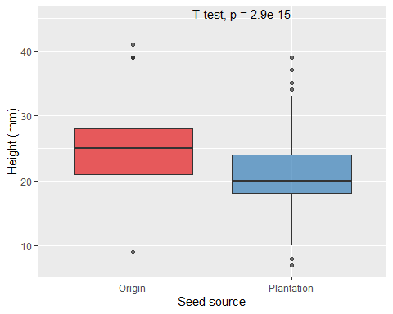

##DBB  
OriginPlot_DBB <- ggplot(GlasshouseTrial_Theterophylla, aes(x=Type, y=GlasshouseTrial_Theterophylla$DBB..mm., fill=Type)) +  
 geom_boxplot(alpha=0.7) +  
 theme(legend.position="none") +  
 scale_fill_brewer(palette="Set1") +  
 xlab("Seed source") + ylab("DBB (mm)") +  
 stat_compare_means(method = "t.test",label.x = 1.5, label.y = 1)   
  
OriginPlot_DBB

## Warning: Removed 17 rows containing non-finite values (`stat_boxplot()`).

## Warning: Removed 17 rows containing non-finite values (`stat_compare_means()`).

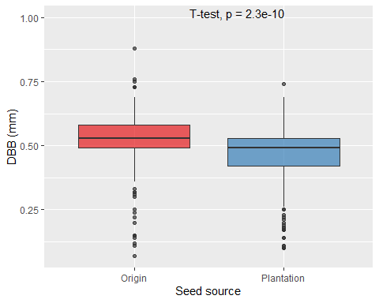

OriginPlot_ProportionMortality <- ggplot(GlasshouseTrial_Theterophylla) +  
 aes(x = Type, fill = status, by = Type) +  
 geom_bar(position = "fill", alpha=0.7) +  
 geom_text(stat = "prop", position = position_fill(.5)) +  
 xlab("Type") + ylab("Proportion") +  
 scale_fill_brewer(palette = "Set1", name="Status")  
OriginPlot_ProportionMortality

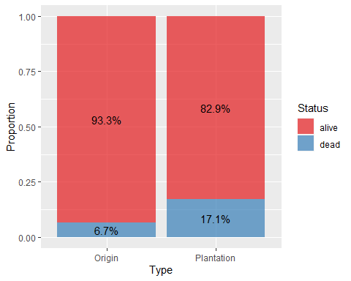

OriginPlot_CountMortality <- ggplot(GlasshouseTrial_Theterophylla) +  
 aes(x = Type, fill = status, by = Type) +  
 geom_bar(alpha=0.7) +  
 geom_text(stat = "prop", position = position_stack(.5)) +  
 xlab("Type") + ylab("Count") +  
 scale_fill_brewer(palette = "Set1", name="Status")  
OriginPlot_CountMortality

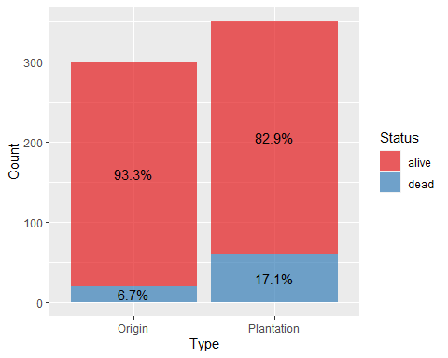

## Warning: Removed 69 rows containing non-finite values (`stat_boxplot()`).

## Warning: Removed 69 rows containing non-finite values (`stat_compare_means()`).

## Warning: Computation failed in `stat_compare_means()`  
## Caused by error in `mutate()`:  
## ℹ In argument: `p = purrr::map(...)`.  
## Caused by error in `purrr::map()`:  
## ℹ In index: 1.  
## ℹ With name: x.3.  
## Caused by error in `contrasts<-`:  
## ! contrasts can be applied only to factors with 2 or more levels

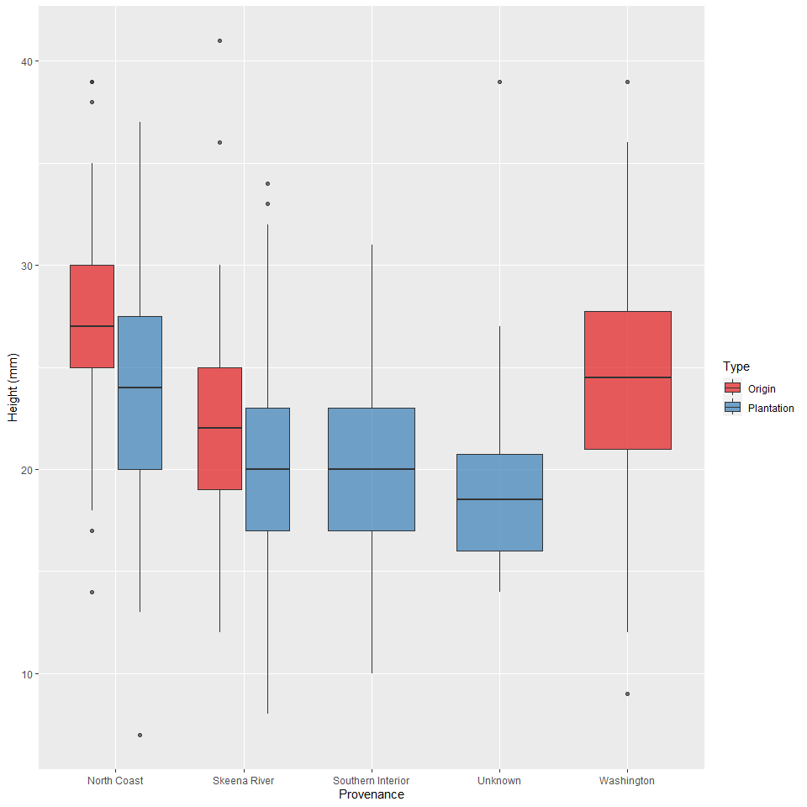

## Warning: Removed 17 rows containing non-finite values (`stat_boxplot()`).

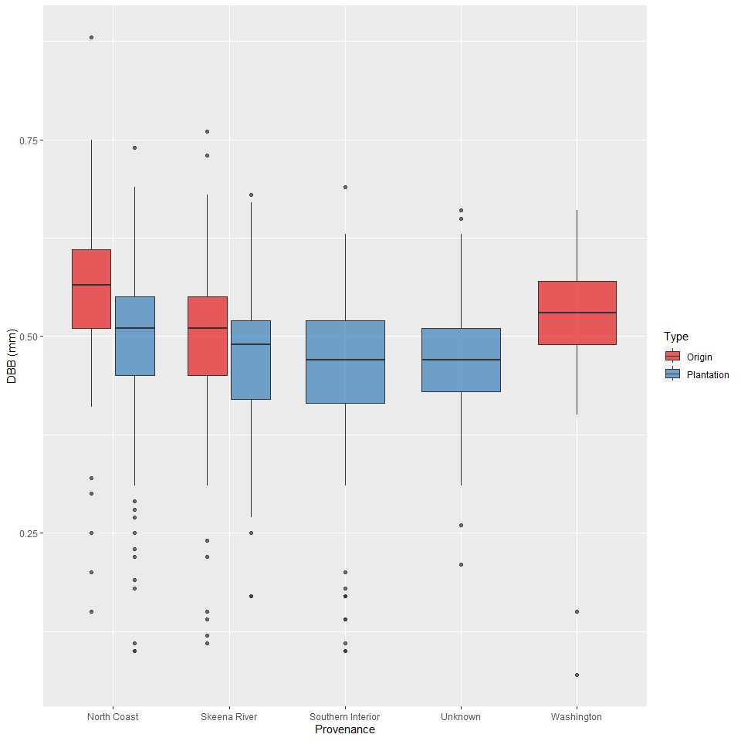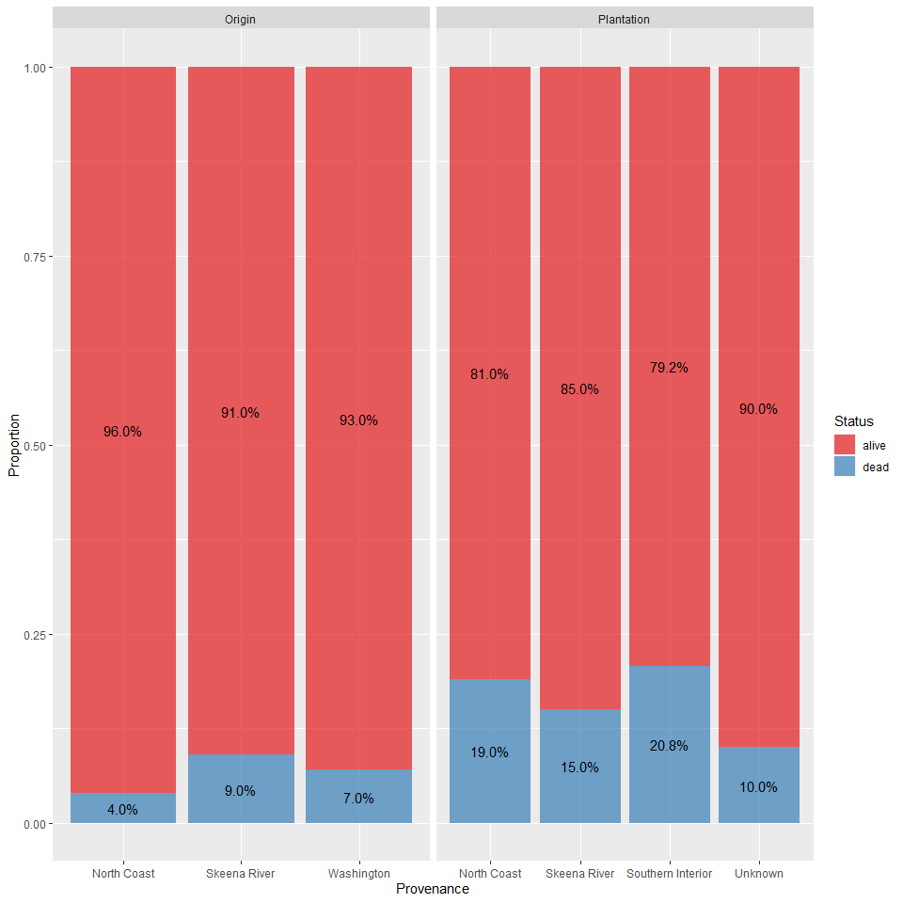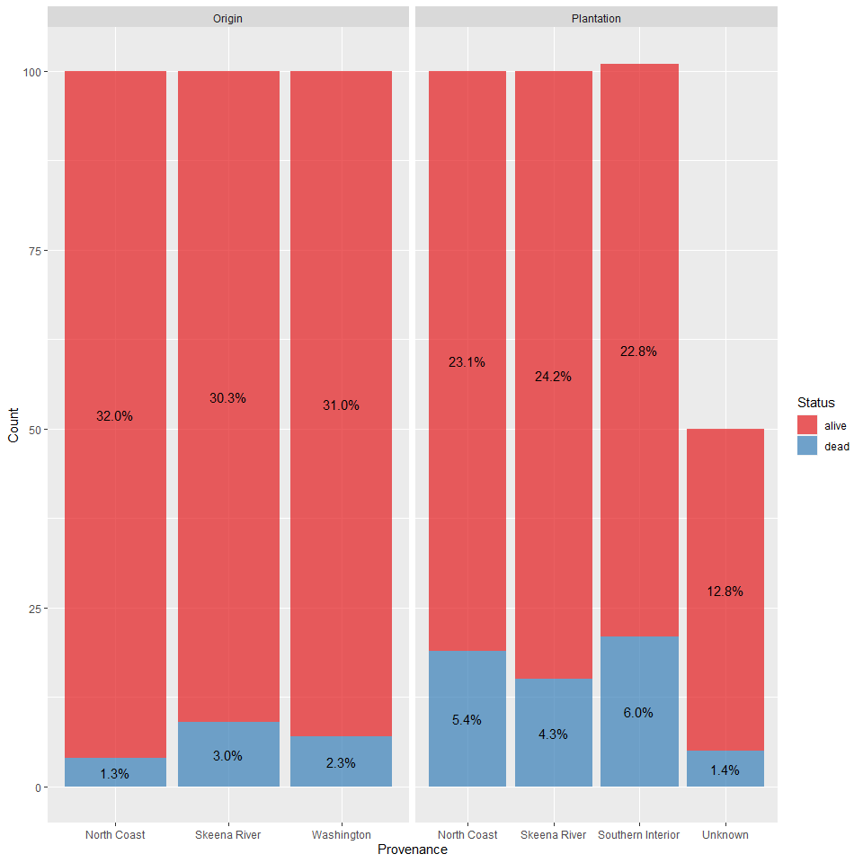

### Extra Trial   
  
###Height   
  
my_comparisons <- list( c("Inveraray", "New Forest"), c("Inveraray", "Rheidol"), c("New Forest", "Rheidol") )  
  
CollectionSitePlot_Height <- ggplot(GlasshouseTrial_TheterophyllaExtra, aes(x=GlasshouseTrial_TheterophyllaExtra$Collection.site..UK., y=GlasshouseTrial_TheterophyllaExtra$Height..mm., fill=GlasshouseTrial_TheterophyllaExtra$Collection.site..UK.)) +  
 geom_boxplot(alpha=0.7) +  
 theme(legend.position="none") +  
 scale_fill_brewer(palette="Set1") +  
 xlab("Collection Site (UK)") + ylab("Height (mm)") +  
 #stat_compare_means(method= "t.test", comparisons = my_comparisons, label.y = c(45, 50, 55), hide.ns = TRUE) +  
 stat_compare_means(method= "anova", label.y = 60)  
CollectionSitePlot_Height

## Warning: Removed 60 rows containing non-finite values (`stat_boxplot()`).

## Warning: Removed 60 rows containing non-finite values (`stat_compare_means()`).

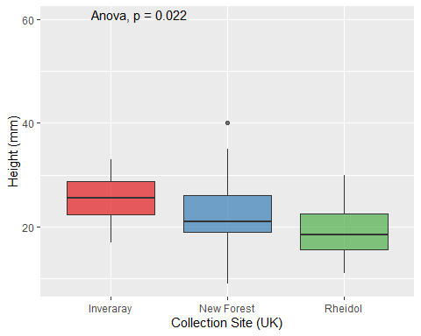

##DBB  
  
CollectionSitePlot_DBB <- ggplot(GlasshouseTrial_TheterophyllaExtra, aes(x=GlasshouseTrial_TheterophyllaExtra$Collection.site..UK., y=GlasshouseTrial_TheterophyllaExtra$DBB..mm., fill=GlasshouseTrial_TheterophyllaExtra$Collection.site..UK.)) +  
 geom_boxplot(alpha=0.7) +  
 theme(legend.position="none") +  
 scale_fill_brewer(palette="Set1") +  
 xlab("Collection Site (UK)") + ylab("DBB (mm)") +  
 # stat_compare_means(method= "t.test", comparisons = my_comparisons, label.y = c(0.75, 0.8, 0.85), hide.ns = TRUE) +  
 stat_compare_means(method= "anova", label.y = 0.9)  
CollectionSitePlot_DBB

## Warning: Removed 40 rows containing non-finite values (`stat_boxplot()`).

## Warning: Removed 40 rows containing non-finite values (`stat_compare_means()`).

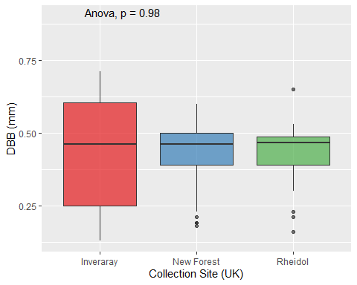

CollectionSitePlot_ProportionMortality <- ggplot(GlasshouseTrial_TheterophyllaExtra) +  
 aes(x = Collection.site..UK., fill = status, by = Collection.site..UK.) +  
 geom_bar(position = "fill", alpha=0.7) +  
 geom_text(stat = "prop", position = position_fill(.5)) +  
 xlab("Collection site( )UK)") + ylab("Proportion") +  
 scale_fill_brewer(palette = "Set1", name="Status")  
CollectionSitePlot_ProportionMortality

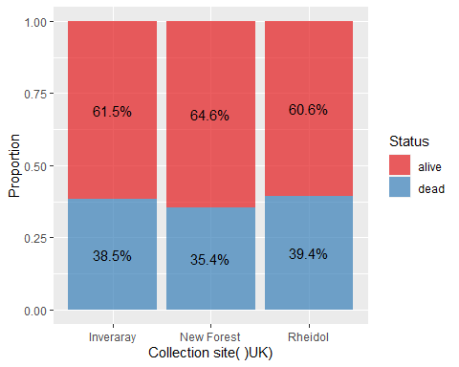

CollectionSitePlot_CountMortality <- ggplot(GlasshouseTrial_TheterophyllaExtra) +  
 aes(x = Collection.site..UK., fill = status, by = Collection.site..UK.) +  
 geom_bar(alpha=0.7) +  
 geom_text(stat = "prop", position = position_stack(.5)) +  
 xlab("Collection site (UK)") + ylab("Count") +  
 scale_fill_brewer(palette = "Set1", name="Status")  
CollectionSitePlot_CountMortality

