Kitchens International scoop three major UK Kitchen Awards

Friday, 07 March, 2014

[](http://inex-online.com/media/k2/items/cache/a0862b8703b49b62b05b477f73d6896c_XL.jpg)

Recognised for their outstanding talent in kitchen design, Scottish kitchen retailer Kitchens International won the ‘big’ prize – Kitchen Retailer of the Year – at the KBB Review Awards held in Birmingham on Tuesday night.

As well as this prestigious ‘Oscar’ of the kitchen and bathroom industry, KI’s designers were also awarded – Kieron Bell won Kitchen Designer of the Year for a project between £30-50,000; and Ailsa Howorth won Kitchen Contract Designer of the Year.  
   
Winning more awards than any other company Kitchens International were commended for their superb design, development strategy and expert approach to the kitchen industry.  
  
The Kitchen Retailer Award recognised that Kitchens International’s overall business makes them among the very best retailers in the industry. Andrew Davies of the kbb Review Awards said: “Kitchens International is a very well deserved winner of this coveted award. It is a fantastic business which truly understands the changing kitchen market and really puts its customers first. It has a really well thought through business plan which values the input of every single employee and it translates that into great products, great design and great service. I can’t wait to see what they come up with to defend their title next year."  
  
Kieron Bell’s award-winning design is for a project for a retired couple in Fife who converted their vaulted cellars into a contemporary kitchen. Kieron, who already has four previous key kitchen awards under his belt, had the vision to turn three dingy cellars into one large open plan space incorporating food preparation and cooking, storage and dining areas. Given the vaulted ceilings the island had to be central and as large as possible. The resulting kitchen is a masterpiece with maximum use of space while giving an airy, stylish feel. Featuring Callerton kitchen cabinetry, V-zug, Gaggenau and Siemens appliances, the owners describe Kieron’s design as: “The mix of new and old gives it a really special atmosphere and it’s exactly what we wanted.”  
  
  
  
Ailsa Howorth’s Kitchen Contract Designer of the Year was awarded for four stunning apartments in Glasgow on the site of the former residence of Sir William Burrell, the great Scottish philanthropist and art collector. Retaining the original features but providing a sympathetic decor with many modern elements was a challenge for Ailsa. The resulting kitchens, featuring Callerton kitchens and state-of-the-art appliances, gives a wonderful contemporary look on a traditional property. Most of these properties were sold immediately, showing how tasteful and high quality these designs were.  
   
Kitchens International MD Gerry Watson said: “These prestigious awards are a huge credit to the whole KI team from top to bottom. Kieron and Ailsa’s awards, in particular, recognise the hard work, well thought out design and innovative kitchens that our designers create. At KI we believe that teamwork is the key to us delivering our promise, and these awards are testament to the hard work, energy, talent and commitment of every single member of our staff. We are delighted to be recognised as one of the best in the whole UK kitchen market.”  
  
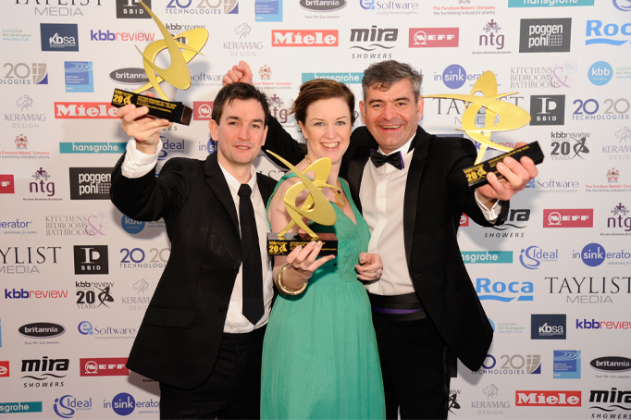  
  
[www.kitchensinternational.co.uk](http://www.kitchensinternational.co.uk/)