KBB Review Awards 2014 winners announced at landmark 20th ceremony

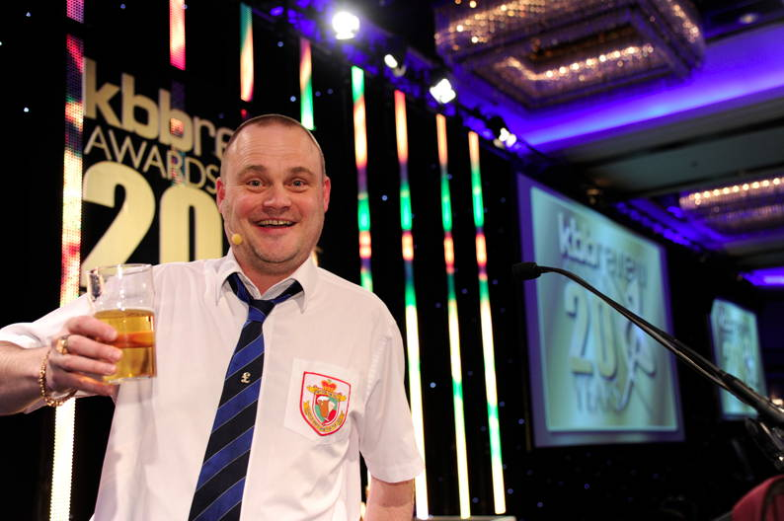

Winners of the kbbreview Awards 2014 were announced at a much anticipated ceremony, held at the Hilton Birmingham Metropole on Tuesday. The occasion marked a landmark 20 years of the most prestigious awards event in the kitchen and bathroom industry, which are organised by kbbreview magazine.

Winners of the 18 award categories were announced by celebrity host, Al Murray, better known as the Pub Landlord, in front of many of the industry's most well respected names. Guests at the glittering gala ceremony enjoyed a three course meal followed by an evening of dancing and entertainment in the gaming room.

"This year's ceremony focused on celebrating a huge milestone in the history of the national kitchen and bathroom awards, and we would like to extend our many congratulations to the kbbreview Awards 2014 winners for the very special part they have played in this," said Tim Wallace, editor of kbbreview.

"The standard of submissions this year was of exceptional quality and our thanks and commendation must go out to all our finalists and attendees for making the kbbreview Awards 2014 such a successful and memorable occasion."

The categories, winners and finalists were:

Kitchen Designer of the Year - project cost over £50,000:  
While cost is no object, judges were keenly looking at value for money and whether the all-important brief has been met.  
Winner: Andrew Rizza, Dream Design  
Finalists:  
* Sofia Bune Strandh, Sola Kitchens  
* Martin Smith, Holloways of Ludlow  
* Dan Stronge, Jones Britain

Kitchen Designer of the Year - project cost £30,000 - £50,000:  
This covers a huge section of the retail market where designers can create dream kitchens, while still giving value for money.  
Winner: Kieron Bell, Kitchens International  
Finalists:  
* Sofia Bune Strandh, Sola Kitchens  
* Jon Hart-Woods, Hart-Woods Kitchens  
* Matt Podesta, Podesta

Kitchen Designer of the Year - project cost up to £30,000:  
Judges were looking for the way designers managed to achieve flair and individuality while keeping within reasonable budgets.  
Winner: Colin Wong, Development Direct  
Finalists:  
* Andrew Hall, Woodstock Furniture  
* Darren Morgan, Designer Kitchen  
* Pippa Paton, Pippa Paton Design

Kitchen Contract Designer of the Year:  
This category rewards kitchen designers who have completed projects for commercial customers such as contractors, developers and house builders.  
Winner: Ailsa Howorth, Kitchens International  
Finalists:  
* Donna Grech, Grech & Grech Interiors & Karen Cox, Cox & Co Interior Design Company  
* Rebecca Tucker & Helen Fewster, Suna Interior Design  
* Colin Wong, Development Direct

Kitchen Retailer of the Year:  
The Kitchen Retailer of the Year Award is the prize that judges your overall business and says you are among the best retailers in the industry.  
Winner: Kitchens International, Edinburgh  
Finalists:  
* Diane Berry Kitchens, Manchester  
* Kitchens by J S Geddes, Kilmarnock  
* Rational Kitchens, Sheffield

Kitchen Showroom of the Year:  
This award honours the very best in kitchen showroom layout and design.  
Winner: Spacefittingfurniture, Cardiff  
Finalists:  
* Bespoke Interiors, Goudhurst  
* Kitchens International, Edinburgh  
* Spillers of Chard, Somerset

Kitchen Product Innovation of the Year:  
This Award is given out to specific products that have been developed to actively move forward the field of product innovation within the kitchen sector.  
Winner: Krushr: Krushr V2 Household  
Finalists:  
* Recycling Compactor Series  
* Fisher & Paykel: 90 litre Built-in Single Oven OB60SL11DCPX1  
* Caple: DD930BK Induction Downdraft  
* Mereway Kitchens: Modern Classic Collection from English Revival  
* Quooker: Quooker Fusion with Combi System  
* Miele: Miele Generation 6000 DGC 6800 XL Combination Steam Oven

Kitchen Customer Service of the Year *  
In every issue of kbbreview a Mystery Shopper visits a different town and evaluates selected retailers in that area, based on her first impressions - and this appears as the publication's 'Shopping Around' feature. Out of the dozens of showrooms visited the Mystery Shopper picks a shortlist of favourites and an eventual winner for the Kitchen Customer Service of the Year Award.  
Winner: Roma, Ashford  
Finalists:  
* deVol, Loughborough  
* Hallwood Furniture, Kettering  
* In-Toto, Bristol

Bathroom Designer of the Year - project cost over £25,000:  
Big budgets can lead to big designs, but has the money created something unique or simply been spent on expensive products?  
Winner: Andrew Rizza, Dream Design  
Finalists:  
* Dorian & Babette Bowen, Project One  
* Pippa Paton, Pippa Paton Design

Bathroom Designer of the Year - project cost £10,000 - £25,000:  
This category rewards the skill of the bathroom designer and also their use of budget, problem solving and meeting the client's brief.  
Winner: Martin & Lisa Hammond, Ripples Solihull  
Finalists:  
* Rachel Barclay, Channel Island Ceramics  
* Susan Boylan, Porcelanosa (Scotland)  
* Alan Crawford, Crawford Partnership

Bathroom Designer of the Year - project cost up to £10,000:  
Modest budgets require as much design skill and expertise as the most premium price tags - individuality is the key to this category.  
Winner: Pippa Paton, Pippa Paton Design  
Finalists:  
* Paul Etheridge, Coastal Bathroom Studio  
* Emma Gilvear, Porcelanosa (Scotland)  
* Leanne McIlwraith, Porcelanosa (Scotland)

Bathroom Contract Designer of the Year:  
Designs and projects created specifically for commercial customers such as contractors, developers and house builders require a unique set of skills to attract the potential buyer.  
Winner: Colin Wong, Development Direct  
Finalists:  
* Simon Lecomber, Nicholas Anthony  
* Siobhan Scott, Ripples Tunbridge Wells  
* Rebecca Tucker & Helen Fewster, Suna Interior Design

Bathroom Retailer of the Year:  
Winner: The Bathroom Company, Perth  
Finalists:  
* The Bathroom Studio (Evesham)  
* TileStyle, Dublin  
* UK Bathroom Village, Bristol

Bathroom Showroom of the Year  
The layout and design of the bathroom showroom is absolutely crucial to its business success and the appeal to the consumer.  
Winner: Bathe and Beyond, Staines-upon-Thames  
Finalists:  
* A E Spink, Doncaster  
* The Bathroom Company, Perth  
* TileStyle, Dublin

Bathroom Product Innovation of the Year:  
The Bathroom Product Innovation of the Year Award rewards specific products for being innovative in their design, application or manufacture.  
Winner: Puro Design: IN wc by Lagares for Puro Design  
Finalists:  
* Vogue UK: Integral valve  
* Designer Bathroom Concepts: The Etna  
* Burgbad: RC40 Cantilevered Washbasin  
* Ideal Standard: Concept Space  
* Teuco: Hydroline and Hydrosonic Hydroline Whirlpool Systems

Bathroom Customer Service of the Year *  
In every issue of kbbreview the Mystery Shopper visits a different town and evaluates selected retailers in that area, based on her first impressions - and this appears as the 'Shopping Around' feature. Out of the dozens of showrooms visited the Mystery Shopper picks a shortlist of favourites and an eventual winner for the Bathroom Customer Service of the Year Award.  
Winner: Kedleston Interiors, Derby  
Finalists:  
* Bathe, Amersham  
* Concept Design, Maidenhead  
* Fiesta, Orpington

Special Achievement Award *  
This award is given to those individuals who have made an outstanding contribution to the kitchen and bathroom industry and this year the winner was Roger Kyme.

The Awards are sponsored by:  
* 2020 Technologies  
* Hansgrohe  
* Ideal Standard  
* InSinkErator  
* Miele  
* Mira Showers  
* Neff  
* Poggenpohl  
* Roca  
* Twyford Bathrooms  
* EQ Software  
* The Furniture Makers' Company  
* The Bathroom Association  
* NTG  
* Keramag design  
* KBB Birmingham  
* Society of British and International Design

Image: Al Murray, host of the kbbreview Awards 2014

For photographs and more information about the kbbreview Awards 2014, visit [www.kbbreview.com](http://www.kbbreview.com/awards)