# Machine Learning

Machine learning is a field of computer science that gives computers the ability to learn without being explicitly programmed.

machine learning explores the study and construction of algorithms that can learn from data and can make predictions on data. Example applications include email filtering, detection of network intruders or malicious insiders working towards a data breach, optical character recognition (OCR), and computer vision.

Machine learning tasks are typically classified into two broad categories, depending on whether there is a learning "signal" or "feedback" available to a learning system:

# Supervised learning:

The computer is presented with example inputs and their desired outputs, given by a "teacher", and the goal is to learn a general rule that maps inputs to outputs. As special cases, the input signal can be only partially available, or restricted to special feedback:

# [Unsupervised learning](https://en.wikipedia.org/wiki/Unsupervised_learning):

No labels are given to the learning algorithm, leaving it on its own to find structure in its input. Unsupervised learning can be a goal in itself (discovering hidden patterns in data) or a means towards an end (feature learning).

# Classification

## Decision Tree

* Presentation
* ID3 : A top Down Learning Algorithm
* Expresiveness of DT
* Bias of ID3
* Best Attributes ( Gain(S,A)
* Dealing with Overfitting

Q.1 Continuous Attributes ( Age, Distance, Weight)

Q.2 When do we stop ? Pruning

Q.3 Regression

# Probability

Probability is the measure of the likelihood that an event will occur. See glossary of probability and statistics. Probability is quantified as a number between 0 and 1, where, loosely speaking, 0 indicates impossibility and 1 indicates certainty. The higher the probability of an event, the more likely it is that the event will occur. A simple example is the tossing of a fair (unbiased) coin. Since the coin is fair, the two outcomes ("heads" and "tails") are both equally probable; the probability of "heads" equals the probability of "tails"; and since no other outcomes are possible, the probability of either "heads" or "tails" is 1/2 (which could also be written as 0.5 or 50%).

## Probability Theory

**Probability theory** is the branch of [mathematics](https://en.wikipedia.org/wiki/Mathematics) concerned with [probability](https://en.wikipedia.org/wiki/Probability). Although there are several different [probability interpretations](https://en.wikipedia.org/wiki/Probability_interpretations), probability theory treats the concept in a rigorous mathematical manner by expressing it through a set of [axioms](https://en.wikipedia.org/wiki/Axioms_of_probability). Typically these axioms formalize probability in terms of a [probability space](https://en.wikipedia.org/wiki/Probability_space), which assigns a [measure](https://en.wikipedia.org/wiki/Measure_(mathematics)) taking values between 0 and 1, termed the [probability measure](https://en.wikipedia.org/wiki/Probability_measure), to a set of outcomes called the [sample space](https://en.wikipedia.org/wiki/Sample_space). Any specified subset of these outcomes is called an [event](https://en.wikipedia.org/wiki/Event_(probability_theory)).

Central subjects in probability theory include discrete and continuous [random variables](https://en.wikipedia.org/wiki/Random_variable), [probability distributions](https://en.wikipedia.org/wiki/Probability_distributions), and [stochastic processes](https://en.wikipedia.org/wiki/Stochastic_process), which provide mathematical abstractions of [non-deterministic](https://en.wikipedia.org/wiki/Determinism) or uncertain processes or measured [quantities](https://en.wikipedia.org/wiki/Quantity) that may either be single occurrences or evolve over time in a random fashion.

Although it is not possible to perfectly predict random events, much can be said about their behavior. Two major results in probability theory describing such behavior are the [law of large numbers](https://en.wikipedia.org/wiki/Law_of_large_numbers) and the [central limit theorem](https://en.wikipedia.org/wiki/Central_limit_theorem).

As a mathematical foundation for [statistics](https://en.wikipedia.org/wiki/Statistics), probability theory is essential to many human activities that involve quantitative analysis of data.[[1]](https://en.wikipedia.org/wiki/Probability_theory#cite_note-1) Methods of probability theory also apply to descriptions of complex systems given only partial knowledge of their state, as in [statistical mechanics](https://en.wikipedia.org/wiki/Statistical_mechanics). A great discovery of twentieth-century [physics](https://en.wikipedia.org/wiki/Physics) was the probabilistic nature of physical phenomena at atomic scales, described in [quantum mechanics](https://en.wikipedia.org/wiki/Quantum_mechanics).

## Probability axioms

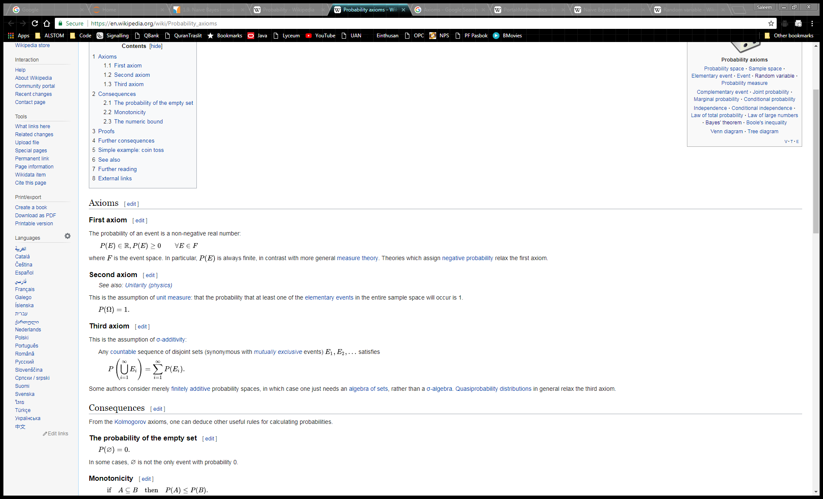

## Applications

Probability theory is applied in everyday life in risk assessment and modeling. The insurance industry and markets use actuarial science to determine pricing and make trading decisions. Governments apply probabilistic methods in environmental regulation, entitlement analysis (Reliability theory of aging and longevity), and financial regulation.

A good example of the use of probability theory in equity trading is the effect of the perceived probability of any widespread Middle East conflict on oil prices, which have ripple effects in the economy as a whole. An assessment by a commodity trader that a war is more likely can send that commodity's prices up or down, and signals other traders of that opinion. Accordingly, the probabilities are neither assessed independently nor necessarily very rationally. The theory of behavioral finance emerged to describe the effect of such groupthink on pricing, on policy, and on peace and conflict.

In addition to financial assessment, probability can be used to analyze trends in biology (e.g. disease spread) as well as ecology (e.g. biological Punnett squares). As with finance, risk assessment can be used as a statistical tool to calculate the likelihood of undesirable events occurring and can assist with implementing protocols to avoid encountering such circumstances. Probability is used to design games of chance so that casinos can make a guaranteed profit, yet provide payouts to players that are frequent enough to encourage continued play.

The discovery of rigorous methods to assess and combine probability assessments has changed society. It is important for most citizens to understand how probability assessments are made, and how they contribute to decisions.

Another significant application of probability theory in everyday life is reliability. Many consumer products, such as automobiles and consumer electronics, use reliability theory in product design to reduce the probability of failure. Failure probability may influence a manufacturer's decisions on a product's warranty.

The cache language model and other statistical language models that are used in natural language processing are also examples of applications of probability theory.