**AirQuality Measure and Notify on AWS**

# Project Dependencies

Please install following packages in your project

* AWSSDK.Core:3.3.103.12

<https://www.nuget.org/packages/AWSSDK.Core/3.3.103.12>

* [AWSSDK.S3.3.3.104](https://github.com/Kitemaker/Uipath-Measure-Air-Quality-OpenAQ-AWS/tree/master/SourceCode/OpenAQCustomActivity/packages/AWSSDK.S3.3.3.104)
* <https://www.nuget.org/packages/AWSSDK.S3/3.3.104.24>
* EILabs.OpenAQActivities: 1.0.3 ( Added in the Project Component)
* UiPath.System.Activities": 19.7.0,
* UiPath.UIAutomation.Activities: 19.7.0
* UiPath.WebAPI.Activities:1.4.2

# AWS Account and AWS SNS Topic:

Create AWS Account and create AWS SNS Topic which shall be used to publish the message. Please use following links:

**AWS SimpleNOtificationService (SNS) (**[**https://aws.amazon.com/sns/**](https://aws.amazon.com/sns/)**)**

Prerequisite to use AWS SNS:AWS Account, AWS Credentials Setup on Windows Machine (<https://docs.aws.amazon.com/sdk-for-net/v2/developer-guide/net-dg-config-creds.html#creds-file>)

# Code Repository

Code repository for the Custom Component and Workflows

* <https://github.com/Kitemaker/Uipath-Measure-Air-Quality-OpenAQ-AWS>

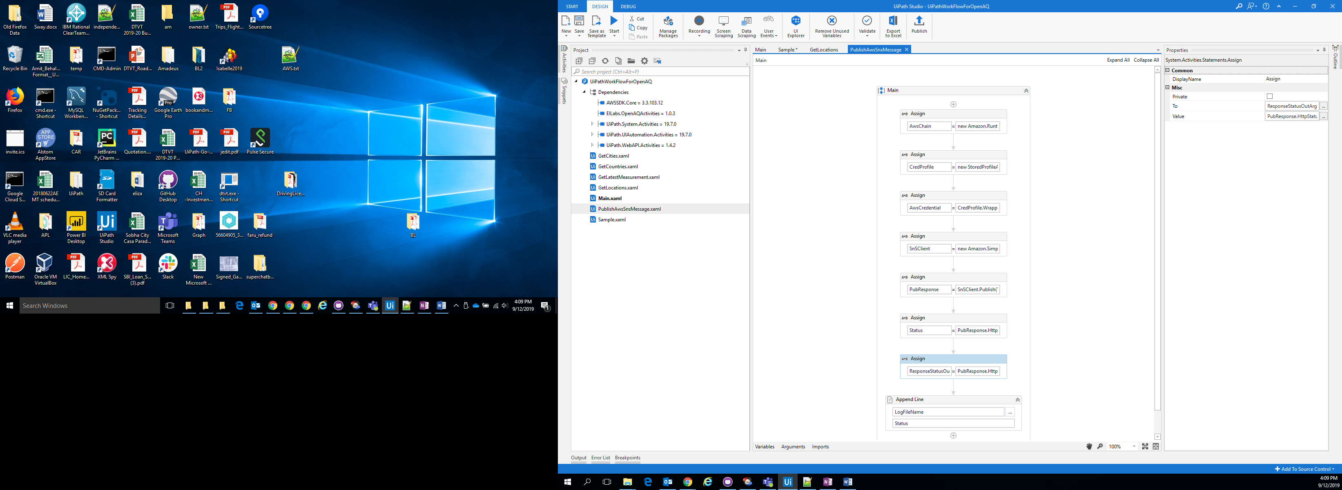

# How To Start:

* Download component from UiPath Go and in UiPath Load the project file Project.Json
* To test your environment Open Sample workflow “Sample.xaml” and provide the AWS Parameters required to run
* Execute the workflow. Program should run and if Parameters “pm25” has more value then it will publish message on AWS SNS .
* Run “GetCountries.xaml” to get list of countries for which data is available
* Run “GetCities.xaml” to get list of cities for which data is available
* Open Main.xaml and provide the values e.g. “Country”, “City”, and AWS Parameters to execute the workflow. You can modify to workflow to check values of multiple parameters

Based on the parameter and Limit values alert can be published on the AWS SNS

Using UiPath Robot , the workflow can be scheduled to run automatically and ,measure various parameters