DTVT_BLUE_1_0 Help

# Tools Required:

1. Python 3.5 from <https://www.python.org/downloads/release/python-350/>
2. Python Package : openpyxl ( run command in cmd to install : pip install openpyxl )

# Folder Structure :

**NOTE: Please Do Not change the folder structure**

Unzip the delivery folder anywhere at your workstation

Please read file ‘VersionInfo.txt’

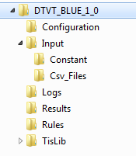

DTVT_BLUE_<vrsion> : Root Folder

Configuration: Contains configuration.xml , at present no input needed

Input-> Constant : Folder contains the project and generic constants, , at present no input needed

Input-> Csv_Files : Folder Contains CSV files of SyDT , Generated by CSV_Generator_v5.1.xls

Logs : Folder for logs

Results : Folder contains result files

Rules : Python scripts for rules

TisLib : Python Library for tool

# How To Execute:

1. Generate CSV Files for the SyDT under test using CSV_Generator_v5.1.xls
2. Place CSV Files in the folder Input -> Csv_Files
3. Launch Windows Command Prompt (cmd)
4. Run the command “ python <python file name with full path> and press “Enter”

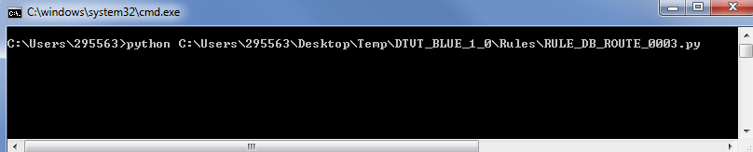

# Rules Implementation Logic

## RULE_DB_ROUTE_0003

### Input Table

* Routes_Cap
* Switchs_Cap
* Points_Cap
* Secondary_Detection_Devices_Cap
* Signalisation_Areas_Cap

### Constants

None

### Logic

1. Get all routes from the table Routes_Cap
2. For each route get the ‘Switch_ID_List’
3. For each switch in the ‘Switch_ID_List’ get the list of points from the columns ‘Convergent_Point_ID_List’ and ‘Divergent_Point_ID_List’
4. For each points in the point list get associated SDD from the table ‘Secondary_Detection_Devices_Cap’ and create Switch_SDD_List
5. For each SDD in the Switch_SDD_List get the associated Signalisation Area Name of type ‘CBI’ from ‘Signalisation_Areas_Cap’ and prepare a list of ‘CBI_Signalisatin_Area_List’. This list contains signalization area name associated to all switches of the ‘Switch_ID_List’
6. ‘CBI_Signalisatin_Area_List’ represent a list of for all Switches in the route selected in step (ii)
7. Now if all items in the list ‘CBI_Signalisatin_Area_List’ are same then test case is ‘OK’ else test case is ‘NOK’