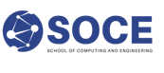  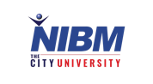  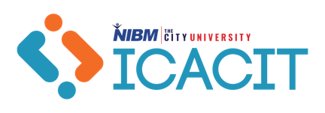 | International Conference of  Advanced Computing and  Information Technology 2026  National Institute of Business Management (NIBM)  AUTHOR/CO-AUTHOR CONSENT FORM

I/We, the undersigned, acknowledge that:

- I/We have authored/co-authored or supervised the research entitled

- In what way were AI tools used, and how do the authors ensure that they take full responsibility for the accuracy and originality of the work?

- I/We agree to publish the above research at the International Conference of Advanced Computing and International Technology 2026 ; | ☐
- The National Institute of Business Management (NIBM) reserves the right to publish this accepted abstract in the university e-repository; | ☐
- The research remains the intellectual property of the authors, who are entitled to submit it for publication in other journals; and | ☐
- Publication in the ICACIT 2026 proceedings may preclude publication of our manuscript, or parts thereof, in another scholarly journal, and it is our responsibility to contact such journals to determine their policies on publications. | ☐

Signed,

 | Name | Affiliation | Signature | Date
Author 01
Author 02
Author 03
Author 04
Author 05
Append a new page for additional authors or supervisors.
All authors must sign the consent form in order for the research to be considered for publication /presentation in the ICACIT 2026.

