**Executive Summary for Group 3, Sea Turtle On Land.**

**1. Robotic Sea Turtle Requirement Specification**

Shelly Plastron is an autonomous robotic sea turtle designed to traverse sandy terrestrial terrain by mimicking the natural motion of a real leatherback sea turtle. It is modelled to move with motorized flippers and utilize ultrasonic sensors to detect and avoid obstacles. The design requirement specifications for the current model are as follows (refer to Appendix A for further specifications):  
**Speed:** Operates at a speed of 3 km/h on sand.   
**Weight:** Weighs up to 2 kg.   
**Run Time:** Functions for up to 15 minutes on a single battery charge.  
**Drive Configuration:** Leatherback turtle flippers.  
**Ground Clearance:** None  
**Environment:** Sand beaches with obstacles like rocks or grass.

**2. Robot Design and Model**

Shelly’s structure includes four motorized flippers, each equipped with two motors to replicate the sea turtle’s movement as it drags itself across the sand. Appendix C1 illustrates the fin design details. The front flippers are larger and provide the main propulsion, with the back flippers giving secondary simultaneous propulsion. The robot chassis has no ground clearance since the shell bottom, known as the plastron, will drag along the ground. The plastron has a long oval shape and ridges, reducing forward drag. The shell, which is designed to be lightweight and detachable for easy maintenance, will be sand proofed to protect the internal electronics from sand infiltration. Additional shell design specifics are outlined in Appendix C2.

For obstacle avoidance, Shelly will be equipped with three ultrasonic sensors mounted on its head two on the side and one on the front. These sensors will have a detection range of 0.5 to 1 meter, enabling the robot to avoid solid objects and either crush or move through softer obstacles like plants or small sand formations (refer to Appendix C4 for control system details). Because the present model only demonstrates the gait of a turtle, the head has not been added yet. An Arduino-based control system within the shell will manage the sensors and motors enabling that navigation (refer to Appendix C3 for control system details). The motors are designed to be sand proof to withstand a turtle’s environment, while the power will be supplied by a rechargeable battery inside the bulk of the shell. CAD development details are discussed in Appendix B.

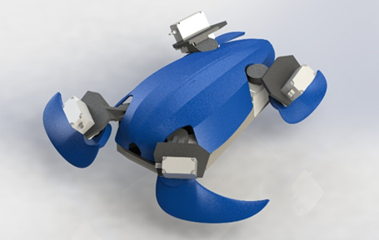

Figure 1: Shelly Plastron, coloured and rendered in SolidWorks.

**3. Discussion and Reflection on Design**

Shelly’s design strikes a balance between replicating the natural movement of a sea turtle and meeting the technical specifications. The main conflict between the specifications were between the weight restrictions and the speed. A larger turtle with longer fins drawing from a larger power source would allow the robot to go faster and operate for longer. However, more material for longer flippers, a larger battery, and larger motors all contribute to a heavier robot. At some point, all the factors that contribute to a faster robot would be outweighed by their weight contribution. The team believes that this design allows for enough speed and a large enough battery while not going over the constraints of weight. Hopefully, when simulation and physical construction commence, this will prove correct.

Apart from the primary specifications, the secondary considerations were durability, adaptability to the environment, and energy efficiency. Durability was chosen because the speed goal requires moving through coarse sand and durability will ensure the robot survives multiple tests. For durability, the material will be selected to be resistant to wear, allowing Shelly to perform reliably in sandy environments without the risk of getting stuck (refer to Appendix C3 for material details). Along with this, the emulated design of the turtle’s shell means that sensitive components such as the Arduino board, rechargeable battery, and motor driver will be sheltered from the sand. The sand-proof construction safeguards the internal electronics and motors from the abrasive effects of sand, ensuring long-term performance reliability.

Adaptability was chosen in advance of having to program the navigation because it is key that the turtle can avoid obstacles that real turtles will face in the wild. In terms of adaptability, The Arduino-controlled system will process real-time data from the sensors to guide Shelly through obstacles. The three ultrasonic sensors will enhance detection accuracy, by giving Shelly enough peripheral vision to clear obstacles it is turning away from, ensuring the robot can navigate around objects within its 0.5 to 1-meter range. The current design allows or enough room and clearance for the sensor head and protection and space for the Arduino control unit to facilitate these future considerations (refer to Appendix C4 for sensor details).

Energy efficiency is critical, given that Shelly operates for only 15 minutes per charge. To ensure Shelly functions within these time constraints, no more than the necessary components has been chosen. Each fin has two motors which is the number required to accurately replicate a turtle’s gait. The additional components, like sensors and Arduino, are designed for the minimum power requirement possible while still completing the navigation component of the project. Hopefully, this balance will allow Shelly to operate effectively within the allotted time frame while still undertaking autonomous navigation.

**Team Member Contributions**

|  |  |
| --- | --- |
| **Team Member** | **Contributions** |
| Shaotong Hong | Designed the original and final CAD model. Contributed to CAD model review. Produced the original URDF file. Jointly developed the launch file. Jointly developed the URDF. Jointly developed the summary and appendix. |
| Shahzeb Pasha | Researched optimal CAD software. Contributed to CAD model review. Drafted and iterated the executive summary. Jointly developed the launch file. Jointly edited the URDF file. |
| Kitili Kisinguh | Contributed to CAD model review. Jointly developed the launch file. Jointly finalised the URDF file. Did final code review. Commented on code. Provided screenshots and video for submission. |
| Calvin Hargis | Provided shared research into URDF files. Contributed to CAD model review. Jointly developed the launch file. Jointly finalised the URDF file. Finalised the executive summary and appendix. |

**Appendix**

**A. Requirement Specification**

The requirement specifications for the robotic sea turtle on land were chosen to ensure the design and functionality aligned with the goal of developing an autonomously navigating, robotic sea turtle on land.

**The weight**, 2kg, was determined by doing research into the needed components, mainly motors and battery, and estimating additional weight of the shell, flippers, and sensors. This weight gives the team enough room to complete the task thoroughly while limiting copious extra development. It also ensures that the robot will not be weighed down and create excess friction on the plastron of the shell against the sand.

**The speed** was determined by watching videos of many types of turtles on land and cross referencing that estimated speed against a feasible flipper length of Shelly and realistic motor choice. The team thinks that 3km/h is ambitious but ultimately within both the scope of the project and the team’s abilities.

**Run Time** was chosen as 15 minutes primarily to avoid the team having to keep Shelly plugged in more than necessary. Too large of a battery would exceed the weight parameter and damage the speed capabilities. Too small and the testing and development process would require constant stoppages to recharge the robot, decreasing efficiency and jeopardizing the whole time-limited project.

**Drive Configuration** was modelled after a leatherback turtle. While not emulating the size of a leatherback, the team determined that the shell design of a leatherback would best decrease sand friction. Therefore, the gait of the robot was modelled after this kind of turtle, with four flippers all pushing forward in unison. This required two points of articulation per flipper, resulting in eight total motors.

**Ground Clearance** was set as none because, after watching videos of leatherback turtles, the team determined that the plastron rarely if ever left the surface of the beach. This would have implications on weight, as constant contact with the sand would mean excess weight would increase friction on the sand.

**Environment** was simply chosen as a sandy beach, as that is what the research determined is the most common environment for a turtle on land. There are recorded instances of turtles navigating on rock shale beaches, but those appeared as outliers. Other chelonians, such as tortoises or terrapins, are found in a wide array of environments, but again, the team decided to stick close to the chosen leatherback turtle inspiration.

**B. Model Development**

The CAD modeling of the robot was completed in SolidWorks, with URDF export to ROS2 for simulation and integration testing. The modeling process was designed to align with the key features outlined in the previous sections. Given the prototype nature of this stage and the limited time available for modeling, the primary objective was to simulate and verify whether the robot design could perform the desired gait and move effectively in a beach environment. Therefore, the detailed modeling was focused on the general structure, joint arrangement, the plastron, and the flipper design

The length of the robot was determined to be 250 mm, so a central skeleton structure was designed as the main framework, connecting all other components to this platform. As shown in Figure 2, the blue outline indicates the planned placement of the servo motors. The rationale behind designing it as a flat surface was not only to facilitate easy space planning and component arrangement but also to simplify the 3D printing process in later stages.

Figure 2: Precise measurements for plastron prototype in SolidWorks.

**B1 First Prototype**

A prototype model was developed and tested. The results of this testing, illustrated in Figure 3, demonstrated the effectiveness of the joint configuration in achieving realistic sea turtle-like movement. A movement demonstration, shown in Figure 4, further highlights the importance of the outer joint's tilt angle, which was set to approximately 60 degrees. This angle was crucial to achieve the combination of two-axis movement, enabling the lifting and dropping gait phases as well as the crawling and swinging phases (see Appendix C1).

Figure 3: Flipper and base prototype in SolidWorks.

|  |  |
| --- | --- |
|  |  |
|  |  |
|  |  |

Figure 4: Prototype Gate Demonstration.

The assembly was created by using the skeleton as a base, then adding the model of the MG996R servo motors and the connecting bearings. With the help of 3D markers, the two sections of front leg components were modeled separately, and the mirror function was used to create a symmetrical counterpart for the opposite side, as depicted and circled in the Figure 5.

Figure 5: Mirrored flipper design in SolidWorks.

**B2 Improvements**

Upon a second look, it was observed that the radius of the flipper span was too large due to interference between the two servo motors and the shape of the flippers required additional adjustments to optimize performance. The curvature and overall shape of the redesigned flippers were specifically crafted to preserve the distinctive appearance of sea turtle flippers, including their broad, flat structure and tapering edges. Furthermore, the angles of the servo motors were adjusted, to increase space for leg rotation and facilitate smoother movement on sandy terrain. These adjustments are shown in figure 6.

|  |  |
| --- | --- |
|  |  |
|  |  |

Figure 6: Updated servo angles and flipper design in SolidWorks.

**B3 Second Prototype**

After these improvements, the model was developed further, including the plastron, new flippers, motors, Arduino, and motor driver, as shown below in Figure 7. The design choices of each of these components is discussed in detail throughout Appendix C.

|  |  |
| --- | --- |
|  |  |
|  |  |

Figure 7: Open top prototype in SolidWorks.

**B4 Final Prototype**

The final change in design came after a team meeting, in which it was pointed out that having the bulk of the motors be above the flippers would allow for the flippers to be closer to the ground and possibly generate more force when in the crawling phase of the gait (see Appendix C1). This change can be seen below in Figure 8. Figure 9 depicts a closeup of the highlighted structural reinforcements added to the motor segment.

|  |  |
| --- | --- |
|  |  |
|  |  |

Figures 8 & 9: Final open shell design diagram in SolidWorks.

Figures 10 & 11: Reinforcement to the new flipper motor.

All the previous diagrams have been without a shell to better showcase the interior of the robot throughout the design process. An image of the robot with the shell can be found in Appendix C1, Figure 14.

**C. Current Design**

The aim for this stage of the project is to obtain the 3D model of the robot. Therefore, the focus is primarily on developing the mechanical structure, including the joint arrangements to preserve the gait of the sea turtle. Additionally, key elements will be discussed regarding the hardware components that occupy significant space, such as the motor and motor driver module, microcontroller (MCU), and battery. After a group discussion, the team decided that to mimic the gait of a sea turtle on land, videos and diagrams of natural sea turtles should be used as reference. The key features of this robotic system, along with the underlying design considerations and their significance, will be discussed in detail in the following sections.

**C1 Leg design**

To ensure the gait of the robotic sea turtle effectively mimics natural movement, an in-depth analysis of the sea turtle's gait was conducted. Wang et al. [1] conducted a comprehensive study that observed the distinctive gait patterns of sea turtles on land. The sea turtle's movement, as seen from a lateral perspective in Figure 12, can be characterized by four distinct phases: leg placement, crawling, leg lifting, and leg swinging, as depicted in Figure 13.

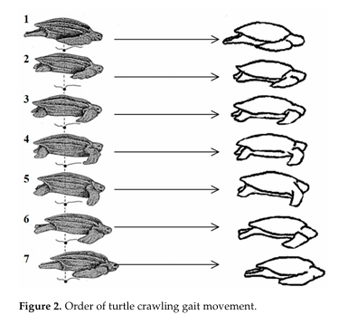

Figure 12: Order of turtle crawling gait movement [2].

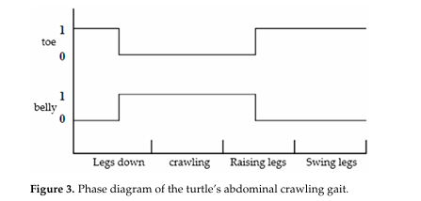

Figure 13: Phase diagram of the turtle’s abdominal gait [1].

Each of these phases was analyzed to replicate the complex movements that allow sea turtles to traverse sandy beaches efficiently. The leg down phase involves moving the limbs downward and in front to contact the sand, then crawling pushes the turtle forward, then raising legs lifts the legs off the sand, and finally the swinging phase places them back at the front, ready to push off again.

Based on the detailed gait analysis, it was determined that to accurately replicate the natural movement of a sea turtle, the robotic turtle must incorporate at least two joints for each leg. The first joint is responsible for facilitating the forward and backward propulsion necessary for the crawling and swinging, while the second joint must enable multidirectional flipper movements, for the remaining up and down phases. This joint design ensures that the robotic turtle can effectively mimic the nuanced, phase-specific leg movements observed in natural sea turtles. Below are several screenshots from SolidWorks that illustrate the gait of the robot.

Figure 14: Gait in legs down phase.

Figure 15: Gait at start of crawling phase.

Figure 16: Gait at end of crawling phase.

Figure 17: Gait in legs up phase.

**C2 Plastron design**

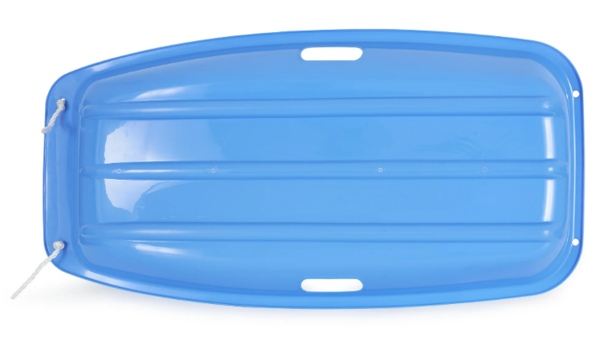

Figure 18: A sled with ridges [2].

In addition to the design of the legs, special consideration was given to the design of the shell of the robot, both the shell top and the plastron. Based on the analysis, when following the natural gait of a sea turtle, the robot's plastron is likely to drag on the sand due to the soft and uneven nature of the terrain, which necessitates a design that minimizes drag. Inspired by the design of sleds, as illustrated in Figure 18, the plastron of the robot will incorporate additional ridges to increase surface area and distribute the load, as shown in Figure 7. This approach aims to prevent the robot from stalling in the sand by allowing air pockets under the ridges and thereby minimizing drag and enhancing movement efficiency.

The top of the shell is modeled to eventually be a sand-proof clip-on attachment to the plastron. The purpose of this is to allow the team easy access to the internal components, which are detailed in Appendix C3, when necessary. Then, once the work has been done, the shell top can be clipped back into place and protect the internals from the sand. This approach would mean the only points where the clipped-in shell would have holes needing extra protection would be the four arms, the head, and the charging port. This limited number of vulnerabilities will save the team time and energy in sand-proofing areas that will, with this design, be protected by the clip-on shell. While this has not been modeled yet, it is an element of the design which will be implemented once the locomotive goals of Shelly have been realized.

The turtle robot is designed to eventually use 3D-printed materials for its structural components, with adjustable infill density to maintain structural integrity while minimizing weight. Choosing a lightweight material should allow Shelly to weigh around 2 kg and still include the crucial components like the Arduino, battery, and motor driver.

The chosen dimensions for the robotic turtle are approximately 330 mm width by 270 mm length. This decision was based on the requirement specifications. To keep the robot light, a smaller frame would be better, however, a larger robot would be better for battery time. Without the ability to model and try again, the group estimated that the chosen length would keep a balance between maneuverability, weight, and power efficiency in the sand.

**C3 Internal Components**

The two main internal components are the battery and the control system. The control system consists of the Arduino, which will control the sensors and motors, and the motor driver, which will allow the Arduino to interface with eight motors at once. An Arduino was selected for two reasons, the first being that it is a lightweight and sufficient board for the needs of this robot, and the second being that the team members already have experience with it. The ease of allowing the team members to use a system and interface they are already comfortable with will decrease the difficulty in realizing the full design later in the project. The motor driver is an extension of the Arduino which expands the board’s capacity for controlling motors. It too has been used by members of the team in previous years, so works well for this project. These two components were placed on opposite sides of the inside of the shell to allow the bulk of the space to be taken up by the battery. This can be seen in Figure 8.

Battery size and capacity was a critical consideration, as it directly impacts the overall weight, motor torque, and operational time of the robot. A smaller, lighter body enables the use of affordable motors that generate less torque, while still providing sufficient power for movement. The battery capacity must be well-balanced with the robot's operational requirements and so the team has designed, although not modeled, that the battery will take up the majority of the internal space of the shell, sitting above the Arduino and motor driver. Hopefully, this will give the robot enough power to meet the 15-minute mark for operational time, but not exceed weight specifications.

**C4 Sensors**

For navigation and obstacle avoidance, the turtle robot will be equipped with a sensor array, such as ultrasonic or infrared sensors, on its head. The sensors will have a detection range of 0.5 to 1 meter. The sensors enable the robot to detect and avoid obstacles, navigating around harder obstacles while potentially crushing or moving through flimsy ones like plants or small sand structures. The programming of the sensors will be completed by the team and then uploaded to the Arduino. In addition to obstacle avoidance, the sensors will allow for other tasks like facial recognition, image processing, environmental mapping, and more depending on what the requirements are, and which type of sensor is selected.

**D. CAD Implementation**

The CAD models were developed iteratively, using the SolidWorks to URDF exporter to transfer designs for simulation in Gazebo. The CAD design was saved as an STL which was then configured as a URDF. Challenges included integrating newer versions of ROS (Jazzy) with older ROS tools, necessitating workarounds like transforming ROS1 packages into ROS2 packages.

Figure 19: pr2.pdf as created in the Linux Ubuntu interface.

Figure 19 is a pr2 file which shows how all the components of the URDF file interact. The base_footprint is the top of the shell, base_link is the plastron, and back left, back right, front left, and front right refer to the respective flippers of the turtle. Each flipper’s first joint, the “shoulder” joint which is visible in Figure 9, is connected to the plastron directly. The second joint, the “elbow” which is also in Figure 9, is connected to the shoulder joint. This pr2 file demonstrates the straightforward manner of the CAD design and will hopefully make the programming of movement in the later stages of this project much easier.

**F. Reflections**

**What Worked**: The approach to design the flippers after observation of turtles on video proved an effective and easy way to accomplish the animal modeling part of the task. The iterative CAD design process was successful because members of the team had experience in SolidWorks and group discussions were held to repeatedly evaluate the current model. Integrating SolidWorks with URDF and ROS was accomplished easily because SolidWorks has a plugin that allows easy conversion from SLT files into URDF files.

**What Did Not Work**: There were challenges with integrating different versions of ROS, particularly in getting Gazebo to launch properly. Using such new versions of both ROS and Gazebo made finding resources and answers to the team’s issues online a very time-consuming process. The initial attempt to load URDF files in Gazebo also encountered technical issues due to the difficulty in translating ROS1 compatible URDF files into those compatible with ROS2, which took a long time. Creating the launch file for the entire process was incredibly difficult, taking up the entire final week of the project, and several versions of the launch file had to be completely abandoned in this process.

**Lessons Learned**: It was important to align the versions of tools used across the software platforms to make sure that each component was compatible with the next one necessary in the process. The team learned that ample time must be given to new steps, such as creating the launch file, as it is often new but simple steps that take more time than familiar and complex ones.

**Skills Acquired**: Team members gained hands-on experience with CAD modeling SolidWorks as well as discussing and understanding improvements to those models. The team’s knowledge of ROS2 and Gazebo as controlled through Linux Ubuntu were also greatly expanded beyond the scope of previous projects. The team learned that creating collaborative places for team members to place resources and discuss what tasks have been completed not only decreases time in searching for answers that are already known, but also in not repeating tasks that have already been completed.

**E References**

1. Z. Wang, W. Peng, and B. Zhang, "Kinematics Analysis and Gait Study of Bionic Turtle Crawling Mechanism," *Biomimetics*, vol. 9, no. 3, p. 147, 2024.
2. Walmart, “ Slippery Racer Downhill Sprinter Plastic Toboggan Snow Sled Blue 2 Pack,” *Walmart*. [Online]. Available: <https://www.walmart.ca/en/ip/Slippery-Racer-Downhill-Sprinter-Plastic-Toboggan-Snow-Sled-Blue-2-Pack/PRD5CC7RFK7J85Y>. [Accessed: 19/10/2024].