**LACKLUSTER GAMES**

**Design Document for:**

# ML-Treadmill

**“Always keep an eye on the coming edge”**

“If everything seems under control, you're not going fast enough”™

All work Copyright ©1999 by Your Company Name

Written by Abdulkarem Alani

Version #3.00

Tuesday, September 27, 2020Table of Contents

Name of Game 1

Design History 5

Version 1.10 5

Version 2.00 5

Game Overview 6

Philosophy 6

Philosophical point #1 6

Philosophical point #2 6

Philosophical point #3 6

Common Questions 6

What is the game? 6

Why create this game? 6

Where does the game take place? 7

What do I control? 7

How many characters do I control? 7

What is the main focus? 7

What’s different? 7

Feature Set 8

General Features 8

Multi-player Features 8

Editor 8

Game play 8

The Game World 9

Overview 9

World Feature #1 9

World Feature #2 9

The Physical World 9

Overview 9

Key Locations 9

Travel 9

Scale 9

Objects 9

Weather 10

Day and Night 10

Time 10

Rendering System 10

Overview 10

2D/3D Rendering 10

Camera 10

Overview 10

Camera Detail #1 10

Camera Detail #2 10

Game Engine 10

Overview 10

Game Engine Detail #1 10

Water 10

Collision Detection 11

Lighting Models 11

Overview 11

Lighting Model Detail #1 11

Lighting Model Detail #2 11

The World Layout 12

Overview 12

World Layout Detail #1 12

World Layout Detail #2 12

Game Characters 13

Overview 13

Creating a Character 13

Enemies and Monsters 13

User Interface 14

Overview 14

Musical Scores and Sound Effects 14

Overview 14

3D Sound 14

Sound Design 14

Single Player Game 15

Overview 15

Single Player Game Detail #1 15

Single Player Game Detail #2 15

Story 15

Hours of Game-play 15

Victory Conditions 15

Multi-player Game 15

Overview 15

Max Players 15

Servers 15

Customization 16

Internet 16

Gaming Sites 16

Persistence 16

Saving and Loading 16

Character Rendering 17

Overview 17

Character Rendering Detail #1 17

Character Rendering Detail #2 17

“Objects Appendix” 18

“User Interface Appendix” 18

“Networking Appendix” 18

# Design History

The story starts with Pepsi Man –who is on a mission to become agent-X. His mission is help find a place on Saturn to survive because our Planet Earth is dying. For this the astronaut – Pepsi Man has to go through set of rigorous training to be in a position to adapt to the new Planet’s atmosphere. This mission could only be accomplished by training yourself on the Treadmill and avoiding the unending geometries coming towards you while the Pepsi Man practices on the Treadmill. If he is able to successfully surpass the coming geometry piece then he earns rewards through which he can claim a place on a different Planet (Saturn) for the people of Earth.

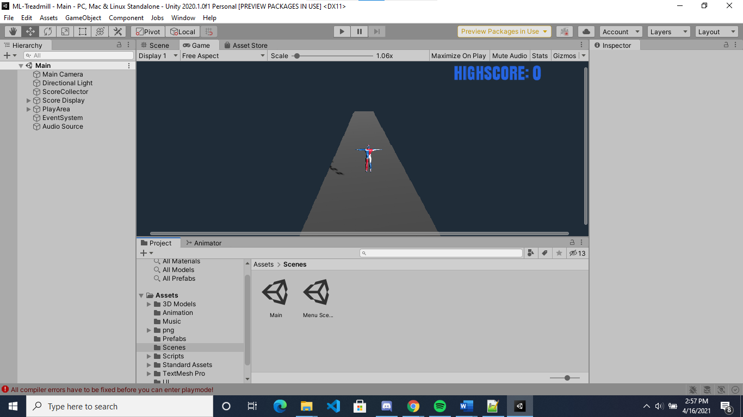

## Version 1.10

Version 1.10 includes some control and texture changes and that our team did after making my initial pass at the design. Here is what we changed.

1. Pairing down of the design scope. (Scope, not design)
2. Story details, options and scoring system design and code change.
3. Added Sound Effects.

## Version 2.00

Version 2.00 is the final version of the design where a major revision has been made now that much more is known about the game. This is as listed below:

* The main Character has been modified and changes to Trainee- Pepsi Man (Astronaut X).
* Sound effects have been changed by making changes in the pitch used in audio.
* Assets have been replaced in terms of that we have Pepsi Cans instead of cylinder and circle.
* The High Score functionality is working efficiently in version 2.00.

# Game Overview

## Philosophy

### Philosophical point #1

Through this game we are trying to explain that by repetitive usage or adopting a pattern you can learn things. We have described the same through our game in which we have the Pepsi Man (Astronaut-X) going through rigorous training sessions to become fit in order adapt to the atmosphere of Saturn Planet. His successful completion to this training will prove that the living being on Earth can survive on another Planet (Saturn). The objective of the Player is to jump through several geometries coming in his way while he practices on the Treadmill. This geometry is a Pepsi Can which is one of the elements you need to avoid on the Planet Saturn. This training will be a contribution from the Pepsi Man (Astronaut-X) to help prove the point that the living being on Earth can survive and adapt to the atmosphere of another Planet.

### Philosophical point #2

Our game only runs on desktop system. The reason for this is that it is a heavy built and takes up a lot of space to run.

## Common Questions

### What is the game?

The game is about the Player who has to jump through several geometries coming in his way while he practices on the Treadmill. This geometry is a Pepsi Can which is one of the elements you need to avoid on the Planet Saturn. This training will be a contribution from the Pepsi Man (Astronaut-X) to help prove the point that the living being on Earth can survive and adapt to the atmosphere of another Planet.

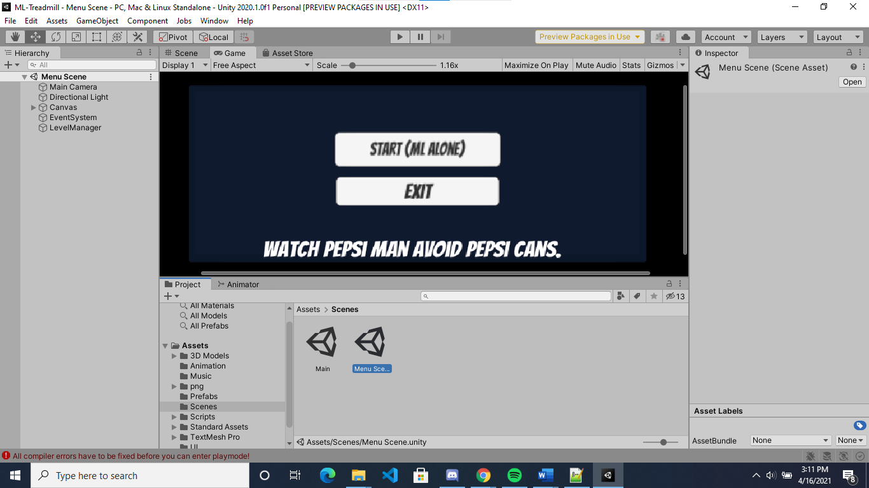

### Why create this game?

This 3-D game is an insight into the world of another Planter (Saturn) which will help the living being on Earth survive under it’s atmosphere after there is no life left on Planet Earth. For this the trainee – Pepsi Man has to undergo rigorous training sessions to adapt to the living condition of the Planet- Saturn.

### Where does the game take place?

The game starts with the story of Pepsi Man (Astronaut-X) Care who has been chosen to use his training and learning methodology to utilize the same in matters of decision making, survival act and adaptability towards the living atmosphere on another Planet- Saturn.

### What do I control?

The player has full control of the Pepsi Man (Astronaut-X) to move forward-backward with A, D and help escape the coming geometry – Pepsi Cans by jumping through space key.

### How many characters do I control?

Our design of the game is such that the player gets to control the Pepsi Man (Astronaut-X). They have the control to gain credits once they are successfully able to escape the Pepsi Can.

### What is the main focus?

The main focus is on training and pattern changing of the main Character to learn to adapt to the living condition of another Planet. Through this mission the player will be able to gain credits as Score displayed on the screen upon escaping a coming Pepsi Can and also to gain High Score to win this training session and prove the aim of this mission that the living being of Planet Earth can survive to another Planet’s (Saturn) atmosphere.

### What’s different?

Our game is created to make a difference in the life of people by making them more active, intelligent by learning the patterns and logic and thereby experiencing wholesome excitement while they are on their journey of this rigorous training and become a fit to survive on another Planet.

# Feature Set

## General Features

Saturn Planet’s Atmosphere and its magnificent world

Controllable player – Pepsi Man (Astronaut -X)

3D graphics

32-bit color

## Multiplayer Features

Single-player platform

Runs on Nintendo, Kinect

Describes about the learning ability and associated pattern

Player can learn a pattern and utilize the same logic to surpass another challenge

## Editor

Editor is easy to use.

## Gameplay

Gameplay experience’s items include –spawning geometries coming towards Player on Treadmill – Pepsi Cans.

Our game also includes – Score Board and High Score.

Saturn’s Atmosphere and an experience to be on another Planet Simulated Training Space Area(Final Build)

# The Game World

## Overview

The main focus is on training and pattern changing of the main Character to learn to adapt to the living condition of another Planet. Through this mission the player will be able to gain credits as Score displayed on the screen upon escaping a coming Pepsi Can and also to gain High Score to win this training session and prove the aim of this mission that the living being of Planet Earth can survive to another Planet’s (Saturn) atmosphere.

## World Feature #1

Our game is different in the way that here the Player has to undergo a rigorous training session where he has to jump through several geometries coming in his way while he practices on the Treadmill to adapt to a totally different atmosphere. The barrier in his training is set of geometries (Pepsi Cans) coming in his way which is one of the elements he needs to avoid on the Planet Saturn.

## World Feature #2

What makes the game unique is the Training Area which simulates the life of another Planet (Saturn), and in this the player’s ability to gain access to assets in the games. This mission is based on pattern learning and utilizing same knowledge to clear more challenging levels which increases or decreases the player’s score.

## The Physical World

### Overview

The game has a training environment with locations of a different Planet (Saturn) consisting of the path on a Treadmill and barriers as Pepsi Cans which the player has to avoid in order to achieve points.

The following describes the key components of the physical world.

### Key Locations

Simulation of the Planet Saturn and creating a training platform for the player on Treadmill to train for victory and avoid coming barriers based on pattern learning and logic which makes it more interesting for the inquisitive minds.

### Travel

A whole new world of another Planet - Saturn is available to the Player.

### Scale

All objects used in the games are scaled to a real world game object scaling criteria.

### Objects

We have made use of build-in Unity Objects such as the main player character, moving Cans (Pepsi Cans) and Score board was designed using UI functionality.

### Weather

Weather in the game is as that of estimated world of another Planet (Saturn).

### Day and Night

All locations have day time set for playing the game.

### Time

There is no particular time limit set. The mechanism used helps the system save the CPU time.

## Rendering System

### Overview

Our game is a mission for the Pepsi Man (Astronaut-X) to undergo rigorous training by following and learning the pattern where it escapes with the opponent objects coming in his way – Pepsi Cans to gain points. This target would be to eventually increase one’s score by getting better at the training sessions and points collection.

### 2D/3D Rendering

The 3D rendering engine used in the game is spawning ability of the path for the Pepsi Man to complete the target of achieving the highest score. The player’ ability to adapt to new pattern and learning mechanism helps him gain points and win the game.

## Camera

### Overview

The camera rotates for every updated frame.

### Camera Detail #1

The camera rotation is controlled by the mouse movement. The starting point of movement starts with initial position of the mouse and the camera rotation is calculated thereafter.

## Game Engine

### 

### Overview

The game is built on Unity-Game engine and built on 3D platform.

### Game Engine Detail #1

The game engine on unity makes it feasible for the player to play from any platform on desktop. We have made use of 3D graphics , Road spawning process and background sounds for city life. The game has a good memory management with Get-Key component which captures the actions and updates the status for the player and Game Object in Unity.

### Collision Detection

Our game engine handles motion sensing in an efficient way and its learning mechanism is really well since we have made use of the key Get-Key component which captures the actions and updates the status for gaining points in the game.

## Lighting Models

### Overview

In order to provide much more realistic view, indirect global illumination technique

### Lighting Model Detail #1

We are using the precomputed Realtime GI lighting technique which helps our character and gameobjects to display colors as per the conditions of the light source changes.

# The World Layout

## Overview

Our game is a mission for the Pepsi Man (Astronaut-X) to undergo rigorous training by following and learning the pattern where it escapes with the opponent objects coming in his way – Pepsi Cans to gain points. This target would be to eventually increase one’s score by getting better at the training sessions and points collection.

## World Layout Detail #1

The world presented is the living atmosphere of another Planet – Saturn and a learning environment for the player to undergo training sessions and adapt to pattern and learning mechanism which helps him gain points and win the game.

# Game Characters

## Overview

Our game consists of:

* The Player – Pepsi Man (Astronaut -X)

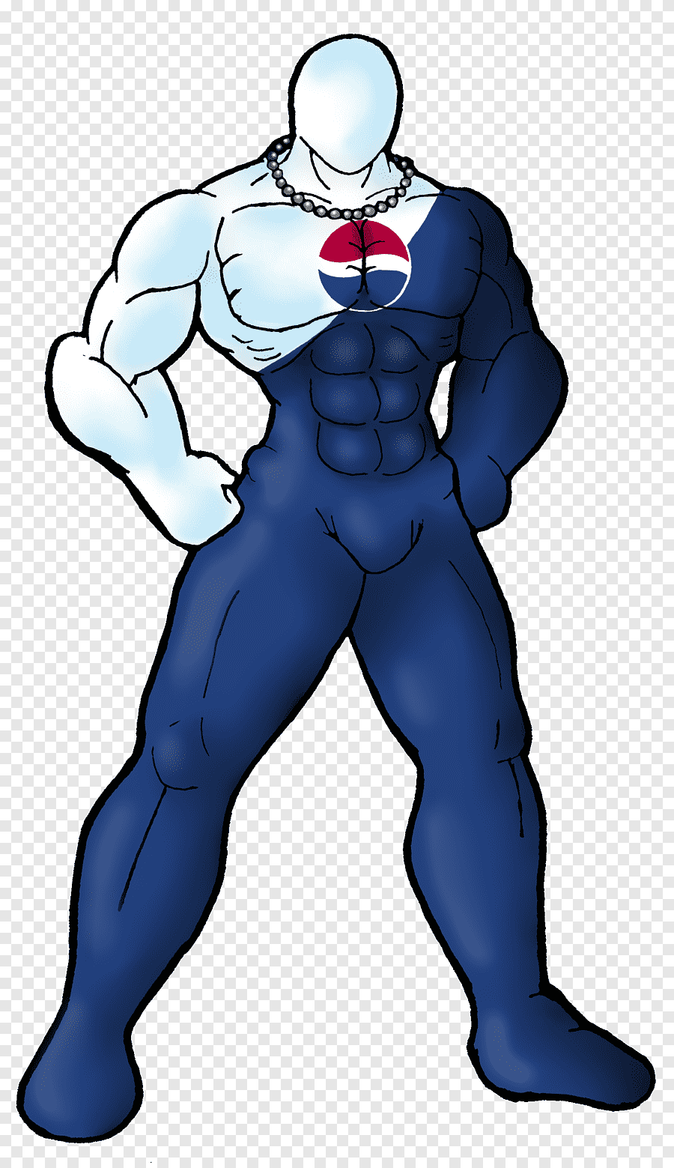

* Barrier - Pepsi Cans



* Pathway – Treadmill

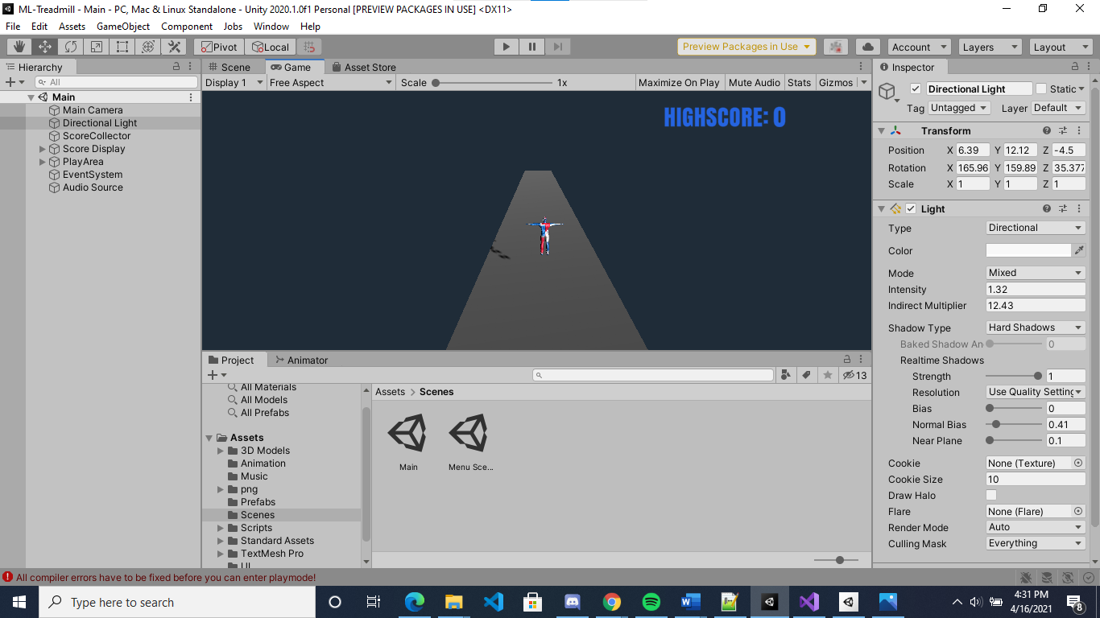

## Creating a Character

We have made use of the Blender made assets to create our player and other Game Objects.

.

## Enemies and Monsters

We have made use of the Blender made assets to create our game barriers for the player’s challenge.

# User Interface

## Overview

Our Interface consists of the UI components as mentioned below:

* High Score:

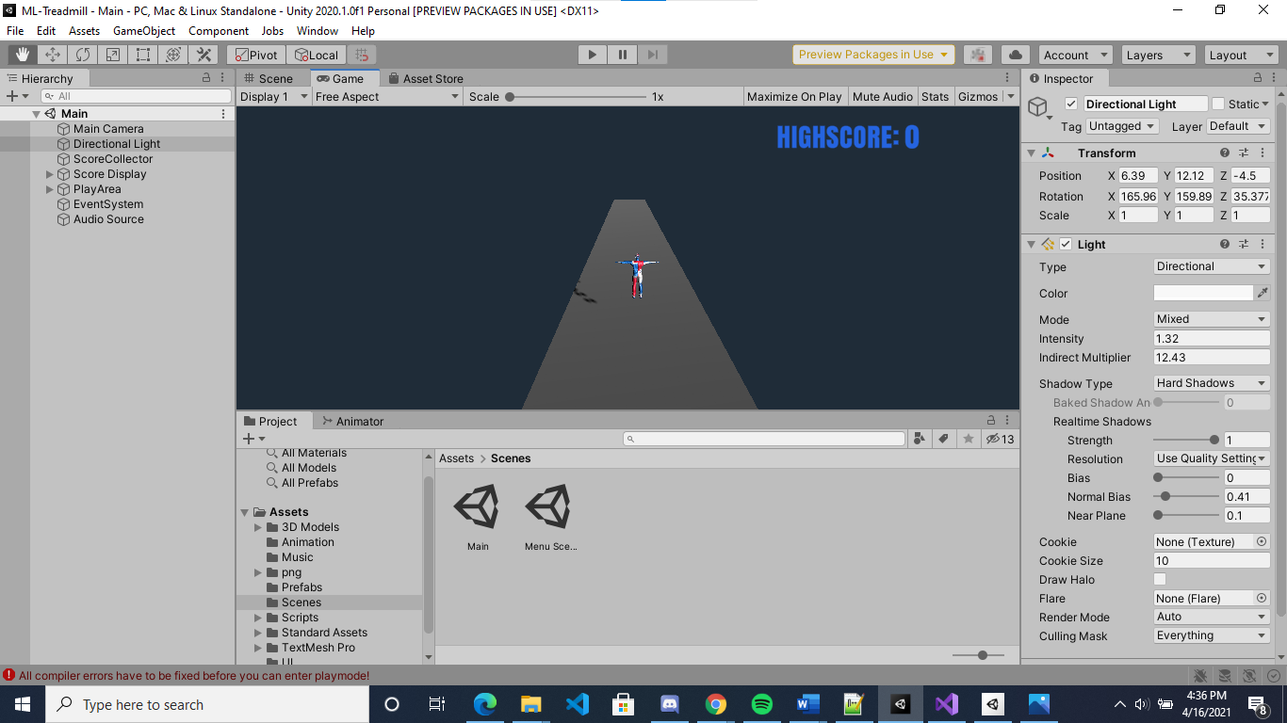

* Start Game Button:

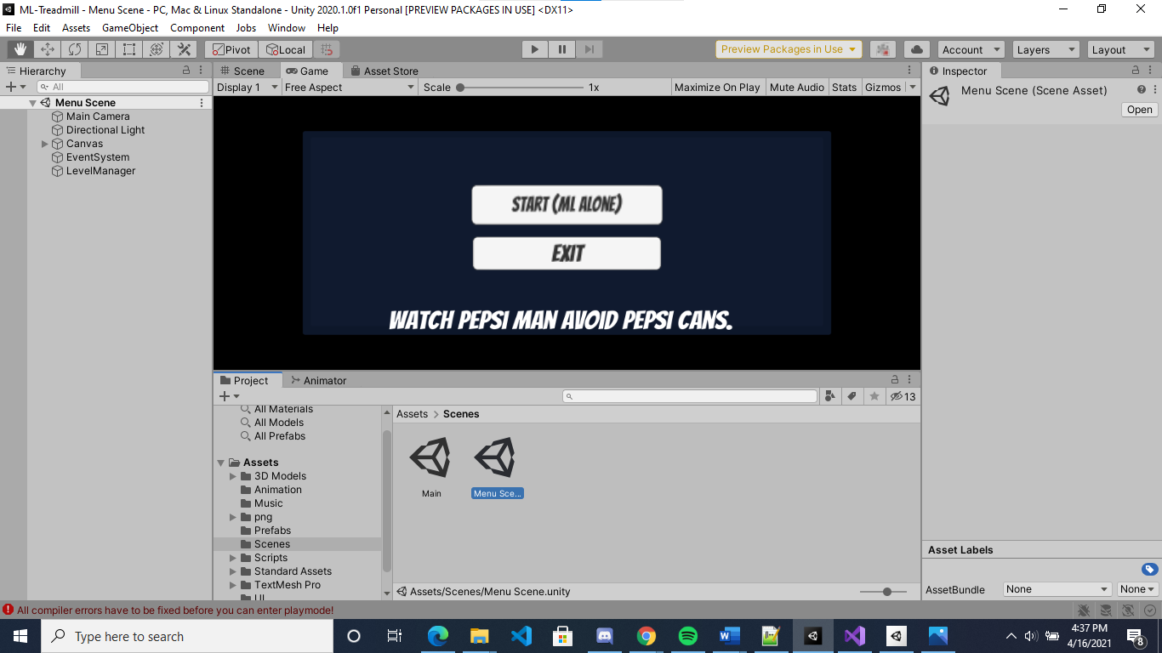

* Exit Screen:



# Musical Scores and Sound Effects

## Overview

We have used audio at scene locations for creating live event and training to make the game more interesting.

## 3D Sound

The 3D sounds consists of the location sounds as that of a training environment of a Space Station and simulated atmosphere of Planet Saturn.

## Sound Design

We aim at creating a unique experience and for the same we have customized the entire libraries for syncing the same with player movement and barrier surpassing events..

# Single-Player Game

## Overview

Our game is a mission for the Pepsi Man (Astronaut-X) to undergo rigorous training by following and learning the pattern where it escapes with the opponent objects coming in his way – Pepsi Cans to gain points. This target would be to eventually increase one’s score by getting better at the training sessions and points collection.

## Single Player Game Detail #1

Single Player is the Pepsi Man (Astronaut-X) Car which completes for completing the training session successfully in order to gain scores.

## Story

The idea or story revolves around the Score the player is able to get in order to become good or get skilled at playing it.

## Hours of Gameplay

The game will be ongoing once you start playing it and collect the highest score.

## Victory Conditions

Check the “Menu Screen” board to grasp the idea which says that the player is supposed to undergo pattern learning session/training in order to become skilled at surviving that particular environment and is able to collect points for same and hits the Highest Score.

# Single-player Game

## Overview

In this game the Player or the Pepsi Man’s mission will be to complete the target of achieving the highest score by undergoing rigorous training sessions which will enable him to learn patterns and utilize the same to win the game.

## Max Players

We have one Player in the game – (Astronaut-X).

## Servers

We have used the Web-GL link to allow player to connect from any end and for same the network connection is always shown on bottom left corner

## 

## Customization

You can train yourself to achieve more points in the ongoing game.

## Internet

The game allows anyone connected to the internet to play the game.

## Gaming Sites

We intend to reach gaming sites such as Shockwave and BlueStacks. We will evaluate the popularity and would be willing to deploy the same on these gaming sites...

## Persistence

We will try to be persistent with our gam e through the use of feedbacks and new modifications to the existing unity game.

## Saving and Loading

Since our system works entirely through networks, we cannot save the existing player and once he rejoins he or she will have to start from initial stage.

# Character Rendering

## Overview

Our characters are rendered by using the Blender made assets which we imported to Unity. We have customized it in order to sync it with our game interface.

## 

## Character Rendering Detail #1

Created the player – main character- Pepsi Man (Astronaut -X) using Blender.

## 

## Character Rendering Detail #2

Created the assets like Pepsi Cans and Treadmill as major training asset – by using Blender and inbuilt Unity Assets functionality and imported the Blender assets along with Treadmill asset to sync the game with the whole interface.

# “Objects Appendix”

We have made use of blender such as for the main player character –Pepsi Man & Pepsi Cans.

We also have other game supporting assets like the Treadmill and metal boxes which acts as barrier for player to conquer in order to accomplish the level which makes the game more interesting.

# “User Interface Appendix”

The player has a Score on top right.

The player gets access to the assets in the ongoing game to get the required training. This makes use of adaptive methodologies and training which makes it unique.

Out gaming strategy for its interface was referenced from the learning environment-

https://github.com/Unity-Technologies/ml-agents/blob/main/com.unity.ml-agents/Documentation~/com.unity.ml-agents.md

# “Networking Appendix”

Anyone can access the game as long as they are connected to the Internet.