实验二：类的封装、继承和多态 实验日期： 年 月 日
批阅教师签字：__________________
班级：计算机1802 姓名： 李杨 学号：1808010222

实验报告内容：
- 实验目的
掌握面向对象的程序设计与开发。掌握，封装，多态，继承，异常处理，上转型技术。
- 实验性质
综合性
- 实验内容
要求完成一个商品租赁系统，该系统允许用户租赁商店里的的各种商品。
您将被要求创建一个Store类，Store类中保存了一个项目列表的引用。该列表（称为itemList）的类型是链表，它包含了商店里面所有项目。这些项目包括：书籍，杂志，DVD（电影），Blurays（电影），MusicCD。这些项目中的每一个物品都需要存储在列表（itemList）中。
要求你使用继承技术创建一个管理此系统的库类。
允许除了添加或删除物品，查找一个物品。
还要实现借用一件物品并能将其归还。
如果借用的商品已经借出应该抛出ItemnotFound的异常。
每个物品的信息应该可以写入磁盘中。
编写测试程序以确保商品租赁系统的能够正常运行。
要求写注释，生成JavaDoc

- 实验环境
1. 计算机一台；
2. 中文Windows操作系统；安装JDK1.6以上版本，安装EclipseIDE软件。

- 实验主要步骤
- 问题分解，（画出程序类图）
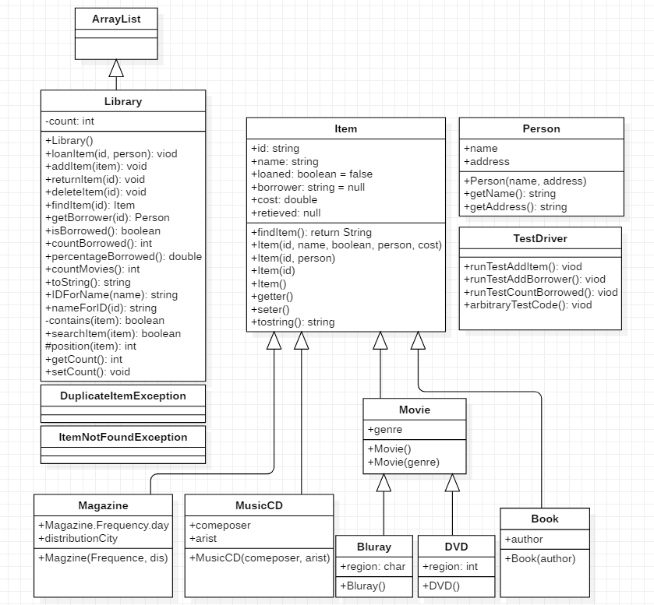

- 给出程序源码
Libray.java~~~~~~~~~~~~~~~~~~~~~~~~~~~~~~~~~~~~~
package com.Library;
import java.util.ArrayList;
import java.util.Iterator;

/* @author 计算机1802李杨
*Version 1.0
*date 2020-04-15
*/
@SuppressWarnings("serial")
public class Library extends ArrayList<Item>{
private int count=size();//记录所有物品的数量
Library(){ }
/**
*将新项目添加到库项目列表中。
* @param target 要添加到列表中的新项目。
* @throws DuplicateItemException thrown 如果项目已经在列表中.
*/
public void addItem(Item target) throws DuplicateItemException
{
if(contains(target))
try {
throw new DuplicateItemException("异常！物品已存在");
}
catch(DuplicateItemException e) {}
else {
super.add(target);
}
}
/**
* @param id 传入物品id
* @throws ItemNotFoundException
* 要删除的物品 在列表中删除物品，首先判断列表中是否有此物品， 若有则调用父类remove函数
*/
public void deleteItem(String id) throws ItemNotFoundException {
Item target = findItem(id);
if (target != null){
remove(position(target));
setCount(getCount() - 1);
}

}

/**
* 将命名项目的状态更改为借用，并将人员添加到借用
*
* @param id 借用物品的ID
* @param newPerson 物品的借方
* @throws ItemNotFoundException thrown if the id is not found.
*/
public void loanItem(String id, Person newPerson) throws ItemNotFoundException
{
Item target = findItem(id);
System.out.println(target);
if (target != null) {
if (target.isLoaned()) {
System.out.println("物品已被借出");
}
else
{
target.setLoaned(true);
target.setBorrower(newPerson);
if(target instanceof Book) {Book temp = (Book) target;set(position(target),temp);}
else if(target instanceof Magazine) {Magazine temp = (Magazine) target;set(position(target),temp);;}
else if(target instanceof DVD) {DVD temp = (DVD) target;set(position(target),temp);}
else if(target instanceof Bluray) {Bluray temp = (Bluray) target;set(position(target),temp);}
else if(target instanceof MusicCD) {MusicCD temp = (MusicCD) target;set(position(target),temp);}
}
}
}

/**
* changes the status of the named item to not borrowed and removes the user from the item.
* The borrower (person) is returned to the caller
* 将命名物品的状态更改为未借用，并将用户从项目中删除。借方（人）返回给呼叫者
* @param id 物品id
* @throws ItemNotFoundException thrown if the id is not found.
*/
public void returnItem(String id) throws ItemNotFoundException {
Item target = findItem(id);
System.out.println(target);
if (target != null) {
if (target.isLoaned()) {
target.setLoaned(false);
target.setBorrower(null);
if(target instanceof Book) {Book temp = (Book) target;set(position(target),temp);}
else if(target instanceof Magazine) {Magazine temp = (Magazine) target;set(position(target),temp);;}
else if(target instanceof DVD) {DVD temp = (DVD) target;set(position(target),temp);}
else if(target instanceof Bluray) {Bluray temp = (Bluray) target;set(position(target),temp);}
else if(target instanceof MusicCD) {MusicCD temp = (MusicCD) target;set(position(target),temp);}
}
else
System.out.println("该物品未被借出");
}
}
/**
* 通过给定的ID查找项目并返回该项目
* @param id 返回的项目
* @return 寻找的项目.
* @throws ItemNotFoundException thrown if the id is not found.
*/
public Item findItem(String id) throws ItemNotFoundException {
Item target = new Item(id);
if(searchItem(target)) {
Item item=super.get(position(target));
if(item instanceof Book) {Book temp = (Book) item;return temp;}
else if(item instanceof Magazine) {Magazine temp = (Magazine) item;return temp;}
else if(item instanceof DVD) {DVD temp = (DVD) item;return temp;}
else if(item instanceof Bluray) {Bluray temp = (Bluray) item;return temp;}
else if(item instanceof MusicCD) {MusicCD temp = (MusicCD) item;return temp;}
}
return null;
}

/**
* 获取项目的借方。如果找不到该项目，则抛出ItemNotFoundException。
* @param id 项目的ID
* @return 项目借方. 如果项目存在未借出返回null
* @throws ItemNotFoundException thrown if the id is not found
*/
public Person getBorrower(String id) throws ItemNotFoundException {
Item target = findItem(id);
return target.getBorrower();
}
/**
* 检查是否借用了特定的图书馆物品。 *
* @param id 要检查的商品的ID。
* @return 项目的状态，无论是否借用。
* @throws ItemNotFoundException thrown if the id is not found.
*/
public boolean isBorrowed(String id) throws ItemNotFoundException {
Item target = findItem(id);
return target.isLoaned();
}

/**
* 根据给定的ID查找库项目的名称。
* @param id 项目ID
* @return 项目名称/未找到的项目名称为空白。
* @throws ItemNotFoundException
* 没有找到抛出异常
*/
public String nameForID(String id) throws ItemNotFoundException {
Item target = findItem(id);
return target.getName();
}
/**
* 根据给定的名称返回库项目的ID。
* @param name 项目名称
* @return 物品Id
*/
public String IDForName(String name) {
Item target = new Item(name);
return target.getId();
}

/**
* 将整个库转换为字符串。这应该调用ArrayList中每个项目的适当的toString方法。
* 应采用以下格式
*Items.txt
*/
public String toString() {
Iterator<Item> it=iterator();
Item temp=new Item();
String our=new String();
String temp1=new String();
our=null;
while(it.hasNext()) {
temp=it.next();
temp1=temp.tostring();
our=our+'\n'+temp1;
}
return our;
}

/**
* 返回借出的项目总数。 *
* @return 该数字代表当前正在借出的物品数
*/
public int countBorrowed() {
int count=0;
for (int i = 0; i < super.size(); i++) {
Item current = super.get(i);
if(current.isLoaned())
count++;
}
return count;
}
/**
* 借出的项目数的百分比。表示为借出占项目总数的百分比。
* @return the percentage borrowed.
*/
public double percentageBorrowed() {
int count =super.size();
System.out.println(count);
float percentage;
percentage = ((float)countBorrowed()/(float)count)*100;
return percentage;
}

/**
* @return 返回Blurays或DVD的项目数 *
*/
public int countMovies() {
int count=0;
for (int i = 0; i < super.size(); i++) {
Item item = super.get(i);
if(item instanceof Movie)
count++;
}
return count;
}

/**
* @param target
* 要查找的物品
* @return true|false 是否包含该物品 遍历父类链表，若找到该物品，返回真，找不到则返回假
*/
private boolean contains(Item target)
{
for (int i = 0; i < super.size(); i++)
{
Item current = super.get(i);
if (current.getId().equals(target.getId()))
{
return true;
}
}
return false;
}
/**
* @param target
* 要寻找的物品
* @return true|false 是否找到该物品
* @throws ItemNotFoundException
* 没有找到的一场 在列表中查找物品 ，调用contains函数，若没有找到则抛出异常
*/
public boolean searchItem(Item target) throws ItemNotFoundException
{
if (this.contains(target))
{
return true;
}
else
{
try
{
throw new ItemNotFoundException("没有找到物品");
}
catch (ItemNotFoundException e) { }
}
return false;
}
/**
* @param target
* 要查找位置的物品
* @return position 该物品的位置 遍历父类链表，标记某物品所在的位置
*/
protected int position(Item target)
{
for (int position = 0; position < super.size(); position++)
{
Item current = super.get(position);
if (current.getId().equals(target.getId()))
{
return position;
}
}
return -1;
}

public int getCount() {
return count;
}
public void setCount(int count) {
this.count = count;
}

}

TestDriver.java~~~~~~~~~~~~~~~~~~~~~~~~~~~~~~~~~~~~~~~~~~~~~
package com.Library;
/**
* @author 计算机1802 李杨
*Version1.0
*date 2020-04-25
*/
public class TestDriver {

public void runTestAddItem() {
System.out.println("***Testing addItem***");
{
System.out.println("-Test add an item and see if it is in the list-");
String expected = "Found";
System.out.println("Expected <"+expected+">");
//Do the Test
Library l1 = new Library();
Item retrieved = null;
String result = "";
try {
l1.addItem(new Magazine(Magazine.Frequency.day, "New York","ID001","Vanity Not So Faire", false, null, 5.95));
retrieved = l1.findItem("ID001");
//此处是为了完整性，以及是否有人编写其他测试并将其用作示例。
//findItem绝不应该返回null，但是当库代码出现问题时，它将覆盖一个事件。
result = retrieved != null? "Found":"Not Found";
} catch (DuplicateItemException e) {
result = "Failed Duplicate Found";
} catch (Exception e) {
result = "Failed Exception Thrown";
}
System.out.println("Got <"+result+">");
if (result.equals(expected)) {
System.out.println("Success");
} else {
System.out.println("Failed");
}
}

{
System.out.println("-Test add an item with a duplicate see if it throws an exception-");
String expected = "Failed Duplicate Found";
System.out.println("Expected <"+expected+">");
//Do the Test
Library l1 = new Library();
Item retrieved = null;
String result = "";
try {
l1.addItem(new Magazine(Magazine.Frequency.day, "New York","ID001","Vanity Not So Faire", false, null, 5.95));
l1.addItem(new Magazine(Magazine.Frequency.day, "New Jersey","ID001","Vanity Not So Faire", false, null, 5.95));
retrieved = l1.findItem("ID001");
result = retrieved != null? "Found":"Not Found";
} catch (DuplicateItemException e) {
result = "Failed Duplicate Found";
} catch (Exception e) {
result = "Failed Exception Thrown";
}
System.out.println("Got <"+result+">");
if (result.equals(expected)) {
System.out.println("Success");
} else {

System.out.println("Failed");
}
}
//You need to write lots of tests here.
}
public void runTestAddBorrower() {
System.out.println("***Testing addBorrower***");
{
System.out.println("-Test loan an item and see if borrower is in the list-");
String expected = "Found";
System.out.println("Expected <"+expected+">");
//Do the Test
Library l1 = new Library();
Person retrieved = null;
String result = "";
try {
l1.addItem(new Magazine(Magazine.Frequency.day, "New York","ID001","Vanity Not So Faire", false, null, 5.95));
l1.loanItem("ID001",new Person("Stewart","Mawson Lakes"));
retrieved = l1.findItem("ID001").borrower ;

//此处是为了完整性，以及是否有人编写其他测试并将其用作示例。
//findItem绝不应该返回null，但是当库代码出现问题时，它将覆盖一个事件。
result = retrieved != null? "Loaned":"Not Loaned";
} catch (ItemNotFoundException e) {
result = "Failed Found Loaned";
} catch (Exception e) {
result = "Failed Exception Thrown";
}
System.out.println("Got <"+result+">");
if (result.equals(expected)) {
System.out.println("Success");
} else {
System.out.println("Failed");
}
}
}
public void runTestCountBorrowed() {
System.out.println("***Testing countBorrowed***");
{
System.out.println("-Test loan an item and see if borrower is in the list-");
String expected = "Found";
System.out.println("Expected <"+expected+">");
//Do the Test
Library l1 = new Library();
int retrieved = 0;
String result = "";
try {
l1.addItem(new Magazine(Magazine.Frequency.day, "New York","ID001","Vanity Not So Faire", false, null, 5.95));
l1.loanItem("ID001",new Person("Stewart","Mawson Lakes"));
retrieved = l1.countBorrowed();
//此处是为了完整性，以及是否有人编写其他测试并将其用作示例。
//findItem绝不应该返回null，但是当库代码出现问题时，它将覆盖一个事件。
result = retrieved != 0? "count":"Not count";
} catch (ItemNotFoundException e) {
result = "Failed count";
} catch (Exception e) {
result = "Failed Exception Thrown";
}
System.out.println("Got <"+result+">");
if (result.equals(expected)) {
System.out.println("Success");
} else {
System.out.println("Failed");
}
}
}
public static void main(String[] args) {
TestDriver td = new TestDriver();

td.runTestAddItem();
td.runTestAddBorrower();
td.runTestCountBorrowed();
//添加更多测试方法
td.arbitraryTestCode();
}
public void arbitraryTestCode() {
Library l1 = new Library();
Person p1 = null;
try {
p1 = new Person("Stewart","Mawson Lakes Blvd");
}
catch (Exception e1) {
e1.printStackTrace();
}
int id=0;
try {
Item[] testSubjects = {
new Magazine(Magazine.Frequency.day, "San Andreas", "ID00"+id++,"Vanity Not So Faire", false, null, 5.95),
new Magazine(Magazine.Frequency.day, "San Andreas", "ID00"+id++,"Click", false, null, 5.95),
new Magazine(Magazine.Frequency.day, "San Andreas", "ID00"+id++,"Renovate", false, null, 5.95),
new Magazine(Magazine.Frequency.day, "San Andreas","ID00"+id++,"Madrid", false, null, 5.95),
new Magazine(Magazine.Frequency.day, "San Andreas","ID00"+id++,"Bikes", false, null, 5.95),
new MusicCD("Rudy Vale","Valen","ID00"+id++,"Gatewars Soundtrack",false,null,19.95),
new MusicCD("Rudy Vale The Third","Valen","ID00"+id++,"Gatewars 2 Soundtrack",false,null,19.95),
new MusicCD("Rudy Vale Sr","Valen","ID00"+id++,"Gatewars 3 Soundtrack",false,null,19.95),
new MusicCD("Rudy Vale Jr","Valen","ID00"+id++,"Gatewars 4 Soundtrack",false,null,19.95),
new MusicCD("Not Rudy Vale","Valen","ID00"+id++,"Gatewars 5 Soundtrack",false,null,19.95),
new MusicCD("Rudy Vale","Not Valen","ID00"+id++,"Gatewars 6 Soundtrack",false,null,19.95),
new Bluray('c',Bluray.Genre.drama,"ID00"+id++,"Gatewars 1 Revenge of the Fallen",false,null,29.95),
new Bluray('c',Bluray.Genre.drama,"ID00"+id++,"Gatewars 2 Ponies Are Ridden",false,null,29.95),
new Bluray('c',Bluray.Genre.drama,"ID00"+id++,"Gatewars 3 Sequels are Lame",false,null,29.95),
new Bluray('c',Bluray.Genre.drama,"ID00"+id++,"Gatewars 3 But They Keep Making Them",false,null,29.95),
new Bluray('c',Bluray.Genre.drama,"ID00"+id++,"Gatewars 5 They Make More Than is Reasonable",false,null,29.95),
new DVD(1,DVD.Genre.scifi,"ID00"+id++,"Darth Yobbit and the Range Runners",false,null,29.95),
new DVD(1,DVD.Genre.scifi,"ID00"+id++,"Darth Yobbit and the Long Jumpers",false,null,29.95),
new DVD(1,DVD.Genre.scifi,"ID00"+id++,"Darth Yobbit and the Domain Walkers",false,null,29.95),
new DVD(1,DVD.Genre.scifi,"ID00"+id++,"Darth Yobbit and the KiloByte",false,null,29.95),
new DVD(1,DVD.Genre.scifi,"ID00"+id++,"Darth Yobbit and the Rabbits",false,null,29.95),
new Book("Arthur C Clarke","ID00"+id++,"The City and The Stars",false,null,14.50),
new Book("Arthur C Clarke","ID00"+id++,"Rendevous With Rama",false,null,14.50),
new Book("Arthur C Clarke","ID00"+id++,"2001",false,null,14.50)
};

for (int i=0;i<testSubjects.length;i++) {
try {
l1.addItem(testSubjects[i]);
} catch(DuplicateItemException ex) {
System.err.println(ex);
}
}
System.out.println("******");

System.out.println(l1);
System.out.println("Should say false "+l1.isBorrowed("ID0022"));
l1.loanItem("ID0022", new Person("Stewart","Mawson Lakes"));
System.out.println("Should say false "+l1.isBorrowed("ID0020"));
System.out.println("Should say true "+l1.isBorrowed("ID0022"));//loanItem()未正常运行
System.out.println("Should say Mawson Lakes " + l1.getBorrower("ID0022").getAddress());
System.out.println("******");

//Various get datas from items
System.out.println(l1.findItem("ID0020").getName());
System.out.println(l1.findItem("ID0020").getId());
System.out.println(l1.findItem("ID0020").getCost());
System.out.println(l1.findItem("ID0020").getBorrower());
System.out.println("Should be false "+l1.findItem("ID0020").isLoaned());
l1.findItem("ID0020").setBorrower(new Person("AAA","ADDRESS"));
l1.findItem("ID0020").setLoaned(true);
System.out.println("Should be true "+l1.findItem("ID0020").isLoaned());

l1.findItem("ID0020").setCost(99.99f);
l1.findItem("ID0020").setLoaned(false);
l1.findItem("ID0020").setName("Changed Name");
System.out.println(l1.findItem("ID0020"));
System.out.println("******");

try {
System.out.println(l1.findItem("ID006"));
}
catch (ItemNotFoundException e) {
e.printStackTrace();
}
System.out.println("******");

System.out.println("Number Borrowed "+l1.countBorrowed());
System.out.printf("Percentage Borrowed %5.2f%% \n",l1.percentageBorrowed());
try {
l1.loanItem("ID001", p1);
l1.loanItem("ID003", p1);
l1.loanItem("ID004", p1);
l1.loanItem("ID009", p1);
}
catch (ItemNotFoundException e) {
e.printStackTrace();
}
System.out.println("Should say true "+l1.isBorrowed("ID009"));
System.out.println("Should say Mawson Lakes " + l1.getBorrower("ID009").getAddress());

System.out.println("******");
System.out.println("Number Borrowed Should say 5 "+l1.countBorrowed());
System.out.printf("Percentage Borrowed %5.2f%% \n",l1.percentageBorrowed());
System.out.println("Should say 10 "+l1.countMovies());
} catch (Exception ex) {
System.err.println("Exception Found in Input "+ex.getMessage());
}
}

}
其他物品、异常类
package com.Library;

public class Bluray extends Movie {
public char region;
public Bluray (char region, Genre genre, String id, String name, boolean b,Person borrower, double d) {
super( genre, id, name, b, borrower, d);
this.region = region;
}

}
package com.Library;

public class DVD extends Movie {
public int region;
public DVD(int region, Genre genre, String id, String name, boolean b,Person borrower, double d) {
super( genre, id, name, b, borrower, d);
this.region = region;
}

}
package com.Library;

public class Book extends Item {
public String author;
public Book(String author, String id, String name, boolean b,Person borrower, double d) {
super( id, name, b, borrower, d);
this.author = author;
}

}
package com.Library;

public class Magazine extends Item {
public enum Frequency{
day,month,season,year
}
Frequency magazineFrequency;
public String distributionCity;

public Magazine(Frequency day, String dis, String id, String name, boolean b,Person borrower, double d) {
super( id, name, b, borrower, d);
this.magazineFrequency = day;
this.distributionCity = dis;

}

}
package com.Library;

public class MusicCD extends Item {
public String comeposer;
public String arist;

public MusicCD(String comeposer, String arist, String id, String name, boolean b,Person borrower, double d) {
super( id, name, b, borrower, d);
this.comeposer = comeposer;
this.arist = arist;
}

}
package com.Library;

public class Movie extends Item{
public enum Genre{
scifi, action, drama, romance
}
Genre genre;
public Movie(Genre genre, String id, String name, boolean b,Person borrower, double d) {
super( id, name, b, borrower, d);
this.genre = genre;
}
public Movie(Genre genre) {
this.genre = genre;
}
public Genre getGenre() {
return genre;
}
}
package com.Library;

public class Person {
public String name;
public String address;
public Person(String name, String address) {
this.name = name;
this.address = address;
}
public String getName() {
return name;
}

public String getAddress() {
return address;
}
}

3.给出程序运行结果

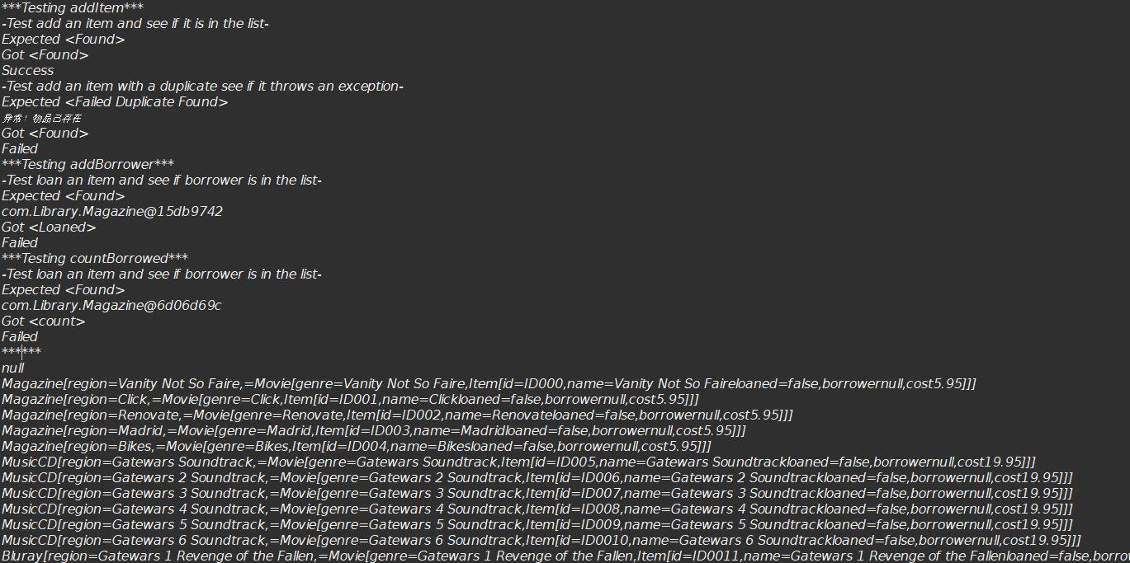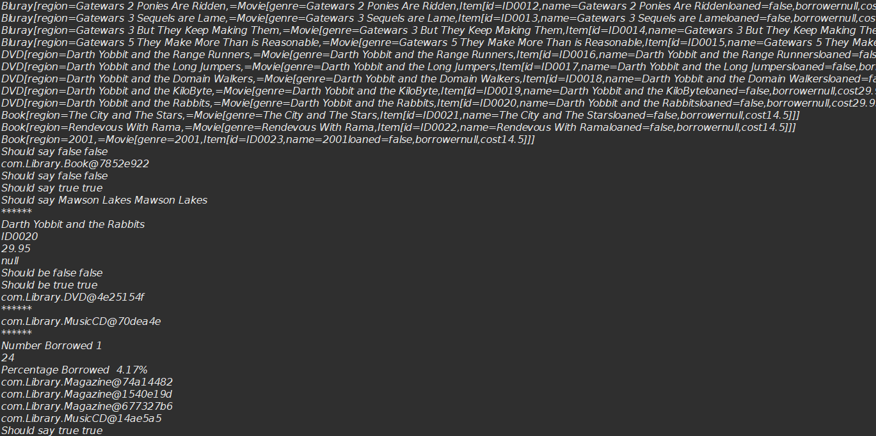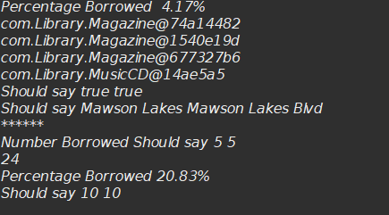

- 实验小结
这次试验难度较大，在调试程序的过程中，容易卡在修改物品信息和状态的方法，函数的调试上，由于ArrayList属于非泛型类在查找物品的方法中需要用到上转型和下转型，如果方法设计出现错误，会影响到后续的程序调试，，toString方法的使用主要是为了方便控制台的打印输出，在查找过程中可以适当的使用迭代器，保证数据和函数的私密性，，迭代器的next()方法可以方便链表的遍历。
整个测试程序TestDriver通过随机测试函数基本能够，调试出程序的问题，其他的测试类仿照着testaddIten编写就好了，经过比较长时间的调试终于将程序调试出来了，期间在网上查找了不同的资料，学习Arraylist的相关知识，和使用方法，期间询问过其他人对比发现自己在设计程序框架上的疏漏和错误，相对来说节省了时间。

