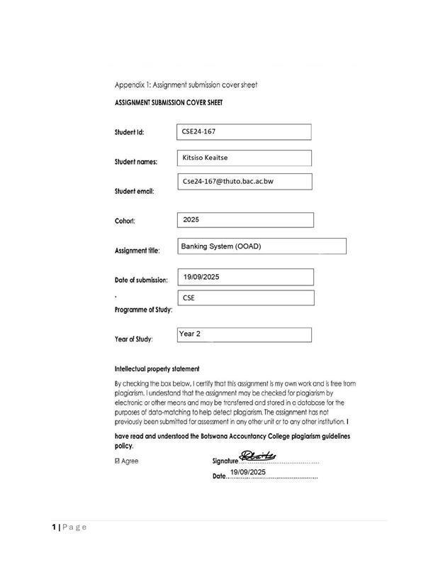

Part A: System Documentation
1. Requirements Elicitation
1.1 Functional Requirements:
- Customer Registration
- The system must allow new customers to register with details such as first name, surname, address, and employment information (for cheque account eligibility).
- Account Management
- The system must allow customers to open one or multiple account types (Savings, Investment, Cheque).
- The system must ensure an account cannot exist without being linked to a customer.
- The system must enforce account-specific rules (e.g., Investment account requires a BWP500 opening balance, Cheque account requires employment details).
- Deposit Transactions
- Customers must be able to deposit money into any of their accounts.
- Withdrawal Transactions
- Customers must be able to withdraw money from Investment and Cheque accounts.
- Withdrawals from Savings accounts must not be allowed.
- Interest Management
- The system must automatically calculate and apply monthly interest:
  - Savings Account: 2.5% for individual customers and 7.5% for company customers.
  - Investment Account: 5% of balance.
- Transaction History
- The system must maintain and display transaction history (deposits, withdrawals, interest payments) for each account.
- Authentication & Login
- Customers must log in securely before accessing account services.
- Database Storage
- Customer and account information must be stored in a database for persistence.
1.2 Non-Functional Requirements
- Security
- Only authorized users can access the system.
  - Sensitive customer data (personal details, account information) must be stored securely, preferably encrypted.
  - Authentication mechanisms (username/password) must prevent unauthorized access.
- Usability
  - The system should provide an intuitive and user-friendly GUI for deposits, withdrawals, account management, and viewing transaction history.
  - The interface must be consistent across all screens to minimize user errors.
- Performance
  - Transactions should be processed in real-time or near real-time to ensure a smooth user experience.
- Reliability & Data Integrity
  - Transactions must be accurate and consistent.
  - Interest calculations must be precise.
  - The system must prevent invalid operations (e.g., withdrawals exceeding balance).
  - Transaction history must always reflect the correct account state.
- Scalability
  - The system must support an increasing number of customers and multiple accounts per customer without degradation in performance.
  - Adding new account types or features should require minimal changes to the existing system.
- Maintainability
  - The system should be modular and well-documented to allow easy updates, debugging, and addition of new features.

- Structural UML Modelling
2.1 System Use Case Diagram
This diagram illustrates the main actors (customers, bank clerks) and their interactions with the banking system, highlighting the system’s core functionalities.

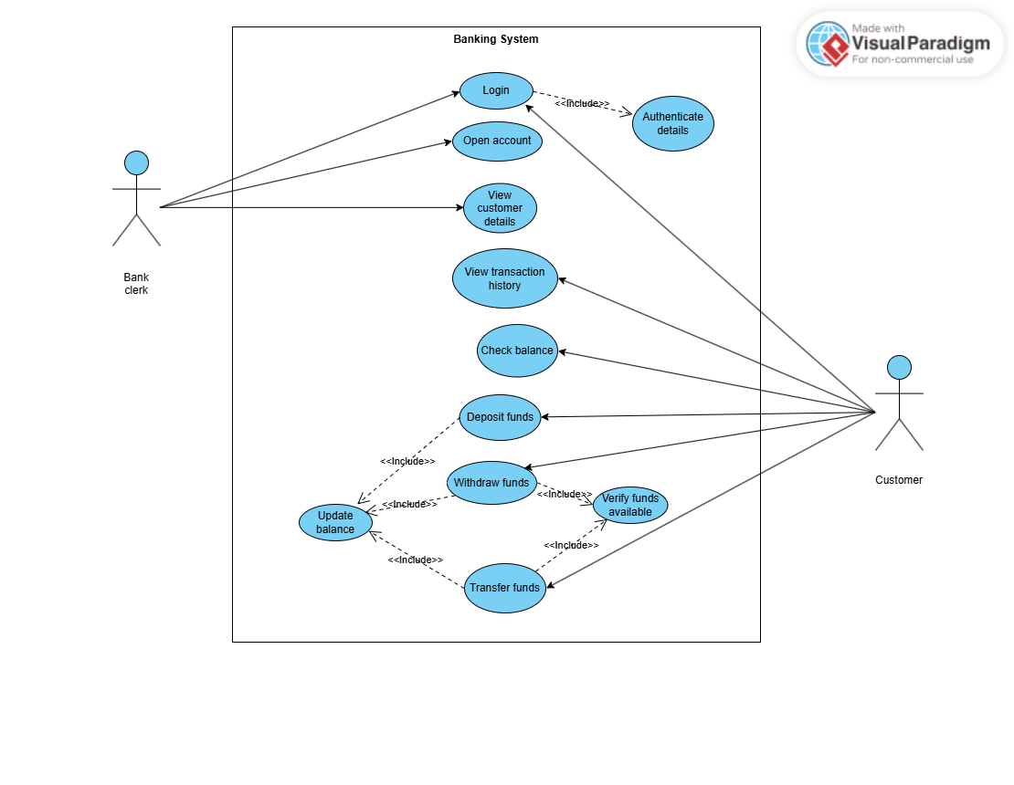

2.2. Class diagram
This diagram shows the static structure of the system, including the key classes, their attributes, operations, and relationships.
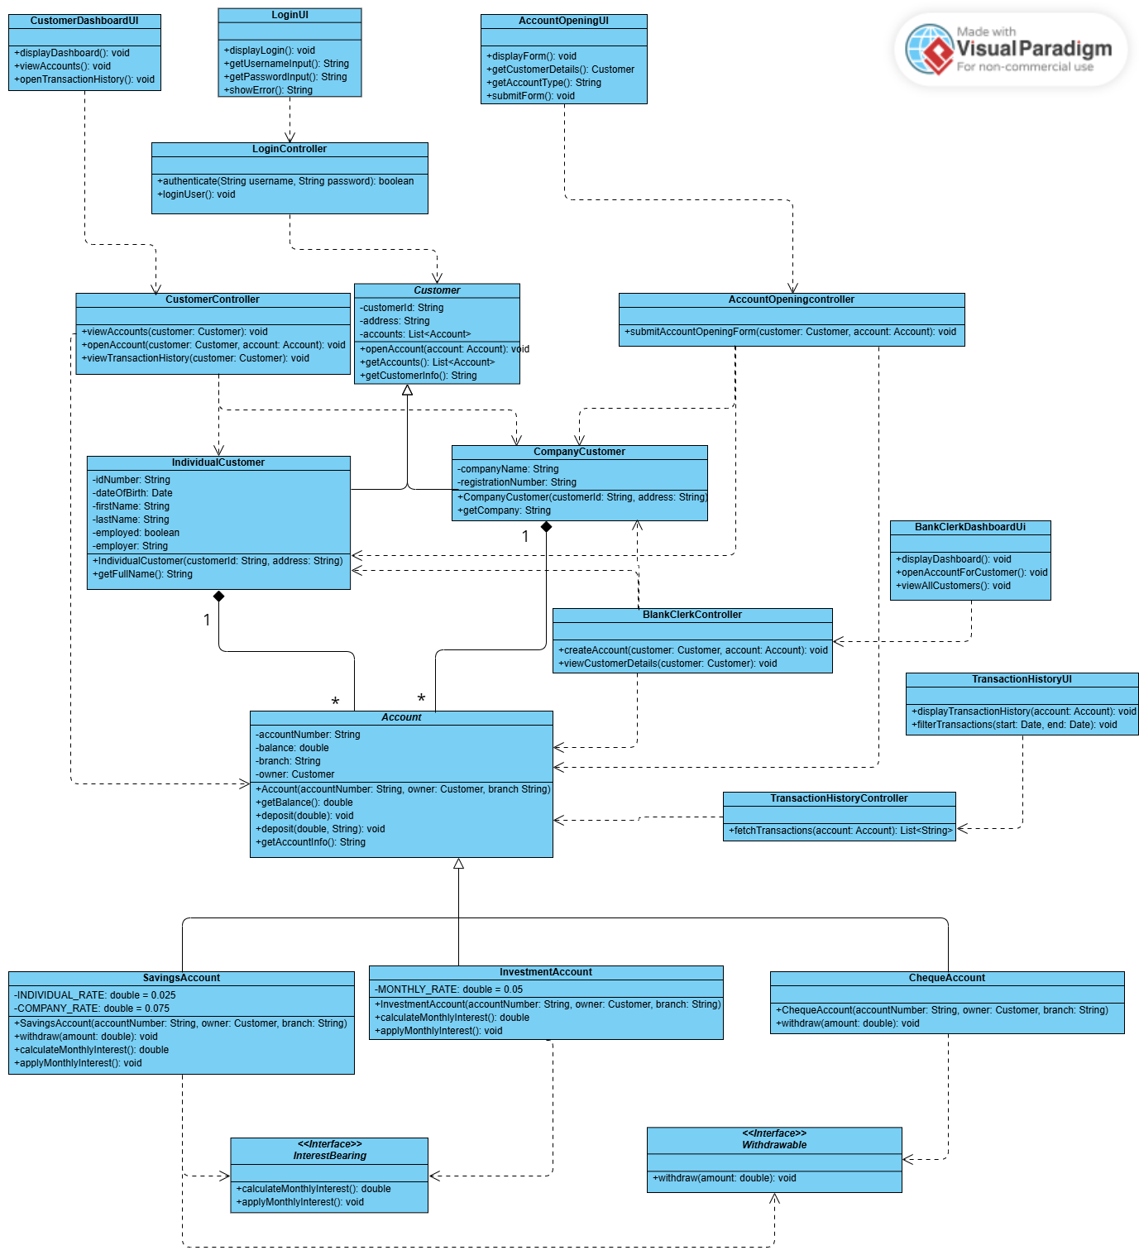
3. Behavioural UML Modelling)
3.1. Sequence Diagrams:
These diagrams model the flow of messages between objects during specific scenarios (login and deposit), demonstrating how the system achieves these functions.
a. Login Sequence diagram
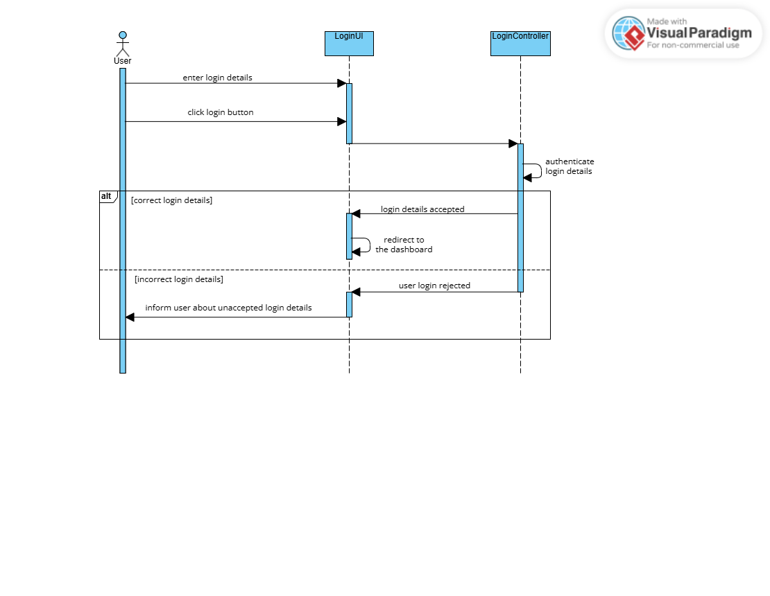
b. Deposit sequence diagram
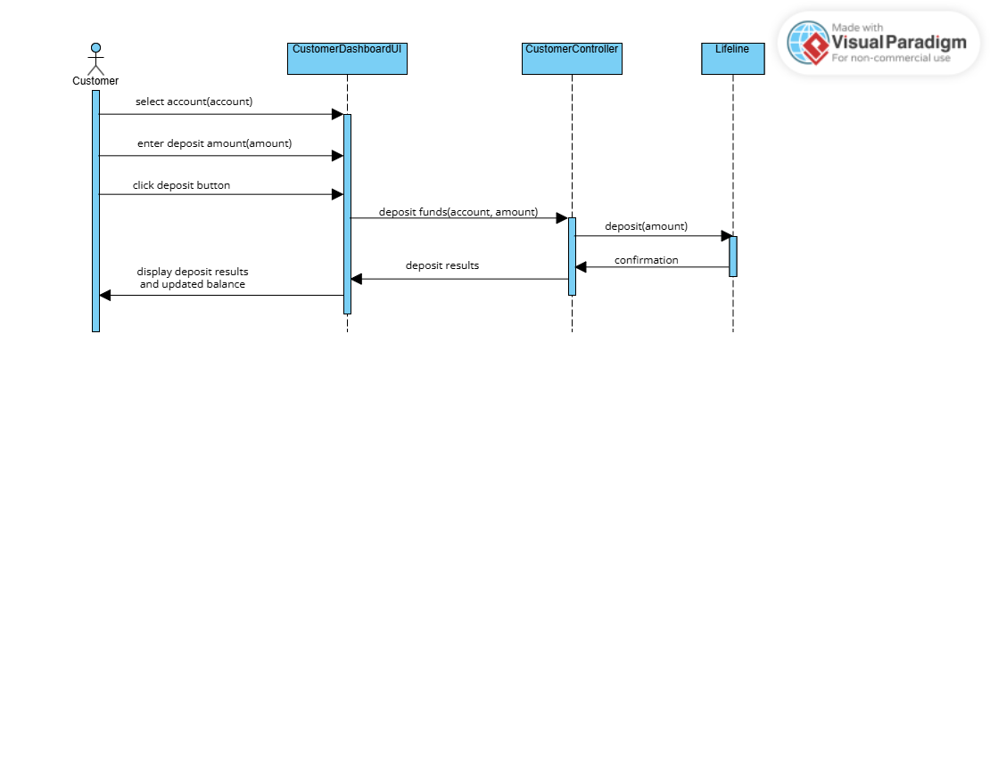

3.2. State Diagram:
This diagram represents the possible states and transitions of a class with a complex lifecycle, InterestBearing, capturing its dynamic behavior.
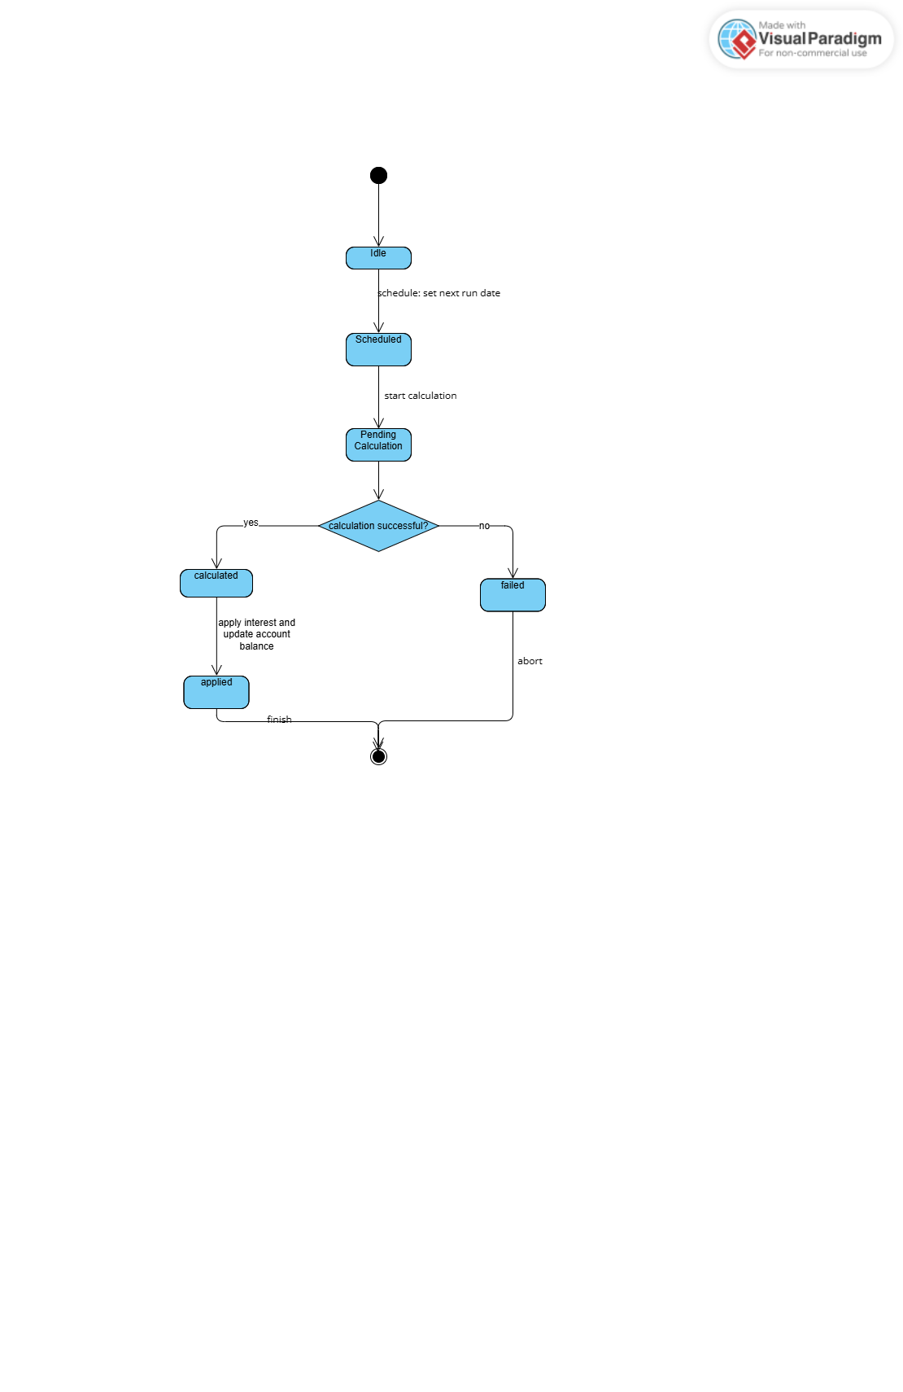

Appendix: Interview Record
This appendix contains the transcript of the mock client interview used to elicit the functional requirements of the banking system.
Date: 17 September 2025
Time: 18:00
Place: Microsoft teams meeting(online)
Participants:
- Interviewer: Mr. Kitsiso Keaitse, Systems Analyst
- Interviewee: Mr. Themba Moeng, Client Representative
Interview Transcript
Q1: What types of accounts does the bank offer, and what rules should apply to each?
A1: The bank offers three account types: Savings, Investment, and Cheque. Each has unique rules, for example, Savings accounts do not allow withdrawals, Investment accounts require a minimum BWP500 opening balance, and Cheque accounts require employment details for eligibility.
Q2: Can a customer hold multiple accounts at the same time?
A2: Yes, customers may hold more than one account. Each account must be linked to the customer’s profile.
Q3: How should the system calculate and apply interest for different account types?
A3: Savings accounts should earn monthly interest of 2.5% for individual customers and 7.5% for company customers, while Investment accounts should earn 5% monthly interest. Cheque accounts do not accrue interest.
Q4: What types of transactions should customers be able to perform (deposit, withdrawal, view balance)?
A4: Customers should be able to deposit into any account. Withdrawals should only be possible from Investment and Cheque accounts, not Savings accounts. They should also be able to view their account balance at any time.
Q5: Are there restrictions or requirements for opening certain accounts (e.g., minimum balance, employment details)?
A5: Yes. Investment accounts require a minimum balance of BWP500 at opening, while Cheque accounts require proof of employment. Savings accounts do not have such restrictions.
Q6: Should customers be able to view their full transaction history?
A6: Yes, the system must maintain a complete transaction history showing deposits, withdrawals, and interest payments.
Q7: What are the minimum balance requirements for each account type?
A7: Savings accounts have no minimum balance, Investment accounts require BWP500 to open, and Cheque accounts depend on employment verification but do not require a fixed minimum.
Q8: How should customer login and authentication be handled to ensure security?
A8: Customers must log in with a secure username and password before accessing account services. Multi-factor authentication can be considered later.
Q9: Should all customer and account details be stored in a database for long-term access and reporting?
A9: Yes, all details must be stored in a persistent database to ensure data integrity, auditability, and future reporting.

