AquaGuard Matlosana
A Serverless, AWS-Native Civic-Tech Platform for Municipal Water Loss Management
Kitso Senwedi · AWS re/Start Program

1. Project Overview
AquaGuard Matlosana is a cloud-native platform that lets residents of the City of Matlosana report water leaks and sewage spills over WhatsApp, and lets municipal staff classify, prioritise, and dispatch repairs from a live dashboard. It was rebuilt end to end on AWS as a hands-on demonstration of practical cloud engineering: designing a serverless architecture, wiring managed services together securely, and making deliberate trade-offs rather than defaulting to a single all-purpose server.
The project is intentionally real: it targets an actual, documented service-delivery problem, uses managed AWS services across compute, data, messaging, AI, identity, and observability, and treats security and cost as first-class design constraints rather than an afterthought.

2. Problem Statement
The City of Matlosana loses a large share of its treated water to untracked leaks, and has one working repair vehicle covering two towns. The Klerksdorp wastewater treatment plant has been non-operational since 2023, and raw sewage has flowed into the Vaal River as a result, contaminating Jouberton, Orkney, and Khuma. The South African Human Rights Commission has found this situation to constitute a human rights violation. Residents currently report leaks informally on Facebook and ward WhatsApp groups, where reports routinely go unanswered.
This is not an isolated case:
- Nationally, municipalities lost R14.89 billion to water losses in the 2023/24 financial year, with 56% of Water Service Authorities exceeding the acceptable 30% loss threshold (Auditor-General South Africa, Water Sector Report, 2025).
- In 2022, only 9 of Matlosana's 40 water department vehicles were operational, and only 54% of reported leak complaints were attended to that month (DA North West, August 2022).
A system that turns an unstructured resident report into a classified, prioritised, trackable ticket directly addresses a documented, worsening service-delivery gap.

3. Solution Overview
The platform follows a simple report-to-resolution flow:
- Report — a resident sends a photo and a GPS pin over WhatsApp; no app install, no data cost, available in Setswana or English.
- Classify — an AI vision model sorts the report into water leak, sewage, or pothole, and estimates litres and Rand lost per day.
- Prioritise — a scoring function ranks the ticket by duration, proximity to schools or clinics, and volume lost.
- Dispatch — a live dashboard shows an optimised route for the day's repair vehicle.
- Track — the resident follows their own ticket's status on a public portal, without exposing their identity or exact location.

4. AWS Architecture
Every part of the system runs on AWS. The only external dependency is the WhatsApp network itself, reached through an AWS-managed service rather than a self-hosted webhook.
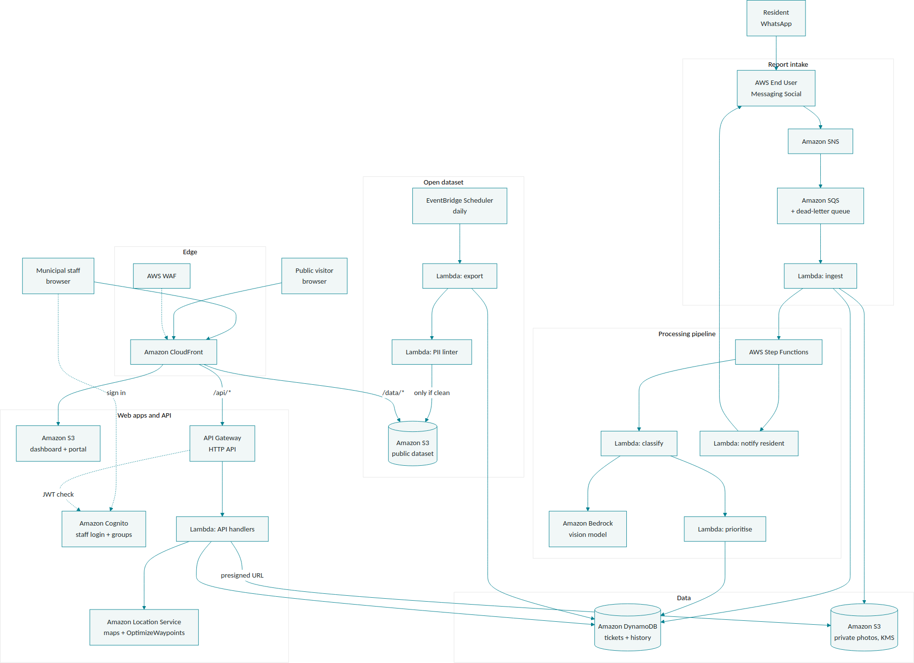

4.1 Request Flow
- A resident sends a photo and location to the WhatsApp number connected through AWS End User Messaging Social.
- The service publishes the inbound event to an Amazon SNS topic, which feeds an Amazon SQS queue with a dead-letter queue, so a spike in traffic or a downstream bug never silently drops a report.
- An ingest Lambda function creates the ticket record in DynamoDB, stores the photo in S3, and starts an AWS Step Functions execution.
- The resident receives their ticket number immediately, before classification runs.
- Step Functions invokes a classification Lambda, which sends the photo to an Amazon Bedrock vision model and receives back a category, severity, and confidence score.
- A prioritisation Lambda scores the ticket and updates DynamoDB; every status change is written to a separate history table.
- Municipal staff access the dashboard through Amazon CloudFront; an API Gateway and Lambda layer serves ticket data and calls Amazon Location Service's OptimizeWaypoints action to sequence the day's repair route.

4.2 Service Mapping
The table below shows how each function is implemented, replacing the earlier prototype's mixed third-party stack with managed AWS services throughout.
Function | Previous Implementation | AWS Implementation
WhatsApp intake | Self-hosted webhook | AWS End User Messaging Social → SNS → SQS → Lambda
API / backend | Node + Express server | Amazon API Gateway (HTTP API) + AWS Lambda
Pipeline orchestration | In-process async calls | AWS Step Functions
Database | Managed Postgres with row-level security | Amazon DynamoDB (on-demand)
File storage | Third-party object storage | Amazon S3 (private, SSE-KMS, presigned URLs)
Staff login | Demo-only login | Amazon Cognito user pool with groups
AI classification | Third-party vision API | Amazon Bedrock (vision-capable model)
Maps and routing | Third-party maps SDK | Amazon Location Service (maps + OptimizeWaypoints)
Frontend hosting | Third-party static host | Amazon S3 + Amazon CloudFront
Edge protection | None | AWS WAF on CloudFront
Secrets | Local .env file | AWS Secrets Manager / SSM Parameter Store + KMS
Open dataset export | Scheduled script | EventBridge Scheduler → Lambda export → Lambda PII check → public S3 bucket
Monitoring | Console logs only | CloudWatch (logs, metrics, alarms), X-Ray, CloudTrail
Deployment | Manual | AWS CDK (TypeScript)
Trade-off worth noting: moving from a relational database with row-level security to DynamoDB removes database-enforced row-level access control. Access control moves into the API layer, using Cognito groups and per-field response filtering in Lambda. Amazon Aurora PostgreSQL Serverless v2 was considered as an alternative that preserves the relational model, at higher cost and with a VPC requirement.

5. Data Model (DynamoDB)

5.1 Tickets Table
Partition key: ticketNumber. Key attributes: category, severity, status, ward, priorityScore, aiConfidence, litresPerDay, randPerDay, nearSensitiveSite, reporterHash, photoKey, createdAt, fixedAt.
- GSI 1 — status + priorityScore: powers “top open tickets for today's route”.
- GSI 2 — ward + createdAt: powers ward filters and the public ward summary.

5.2 TicketHistory Table
Partition key: ticketNumber. Sort key: changedAt. Attributes: oldStatus, newStatus, changedBy. This table is the system's audit trail, satisfying the requirement that every status change be independently traceable.

5.3 Public Data Projection
The public-facing API returns only ticketNumber, category, severity, status, ward, and createdAt. This projection is implemented in a single Lambda function so it can be tested and reviewed independently of the rest of the API.

6. Security Controls
Each control below maps to a specific, testable requirement rather than a general intention.
Requirement | AWS Control
Hash phone numbers | HMAC-SHA256 with a secret key held in Secrets Manager (not plain SHA-256, which is brute-forceable against a small number space)
Anonymised public data | Dedicated field-projection Lambda; a PII-linting Lambda gates every scheduled export
No secrets in source code | Secrets Manager / SSM SecureString, fetched at runtime
Role-based access | Cognito groups (admin, dispatcher, viewer) + API Gateway JWT authorizer
Rate limiting | AWS WAF rate-based rule on CloudFront + API Gateway stage throttling
Encryption in transit and at rest | TLS throughout; KMS for S3, DynamoDB, SQS, and Secrets Manager
Retention and deletion | S3 lifecycle rules, DynamoDB TTL, and a resident-facing deletion-request endpoint
Audit trail | TicketHistory table + CloudTrail
Least privilege | One IAM role per Lambda function; permission boundary on the deployment role

7. Region and Availability Considerations
Confirmed before implementation, since these are the most common reasons a design like this stalls in practice:
- Africa (Cape Town), af-south-1, is an opt-in AWS Region and must be explicitly enabled on the account used.
- AWS End User Messaging Social has a specific, evolving list of supported Regions; if the target Region is unsupported, the design falls back to an API Gateway and Lambda webhook that verifies Meta's request signature directly.
- Amazon Bedrock model access must be enabled per account, and cross-Region inference may route requests outside South Africa — a data-residency question worth documenting explicitly given the personal information involved.
- Amazon Location Service's Routes API and OptimizeWaypoints action availability should be confirmed for the chosen Region before the routing feature is built.

8. Skills Demonstrated
- Compute & API: AWS Lambda, Amazon API Gateway, AWS Step Functions
- Data & Storage: Amazon DynamoDB (single-table design, GSIs), Amazon S3, KMS encryption
- Identity & Access: IAM least-privilege roles, Amazon Cognito, permission boundaries
- Messaging & Integration: Amazon SNS, Amazon SQS (with dead-letter queues), Amazon EventBridge
- AI/ML: Amazon Bedrock (multimodal inference)
- Geospatial: Amazon Location Service (maps, route optimisation)
- Edge & Delivery: Amazon CloudFront, AWS WAF
- Security Operations: AWS Secrets Manager, AWS KMS, AWS CloudTrail
- Observability: Amazon CloudWatch (logs, metrics, alarms), AWS X-Ray
- Infrastructure as Code: AWS CDK (TypeScript), AWS Budgets and resource tagging for cost control

9. Build Roadmap
- Foundation: CDK project scaffold, IAM roles, KMS key, S3 buckets, DynamoDB tables, AWS Budgets alert.
- API and data: API Gateway and Lambda handlers, Cognito user pool, synthetic seed data.
- Frontend: dashboard and portal served from S3 through CloudFront, pointed at the API.
- Intake and AI: SNS/SQS ingest path, Step Functions pipeline, Bedrock classification, resident notifications.
- Routing and maps: Amazon Location Service maps and OptimizeWaypoints integration.
- Hardening: WAF rules, CloudWatch alarms, dead-letter queue handling, and the scheduled PII-linted export.

Kitso Senwedi
AWS re/Start Program Trainee · AWS Certified Cloud Practitioner · AWS Certified Solutions Architect – Associate

